**IBM NAAN MUDHALVAN**

**Phase 5 – IOT**

**Project name : Smart Water fountain**

**Objective:**

The objective of creating a smart water fountain using IoT (Internet of Things) is to enhance the functionality and efficiency of a traditional water fountain by integrating it with IoT technologies.

**IOT Device setup:**

1. Select the Hardware:Choose a microcontroller or single-board computer (e.g., Arduino, Raspberry Pi) as the brain of your IoT device.Select the appropriate sensors, such as water level sensors, proximity sensors, water quality sensors, and environmental sensors (e.g., temperature, humidity).
2. Connect Sensors:Wire and connect the selected sensors to the microcontroller. Follow the datasheets and pin configurations for proper connections.
3. Power Supply:Ensure the IoT device and sensors have a stable power supply. Consider using a power source suitable for your setup, which may include batteries or a reliable power adapter.

**Code Implementation:**

**```c**

**#include <stdio.h>**

**#include <stdbool.h>**

**#include <wiringPi.h>**

**#define WATER_LEVEL_SENSOR 0**

**#define PROXIMITY_SENSOR 1**

**#define WATER_PUMP_PIN 2**

**int main() {**

**if (wiringPiSetup() == -1) {**

**return 1;**

**}**

**pinMode(WATER_LEVEL_SENSOR, INPUT);**

**pinMode(PROXIMITY_SENSOR, INPUT);**

**pinMode(WATER_PUMP_PIN, OUTPUT);**

**while (1) {**

**int waterLevel = digitalRead(WATER_LEVEL_SENSOR);**

**int proximity = digitalRead(PROXIMITY_SENSOR);**

**if (waterLevel == LOW) {**

**digitalWrite(WATER_PUMP_PIN, HIGH); // Turn on the pump**

**} else if (proximity == HIGH) {**

**digitalWrite(WATER_PUMP_PIN, HIGH); // Turn on the pump**

**} else {**

**digitalWrite(WATER_PUMP_PIN, LOW); // Turn off the pump**

**}**

**}**

**return 0;**

**Block Diagram for smart water fountain :**

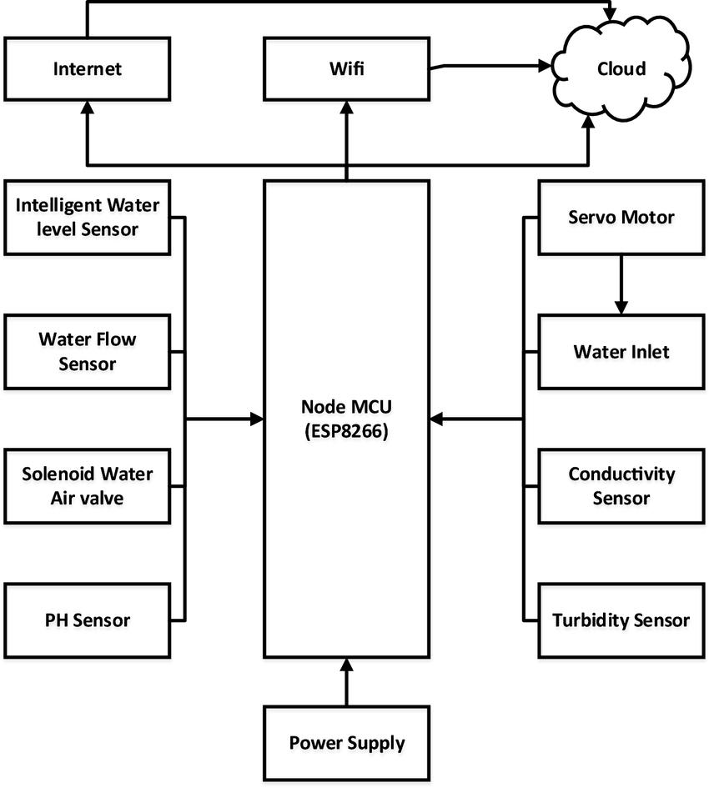

**Explanation of the Project :**

A smart water fountain project involves the creation of an intelligent and connected water fountain that leverages technology, sensors, and IoT (Internet of Things) capabilities to enhance its functionality, efficiency, and user experience.

Here's an explanation of the key components and features of a typical smart water fountain project:1. IoT and Connectivity:The heart of the smart water fountain is an IoT device (usually a microcontroller or single-board computer) that is equipped with communication capabilities (e.g., Wi-Fi, Bluetooth, or cellular). This enables the fountain to connect to the internet and communicate with other devices or services.

2. Sensors:Various sensors are integrated into the fountain to monitor and collect data. Common sensors include water level sensors, proximity sensors, water quality sensors, and environmental sensors (e.g., temperature and humidity sensors).

3. Data Collection:The sensors continuously collect data relevant to the fountain's operation, such as water level, water quality, user proximity, and environmental conditions. This data is then processed and used for decision-making.

4. User Interaction:Smart water fountains often offer user-friendly interfaces for controlling and customizing the fountain's behavior. This can include mobile apps or web interfaces that allow users to start or stop the fountain, change water flow patterns, colors, or music synchronizations.

5. Remote Monitoring and Control:Users can remotely monitor and control the fountain through a smartphone app or a web portal, providing convenience and flexibility.

6. Efficiency and Water Conservation:The smart fountain is designed to use water more efficiently. For example, it may have features that automatically shut off the fountain when water levels are low or schedule its operation during specific times to reduce water wastage.

7. Energy Efficiency:The system is optimized for energy efficiency. For instance, the water pump is turned on only when needed, reducing energy consumption.