**Knowledge Graphs Lab**

Semantic Data Management

Lab Report

Víctor Diví

Pietro Ferrazzi

May, 2022



# B.1: TBOX Definition

The TBOX has been generated programmatically using the Jena API, the code can be found in the file “Pietro Victor-B1-FerrazziDivi.java” or inside the executable project as the TBox class.

The TBOX generated uses several OWL elements and concepts, some of which may be out of scope for the project. Since they had been already implemented by the time that fact came to knowledge, they are included in the TBOX and in this report. However, the generating code is split in two parts, one that builds the base model, and another that extends it with OWL restrictions. In particular, the base model uses the following OWL elements:

* owl:DatatypeProperty
* owl:ObjectProperty
* owl:inverseOf

Any other OWL element used in the TBOX is added in the second part.

Two Turtle files are included in the project regarding this section:

* Base TBOX: “Pietro Victor-B1-FerrazziDivi-Base.ttl”
* Extended TBOX: “Pietro Victor-B1-FerrazziDivi-Extended.ttl”

Figure 1 below shows a simplified version of the class diagram implemented (in particular, Datatype Properties are not being shown).

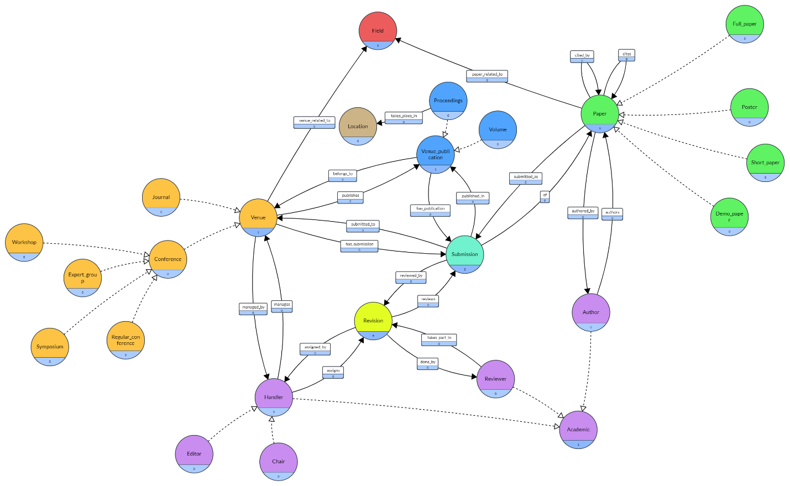

Figure 1 TBOX class diagram (Classes and Object Properties only)

As can be seen by the colors, we have 4 hierarchies: Paper, Academic, Venue, and Venue Publication; and 4 single classes: Revision, Submission, Field and Location. All classes and properties are local, except for Location, which is from the dbpedia ontology (<http://dbpedia.org/Ontology/Location>).

Table 1 lists all the Object Properties shown previously in the diagram, showing also the relationship between them (inverse properties), as well as the cardinality of each one (the slash separates the cardinality of the property and the cardinality of the inverse).

|  |  |  |  |  |
| --- | --- | --- | --- | --- |
| Property | Domain | Range | inverseOf | Cardinality |
| authors | Author | Paper | authored_by | ≥1 / ≥1 |
| cites | Paper | Paper | cited_by | - / - |
| submitted_as | Paper | Submission | of_paper | - / =1 |
| submitted_to | Submission | Venue | has_submission | =1 / - |
| published_in | Submission | VenuePublication | has_publication | ≤1 / - |
| belongs_to | VenuePublication | Venue | publishes | =1 / - |
| manages | Handler | Venue | managed_by | ≥1 / ≥1 |
| assings | Handler | Revision | assigned_by | - / ≥1 |
| done_by | Revision | Reviewer | takes_part_in | ≥2 / ≥1 |
| reviews | Revision | Submission | reviewed_by | ≥1 / =1 |
| paper_related_to | Paper | Field | - | ≥1 |
| venue_related_to | Venue | Field | - | ≥1 |
| takes_place_in | Proceedings | Location | - | ≥1 |

Table 1 List of Object Properties

Table 2 lists all the Datatype Properties of the TBOX that are missing in Figure 1 (following the same color code). The last column shows the cardinality of each property. Note that we accept having multiple values of most textual properties to be able to have translations.

|  |  |  |  |  |
| --- | --- | --- | --- | --- |
| Domain | Property Name | Range (XSD) | SubPropertyOf | Cardinality |
| Academic | name | String | rdfs:label | ≥1 |
| Paper | doi | String | - | ≤1 |
| Paper | title | String | rdfs:label | ≥1 |
| Paper | abstract | String | rdfs:comment | ≥1 |
| Submission | submission_date | Date | - | =1 |
| Submission | submission_accepted_date | Date | - | ≤1 |
| Revision | accepted | Boolean | - | ≤1 |
| Revision | review_text | String | rdfs:comment | - |
| Revision | revision_date_start | Date | - | =1 |
| Revision | revision_date_end | Date | - | ≤1 |
| Field | keyword | String | rdfs:label | ≥1 |
| Venue | venue_name | String | rdfs:label | ≥1 |
| VenuePublication | year | Year | - | =1 |
| Volume | volume_number | Integer | - | =1 |

Table 2 List of Datatype Properties

The following assumptions were made in the TBOX design:

* In a revision of a submission, only one review text and final decision is made. I.e., there is one review text and decision per revision, not per reviewer.
* At least one attribute has been added per hierarchy, meaning that each concept is in the domain of at least one attribute, although it may not be directly (e.g., Handler has no attributes, but Academic does).
* Conferences may take place in different locations each year, and therefore that location is related to the Proceedings of that Conference.

In addition to the restrictions defined by the cardinalities specified in Table 1 and Table 2, the following restrictions are implemented as OWL restrictions, and therefore, the violation of any of them would make the Ontology inconsistent:

* The seven main classes (Academic, Venue, VenuePublication, Paper, Submission, Revision and Field) are pairwise disjoint.
* The seven main classes (Academic, Venue, VenuePublication, Paper, Submission, Revision and Field) are pairwise disjoint.
* Academic subclasses are complete (i.e., Academic is equivalent to the union of Author, Reviewer and Handler).
* Handler subclasses are complete.
* Paper subclasses are complete and pairwise disjoint.
* Venue subclasses are complete and pairwise disjoint.

Conference subclasses are complete and pairwise disjoint.

* VenuePublication subclasses are complete and pairwise disjoint.
* Journals (Conferences) can only publish Volumes (Proceedings). Conversely, Volumes (Proceedings) can only belong to Journals (Conferences).

The following restrictions were identified as necessary for a semantically correct Ontology, but they are not implemented, so violating any of them would not generate an inconsistency:

* Posters can only be submitted/published in Conferences
* A Submission can only be published if it is accepted by the Revision
* A Paper can only be published once

It’s possible that more restrictions could exist in the model, but since they have not been identified, they are considered out of scope for this project.

# B.2: ABOX Definition

The ABOX has been generated programmatically with Jena API (like the TBOX), using files originally created for the 1st Lab of SDM (Property Graphs Lab). We refer to Annex 1 for an explanation on how these files were created, although a brief explanation of the files used and their relevant fields can be found in this section.

Since the ABOX has been created with the same tool as the TBOX, the links between them have been created along with the individuals. In particular, we use OntClass::createIndividual to create all the individuals, which sets the type of the individual created to the class used.

The code for the ABOX creation can be found in “Pietro Victor-B2-FerrazziDivi.java” or inside the executable project as the ABox class. Note that these files contain the code for both B.2 and B.3 sections of the lab. One Turtle file is added containing the output of the program (using the extended TBOX) named “Pietro Victor-B2-FerrazziDivi.ttl”.

The following subsections explain the 4 different files used.

## Data

The main CSV file, named data.csv, contains the major part of the information, and is used to create the Papers, Authors, Venues, VenuePublications, Submissions and Fields. The following table shows the fields used and the information they contain.

|  |  |
| --- | --- |
| Field | Meaning |
| Authors | Names of the authors |
| Author(s) ID | Ids of the authors |
| Title | Title of the paper |
| Year | Year of publication of the paper |
| Source title | Name of the venue that published the paper |
| Volume | Volume of the venue in which the paper is published |
| DOI | DOI of the published paper |
| Abstract | Abstract of the paper |
| Index keywords | Keywords of the paper |
| Document Type | Indicates whether the venue is a journal or a conference |

For each row in the file, the following individuals and datatype properties are created:

* 1 Paper, with an autogenerated URN, and a title, an abstract and a DOI. If the paper is published in a conference, then one paper subclass will be randomly selected as the type of the paper, the same happens if it is published in a journal, but without Poster as an option.
* At most 1 Author per item in “Authors”/“Author(s) ID” fields, using the ids in “Author(s) ID” as URNs, to be able to reuse them when they appear again. If a new name appears with the same id, it is added again (they are normally the same name with minor changes in spelling or abbreviations).
* At most 1 Venue, with an autogenerated URN and a name. Like the authors, venues are reused. If the venue is a journal, then the class Journal is used to create the instance, otherwise, one of the Conference subclasses is randomly selected and used. When the venue is created, three Handlers of the corresponding subclass (Chair for Conferences, Editor for Journals) are created with an autogenerated URN.
* At most 1 VenuePublication, with a URN that depends on the Venue URN and the Volume/Year. Like the venues, they are reused. If the venue is a journal, then the Volume class will be used to create the instance, and a volume number will be added. If the venue is a conference, the Conference will be used instead, and the instance will be related to a Location instance (:Barcelona is used for every one).
* 1 Submission, with an autogenerated URN, and related to the paper, venue and venue publication through the corresponding properties.
* At most 1 Field per element in “Index Keywords” field, with a keyword. Both the paper and venue are related to each field through the corresponding properties.

## Citations

The citations.csv file contains pairs of papers, meaning that, for each pair, the first cites the second. Therefore, for each row in the file, a property :cites is created between the first and second paper.

## Reviews and reviewers

The revision information is contained in two files:

* reviewers.csv: Contains pairs of Paper and Authors indicating that said Authors review said Paper (note that in the resulting graph, all Reviewers will also be Authors).
* reviews.csv: Contains, for each Paper-Reviewer pair, the decision and the review text.

To create the Revisions, first reviews.csv is iterated and, for each paper (not for each row, only the first row that has a positive outcome for each paper is used), a revision is created, with a review text and an accepted value (which is always true), and it is related to the submission of the paper and to a randomly selected handler of the venue to which the paper is submitted through the corresponding properties.

The, for each row in reviews.csv, the revision is related to the reviewers through the :done_by property.

# B.3: Ontology Overview and Statistics

For the Ontology generated, an OWL-QL entailment regime is considered. Which provides the expressive power to represent the cardinality constraints and other restrictions used, and allows us to skip the explicit generation of the following properties:

* rdfs:label of Academic, Venue, Field and Paper instances, via the rdfs:subPropertyOf from :name, :venue_name, :keyword and :title respectively.
* rdfs:comment of Paper and Revision instances, via the rdfs:subPropertyOf from :abstract and :review_text respectively.
* rdfs:type via rdfs:subClassOf of the following instances:

|  |  |
| --- | --- |
| Explicit class | Inferred classes |
| Chair, Editor | Handler, Academic |
| Author, Reviewer | Academic |
| Volume, Proceedings | VenuePublication |
| Journal | Venue |
| Workshop, Symposium, Expert Group, Regular Conference | Conference, Venue |
| Full Paper, Short Paper, Demo Paper, Poster | Paper |

Table 3 Inferred classes via the rdfs:subClassOf property

* rdfs:type of Reviewer is inferred when creating a :done_by property between the individual (which at the moment were only of type Author) and a Revision instance.
* All properties that have an inverse (see Table 1 above) are just created in one of the directions. The inverse property is inferred thanks to the owl:inverseOf property.

# B.4: Ontology Querying

All following queries can be found in “Pietro Victor-B4-FerrazziDivi.sparql” and make use of the following prefixes:

PREFIX rdf: <http://www.w3.org/1999/02/22-rdf-syntax-ns#>

PREFIX rdfs: <http://www.w3.org/2000/01/rdf-schema#>

PREFIX owl: <http://www.w3.org/2002/07/owl#>

PREFIX fd: <https://ferrazzi.divi/#>

1. Find all Authors.

SELECT ?person WHERE {

?person rdf:type fd:Author

}

1. Find all properties whose domain is Author.

SELECT ?property WHERE {

?property rdfs:domain fd:Author

}

1. Find all properties whose domain is either Conference or Journal.

SELECT ?property WHERE {

{?property rdfs:domain fd:Conference}

UNION

{?property rdfs:domain fd:Journal}

}

1. Find all the papers written by a given author that were published in database conferences

SELECT ?paper WHERE {

?paper rdf:type fd:Paper ; #*

fd:authored_by fd:<insert authorId here> ;

fd:submitted_as ?submission .

?submission rdf:type fd:Submission ; #*

fd:published_in ?proceedings .

?proceedings fd:belongs_to ?conference .

?conference rdf:type fd:Conference ;

fd:venue_related_to ?field .

?field fd:keyword “databases” .

}

In this query, the lines marked with an * are not really needed, since they are redundant with the properties also queried (fd:Paper is the domain of both fd:authored_by and fd:submitted_as, and fd:Submission is the range of fd:submitted_as and domain of fd:published_in).

# References

**There are no sources in the current document.**