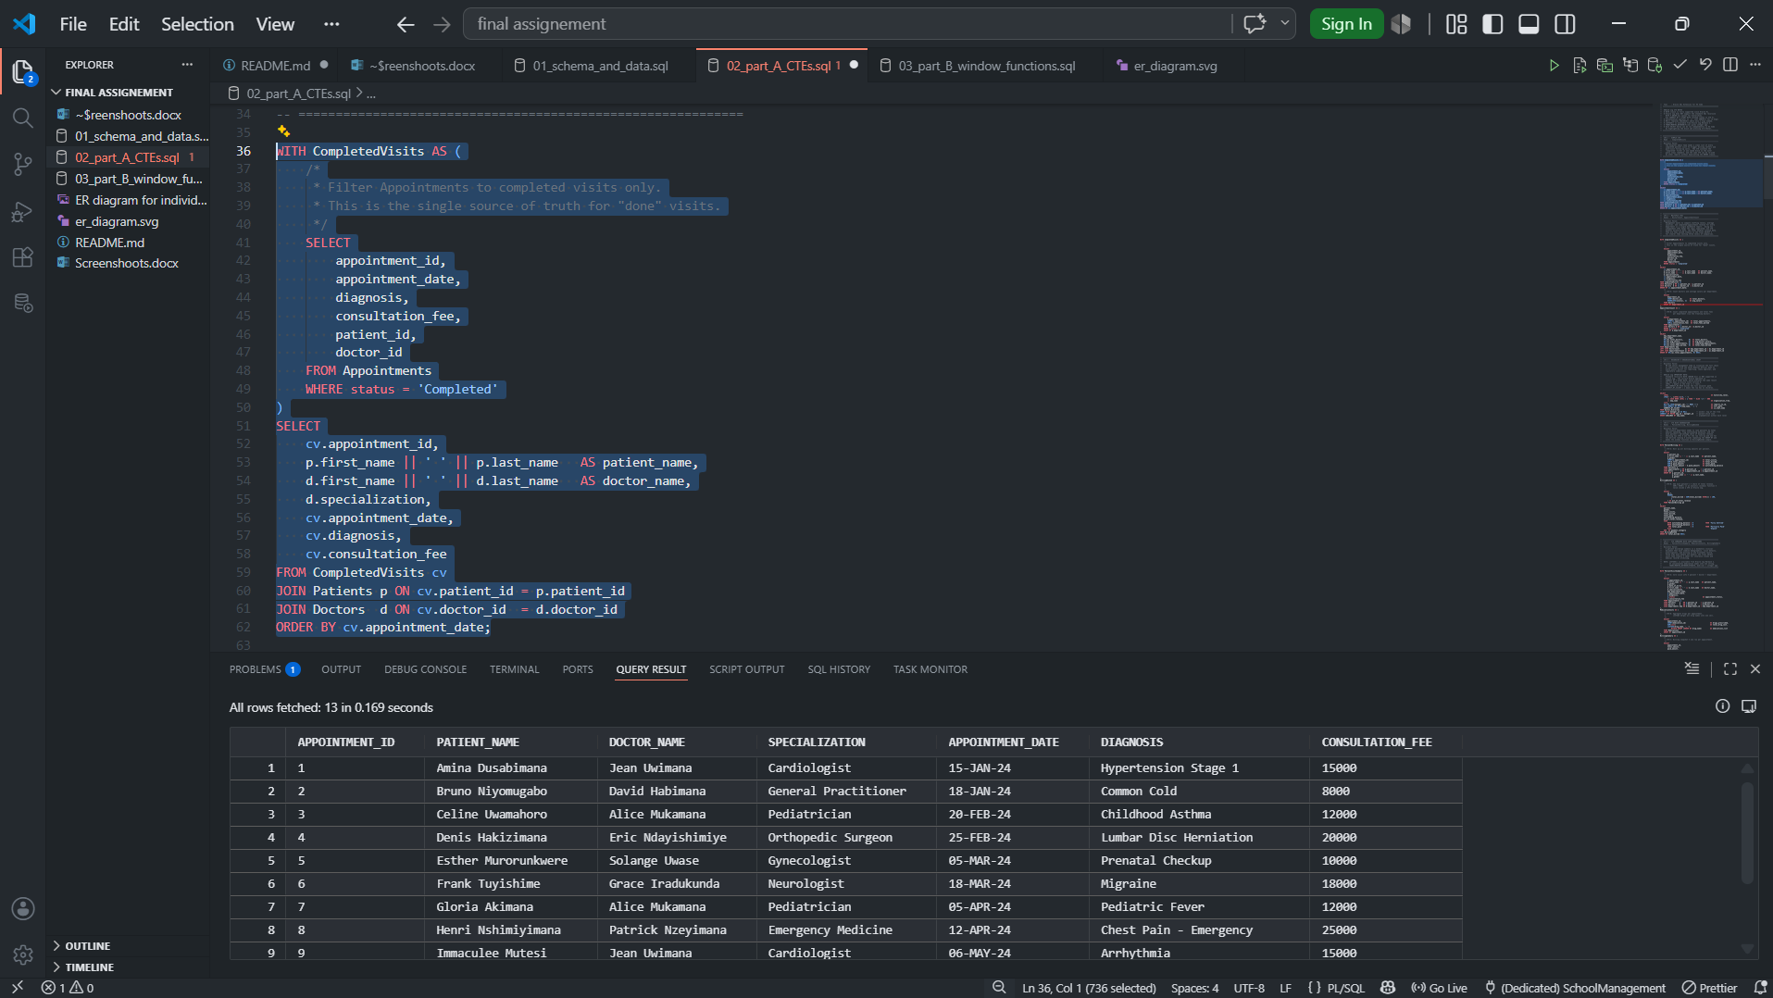

The above photo shows simple CTE
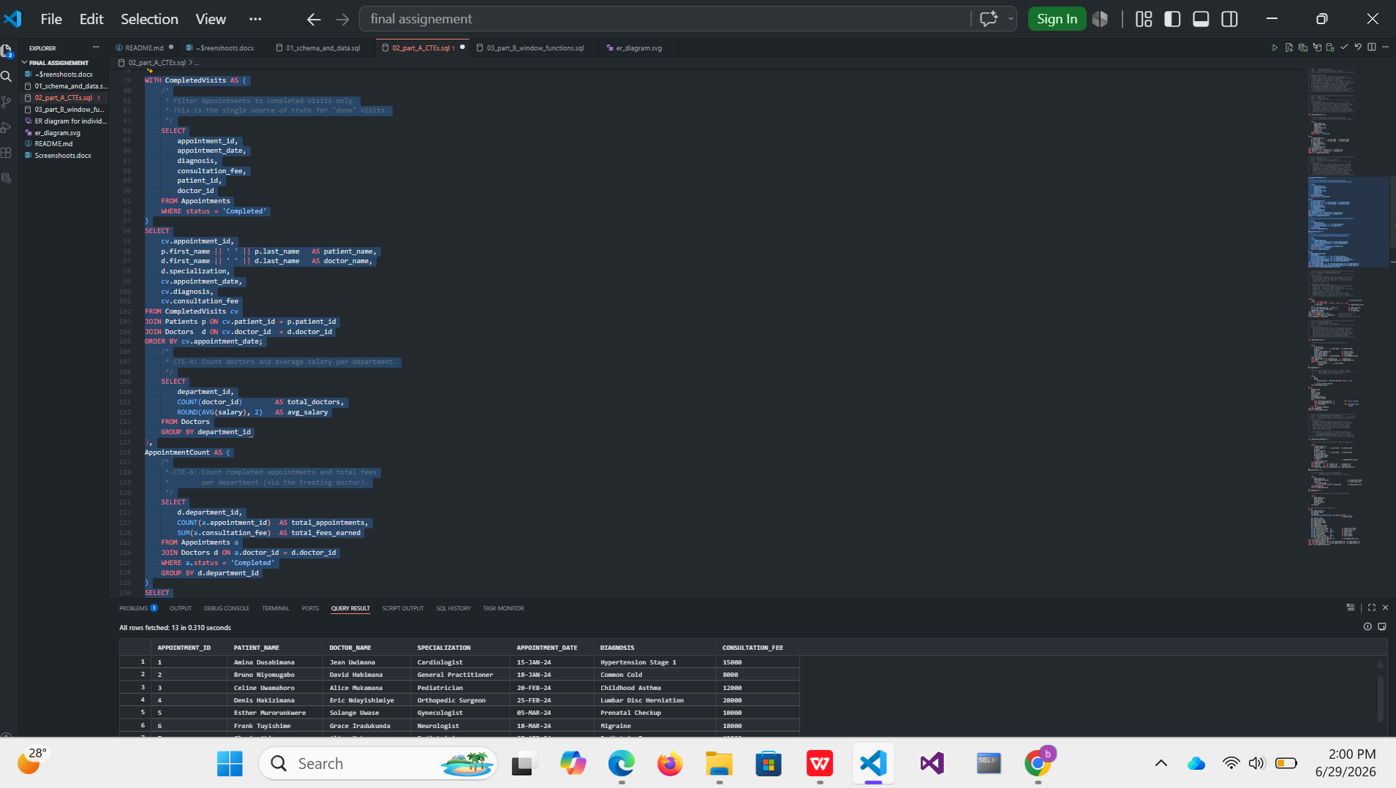
THE ABOVE PHOTO SHOWS MULTIPLE CTEs
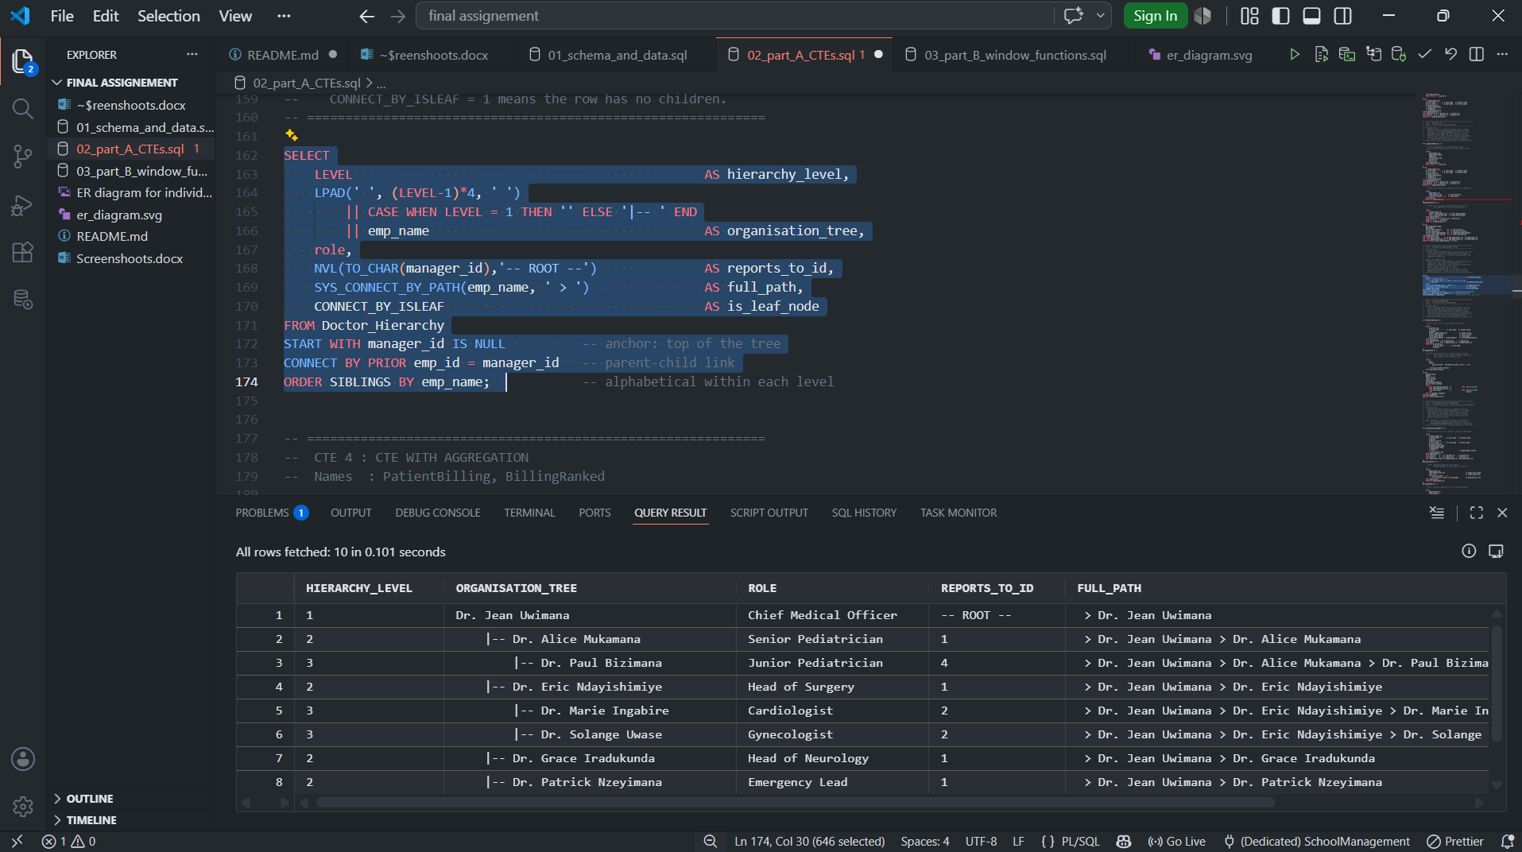
The above photo is showing rucurcive CTE
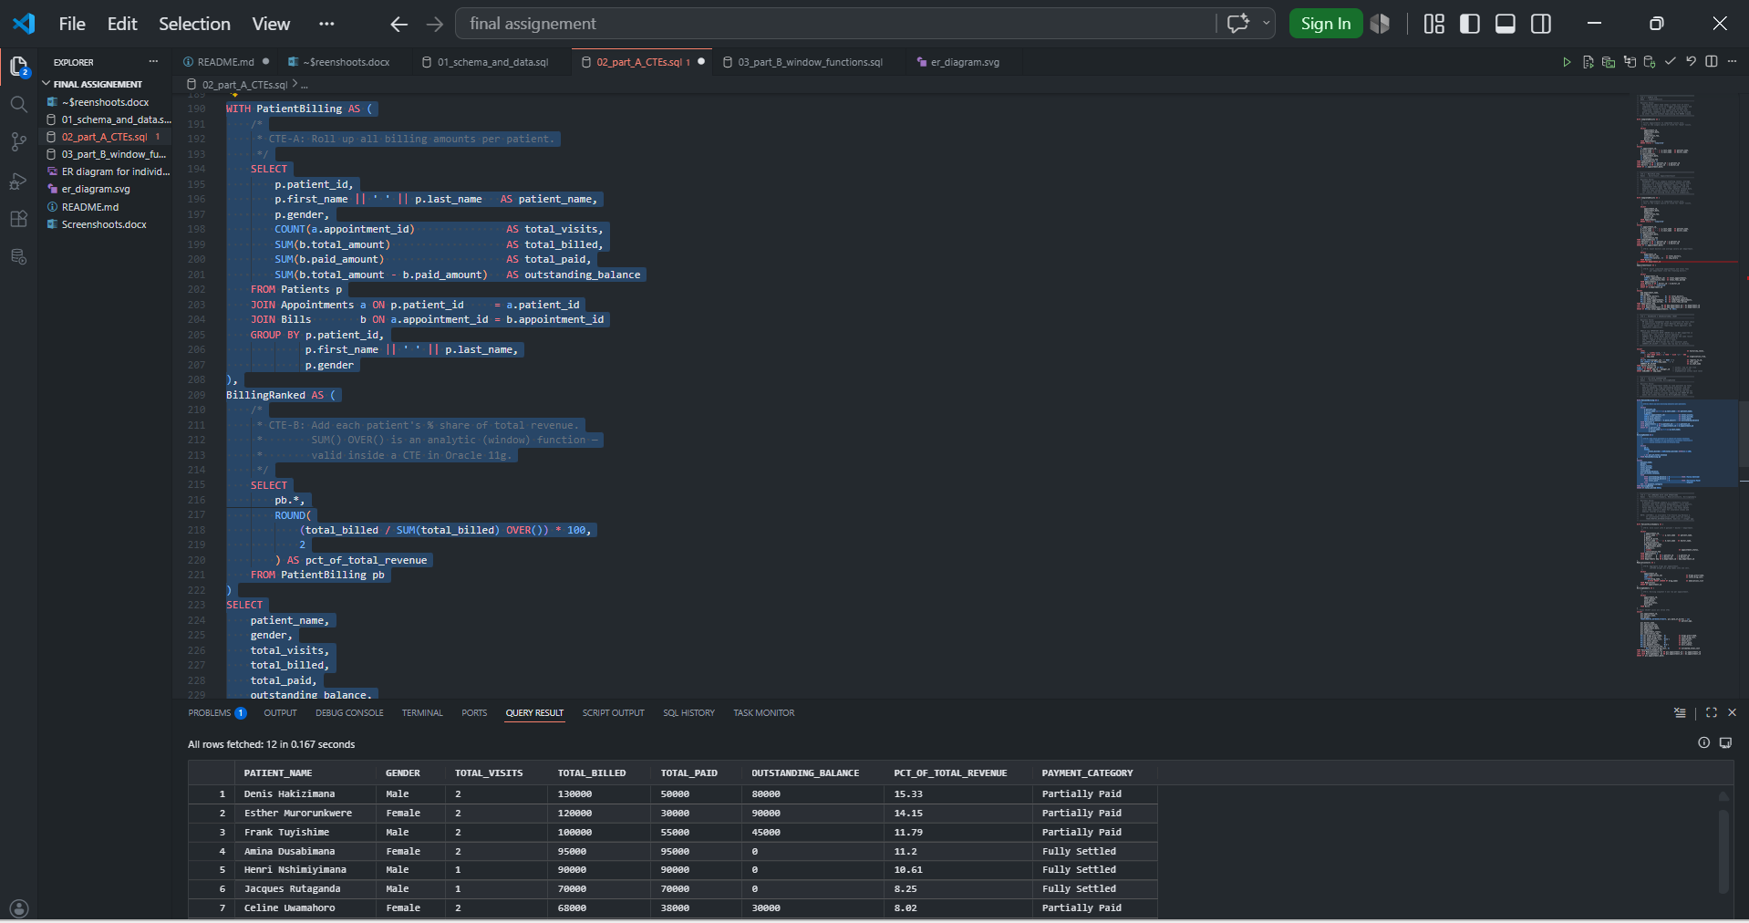
The above photo shows CTE with Aggregation
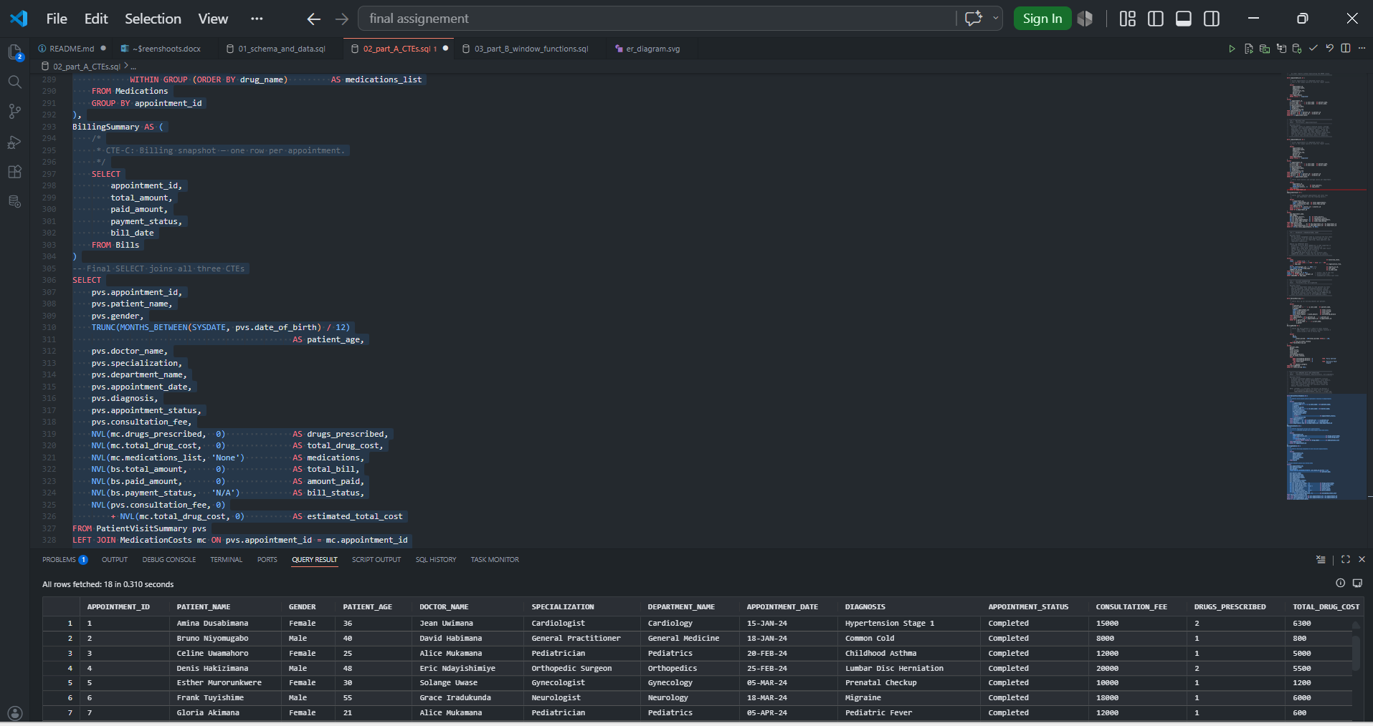
The above photo is showing CTE combined with JOIN operations

Final question Part B: SQL Window Functions

- Ranking Functions
• ROW_NUMBER()
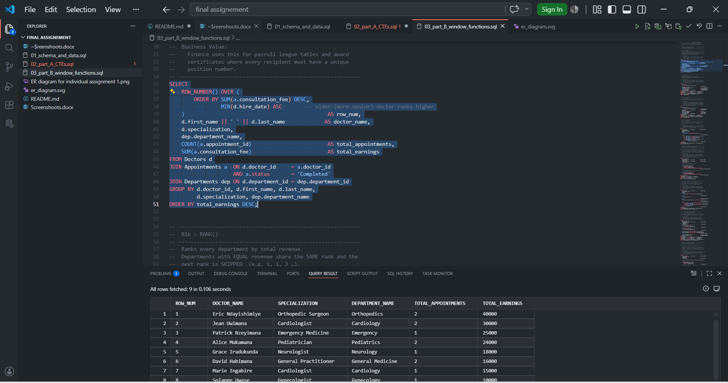

This picture shows • RANK() 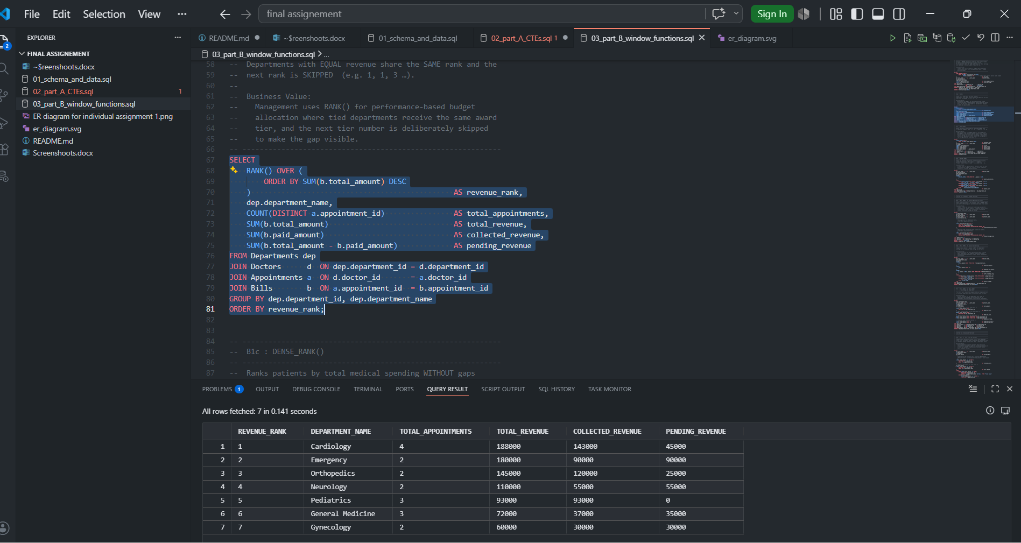

This picture shows • DENSE_RANK()

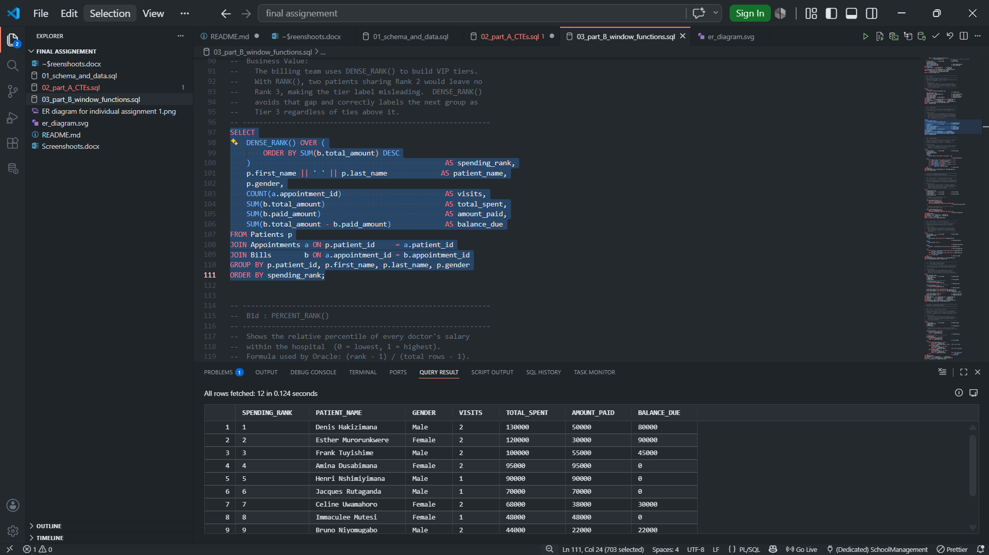

This next picture shows • PERCENT_RANK()

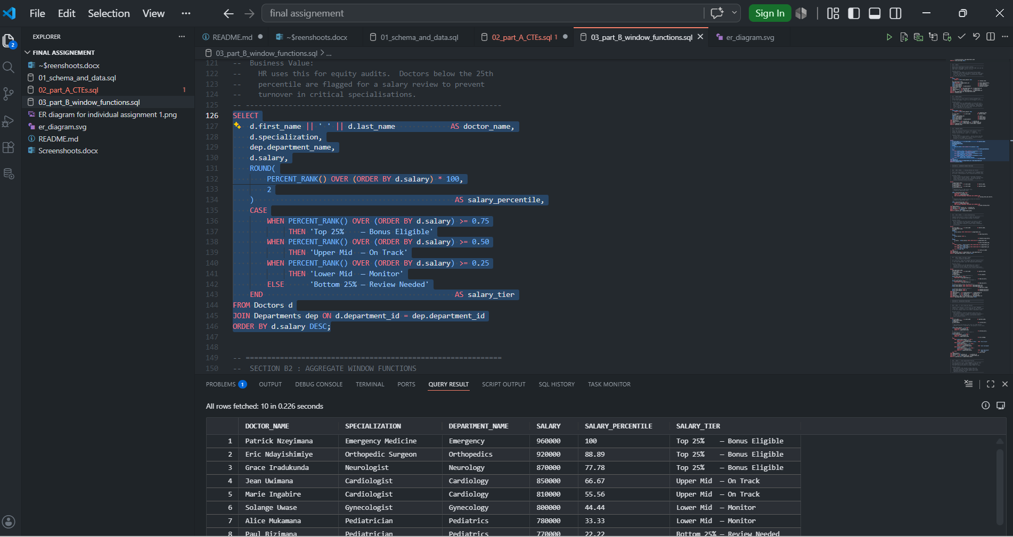

2. Aggregate Window Functions

This picture is showing • SUM() OVER()
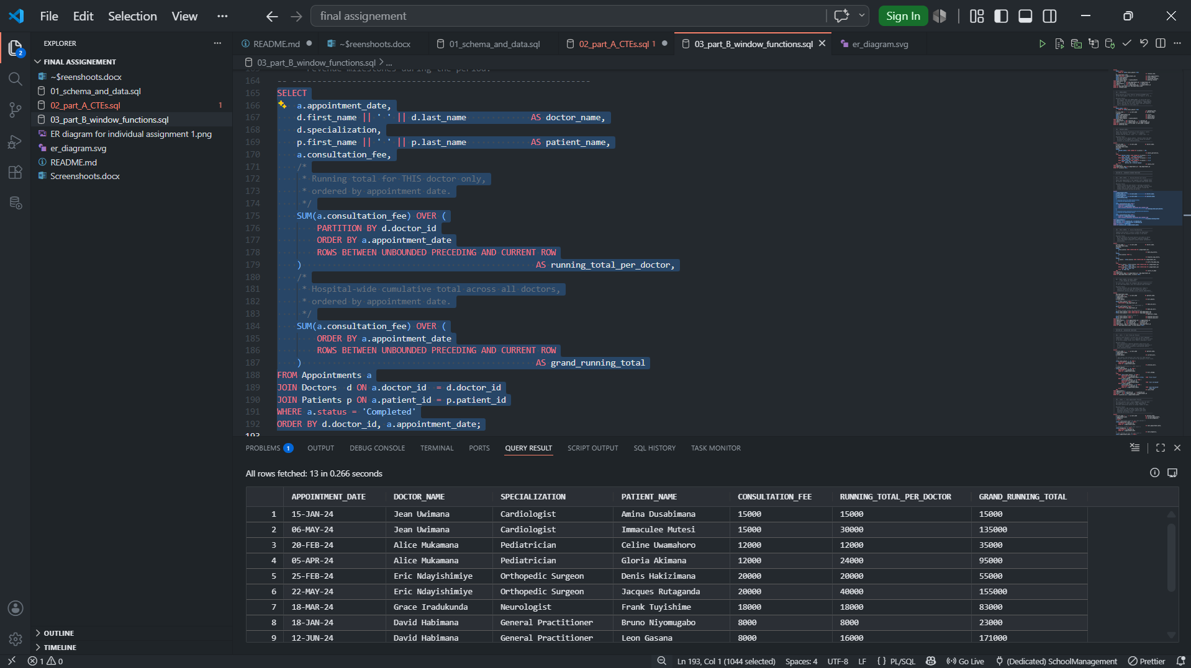

This picture is showing • AVG() OVER()

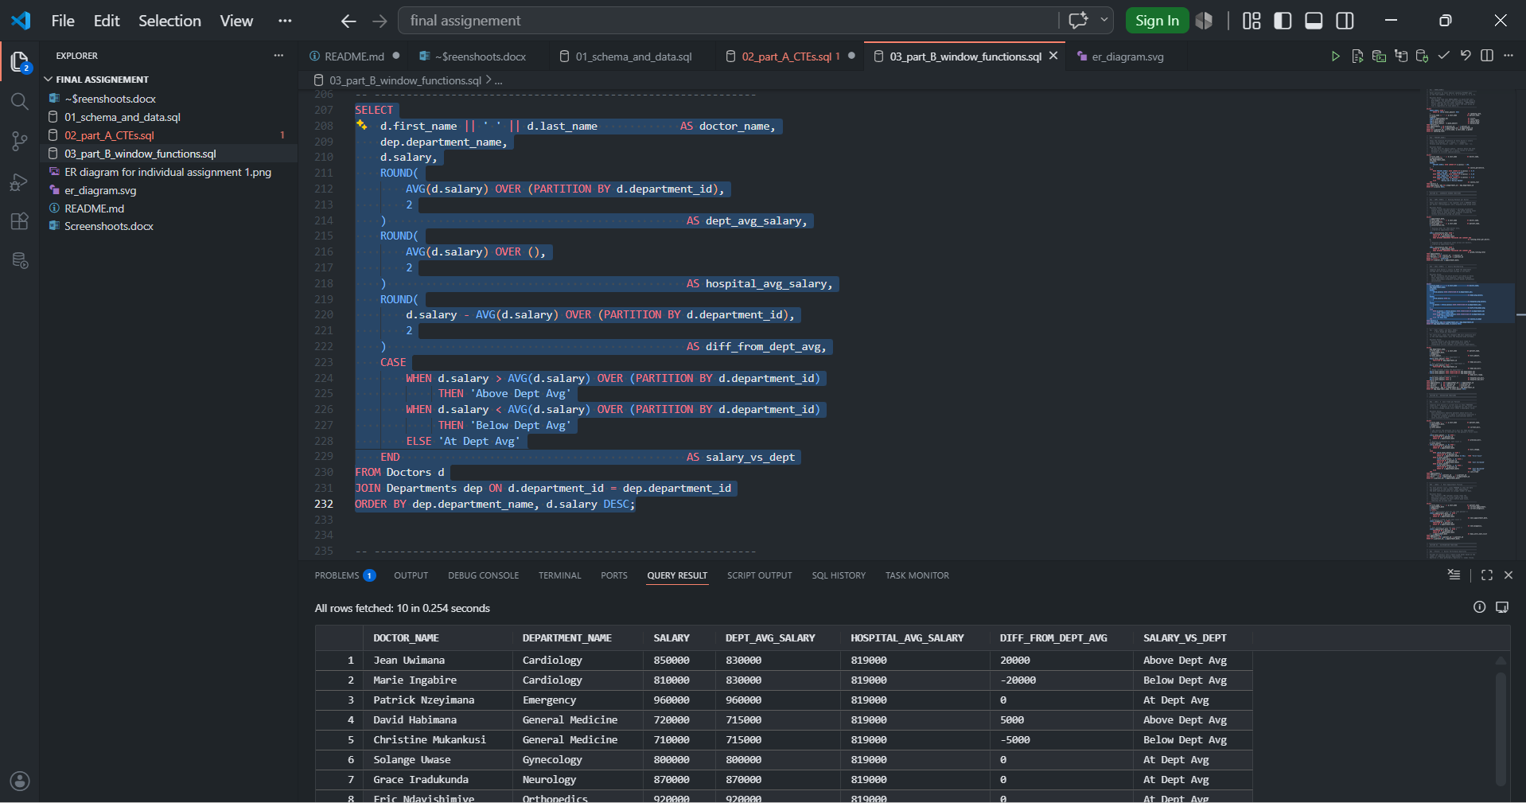

This picture is showing • MIN() OVER() and MAX() OVER()

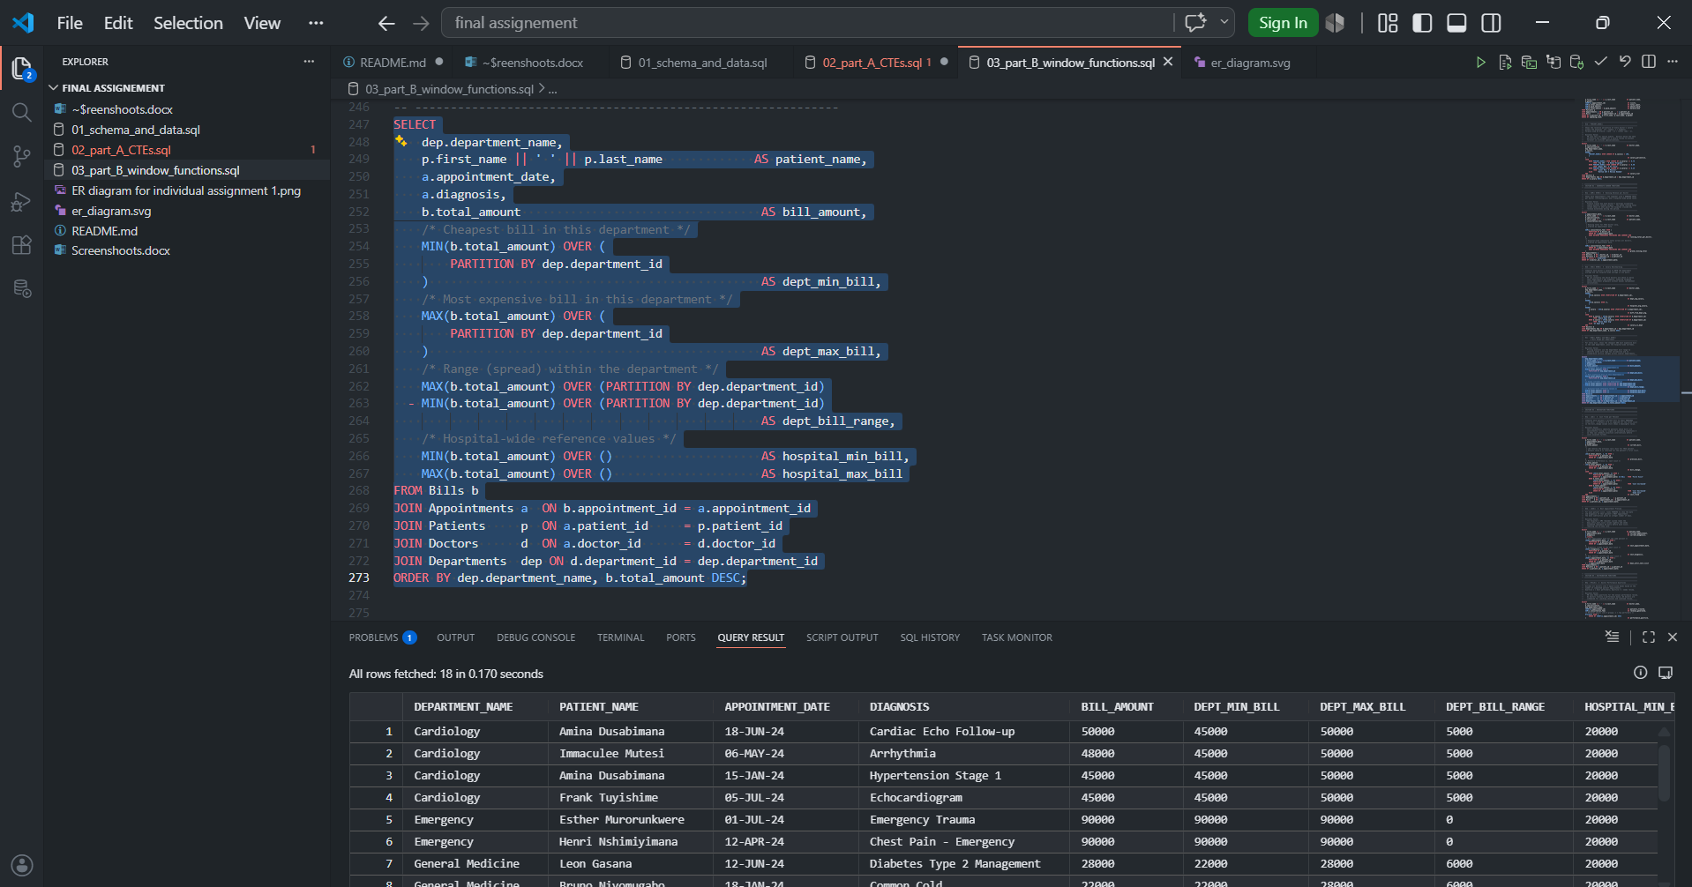

Navigation Functions •
LAG()

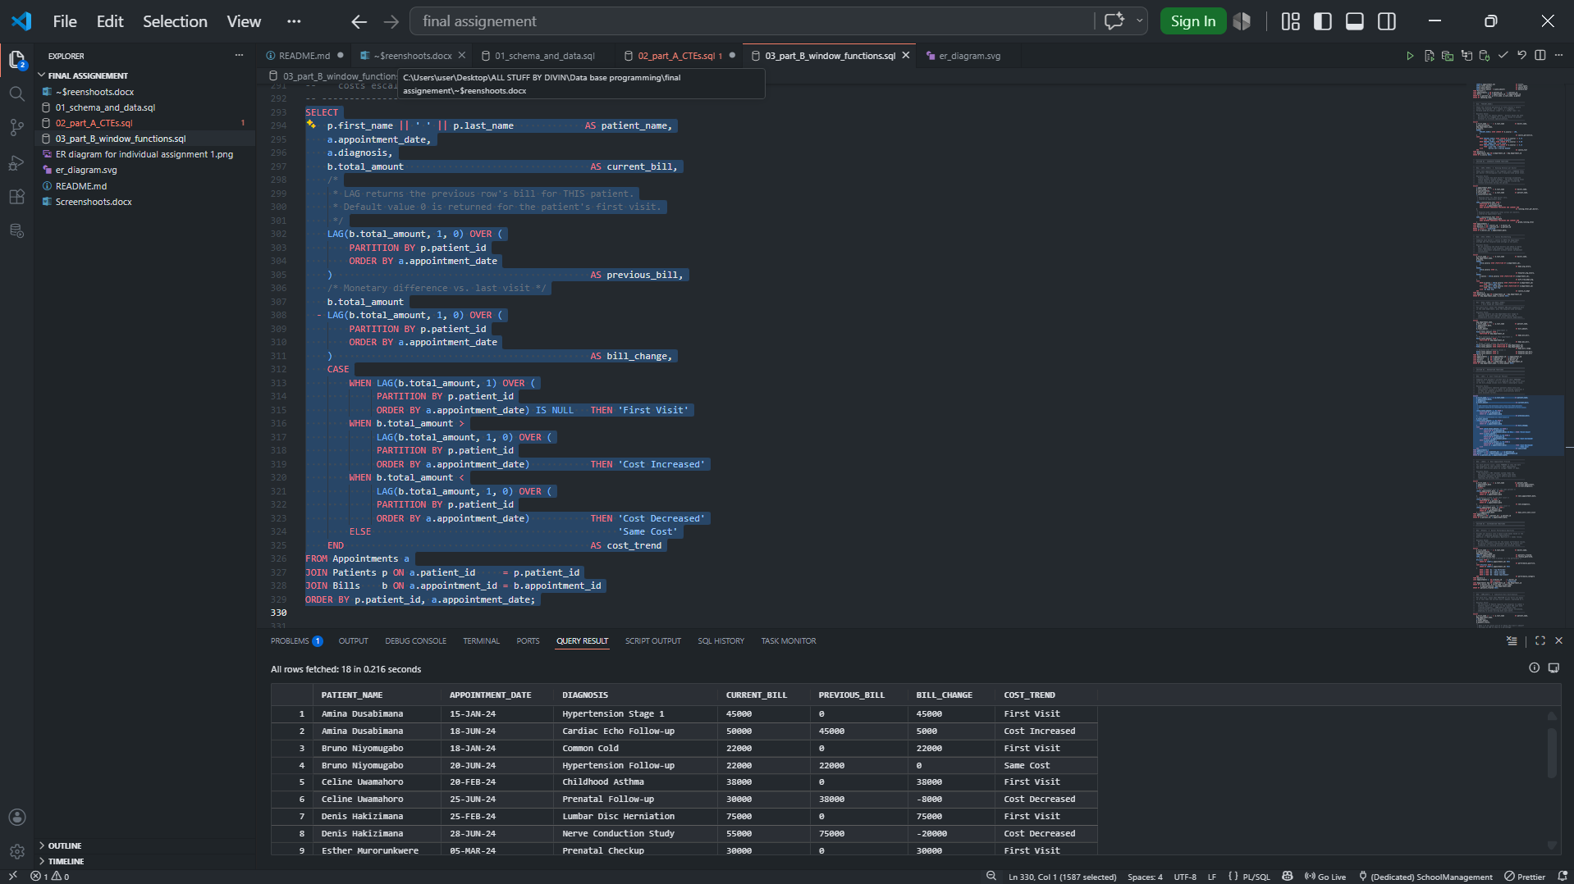

LEAD()

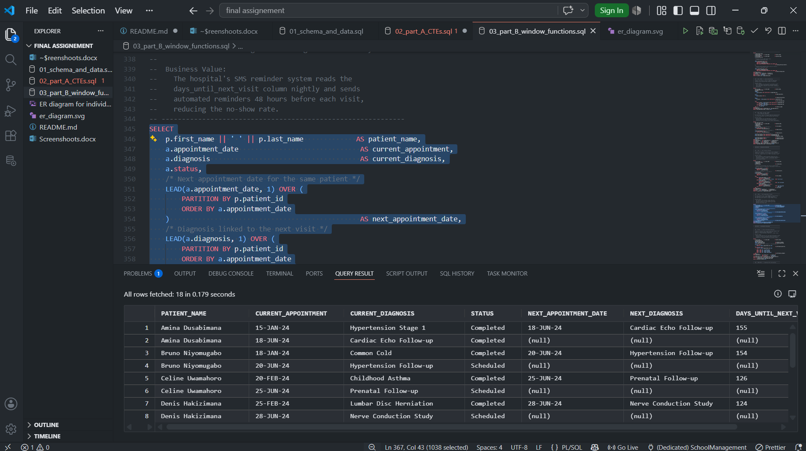

Distribution Functions •
NTILE()

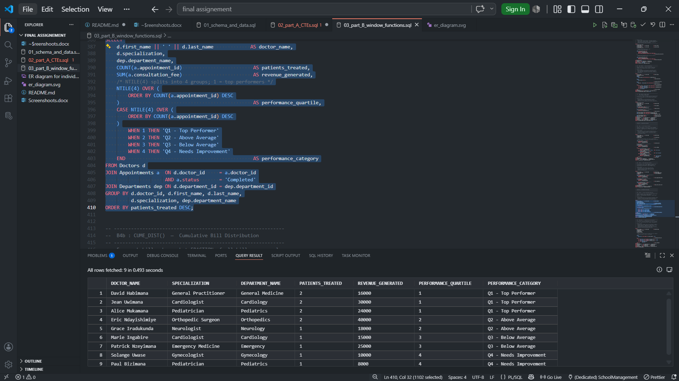

CUME_DIST()

