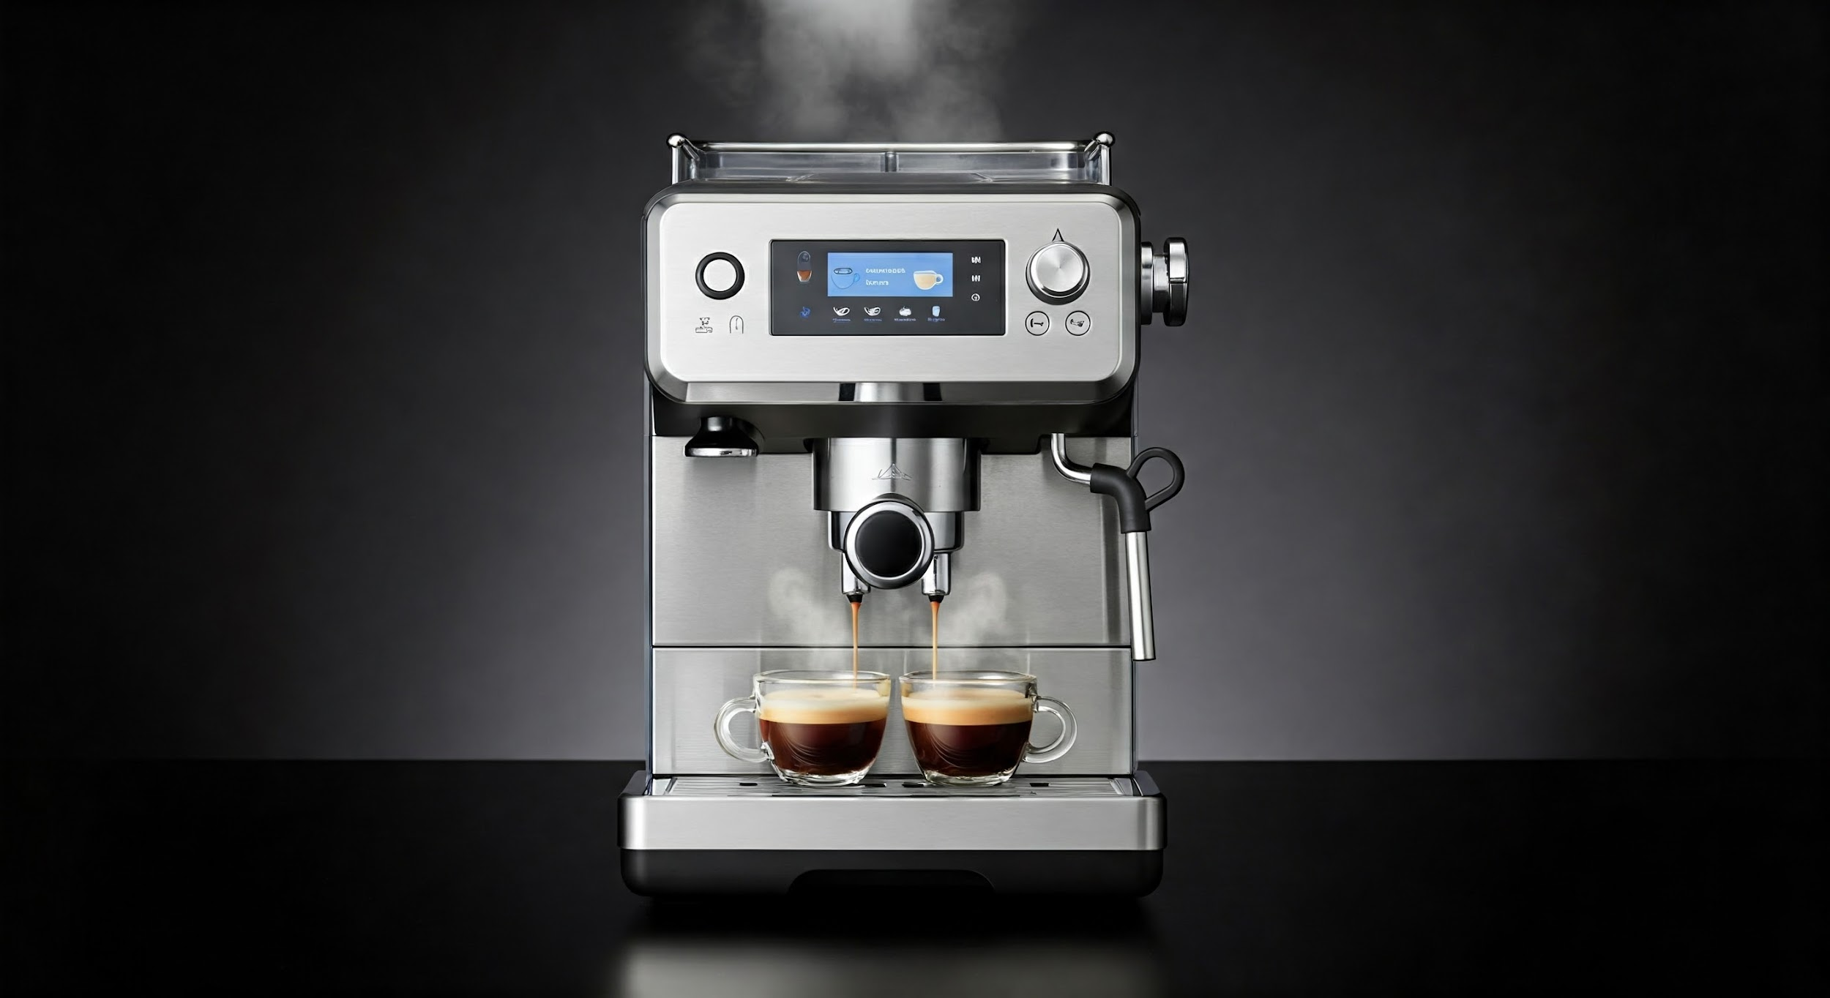

AI-Powered Coffee Machine Roadmap

**Introduction**

The future of coffee brewing lies in the integration of artificial intelligence (AI) into coffee machines. This roadmap outlines the path to developing an AI-powered coffee machine, highlighting key features, milestones, timelines, and future strategic initiatives.

# Key Features

* **Personalized Brewing Profiles:**  
    
  The AI will learn user preferences and create personalized brewing profiles, adjusting settings to deliver the perfect cup every time.
* **Bean Recognition and Automatic Adjustments:**  
    
  The machine will recognize different coffee beans and automatically adjust brewing parameters for optimal extraction.
* **Predictive Maintenance:**  
    
  The AI will monitor machine performance and predict maintenance needs, minimizing downtime and ensuring consistent operation.
* **Voice and Mobile App Control:**  
    
  Users will be able to control the machine using voice commands or a mobile app, allowing for convenient and hands-free operation.
* **Smart Inventory Management:**  
    
  The machine will track coffee bean and water levels, notifying users when supplies are low and facilitating automatic reordering.

# Roadmap and Milestones

| Phase | Timeline | Milestones | Initiatives |
| --- | --- | --- | --- |
| **Phase 1: Proof of Concept** | 0-6 Months | Develop a prototype with basic AI capabilities, such as personalized brewing and bean recognition. | - Research and development of AI algorithms. - Integration of sensors and actuators. - Design of user interface. |
| **Phase 2: Beta Testing** | 6-12 Months | Test the prototype with a select group of users and gather feedback. | - User experience testing. - Refinement of AI algorithms. - Development of mobile app. |
| **Phase 3: Market Launch** | 12-18 Months | Launch the AI-powered coffee machine in the market. | - Manufacturing and distribution. - Marketing and sales. - Customer support. |

# Future Strategy Breakdown

| Timeline | Key Milestones | Initiatives |
| --- | --- | --- |
| **1-3 Years** | Expand AI capabilities to include advanced features such as beverage customization and recipe suggestions. | - Continuous improvement of AI algorithms. - Integration of additional sensors and actuators. - Expansion of beverage options. |
| **3-5 Years** | Develop a cloud-based platform for data collection and analysis, enabling remote monitoring and machine learning. | - Development of cloud infrastructure. - Data security and privacy measures. - Machine learning and predictive analytics. |
| **5+ Years** | Explore integration with smart home ecosystems and other IoT devices. | - Partnerships with smart home companies. - Development of APIs and integrations. - Expansion into new markets. |

# Conclusion

The development of an AI-powered coffee machine represents a significant advancement in coffee brewing technology. By following this roadmap and implementing the outlined strategies, we can create a machine that delivers a personalized, convenient, and efficient coffee experience. The integration of AI will not only enhance the brewing process but also revolutionize the way we interact with our coffee machines.