# Student Performance Analysis and Visualization Report

### Overall Performance Statistics

count 128.00  
mean 57.39  
std 12.03  
min 24.00  
25% 50.00  
50% 56.00  
75% 65.00  
max 87.00  
Name: Total Score, dtype: float64

### Histogram Displaying Distribution of Total Scores

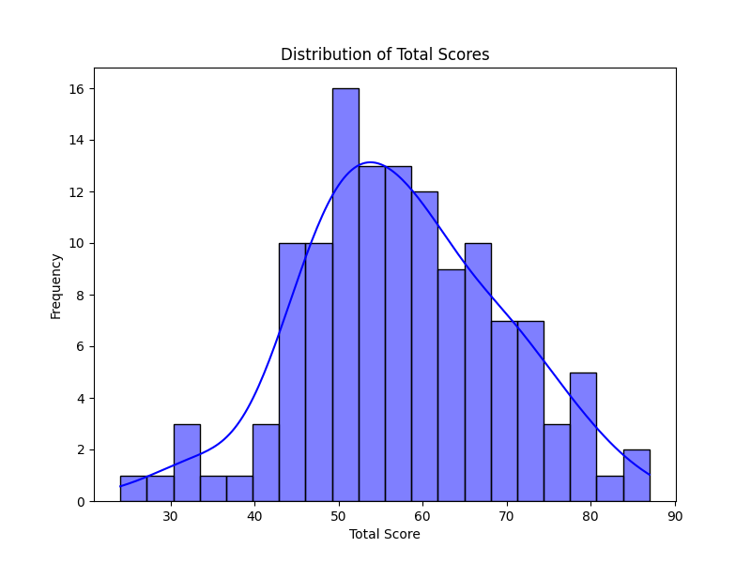

### Boxplot Comparing Total Scores by Pass/Fail Status

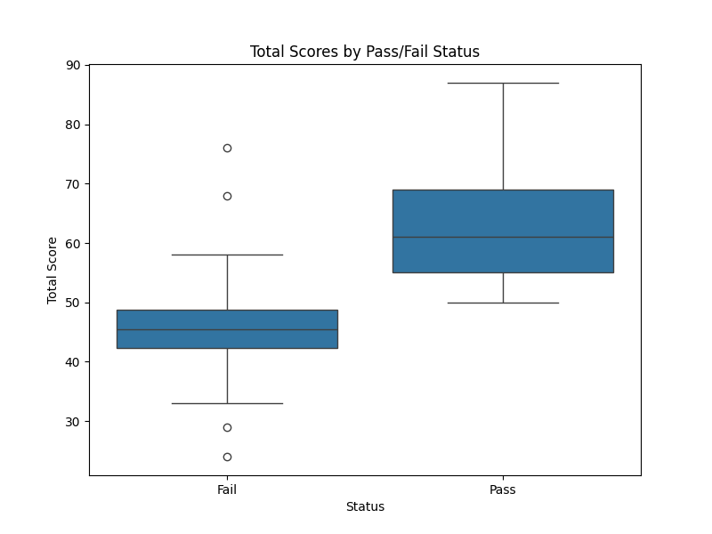

### Countplot Displaying Pass/Fail Distribution

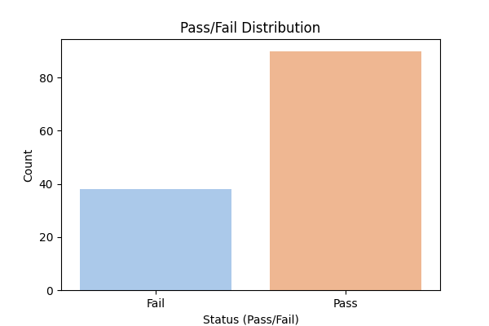

### Correlation between Study Hours and Total Score

Correlation between Study Hours and Total Score: -0.01

### Scatterplot Displaying the Relationship between Study Hours and Total Score

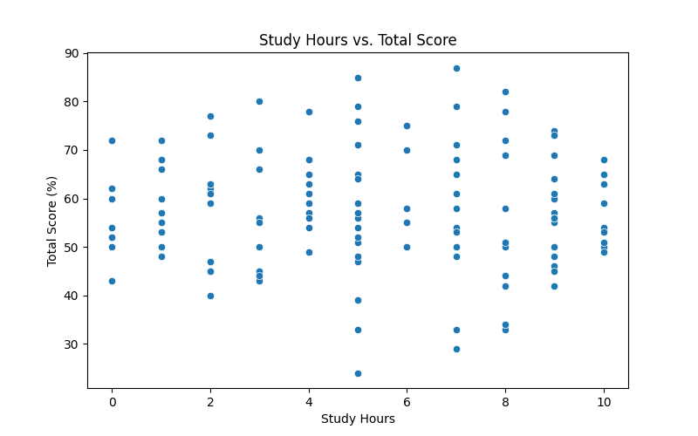

### Boxplot Displaying the Relationship between Study Hours and Pass/Fail Status

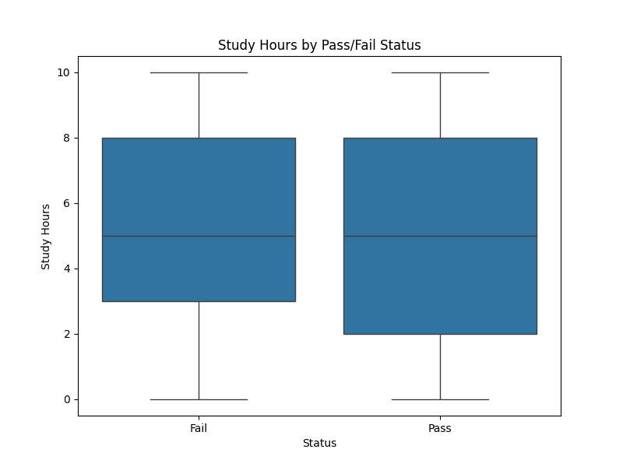

### Correlation between Participation Score and Total Score

The correlation between participation score and total Score is 0.49

### Boxplot Displaying the Relationship between Participation Scores and Pass/Fail Status

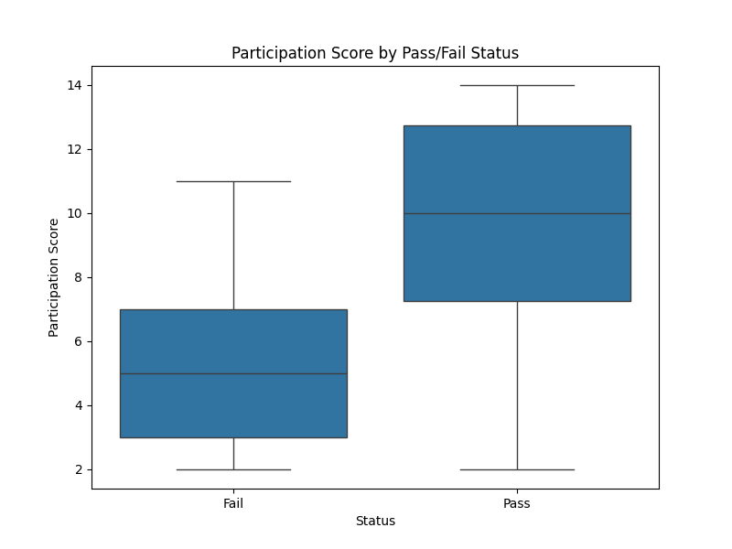

### Pivot Table Showing Study Hours vs Total Score by Pass/Fail

Study Hours 0 1 2 3 ... 7 8 9 10  
Status ...   
Fail 43.00 58.00 45.17 46.6 ... 40.75 42.20 47.60 49.00  
Pass 59.56 58.25 64.88 64.2 ... 65.89 65.25 61.27 57.88  
  
[2 rows x 11 columns]