Assignment 1 - Group 6

Date: 09/23/2024

Laura Aguirre - 200595782
Isaac Kim - 200609053
Sharon Chrysler - 200601320
Burak Alay - 200597837
Divine Lotanna Mbamara - 200594413

Question 1:
Create a database for this assignment.
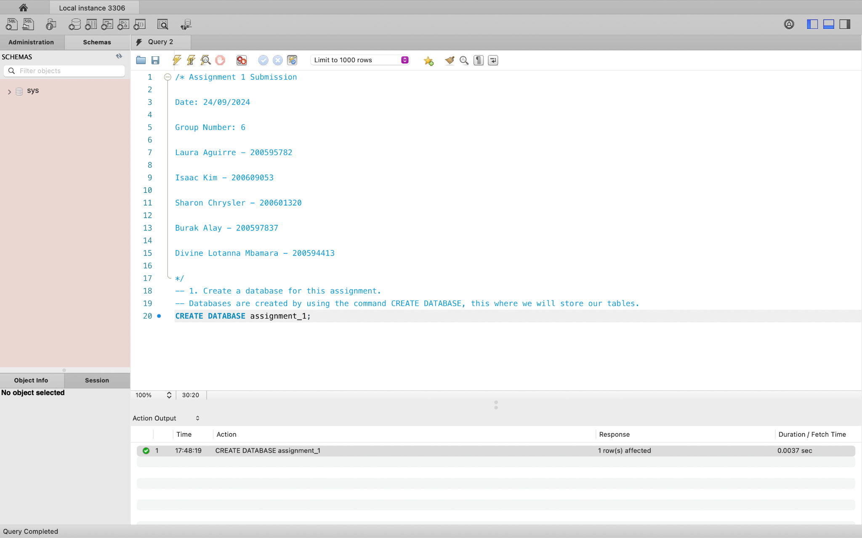
Question 2:
Instruct MySQL Server to use the database you just created.
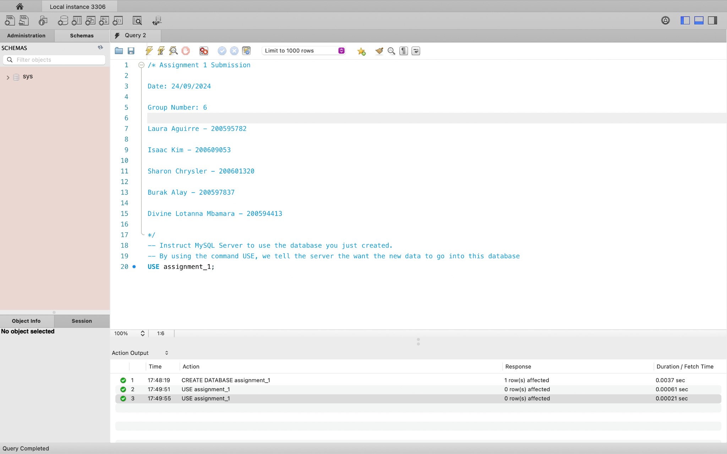

Question 3:
In a separate SQL tab, open the barrie_weather.sql file provided. Under question 3, copy its contents into your assignment1 script, then run the commands to create the table (also called barrie_weather, and will be used to answer following questions) and then populate it with data using the provided insert statements
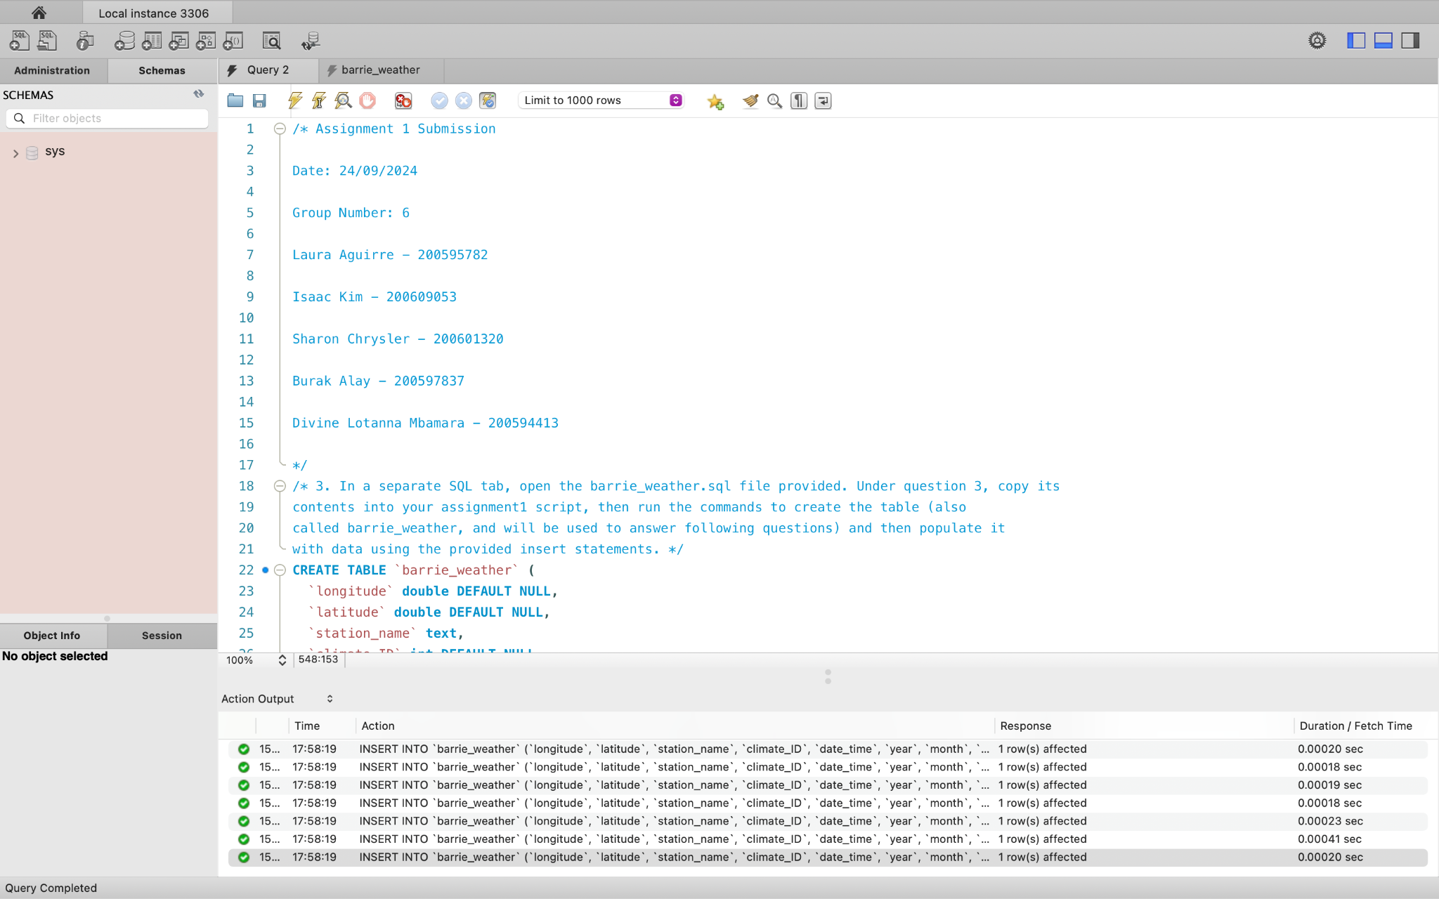

Question 4
In the report only, explain how the provided CREATE TABLE statement could be improved. Please focus on the data types and parameters for this discussion:

The CREATE TABLE statement can be improved in the following ways:
a) ‘longitude’ and ‘latitude’ should be represented as geospatial data types.
b) ‘station_name’ and ‘weather’ should be stored as VARCHAR instead of TEXT.
c) ‘date_time’, ‘year’, ‘month’, ‘day’, and ‘time’ should be stored in a single parameter, date_time as DATETIME data type to allow for built-in datetime functions.
d) ‘temp’, ‘visibility’, ‘pressure_kPa’, ‘hmdx’, and ‘wind_chill’ should be stored as DECIMAL.
e) ‘temp_flag’, ‘dew_pt_flag’, ‘rel_hum_flag’, ‘wind_dir_flag’, ‘wind_spd_flag’, ‘vis_flag’, ‘pressure_flag’, ‘hmdx_flag’, and ‘wind_chill_flag’ should be stored as CHAR.
f) ‘rel_hum’ and ‘wind_dir_10d’, should be stored as INT.
g) Data types should be written in uppercase.
h) Some parameters should be refined to more meaningful names. They include:
‘temp’, ‘temp_flag’, ‘dew_pt’, ‘dew_pt_flag’, ‘rel_hum’, ‘rel_hum_flag’, ‘wind_dir_10d’, ‘wind_dir_flag’, ‘wind_spd_kmh’, ‘wind_spd_flag’, ‘vis_flag’, ‘hmdx’, and ‘hmdx_flag’.

Question 5
The provided INSERT statements in barrie_weather were generated automatically and load data very slowly because of the way that the script’s commands have been structured. What is it about the structure that causes the script to run slowly? In the report only, explain how you could restructure the commands if you were tasked with inserting the same data into barrie_weather.

The script runs slowly because multiple INSERT statements were used to enter multiple rows into the same columns. A better way to restructure the commands would be to use a single INSERT statement and store every set of values into a single VALUES section. Each set of values should be in parentheses, separated by commas and a semicolon at the end:

INSERT INTO barrie_weather (longitude, latitude, station_name, climate_ID, date_time, year, month, day, time, temp, temp_flag, dew_pt, dew_pt_flag, rel_hum, rel_hum_flag, wind_dir_10d, wind_dir_flag, wind_spd_kmh, wind_spd_flag, visibility, vis_flag, pressure_kPa, pressure_flag, hmdx, hmdx_flag, wind_chill, wind_chill_flag, weather)

VALUES (-79.55, 44.48, 'BARRIE-ORO', 6117700, '9/1/2019 0:00', 2019, 9, 1, '0:00', 11.3, ' ', 9.1, ' ', 86, ' ', '36', ' ', 4, ' ', ' ', ' ', 99.22, ' ', NULL, ' ', ' ', ' ', 'NA'),
(-79.55, 44.48, 'BARRIE-ORO', 6117700, '9/1/2019 1:00', 2019, 9, 1, '1:00', 10.7, ' ', 9.2, ' ', 91, ' ', NULL, 'M', 0, ' ', ' ', ' ', 99.21, ' ', NULL, ' ', ' ', ' ', 'NA'),
(-79.55, 44.48, 'BARRIE-ORO', 6117700, '9/1/2019 2:00', 2019, 9, 1, '2:00', 10.7, ' ', 8.9, ' ', 88, ' ', '2', ' ', 3, ' ', ' ', ' ', 99.2, ' ', NULL, ' ', ' ', ' ', 'NA');

Question 6
Select all data for every hour of data where the temperature (temp) was 28.5 or greater. Provide an additional comment in your SQL script that states the number of rows returned.
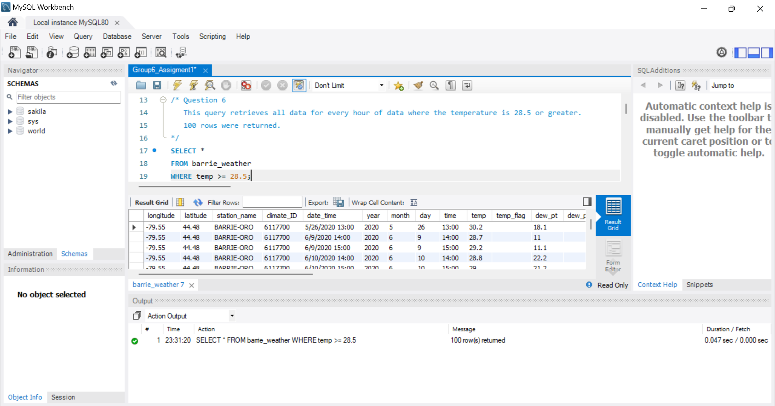

Question 7
Select all data for every hour of data where the temperature was 25 or greater and the air pressure (pressure_kPa) was greater than 98.63. Provide an additional comment in your SQL script that states the number of rows returned.
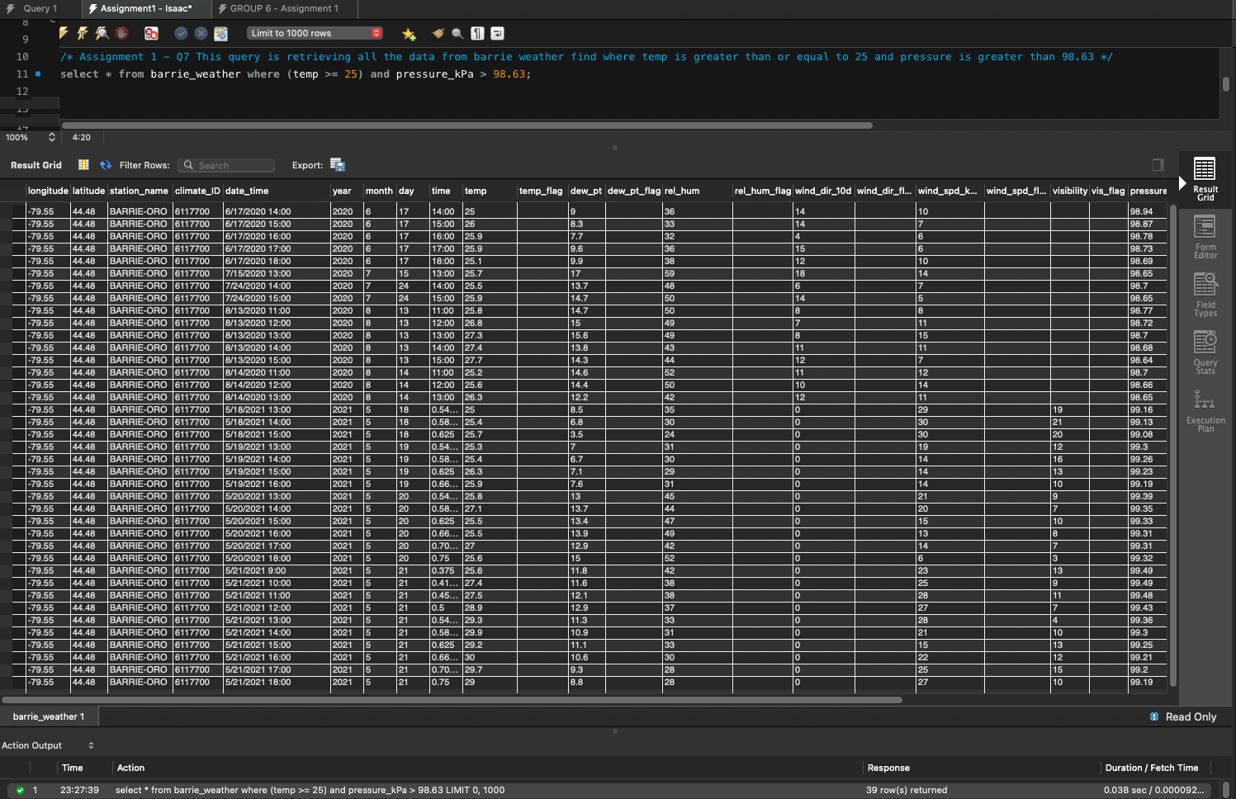

Question 8
Select only the date and time (date_time), temperature (temp) and temperature flag (temp_flag) columns for every hour where temperature data has been marked as missing using an M value in the temp_flag column. In the report, record the date and time.
Hint: remember that single quotes are required for text values.

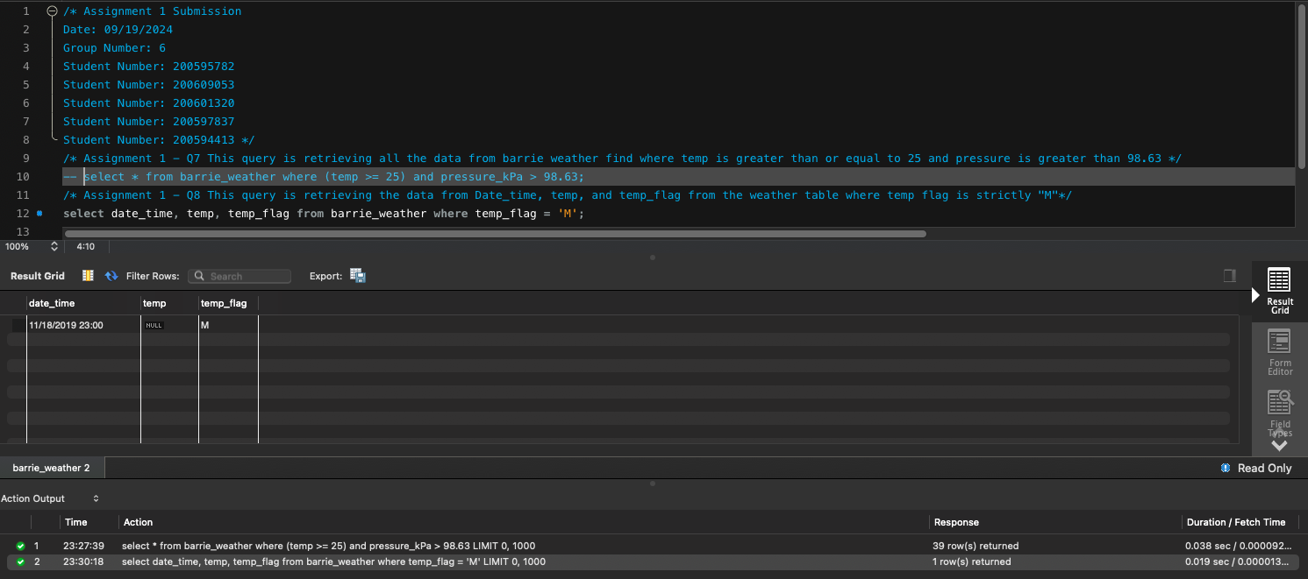
Question 9:
Uh oh! It has been noted that later in the dataset, instead of recording missing as M, it was being recorded as Missing. Construct a query that will return either M or Missing values.
Note: There are a number of ways of doing this, please use LIKE
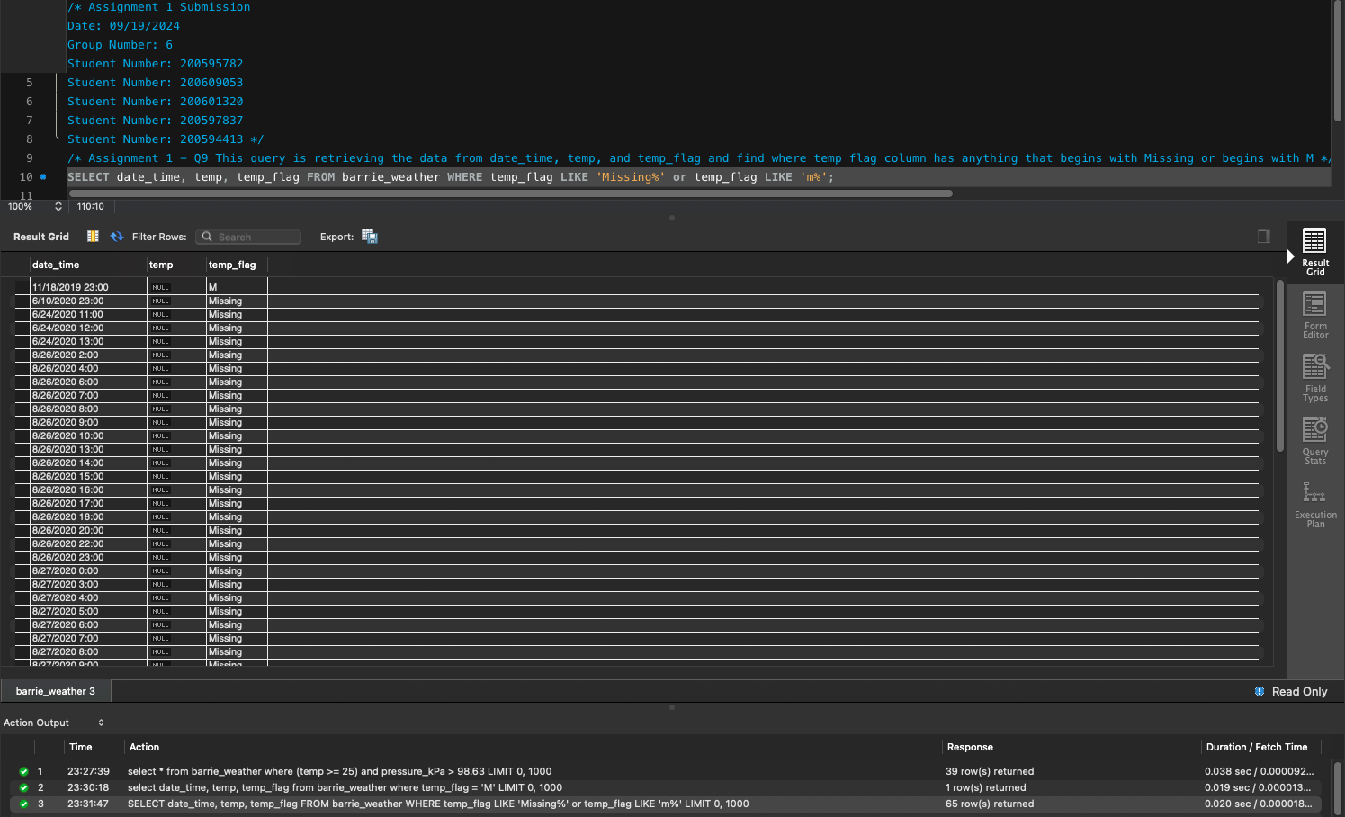
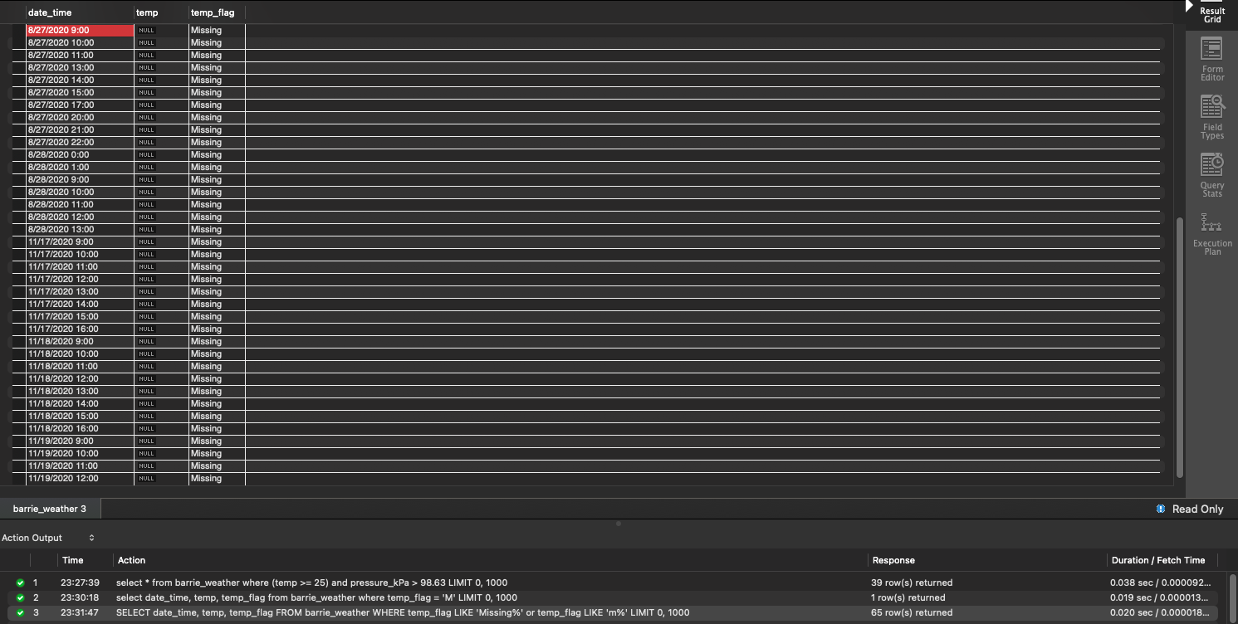

Question 10:
Count (SELECT COUNT) the number of hours contained in this dataset.
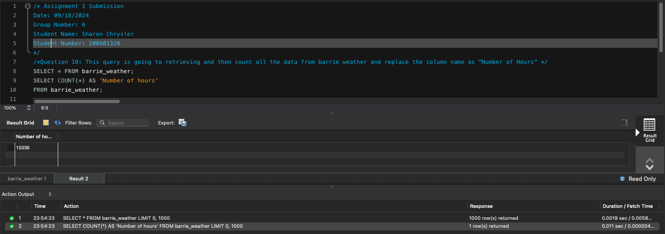

Question 11:
Count the number of hours that the wind was blowing (wind_spd_kmh is greater than 0) and from a direction ranging between south and west (wind_dir_10d is between 18 and 27)
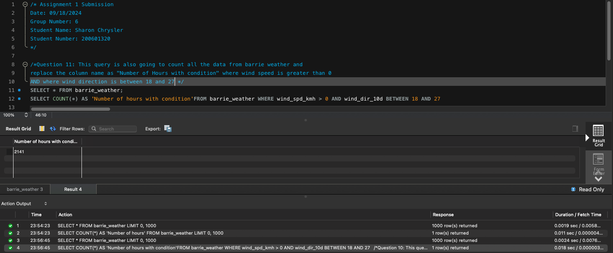

Question 12:
In the report only, in Barrie what percent of the time are the conditions listed in Q11 true?

13.96%

Question 13:
Select all data for every hour of data where either the temperature (temp) below freezing, or wind chill (wind_chill) made it feel like it was. Additionally, the wind speed flag (wind_spd_flag) must indicate that there were no problems with the wind speed instrument (i.e. no M or Missing values present) BTW: an anemometer is an instrument that measures wind speed
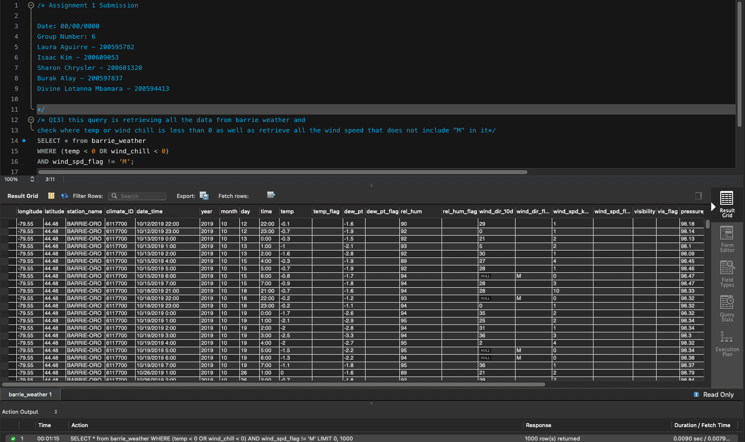

Question 14:
Fix the M vs Missing problem in the temperature flag field by using UPDATE to change any instances of Missing values to just plain M.
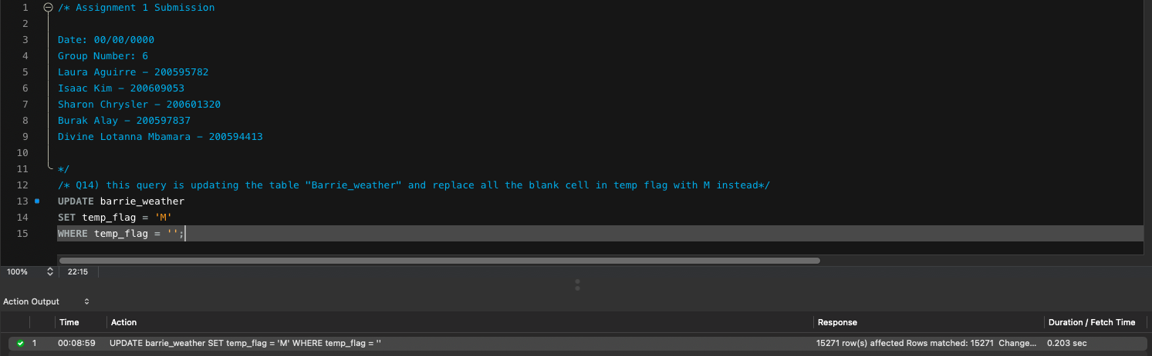

Question 15:
Use an update statement to change all ' ' values in the temp_flag column to NULL (no quotes, just the letters N-U-L-L) this will change.
Hint: The values should end up looking like those in the humidex (hmdx) column. FYI: The best way to store null data is using the NULL value. Look to the humidex (hmdx) column for an example of this being implemented properly.
