Assignment 2 – Relational Database

Divine Lotanna Mbamara
200594413
Department of Computer Programming, Georgian College
COMM 2003: Relational Database
October 8, 2024

Question 1:
Make a database and name it ‘Assignment2’ and add the data from Customers.sql to your
database.
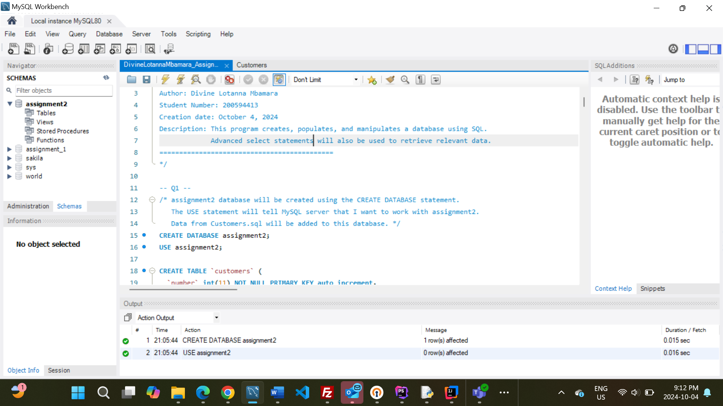

Question2:
Use a single line SQL command to return the structure of the table from Q1. In your report, tell me what command you would use to generate a list of all the tables in your database. Answer: SHOW TABLES.
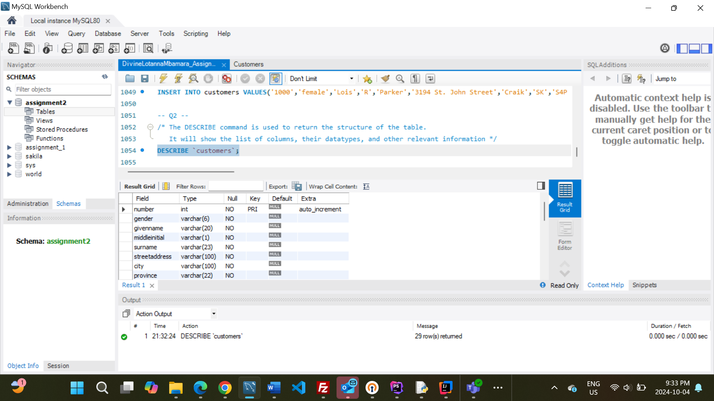
Question 3:
Add a column named bonus to your table. Place it after surname. Enable the users to store bonuses with values such as: 1099.99 or 2.00 by choosing the proper data type for bonus. In your report, mention the data type you chose and another that you considered but chose not to use. Answer: Data type used – DECIMAL, Data type considered – DOUBLE.
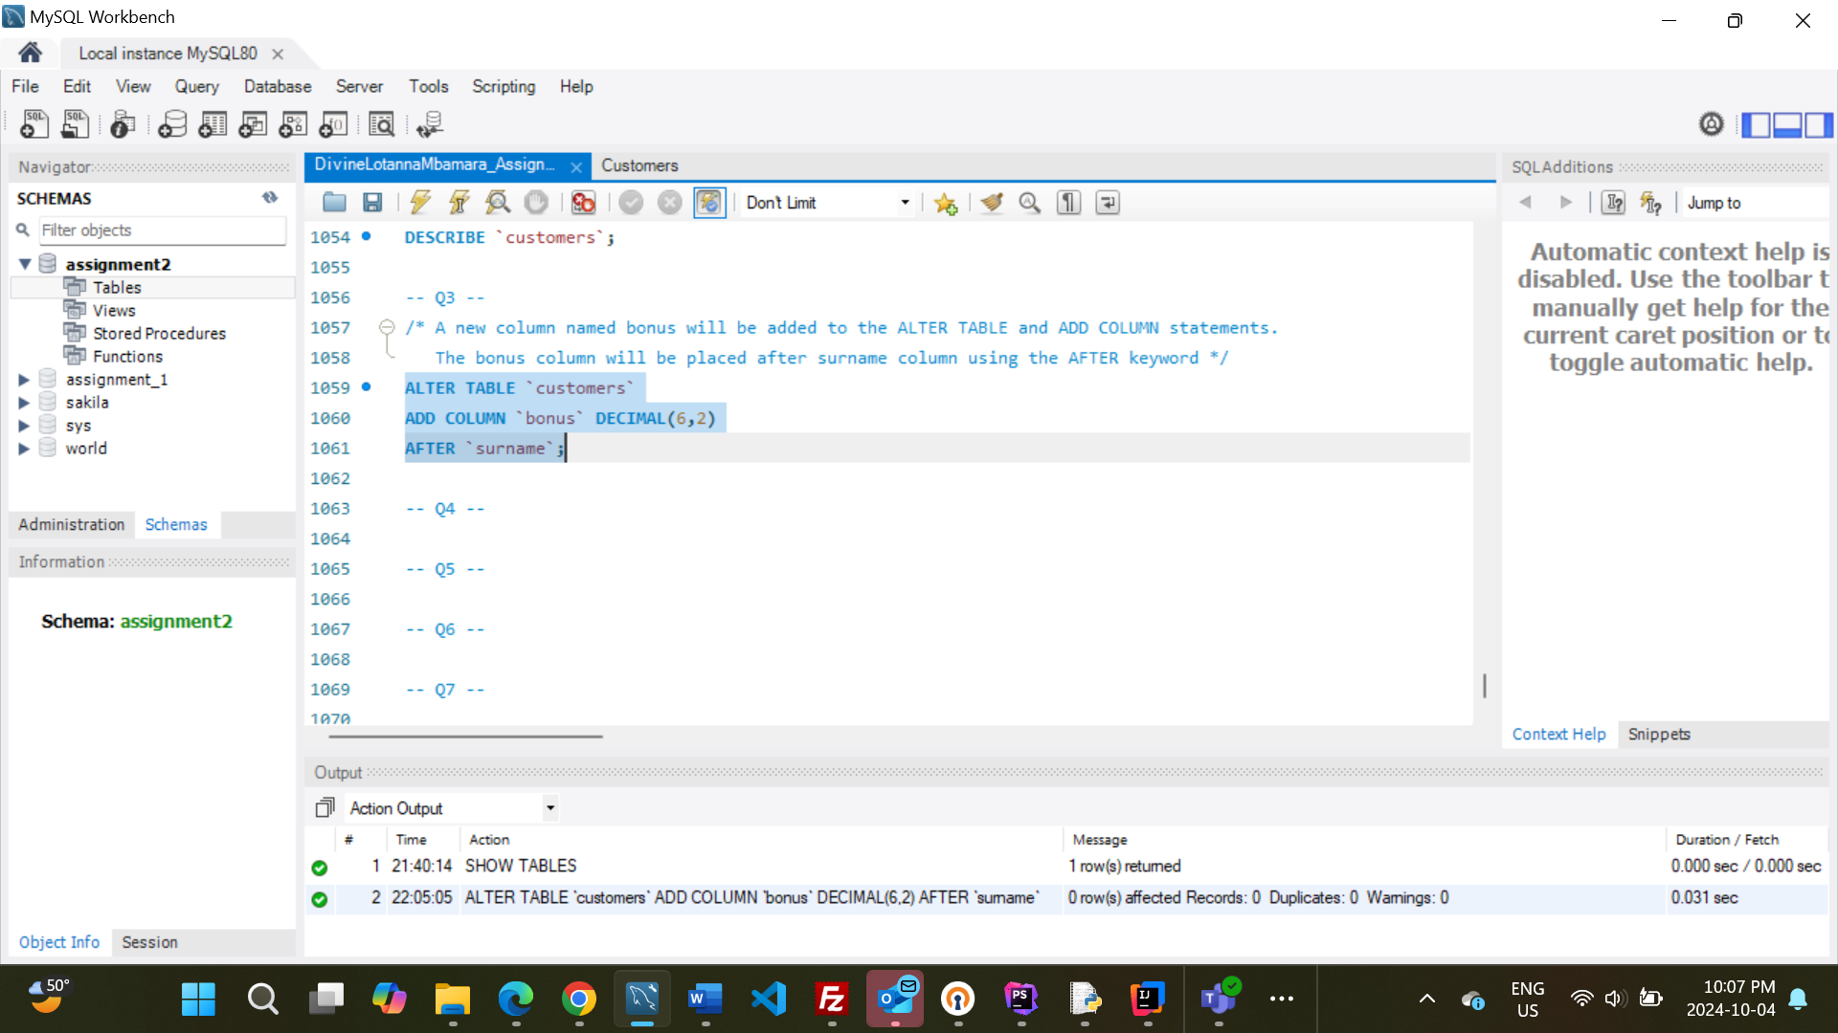

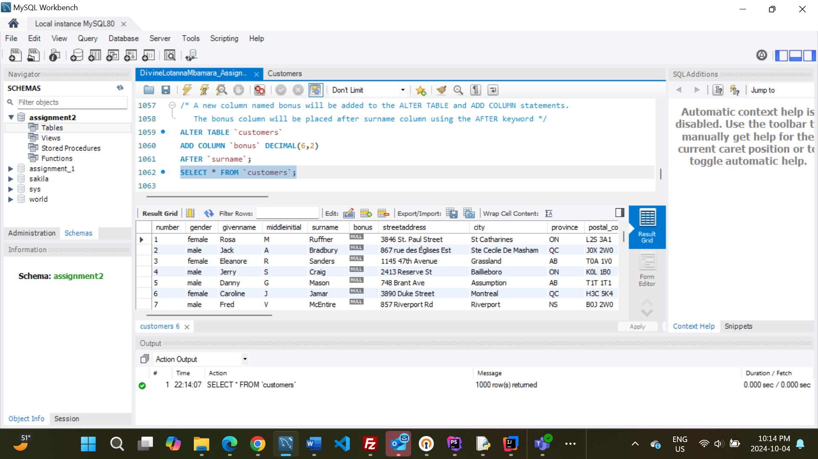

Question 4:
Using a CASE command fill the data for the bonus column.
- If customers hold a Mastercard and they live in Ontario the bonus will be 200.00
- Otherwise, if they live in any other provinces and have Mastercard, they will get 155.99 CAD as bonus.
- Then, all Visa holders will get 100.00 CAD
- Then, customers with any other credit cards will get 55.99 CAD as bonus.
- Lastly, non-credit card holders will receive a bonus of zero. In your report, explain the considerations that were made in constructing this statement.
Answer: Considerations made in constructing this statement:
- Customers can only get a bonus of 200.00 CAD when they both hold a MasterCard AND they live in Ontario.
- If they have a MasterCard however, but they live in a province that is NOT Ontario, then they get a bonus of 155.99 CAD.
- There is no extra condition for Visa holders. Whether they live in Ontario or not, they get the same bonus of 100.00 CAD.
- Customers with any other credit cards(NOT MasterCard AND NOT Visa) get the bonus of 55.99. It does not matter the province they live in.
- Any other condition gets 0.00 CAD.
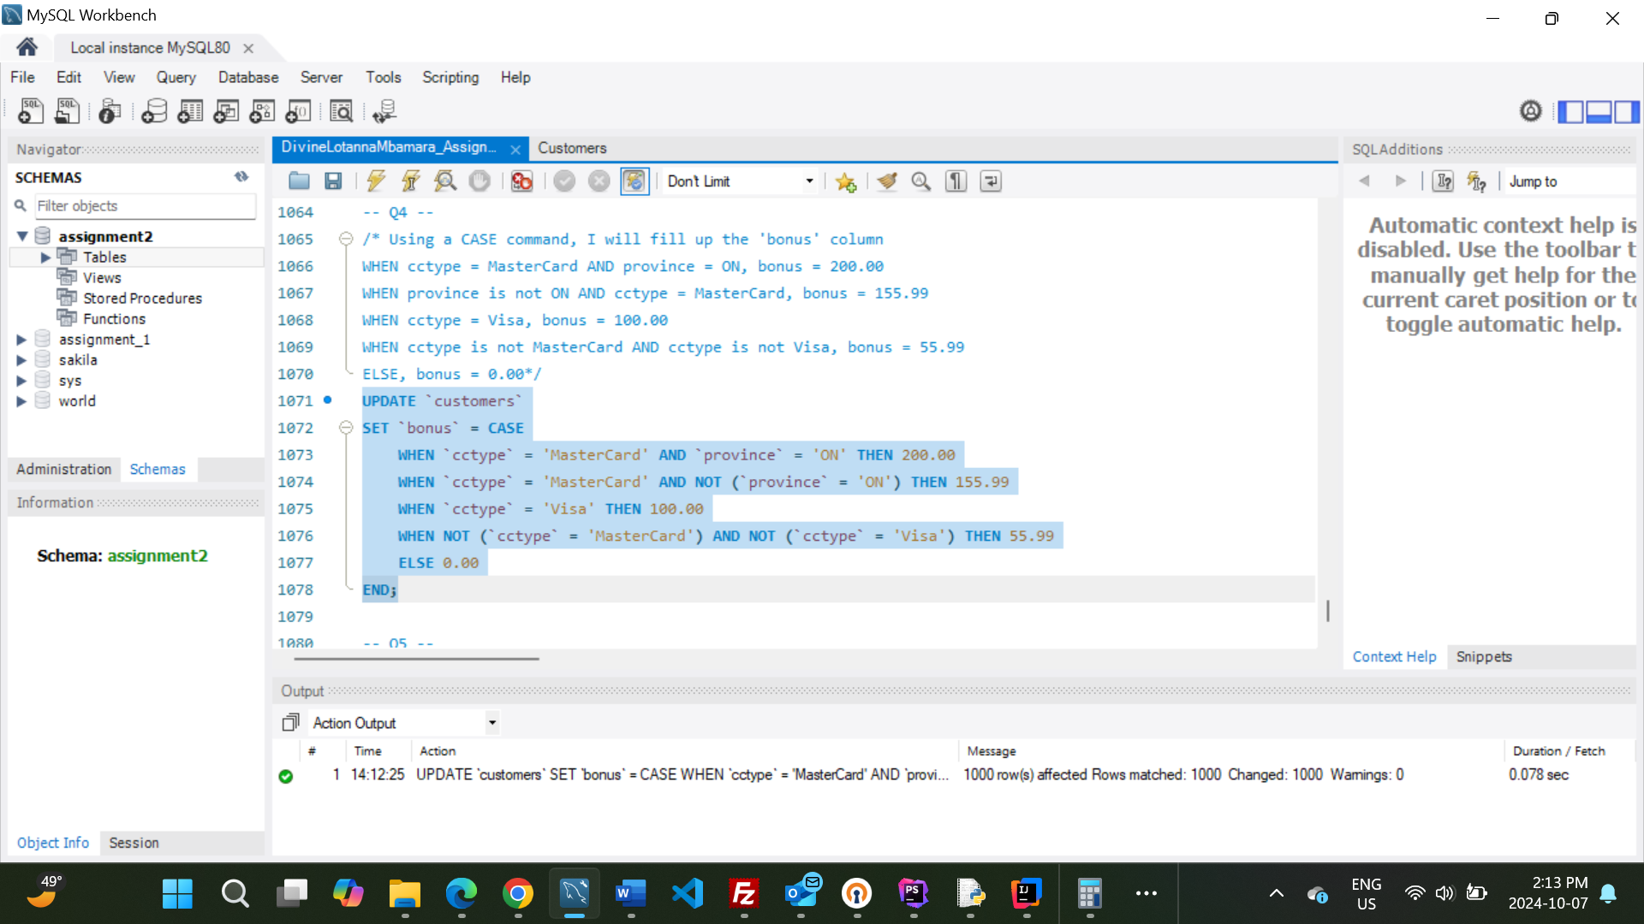
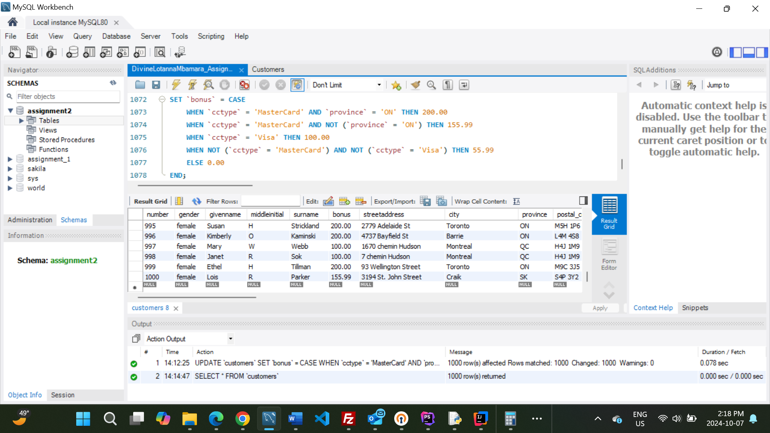

Question 5:
Let’s increase the bonuses. Please increase all the bonuses by 320.00 CAD for customers who are working as a model or have the first name 'Mary'. But, please only apply this increase to the people who were only getting a $155.99 bonus. (Hint: only 7 rows must be updated.)
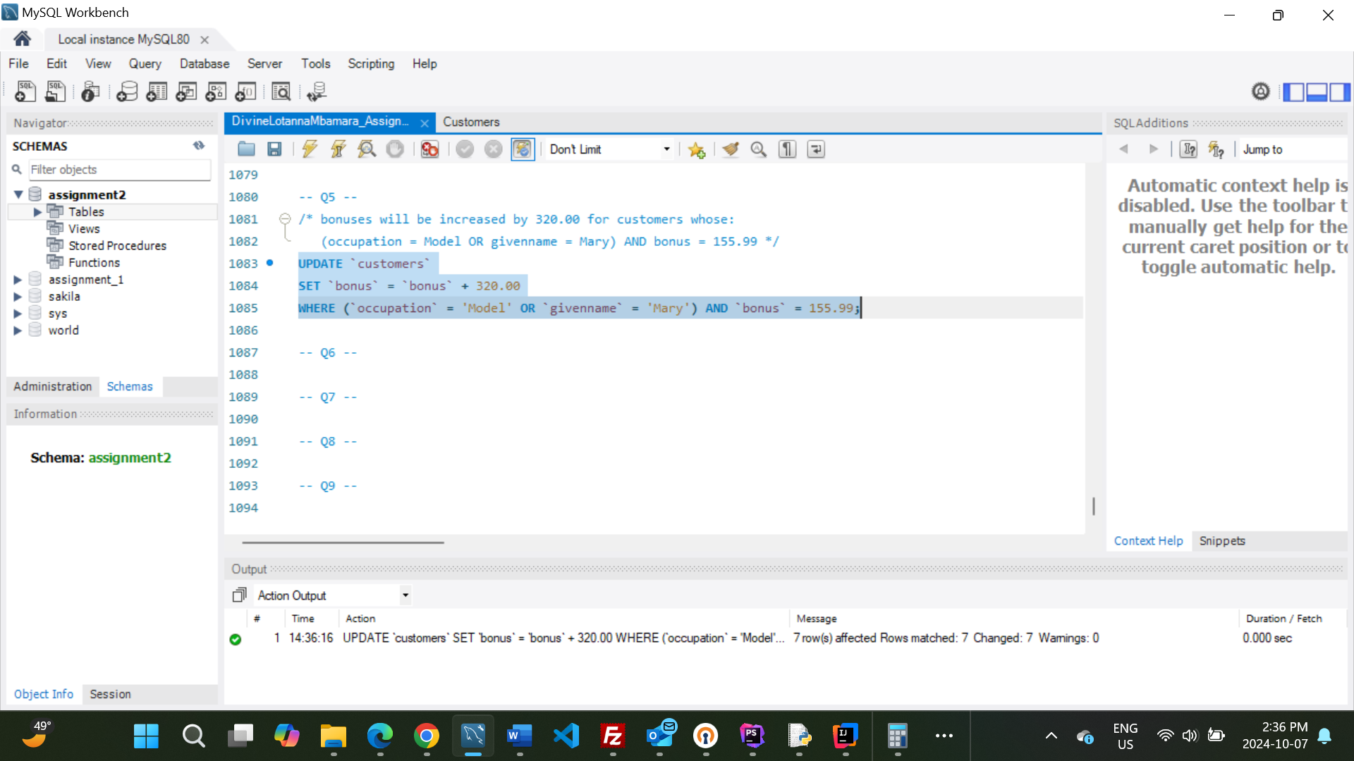

Question 6:
We need to calculate the total dollar value of bonuses being given to customers in each province.
- List each province and tabulate the total value of bonus dollars provided to customers in that province and name the new column as total_bonuses.
- Sort the list by the total amount of bonuses provided in each province.
In your report, explain the considerations that were made in constructing this statement.
Answer: The SUM is an aggregate function that was used to calculate the total value of bonus dollars. The new column, total_bonuses was created using the AS statement. The GROUP BY statement adequately groups the province and ensures each province appears only once in the list. The list was sorted using the ORDER BY keyword to sort in the default ascending order.
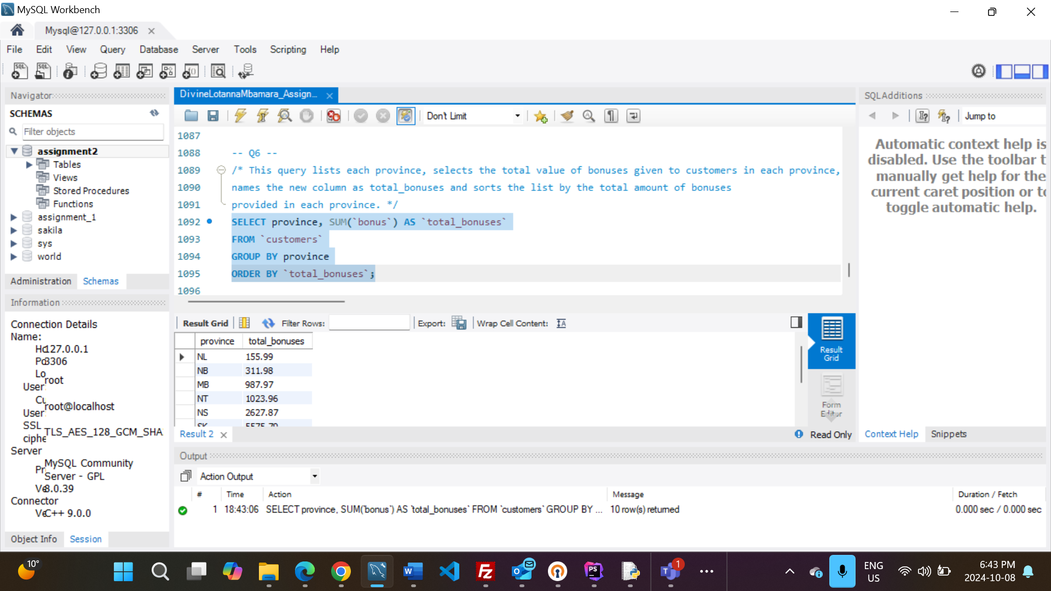

Question 7:
Generate a list displaying only the five longest surnames in customers’ table. In two columns display the surname, and the length of their surname in a field called name_length. Please have the list sorted from longest to shortest. In your comments, how you would return surnames 6 though 10 of this same list. An example table is provided with surnames 1 through 5, your results should mirror what is presented below.
surname name_length
Hollingsworth 13
Blankenship 11
Brockington 11
Hershberger 11
McLaughlin 10
Answer: To return surnames 6 through 10 of this same list, the LIMIT will be set to 5 and OFFSET will be set to 5 to skip the first 5 longest names.
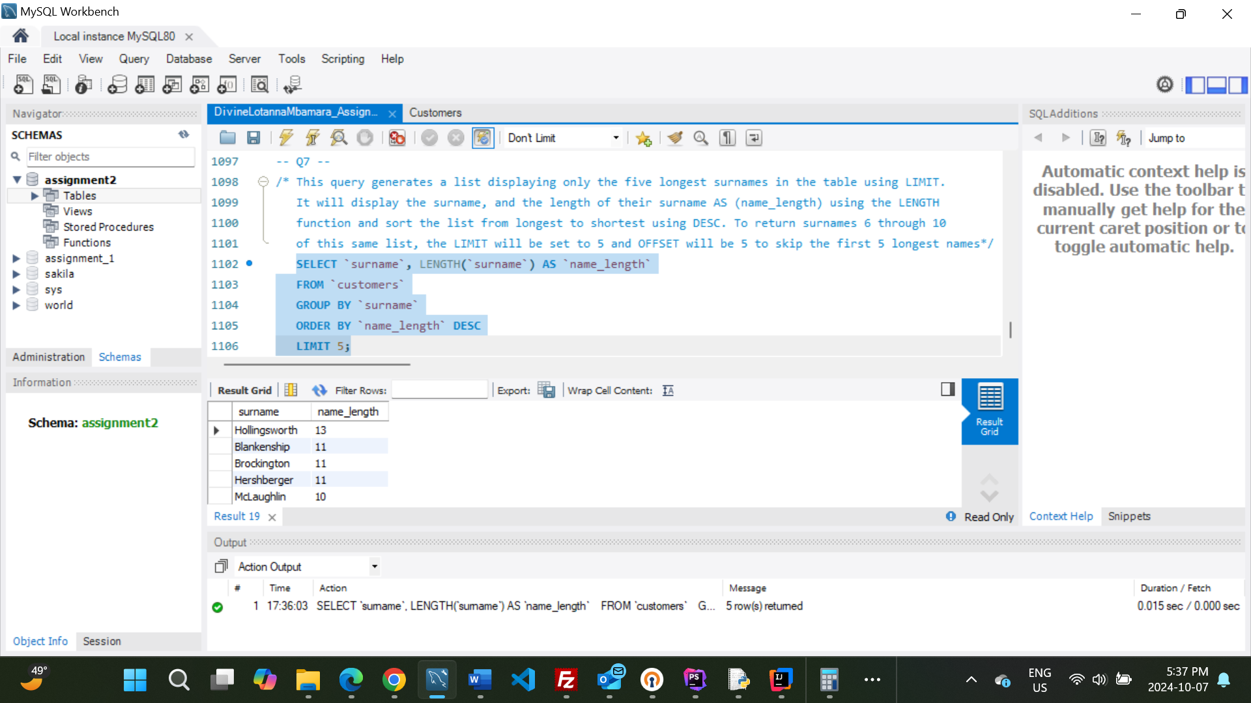

Question 8:
Write a query to show customers’ full names, street address and city.
- Please return their first name in all capital letters.
Is it possible to show both their first and last name in one column in the returned selection?
- If it is, please alter your script to name the column 'full_name' and include both their first and last name in this column.
- If it is not possible, please explain why it isn’t in your report.
Answer: It is possible to show both their first and last name in one column AS full_name using the CONCAT function and a space in the middle to differentiate first and last name.
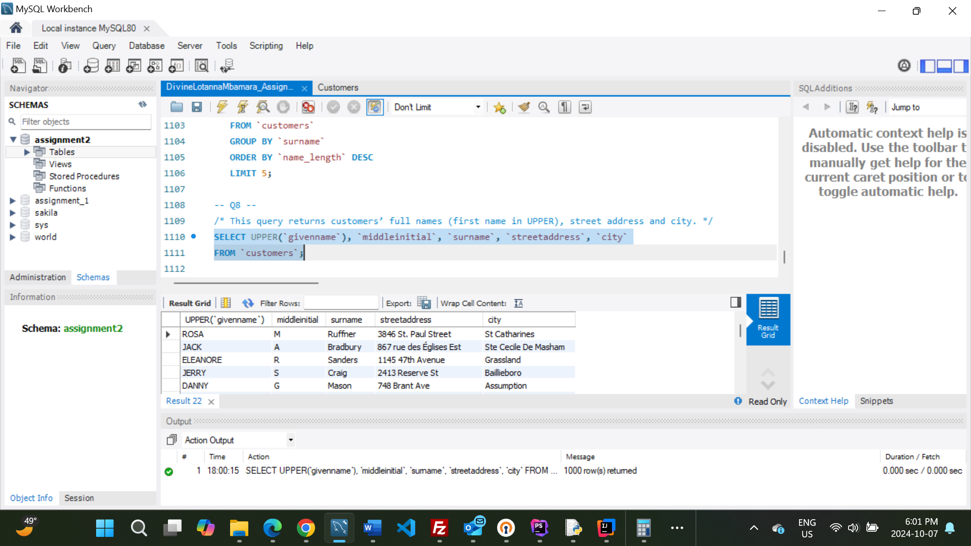

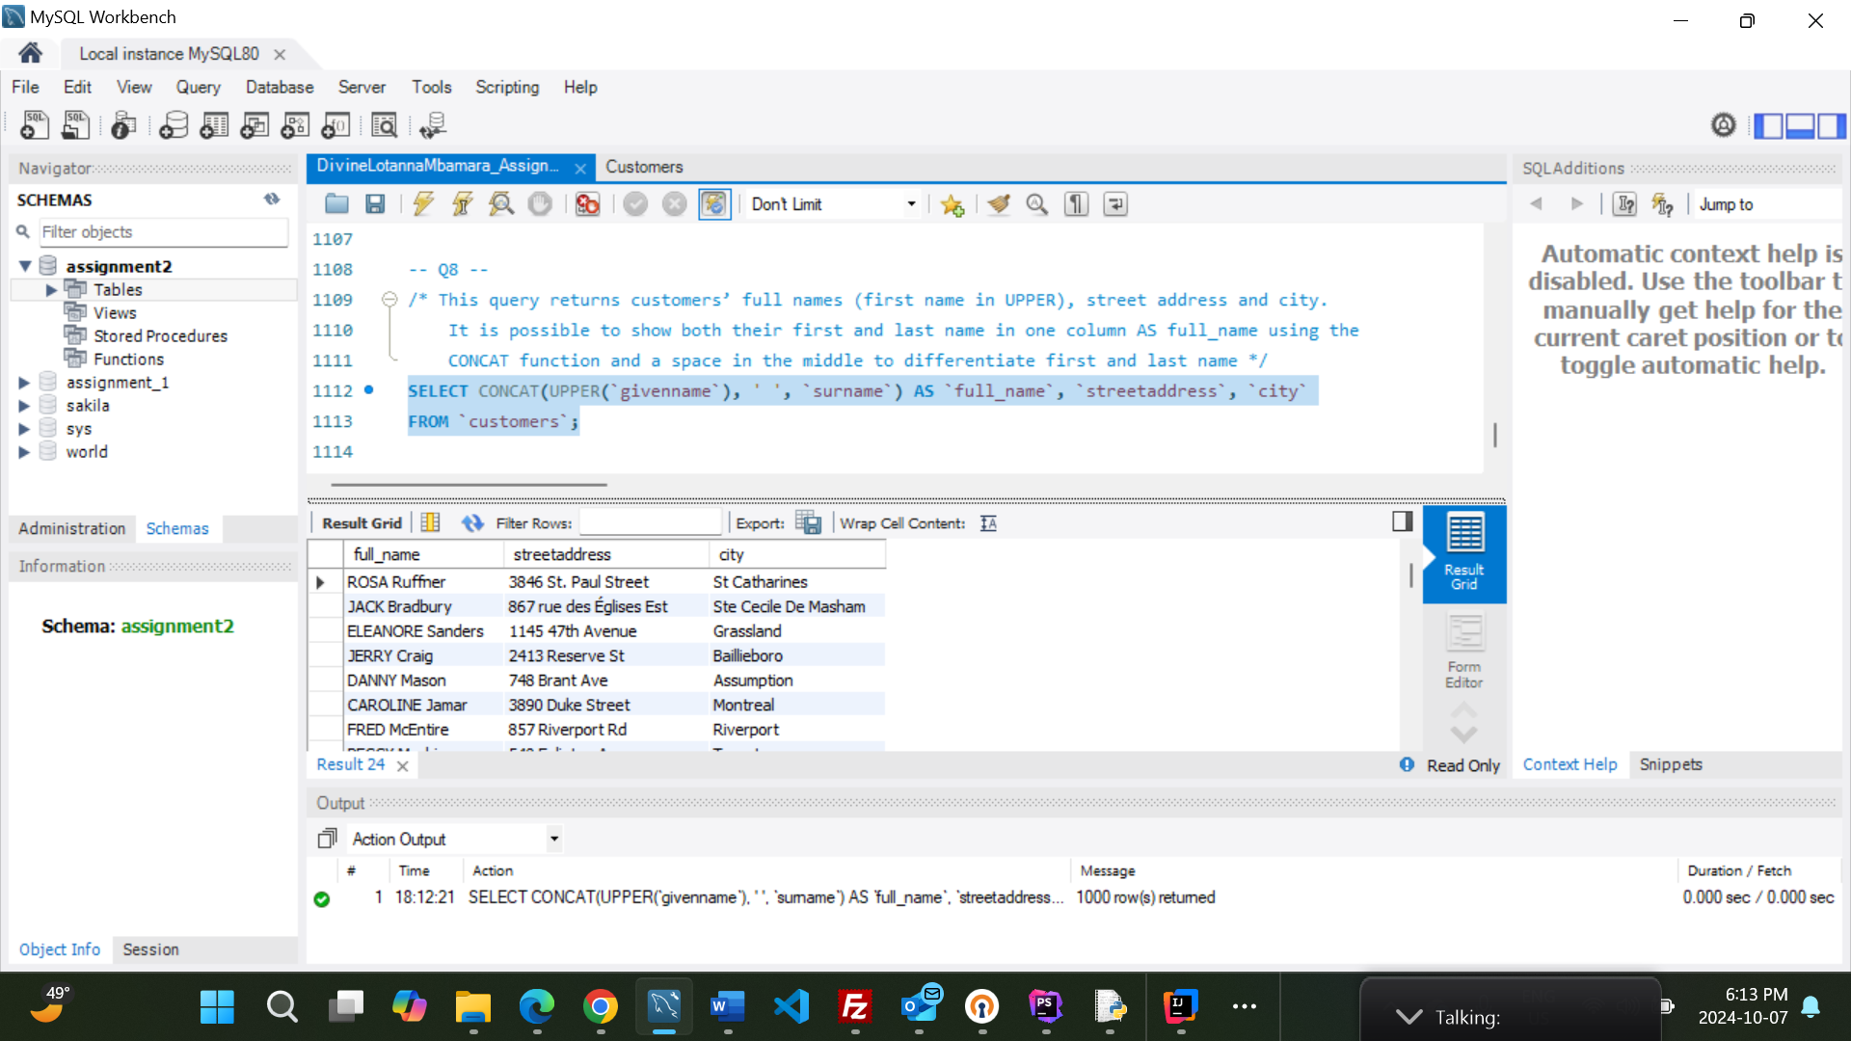

Question 9:
Write a query to show how many customers have MasterCards and how many are using Visa. In your comments, explain how you would sort this table alphabetically by credit card type. An example table is provided below; these numbers are fictitious.
cctype num_customers
Visa 589
MC 432
Answer: To sort the table alphabetically by credit card type, ORDER BY cctype ASC will be used.
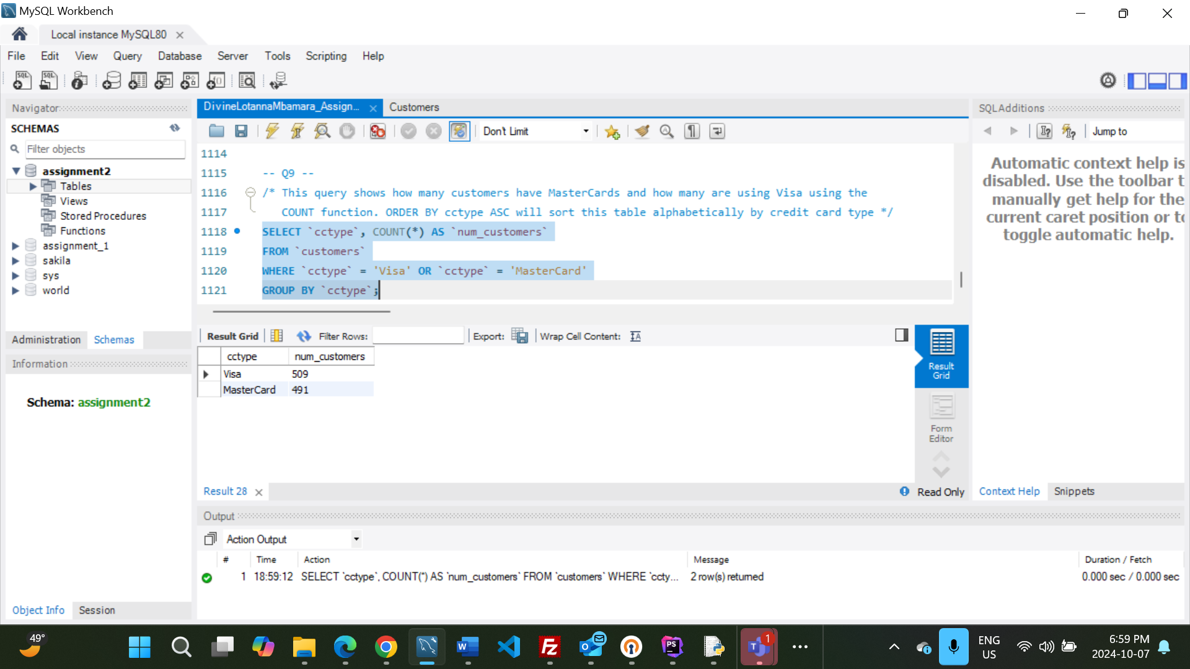

Question 10:
If you were asked to add a total_bonuses column to the output results of Q9’s query tabulating the total amount of bonuses provided to Visa vs MC customers,? How you would do so?
Answer: To add a total_bonuses column to the output results of Q9’s query, I would simply add a comma and SUM(bonus) AS total_bonuses in question 9’s SELECT statement. This will calculate the total sum of all bonuses for Visa and for MasterCard seperately. The query will look like this:
SELECT `cctype`, COUNT(*) AS `num_customers`, SUM(`bonus`) AS `total_bonuses`
FROM `customers`
WHERE `cctype` = 'Visa' OR `cctype` = 'MasterCard'
GROUP BY `cctype`;

