Assignment 4 – Relational Database

Divine Lotanna Mbamara
200594413
Department of Computer Programming, Georgian College
COMM 2003: Relational Database
December 10, 2024

Question 1:
Create an appropriately named database for this assignment.
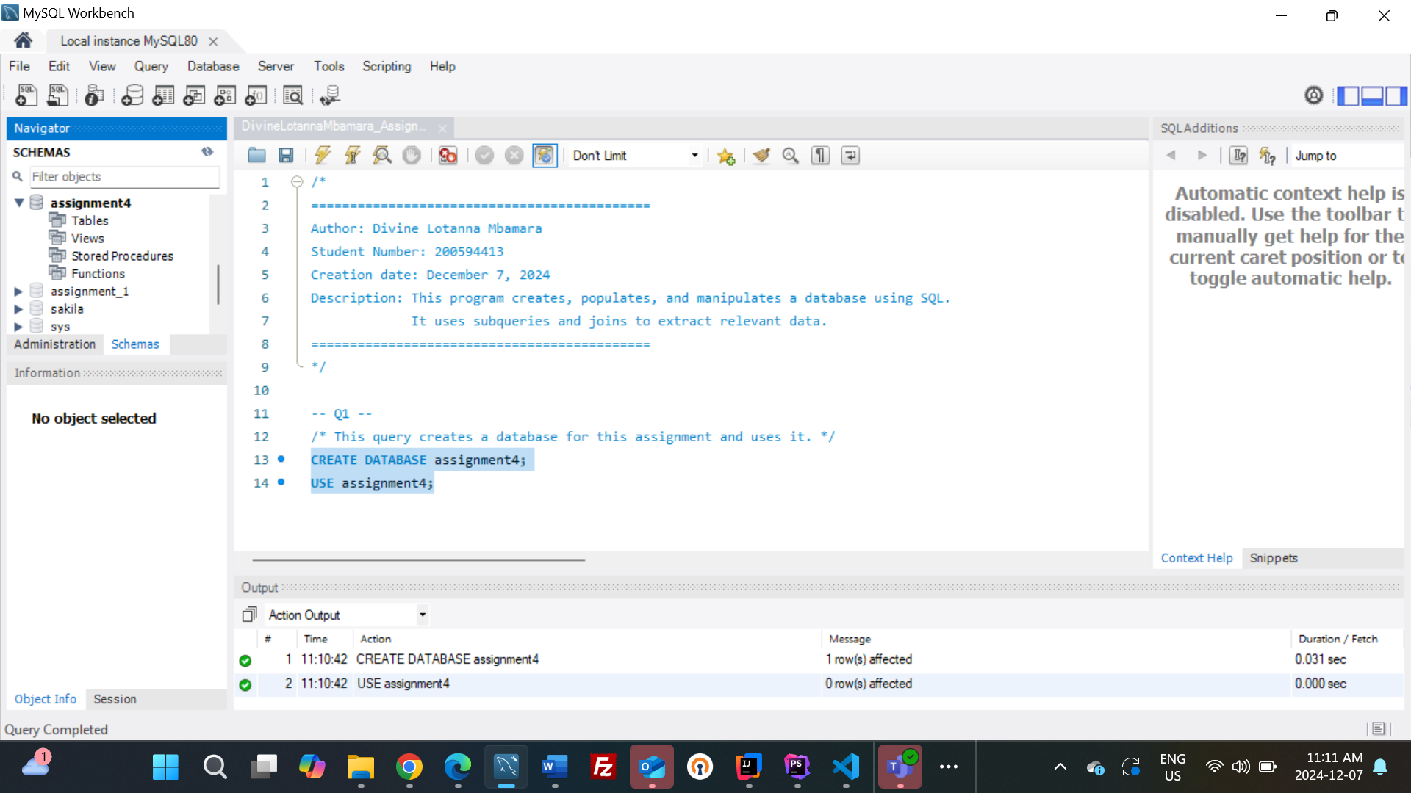

Question 2:
Use the a4_data.sql file to populate your assignment database.
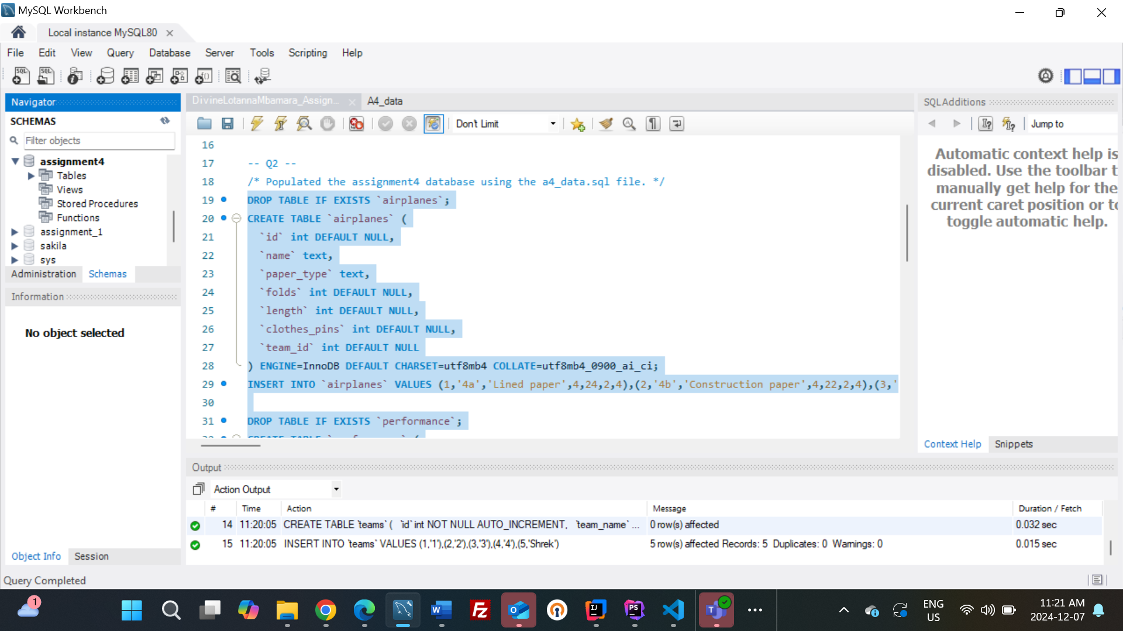

Question 3:
Using a JOIN, retrieve all flight information along with the corresponding team name.
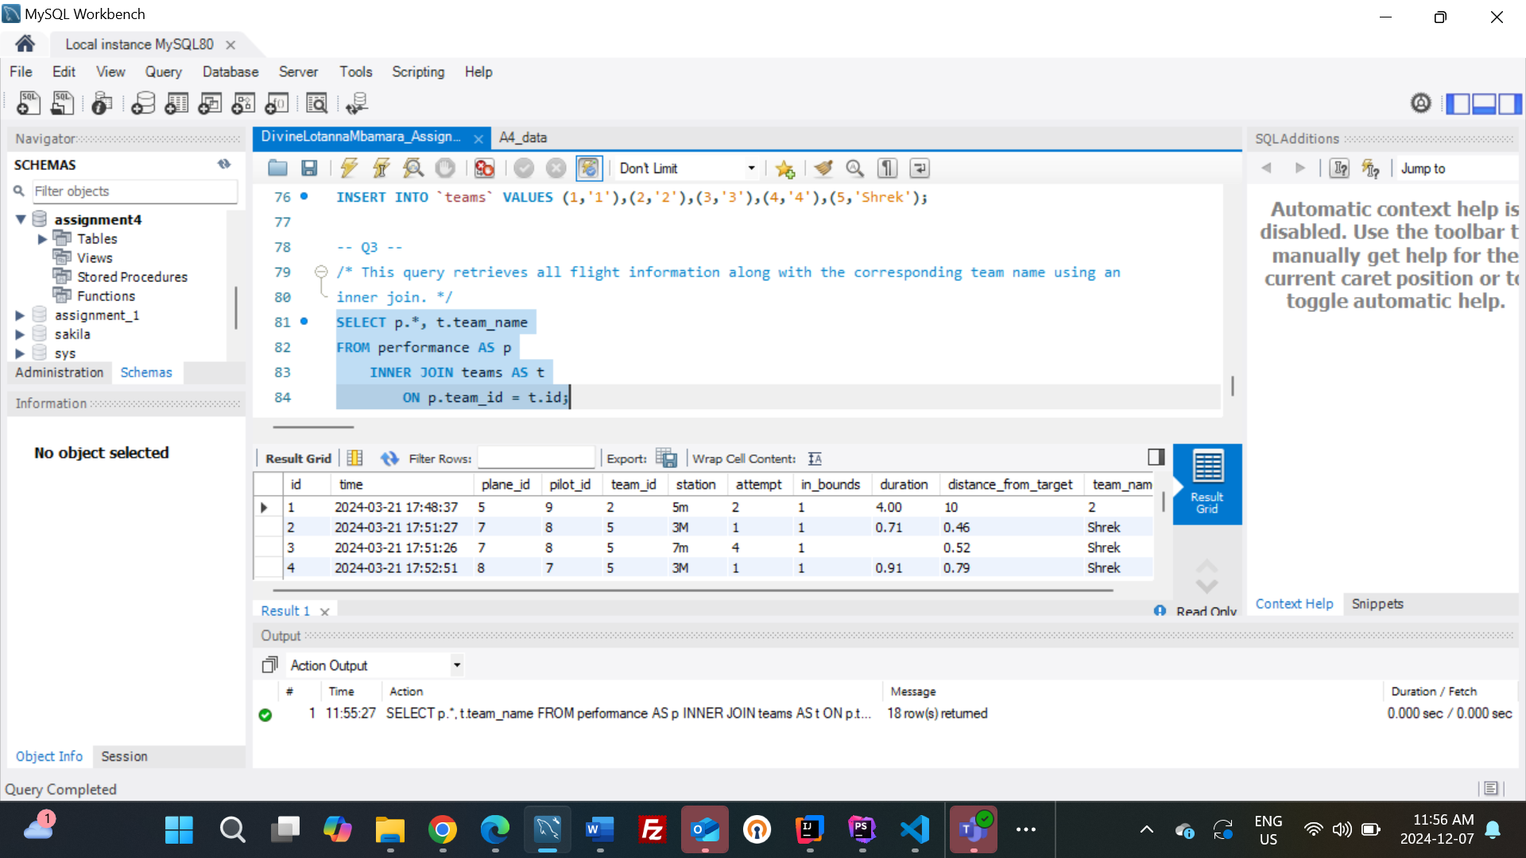

Question 4:
Using a SUBQUERY, list all pilot ID’s, their gender, and the name of team they belong to.
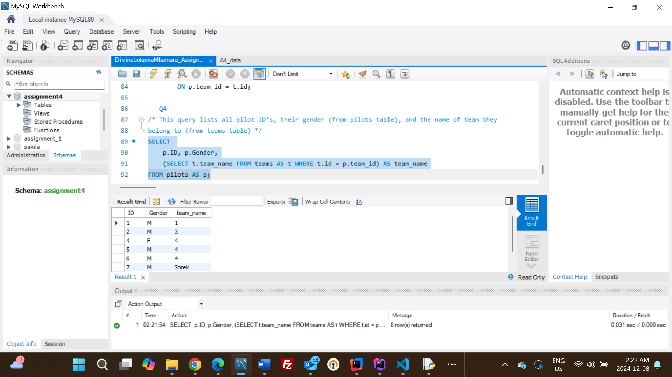

Question 5:
Retrieve the id, time, and distance from target for each flight, along with the first name of the pilot.
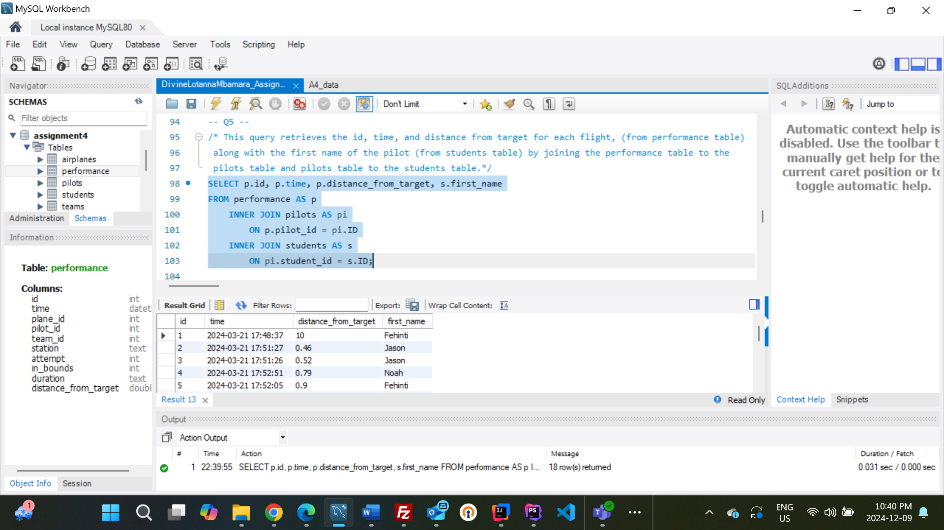

Question 6:
Retrieve the full name of each student that attended, as well as their team name.
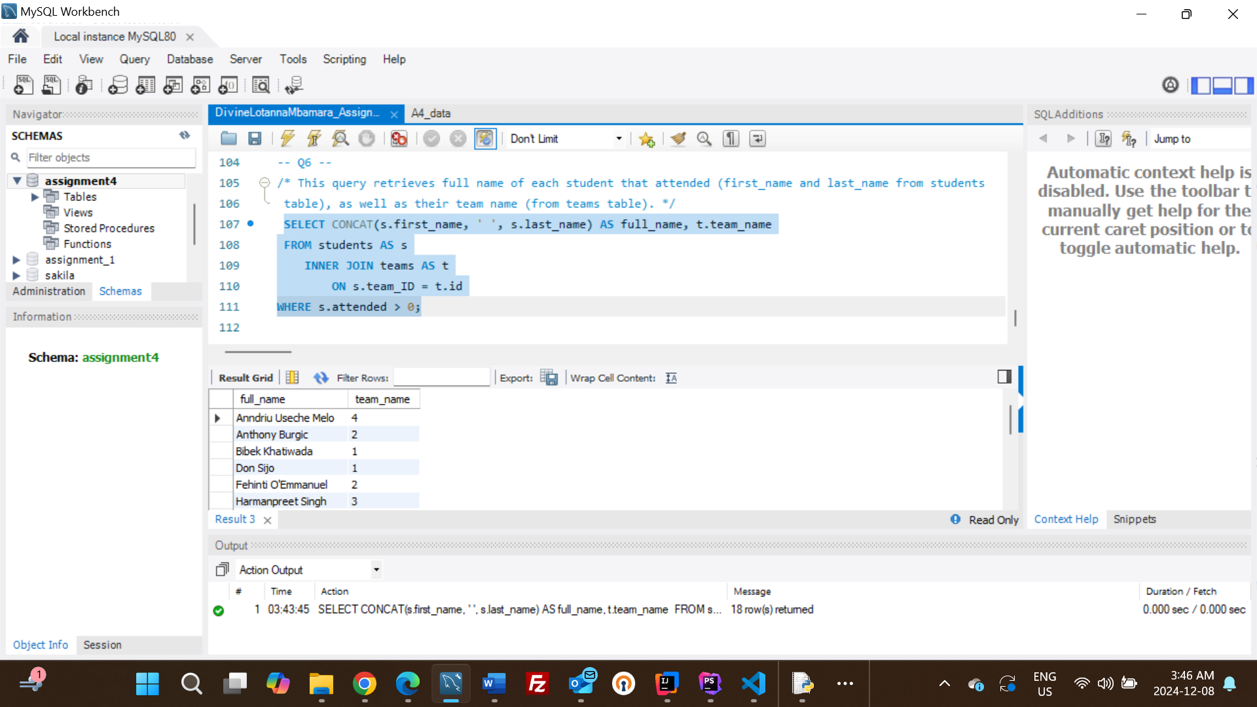

Question 7:
Get the total number of flights attempted by each team.
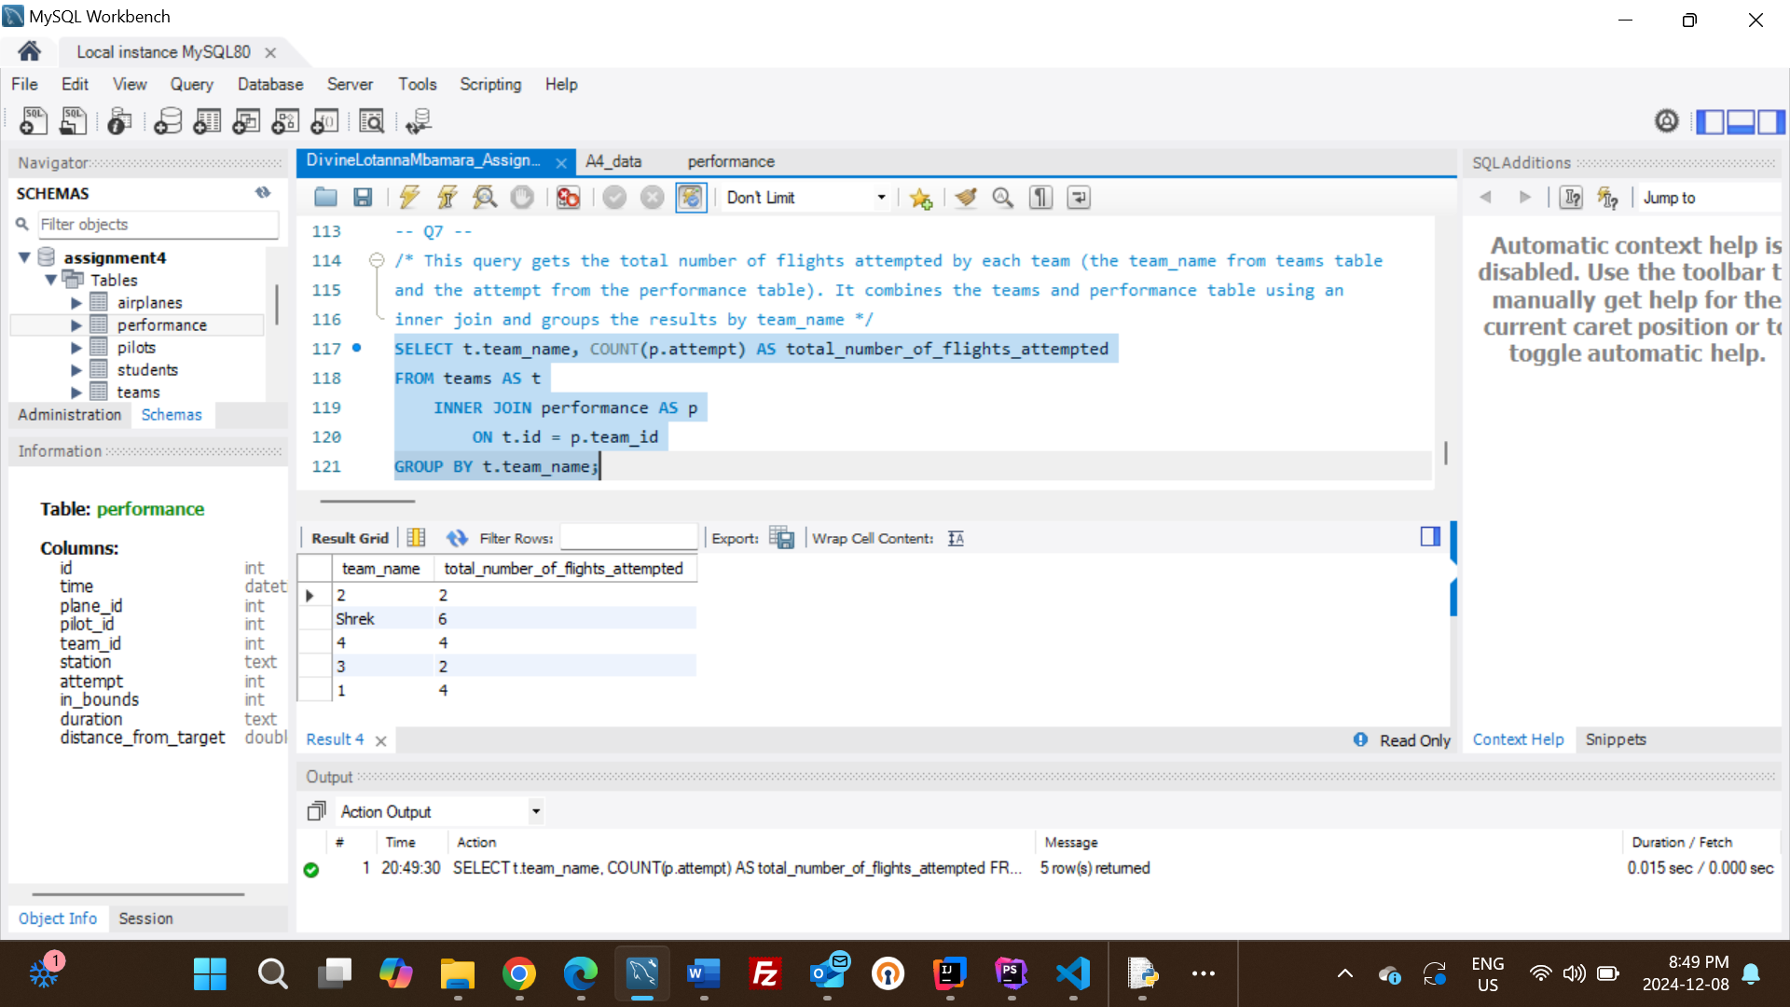

Question 8:
Find the average arm length of pilots in each team.
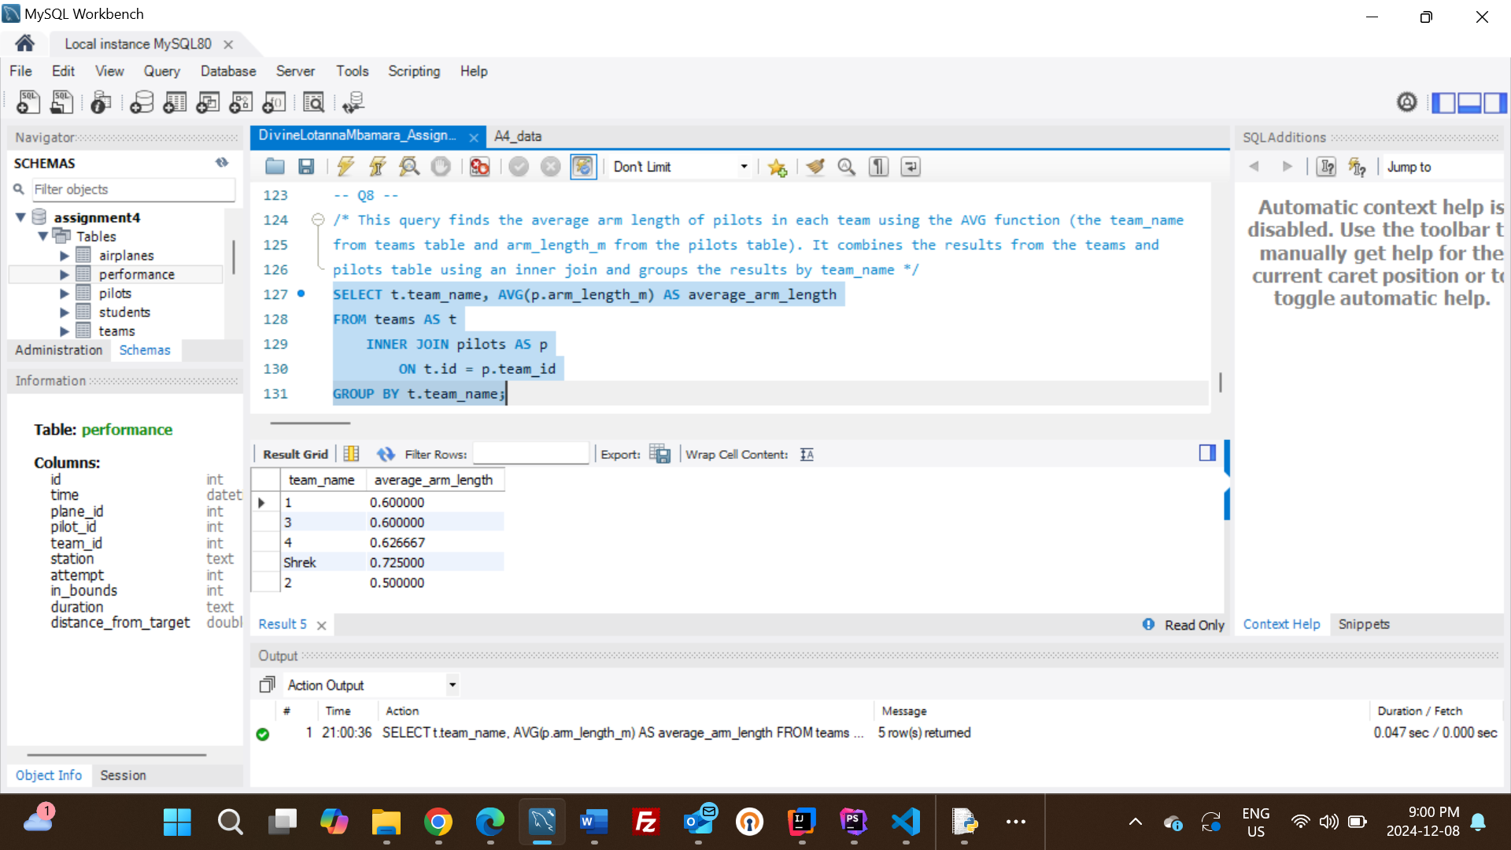

Question 9:
Generate a list of which airplanes belong to the team that has the most students.
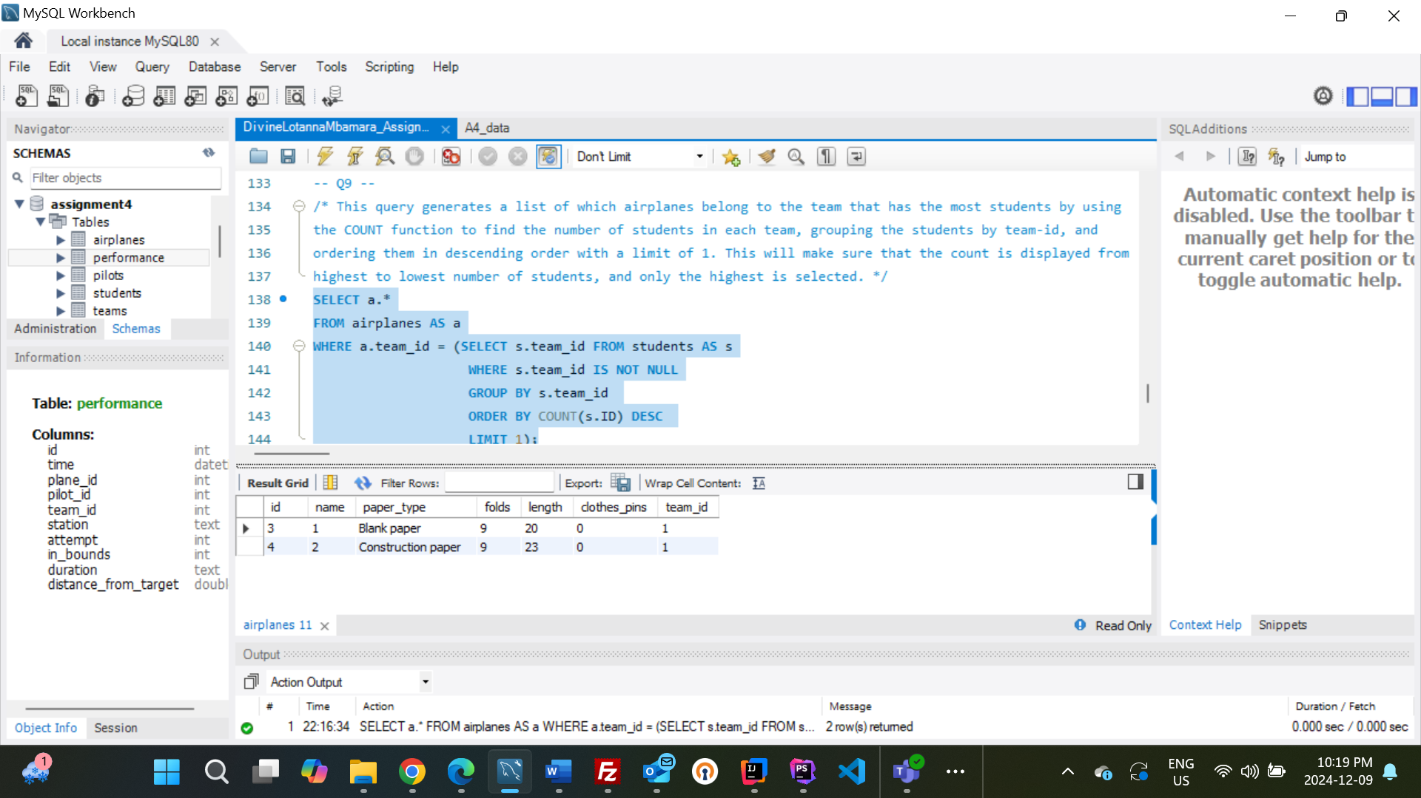

Question 10:
List the names of students who are not pilots.
