 San Francisco Bay University

EE461 Verilog-HDL
Homework #3
Due day: 3/7/2023

Instruction:

- Push answer sheets/source code to Github
- Please follow the code style rule like programs on handout.
- Overdue homework submission could not be accepted.
- Takes academic honesty and integrity seriously (Zero Tolerance of Cheating & Plagiarism)

- Design a static logic gate f =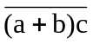in Verilog modeling by PMOS/NMOS devices based on the logic schematic as follows. And then write the testbench to verify the design to cover all input combinations and some x/z.
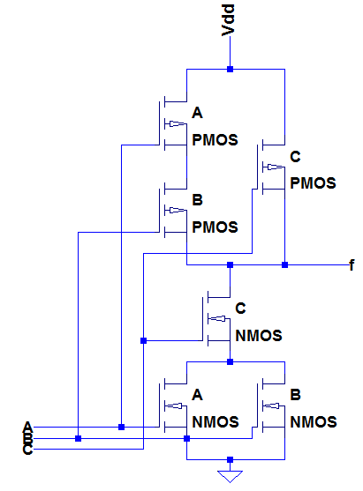
Answer:
module circuit(
input a_i,
input b_i,
input c_i,
output f_o
);

supply0 gnd;
supply1 vdd;

wire dp1,dn12;

pmos(dp1, vdd, a_i);
pmos(f_o, dp1, b_i);
pmos(f_o, vdd, c_i);

nmos(dn12, gnd, a_i);
nmos(dn12, gnd, b_i);
nmos(f_o, dn12, c_i);

endmodule

module circuit_tb;
reg a_r;
reg b_r;
reg c_r;
wire f_w;

circuit uut(
.a_i(a_r),
.b_i(b_r),
.c_i(c_r),
.f_o(f_w)
);
//stimulus

initial begin
{a_r,b_r,c_r}=3'b000; #5
{a_r,b_r,c_r}=3'b001; #5
{a_r,b_r,c_r}=3'b010; #5
{a_r,b_r,c_r}=3'b011; #5
{a_r,b_r,c_r}=3'b100; #5
{a_r,b_r,c_r}=3'b101; #5
{a_r,b_r,c_r}=3'b110; #5
{a_r,b_r,c_r}=3'b111; #5
$finish;
end
//monitor statements
initial
$monitor("%g \t A=%b \t B=%b \t C=%b \t f=%b \t",$time,a_r,b_r,c_r,f_w);
endmodule

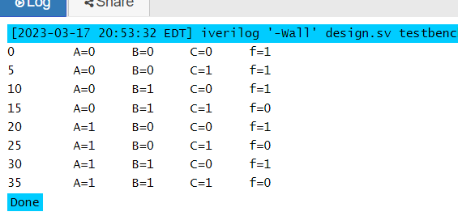

- Design a 2-to-1 mux UDP, and write testbench to assign selection bit to 0, 1 and X/Z to verify you design.

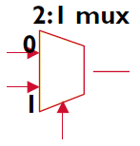

Answer:

primitive mux(
output m_out,
input in0,
input in1,
input sel
);

table // in0,in1,sel, m_out

0 ? 0: 0;
1 ? 0: 1;
? 0 1: 0;
? 1 1: 1;

endtable
endprimitive

module testbench;
reg in0, in1, sel;
wire m_out;

mux u(
.m_out(m_out),
.in0(in0),
.in1(in1),
.sel(sel)
);
initial begin
$monitor("in0: %b\tin1: %b\tsel: %b\tout: %b", in0, in1, sel, m_out);
{in0,in1,sel} = 3'b000; #3
{in0,in1,sel} = 3'b100; #3
{in0,in1,sel} = 3'b011; #3
{in0,in1,sel} = 3'b000; #3
{in0,in1,sel} = 3'b10x; #3
{in0,in1,sel} = 3'b01x; #3
{in0,in1,sel} = 3'b10z; #3
{in0,in1,sel} = 3'b01z; #3
$finish;
end
endmodule

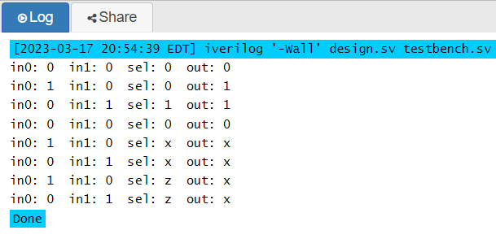

- Create top module to instantiate mux UDPs from the above primitive and system gates with delay time as below and simulate it by testbench with only several inputs values. What is the delay time of longest path from inputs to output in hand calculation if we don't consider the delay from the selection bit to output in two muxes? If D is either 1 or 0, what is the possible delay time of longest path from the inputs to output?

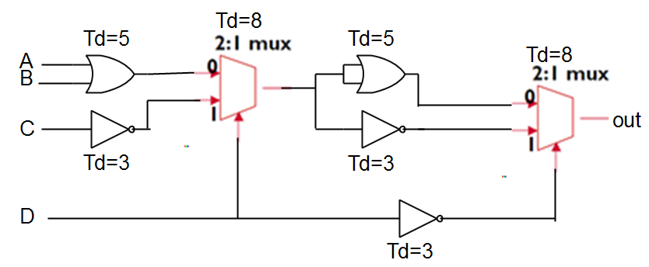

The sum of (Td = 5; Td = 8; Td = 5; and Td = 8), which is 26 units of time, is the longest delay path. Nonetheless, in the case where D is inverted for mux 2, the mux 2 will pass a 1 if the mux "1" passes a 0. When this occurs, the longest delay begins at "D" (Td = 3, Td = 3, Td = 8, Td = 5, Td = 5), which equals 24 time units. To confirm, look at the program output.

The maximum delay will be eight (8) units of time if the delay of the mux isn’t considered.

module Q3_top;
reg a, b, c, d;
wire out;
wire or1_w, or2_w, notc_w, not2_w, not3_w;
assign #5 or1_w = (a | b);
assign #3 notc_w = (~c);
wire mux1_w; // declare mux1_w as a wire

mux2to1 #8 u1(
.in0(or1_w),
.in1(notc_w),
.sel(d),
.m_out(mux1_w)
);
assign #5 or2_w = (mux1_w | mux1_w);
assign #3 not2_w = (~mux1_w);
assign #3 not3_w = (~d);

mux2to1 #8 u2(
.in0(or2_w),
.in1(not2_w),
.sel(not3_w),
.m_out(out)
);
initial begin
$dumpfile("Q3.vcd");
$dumpvars(0,Q3_top);
$monitor("time: %g \ta: %b\tb: %b\tc: %b\td: %b\tout: %b", $time, a, b,
c, d, out);
a = 1;
b = 0;
c = 0;
d = 1;
#30
a = 0;
b = 0;
c = 1;
d = 0;
#30
$finish;
end
endmodule

primitive mux2to1(
output m_out,
input in0,
input in1,
input sel
);

table // in0,in1,sel, m_out

0 ? 0: 0;
1 ? 0: 1;
? 0 1: 0;
? 1 1: 1;

endtable
endprimitive
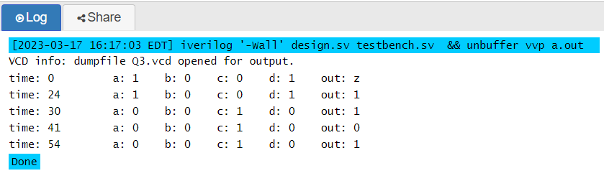

- Fix the bugs in the following example primitive, and explain why.

#include “basicPrimitive.v”
primitive example(a, b, c, d, e, f, g, h, i, j, k, l, m, n, o, p, q, r);
output[1:0] a, r;
input b, d, e, f, g, h, i, j, k, l, m, n, o, p, q;
inout c;

reg[1:0] a, r;

table
//a: c: r: b d e f g h i j k l m n o p q
00: 1: 01: 0 1 0 1 0 1 0 1 0 1 0 1 0 1 0
1: 1: 11: 0 1 0 1 0 1 0 1 0 1 0 1 0 1 ?
00: 0: 01: 0 1 0 1 0 1 0 1 0 1 0 1 0 1 0
... ...
endtable

basicPrimitive u0(a, b, c, d, e, f, g, h, i, j, k, l, m, n, o, p, q, r);

endprimitive

Bugs identified and explanations.

- A user-defined primitive (UDP) program is limited to 10 inputs and one output. There are two outputs and about 15 inputs in the the above program.

- The basicPrimitive is created inside the example primitive in the program above; a user-defined primitive (UDP) program cannot create another UDP or module.

- It is not possible to declare a non-sequential output terminal as a reg data type. The output from the the above program is declared as a reg data type and is combinational.

- User-defined primitive (UDP) programs are not supported on the inout port.

- The program above doesn't have both inputs and outputs listed in the same order, which is required.

Fixed version:
primitive example(a, b, c, d, e, f, g, h, i, j, k);
output a;
input b, c, d, e, f, g, h, i, j, k;

reg a;

table
//b c d e f g h i j k a
0 0 1 0 1 0 1 0 1 0: 0;
1 0 1 0 1 0 1 0 1 0: 1;
0 0 1 0 1 0 1 0 1 0: 0;
... ...
endtable
endprimitive

- Generate UDP of D-Flip Flop with reset, and then build 3-bits counter in top module by instantiating UDP of DFF and NOT/NAND/XOR gates in terms of following schematic. After that, write testbench to observe output results.

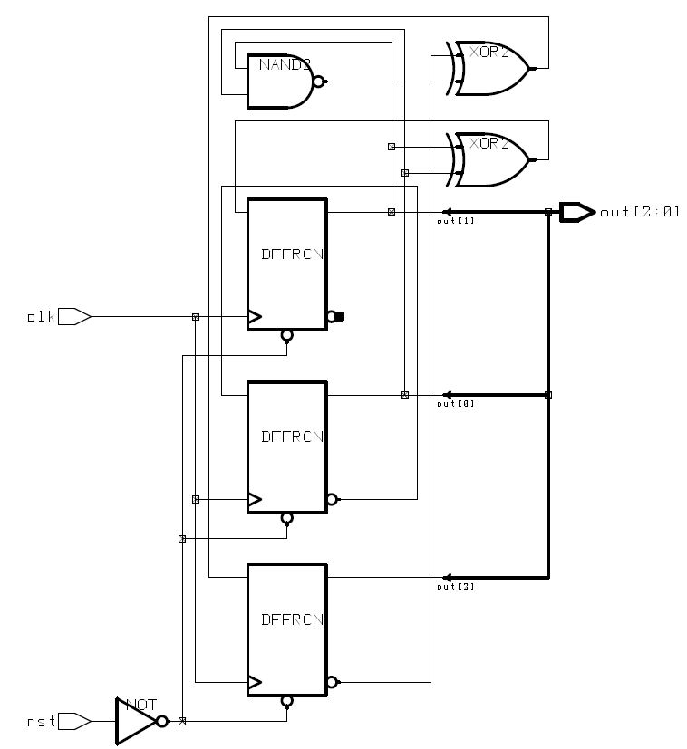

primitive dff_reset_udp(
output reg q,
input d,
input clk,
input rst_b
);
table
// d clk rst: q: q+;
? ? 0 : ?: 0;
? ? (01): ?: -;
0 (01) 1: ?: 0;
1 (01) 1: ?: 1;
? (x1) 1: ?: -;
? (10) 1: ?: -;
? (1x) 1: ?: -;
(??) ? 1: ?: -;

endtable
endprimitive

primitive udpNand(f_o, a_i, b_i);
output f_o;
input a_i;
input b_i;table
// a b : f;
1 1 : 0; // If adding one more line, like a = 1 and b = 1, f=0, it is
illegal.
0 ? : 1;
? 0 : 1; // ? expanded to 0, 1, x
endtable
endprimitive

primitive udpXor(f_o, a_i, b_i);
output f_o;
input a_i;
input b_i;
table
// a b : f;
1 1 : 0;
0 1 : 1;
1 0 : 1;
0 0 : 0;
endtable
endprimitive

module Q5_top(
output[2:0] out,
input clk, input rst
);
wire d_1, d_2, nand_w, rst_b;
udpXor xor_1(
.f_o(d_1),
.a_i(out[1]),
.b_i(out[0])
);
dff_reset_udp dff_1(
.q(out[1]),
.d(d_1),
.clk(clk),
.rst_b(rst_b)
);
udpNand nand_1(
.f_o(nand_w),
.a_i(out[1]),
.b_i(out[0])
);
udpXor xor_2(
.f_o(d_2),
.a_i(!out[2]),
.b_i(nand_w)
);
dff_reset_udp dff_0(
.q(out[0]),
.d(!out[0]),
.clk(clk),
.rst_b(rst_b)
);
udpNot not1(
.a_i(rst),
.f_o(rst_b)
);
dff_reset_udp dff_2(
.q(out[2]),
.d(d_2),
.clk(clk),
.rst_b(rst_b)
);
endmodule

module q5_top_tb;
reg clk, rst;
wire[2:0] out;
q5_top u(
.clk(clk),
.rst(rst),
.out(out)
);
always #2 clk = ~clk;
initial begin
$dumpfile("q5.vcd");
$dumpvars(0, q5_top_tb);
clk = 1;
rst = 1;
#3
rst = 0;
#40
rst = 1;
#5
rst = 0;
#30
$finish;
end
endmodule

