PharmaSync
Prototype Demonstration
Demonstration evidence for the pharmacy management prototype, mapped to the nine requested system capabilities.
Captured | 30 September 2026
Environment | Local Vite + Express API with PostgreSQL health check
Safety scope | No inventory record saved; no purchase, sale, or external payment submitted

Requirement map
# | Demonstration item | Evidence
1 | System login | 01-login.png
2 | Main system functionality | 02-dashboard.png
3 | Database-backed inventory | 03-inventory.png
4 | Inventory and stock workflows | 12-inventory-workflows.png
5 | Medicine data creation | 04-medicine-draft.png
6 | API and database connectivity | 05-database-health.png
7 | POS data exchange and provider handoff | 06-pos-provider-handoff.png
8 | Search and validation feedback | 07-no-results.png
9 | Service error handling | 08-api-error-handling.png
10 | Admin roles and user roster | 10-admin-user-roles.png
11 | User creation | 13-user-creation-draft.png
12 | Audit and traceability | 14-audit-log.png
13 | Reports and analytics | 15-reports.png
14 | Backup administration | 16-backup-administration.png
15 | Supplier data creation | 17-supplier-creation-draft.png
16 | Pharmacist authorization | 11-pharmacist-role-security.png
17 | Cashier authorization | 09-cashier-role-security.png

Observed API traffic
Method | Endpoint | HTTP
GET | /api/session | 401
POST | /api/login | 200
GET | /api/state | 200
GET | /api/health | 200
GET | /api/session | 200
GET | /api/audit | 200
GET | /api/reports | 200
GET | /api/backups | 200
GET | /api/medicines/archived | 200
GET | /api/backups/changes | 200
POST | /api/logout | 200
HTTP 401 on the initial unauthenticated session check is expected. The 503 error screen is a controlled browser simulation, not a production outage.

Role access matrix
Role | Visible areas
ADMIN | Dashboard, POS, inventory, suppliers, users, reports, audit, settings
PHARMACIST | Dashboard, inventory, suppliers, settings
CASHIER | Dashboard, POS

01 System login
The sign-in screen is presented before authenticated access. Demo credentials are not shown in the image.
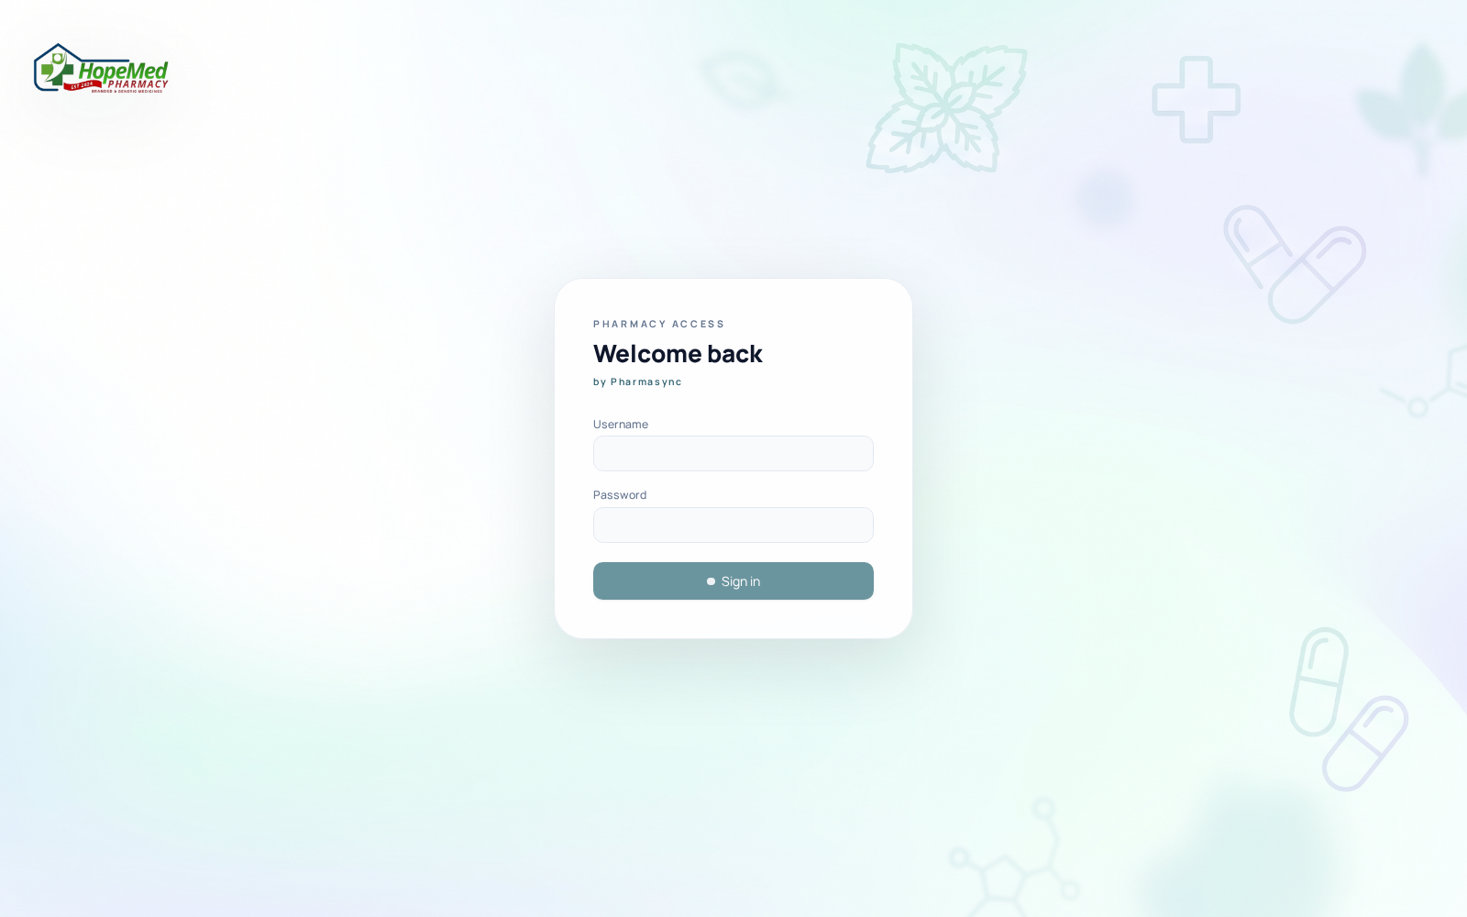
01-login.png

02 Main system functionality
Admin dashboard loaded with live application state after successful authentication.
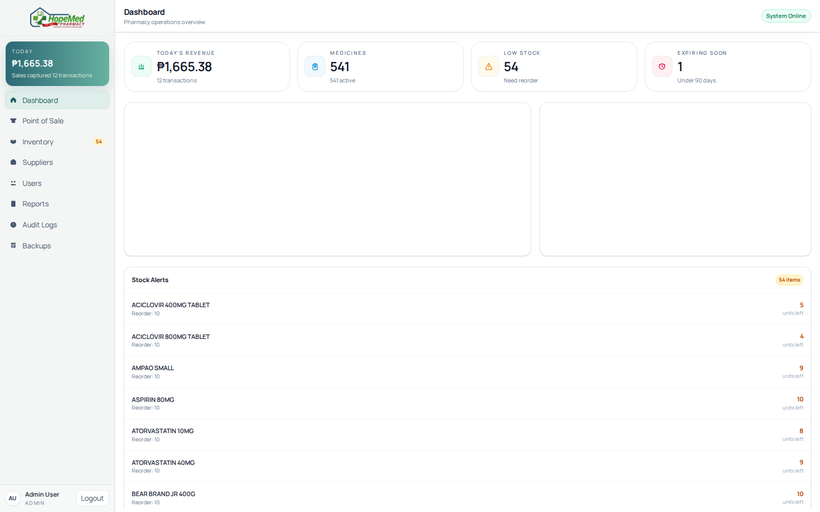
02-dashboard.png

03 Database-backed inventory
Inventory records loaded after authenticated GET /api/state from PostgreSQL.
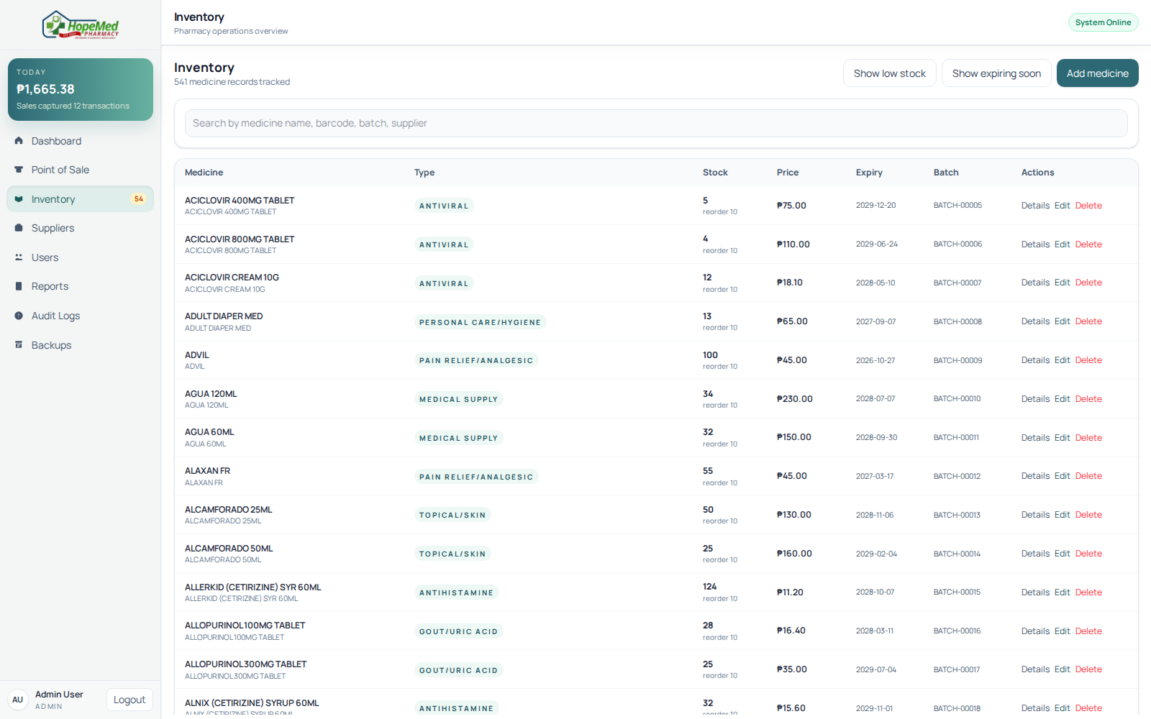
03-inventory.png

04 Inventory and stock workflows
Expanded inventory screen includes catalog, purchase receiving, and stock-movement workflows. No mutation was submitted.
12-inventory-workflows.png

05 Medicine data creation
Medicine creation form populated as a draft. Save was not pressed, so no medicine record was written.
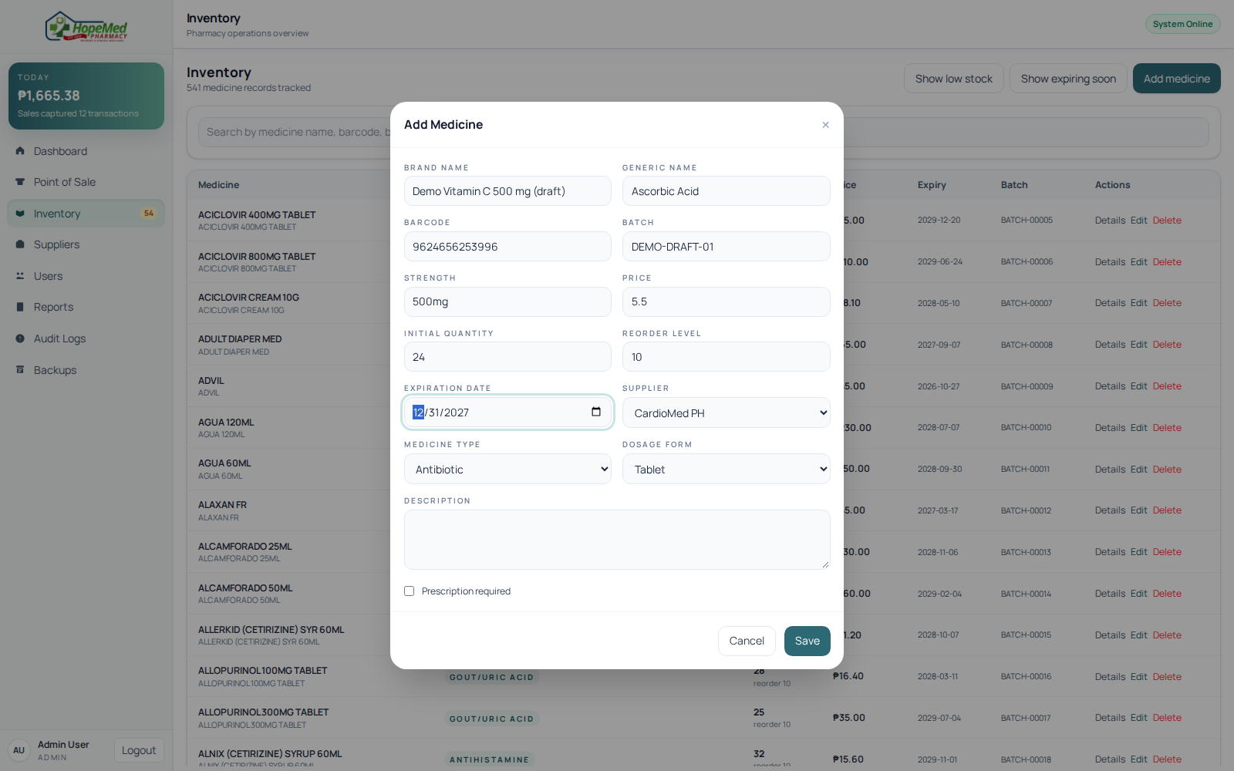
04-medicine-draft.png

06 API and database connectivity
The browser requested the health endpoint and received HTTP 200 with PostgreSQL reported as the active database.
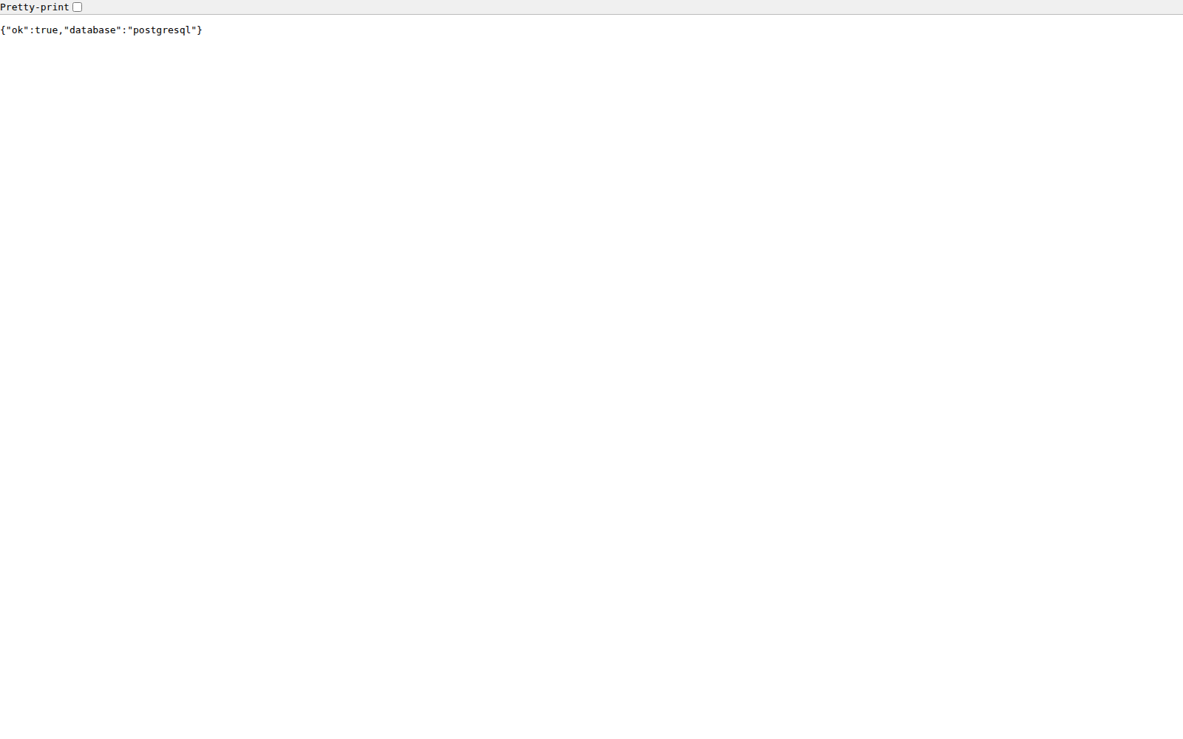
05-database-health.png

07 POS data exchange and provider handoff
A medicine is staged in the cart and GCash selected. Checkout was not started; no payment request was sent.
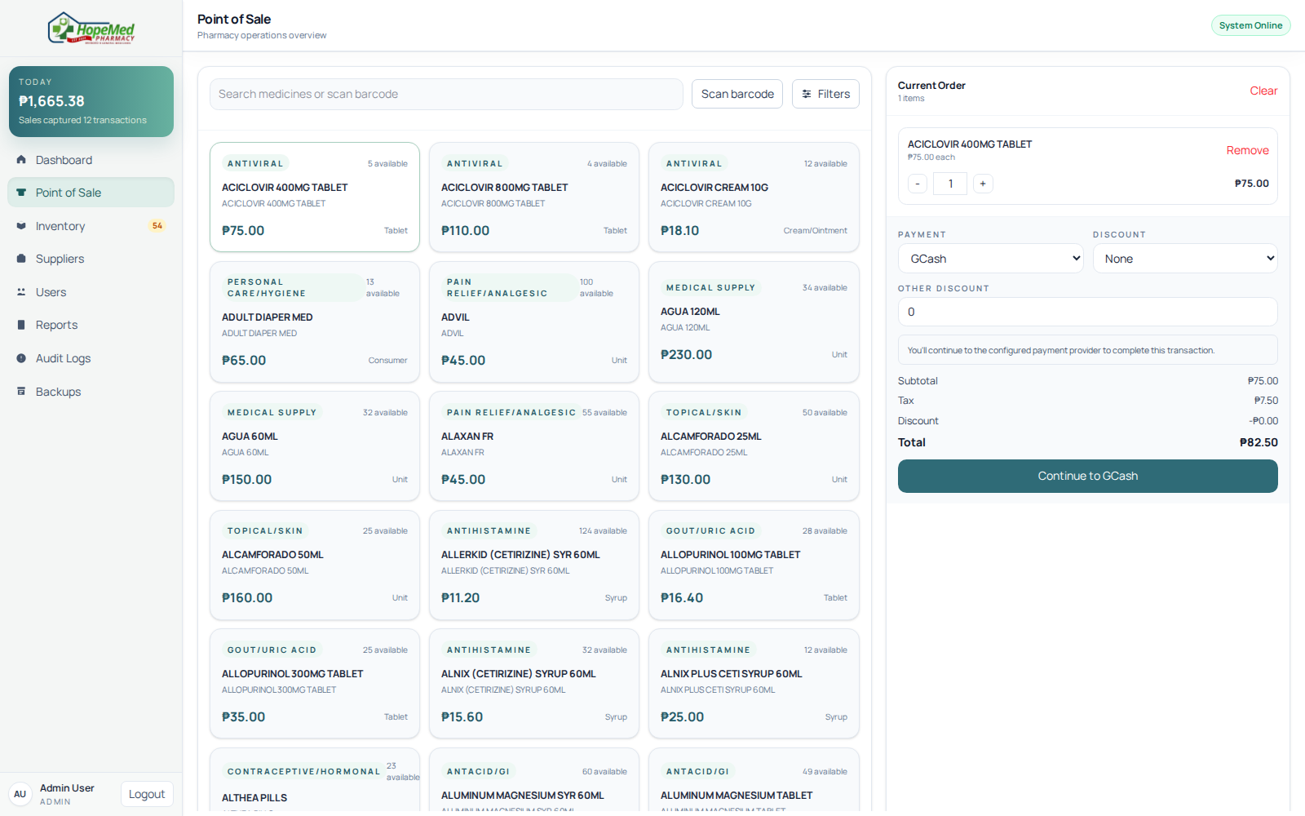
06-pos-provider-handoff.png

08 Search and validation feedback
POS presents a clear no-match state for an unknown medicine search.
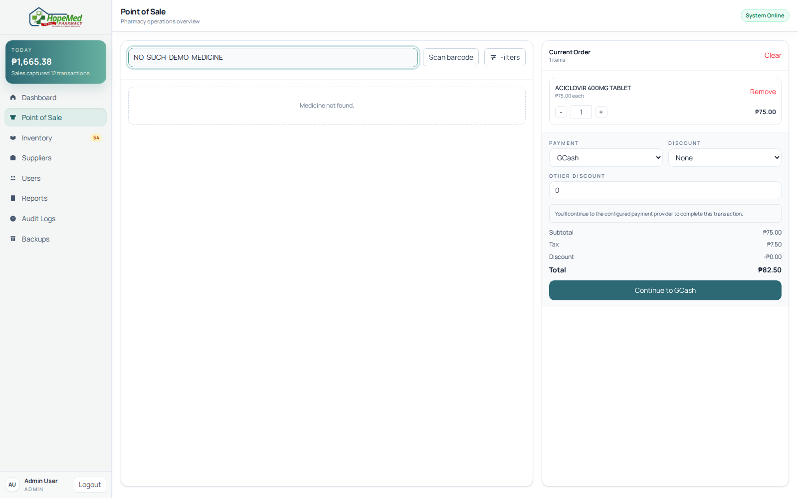
07-no-results.png

09 Service error handling
A controlled browser-route simulation returned HTTP 503 from /api/session; the app displayed its Service unavailable state.
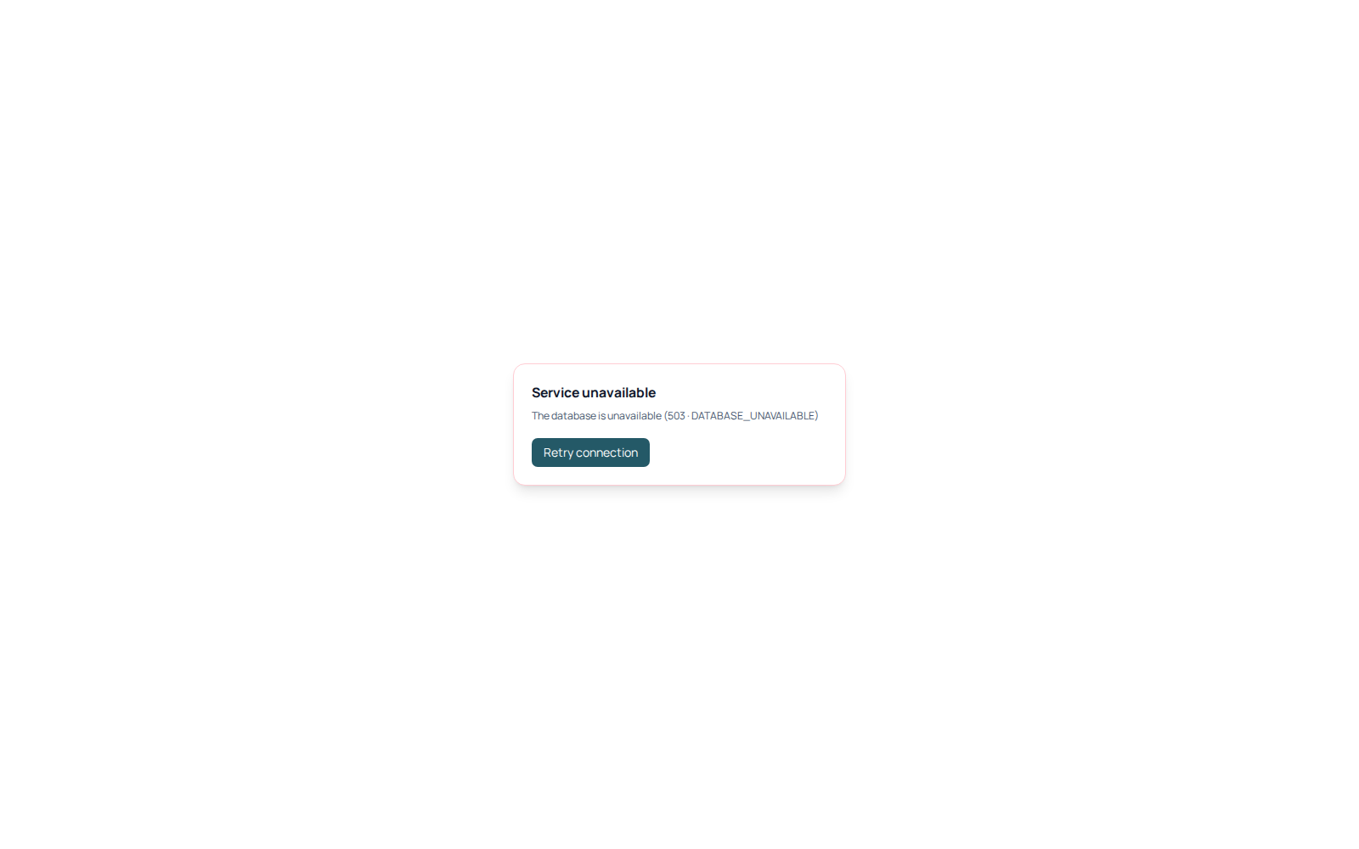
08-api-error-handling.png

10 Admin roles and user roster
Admin sees the active ADMIN, PHARMACIST, and CASHIER user records and user-administration controls.
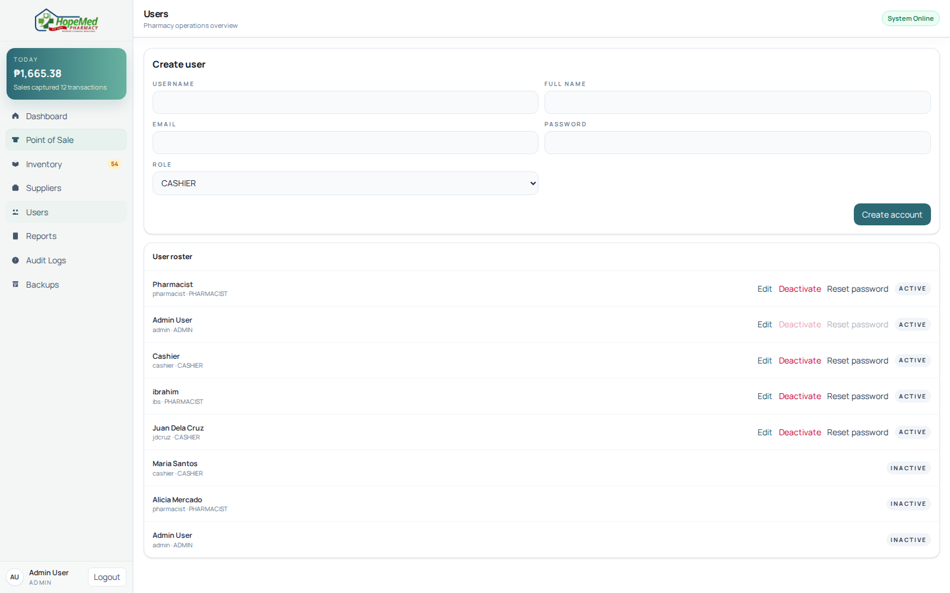
10-admin-user-roles.png

11 User creation
A new pharmacist account is prepared in the admin form as an unsaved draft; no user was created.
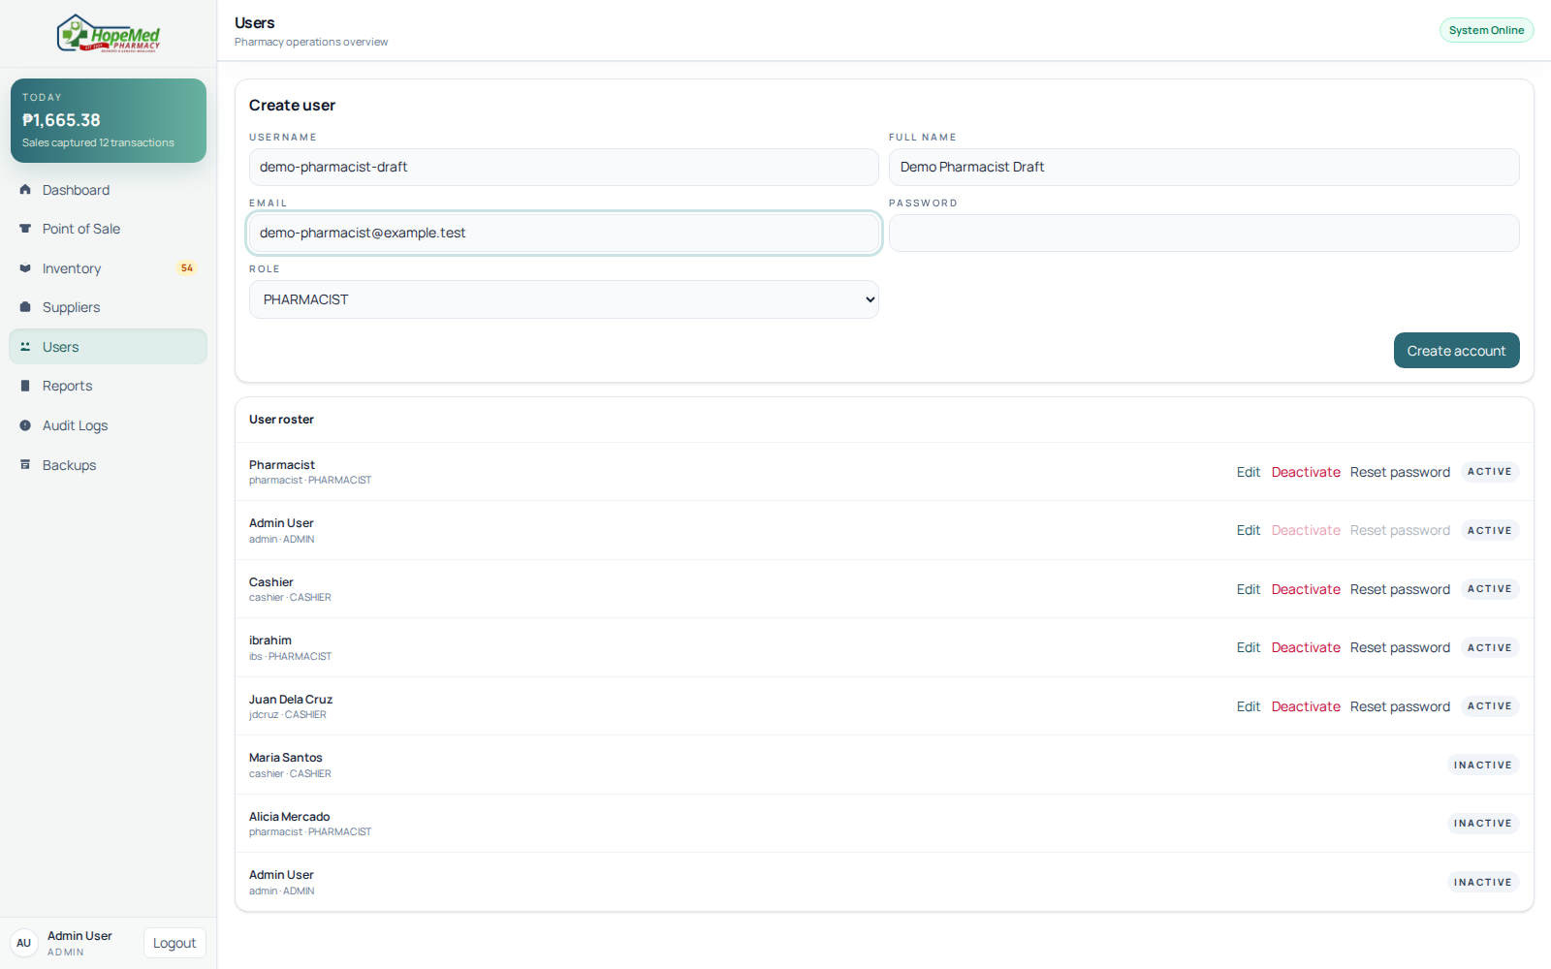
13-user-creation-draft.png

12 Audit and traceability
Admin audit screen shows recorded system activity with actor, action, entity, and timestamp fields.
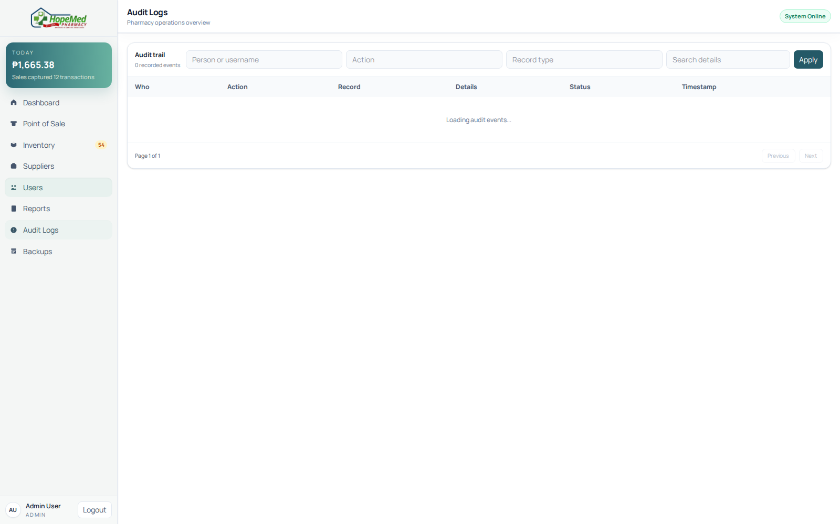
14-audit-log.png

13 Reports and analytics
Admin report view presents sales and inventory reporting controls and summary metrics.
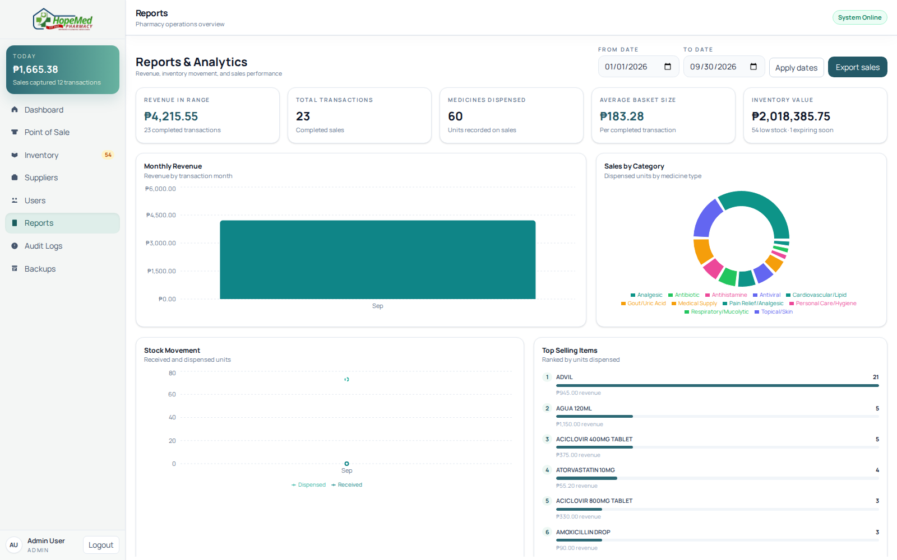
15-reports.png

14 Backup administration
Admin backup history and controls are shown. No backup operation was started.
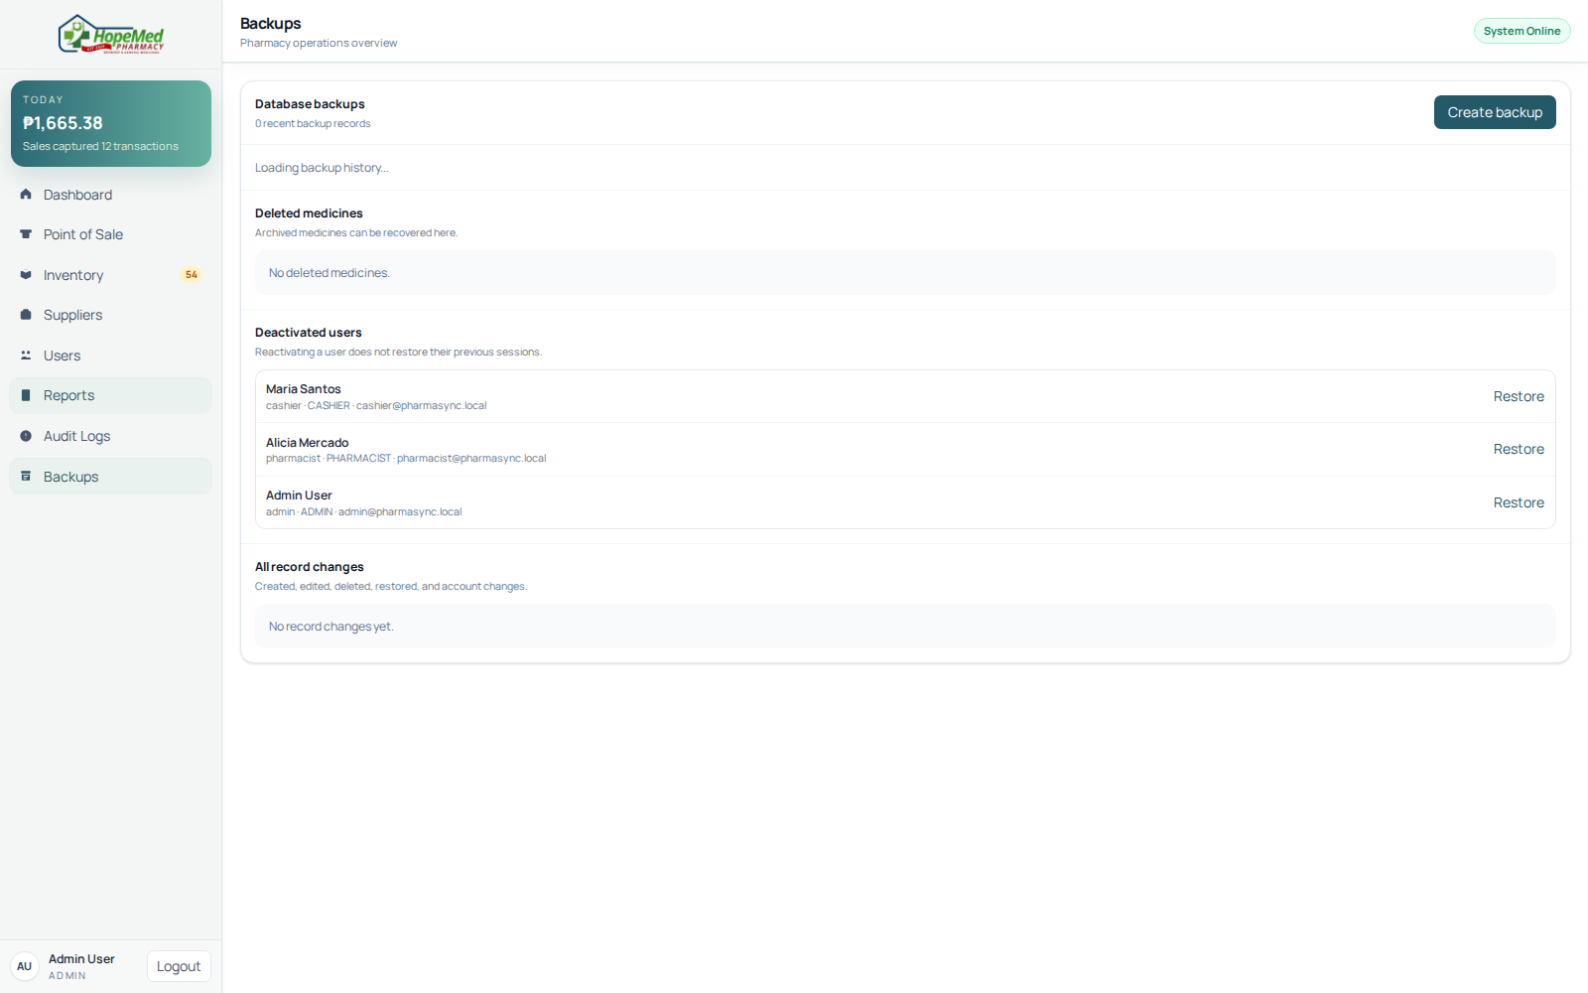
16-backup-administration.png

15 Supplier data creation
Supplier details are populated as a draft; Save supplier was not pressed.
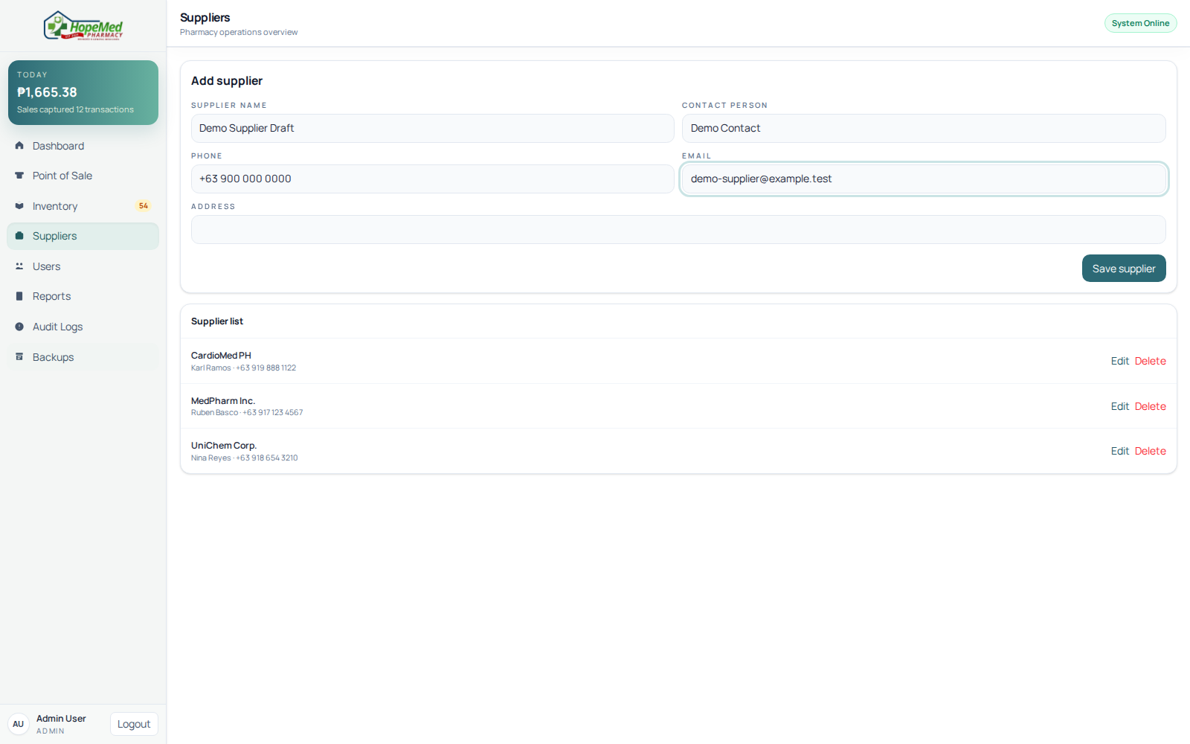
17-supplier-creation-draft.png

16 Pharmacist authorization
Pharmacist navigation includes inventory and suppliers, and excludes POS and user administration.
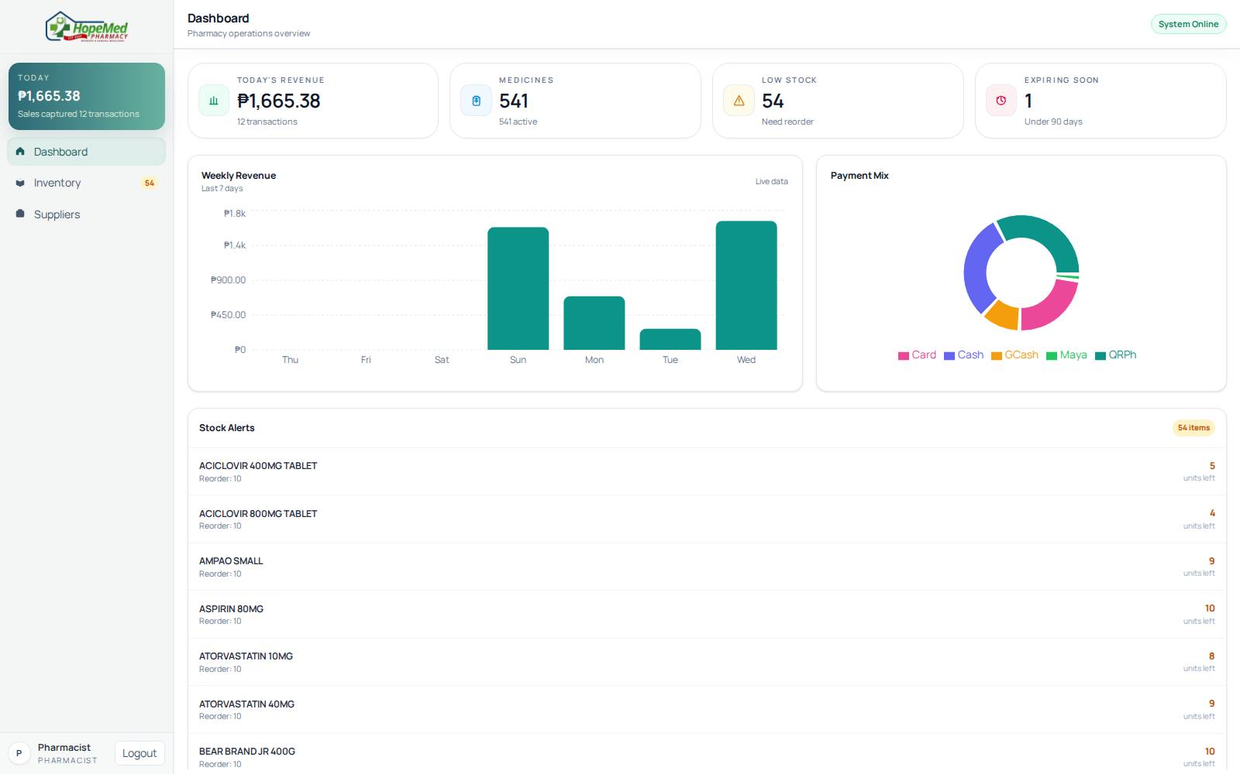
11-pharmacist-role-security.png

17 Cashier authorization
Cashier navigation includes POS and excludes inventory and user administration.
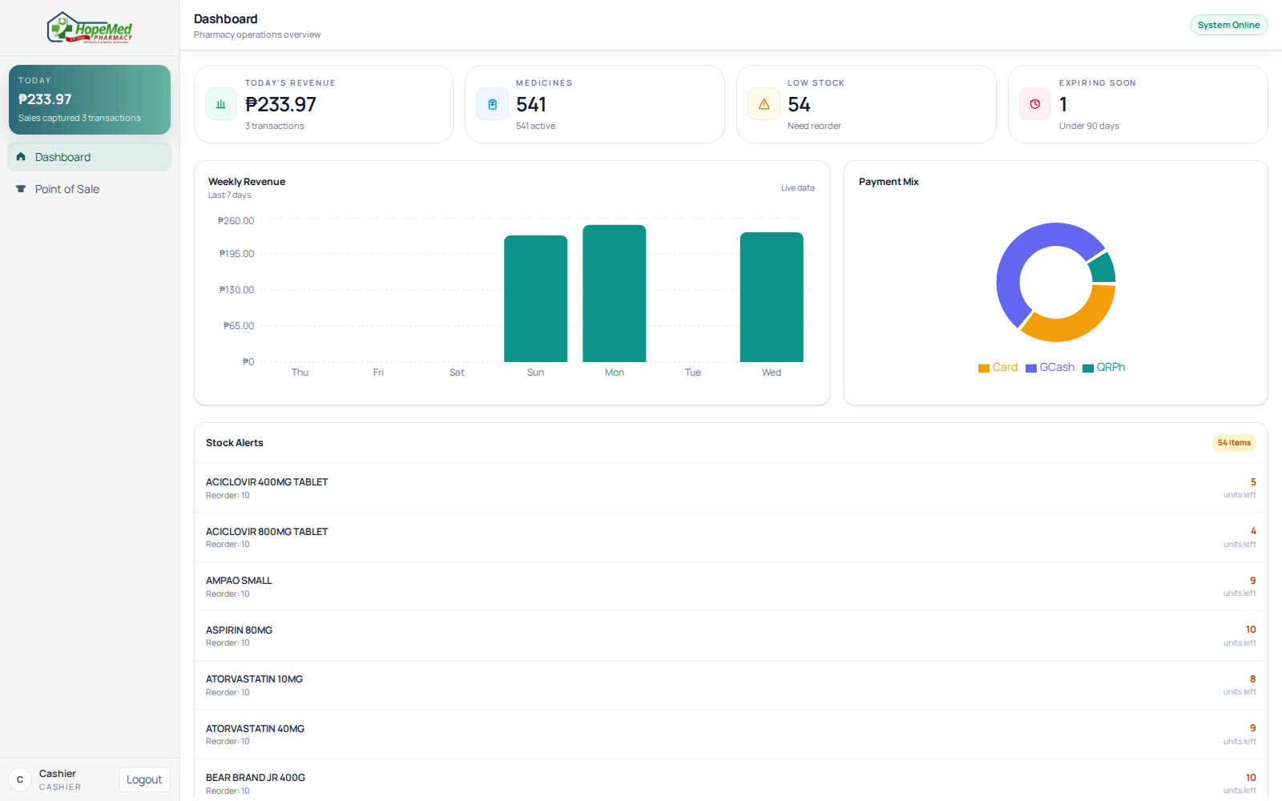
09-cashier-role-security.png

