**DATA WAREHOUSE**

In the modern era of digital transformation and data-driven decision-making, businesses rely heavily on the ability to analyze and process large volumes of data. This need has given rise to the concept of Data Warehousing, which serves as the foundation for Business Intelligence (BI) and data analytics systems. A Data Warehouse (DW) is a central repository of integrated data collected from various operational sources, structured in a way that supports query and analysis rather than transaction processing.

**DEFENITION:**

A Data Warehouse is a subject-oriented, integrated, time-variant, and non-volatile collection of data that supports management's decision-making process. This definition, proposed by Bill Inmon, the "father of data warehousing," highlights the core attributes of a data warehouse:

* Subject-Oriented
* Integrated
* Time Variant
* Non – Volatile

**Subject-Oriented:** Organized around major subjects such as customers, products, sales, etc.

**Integrated:** Combines data from multiple heterogeneous sources into a cohesive format.

**Time Variant:** Contains historical data and can analyse trends over time.

**Non – Volatile:** Data is stable and not changed once entered into the warehouse.

**Architecture Of Data Warehouse:**

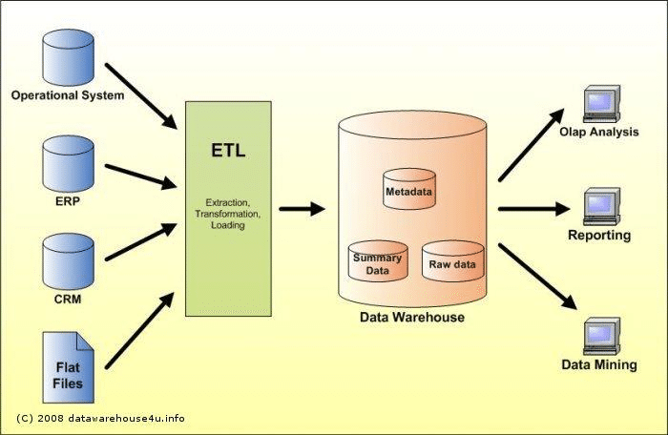

Fig - 1.1

A typical data warehouse follows a **layered architecture**, designed to efficiently manage the flow of data from source systems to end-user tools. This layered design ensures that data is systematically extracted, transformed, stored, and made available for reporting and analysis. The major layers include:

1. **Data Source Layer:** This is the foundation layer of a data warehouse. It consists of various operational and transactional data sources such as:

* ERP (Enterprise Resource Planning) systems
* **CRM** (Customer Relationship Management) systems
* Legacy databases
* Flat files (CSV, TXT)
* **Web logs, Excel sheets**, and external APIs

These data sources generate large volumes of structured and unstructured data, which are often scattered across multiple platforms and formats. The primary role of this layer is to **supply raw data** to the ETL system for further processing.

1. **ETL Layer (Extract, Transform, Load):** This is one of the most critical layers in the data warehouse architecture. ETL tools such as Informatica, Talend, Apache Nifi, or Microsoft SSIS are used to:

* **Extract:** Gather data from multiple, heterogeneous sources.
* **Transform:** Cleanse, normalize, format, and apply business rules to the data. This step may include filtering out noise, handling missing values, converting data types, and removing duplicates.
* **Load**: Insert the processed data into the data warehouse system in a structured and optimized format.

1. **Data Storage Layer:** This is the core layer of the architecture. It acts as a centralized repository where processed data is stored in a format optimized for query performance and historical analysis. It includes several subcomponents:

* **Staging Area:**
  + A temporary storage location for raw data before transformation.
  + Allows data validation and cleansing before it is moved to the main warehouse.
  + Provides isolation from production systems, minimizing risks.
* **Data Warehouse Database**:
  + This is the central hub of the architecture where cleaned and transformed data is stored.
  + Supports multidimensional models such as **star schema** and **snowflake schema** for faster analytical queries.
  + Designed for read-intensive operations and optimized for complex joins and aggregations.
* **Data Marts**:
  + These are subject-specific subsets of the data warehouse.
  + Provide focused access to data for specific business units or departments, such as sales, finance, or HR.
  + Can be **dependent** (sourced from the main data warehouse) or **independent** (built directly from operational sources).

1. **Presentation Layer:** The presentation layer is the interface between the data warehouse and the end-users. It delivers processed data through various tools and platforms such as:

* Business Intelligence (BI) Tools like Power BI, Tableau, QlikView
* **Reporting tools** for scheduled or ad-hoc reports
* **Dashboards and KPIs** for executives and analysts
* **Online Analytical Processing (OLAP)** systems for multidimensional analysis.

**Types of Data Warehouses:**

* Enterprise Data Warehouse (EDW)
* Operational Data Store (ODS)
* Data Mart

**Benefits of a Data Warehouse:**

* **Improved Decision Making:** Consolidated data enables better analysis and forecasting.
* **Faster Query Performance**: Optimized for complex queries compared to transactional databases.
* **Historical Intelligence**: Allows trend analysis over months or years.
* **Data Consistency**: Integrated and cleansed data reduces redundancy and errors.
* **Business Insights**: Supports tools like OLAP (Online Analytical Processing) and data mining.

**Applications of Data Warehousing:**

* **Retail:** Customer behavior analysis, inventory management.
* **Banking**: Fraud detection, risk analysis.
* **Healthcare**: Patient care analysis, hospital resource planning.
* **Telecommunications:** Call detail analysis, customer churn prediction.
* **Government**: Policy planning, tax collection optimization.

**Conclusion:**

A Data Warehouse is a powerful tool for any organization that wants to leverage data for strategic decisions. By consolidating diverse data sources into a single repository optimized for analysis, it enhances the ability to perform business intelligence tasks effectively. Despite its challenges, the benefits and growing technological advancements make data warehousing an essential component of modern data architecture.