**Q1.**

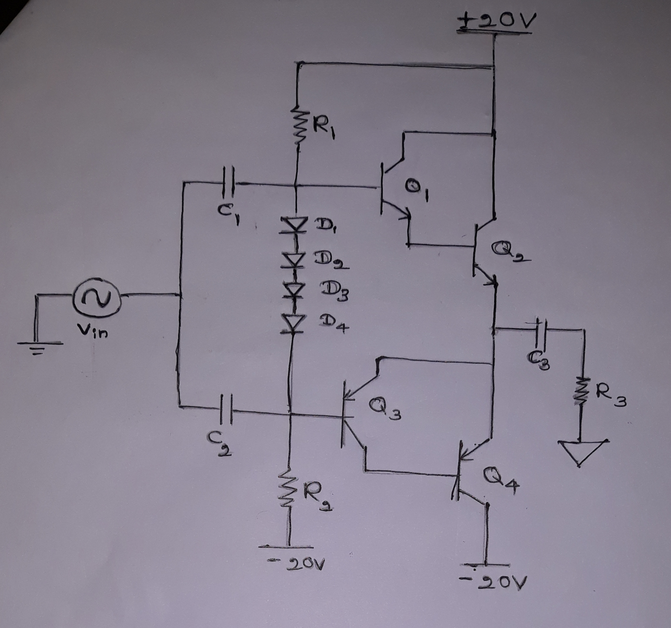

Base Emitter Voltage of a Transistor – 0.7V

Maximum Output Current Imax  - 3A

Current Gain – 50

Supply Voltage - +20V, -20V

Output Power – 22.5W

Signal Diodes – D1, D2, D3, D4

* 1N4148

Capacitors –

* C1 – 1uF
* C2 – 1uF
* C3 – 1uF

Transistors –

* Q1 – 2N3904 (NPN)
* Q2 – 2N3904 (NPN)
* Q3 – 2N3906 (PNP)
* Q3 – 2N3906 (PNP)

Resistors –

* R1 – 1K
* R2 – 1K

*Complementary Symmetry is used.

Total Current Gain – h1xh2 = 50 x 50 = 2500

Ibase = 3A/2500 = 1.2mA

Ibias = 1.2mA x 50 = 60mA

Vbias per Darlington pair= 0.7V x 2 = 1.4V

Vbias Total = 1.4V x 2 = 2.8V