Deep Learning Assignment Report

Introduction
This assignment focuses on image classification using deep learning techniques. Three major tasks were completed:
1. Building and training a Basic Convolutional Neural Network (CNN) on the Imagenette dataset.
2. Adding regularization using techniques such as data augmentation or dropout and comparing the effect.
3. Performing Transfer Learning by fine-tuning an Imagenette-trained model on the CIFAR-10 dataset and comparing it with training the same model from scratch.

I. Basic CNN Model

Model Overview
A custom CNN was implemented consisting of convolutional layers with ReLU activation, MaxPool layers for spatial downsampling, fully connected layers, and a softmax output.

Training Procedure
The model was trained on the Imagenette dataset using the Adam optimizer and cross entropy loss. Early stopping was applied based on validation loss.

Results
Training and validation losses showed convergence, and early stopping prevented overfitting. The final test accuracy was reasonable for a lightweight CNN.
Epoch 5: 100%
148/148 [00:56<00:00, 2.62it/s, v_num=1, train_loss=0.0719, val_loss=1.560, val_acc=0.662, train_acc=0.951]
Final Test Loss (Part 1): 1.5629
Final Test Accuracy (Part 1): 0.6619
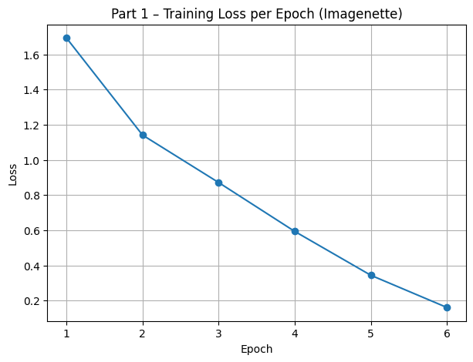
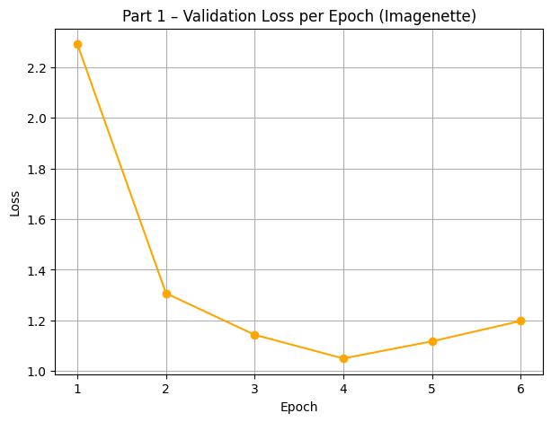
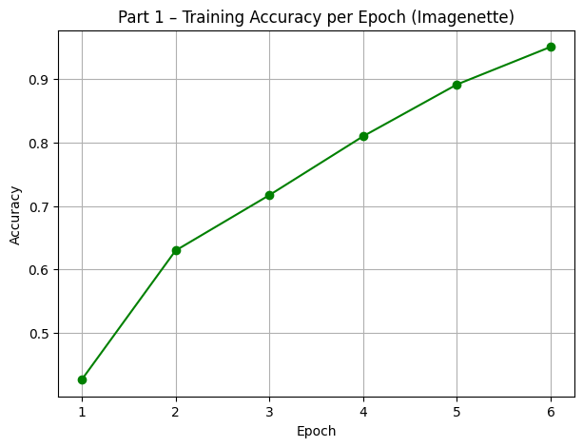
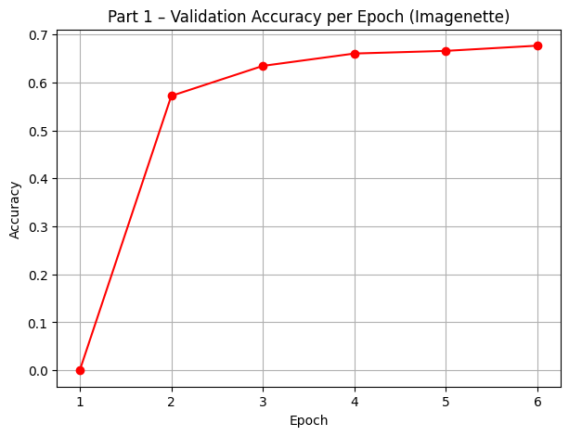

II. Regularization
Regularization was introduced using data augmentation techniques such as random horizontal flips, random crops with padding, and optional color jitter. This improved generalization and reduced overfitting.

Comparison
With regularization, validation loss decreased and model accuracy improved compared to the non-regularized version.
Epoch 9: 100%
148/148 [01:01<00:00, 2.40it/s, v_num=2, train_loss=0.536, val_loss=0.860, val_acc=0.730, train_acc=0.821]
INFO: `Trainer.fit` stopped: `max_epochs=10` reached.
REGULARIZED MODEL TEST RESULTS (Part 2)
Test Loss: 0.8737
Test Accuracy: 0.7297
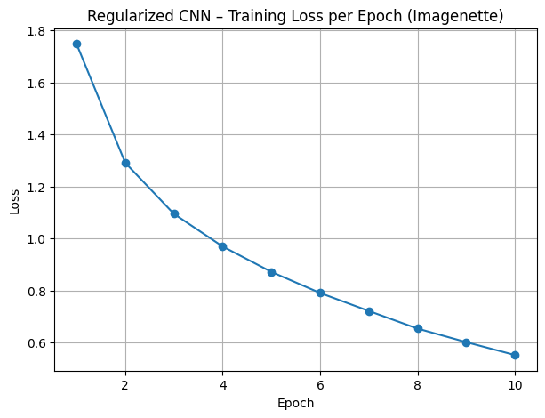
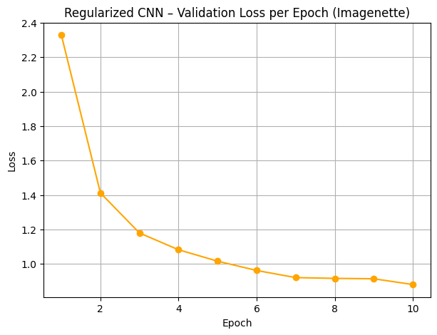
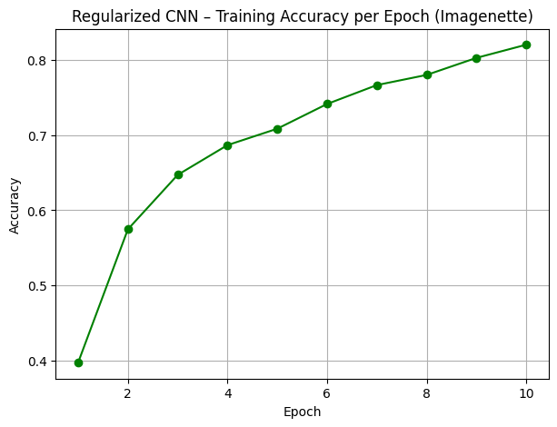
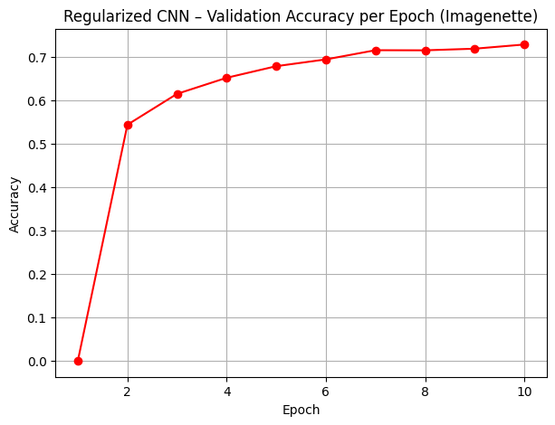

III. Transfer Learning on CIFAR-10
Transfer learning was performed in two configurations: training from scratch and fine-tuning a model pre-trained on Imagenette. The fine-tuned model converged faster and achieved higher accuracy.
Epoch 11: 100%
782/782 [01:05<00:00, 11.92it/s, v_num=3, train_loss=0.365, val_loss=0.755, val_acc=0.753, train_acc=0.822]
CIFAR-10 FROM SCRATCH
Test Loss: 0.7530
Test Accuracy: 0.7526
INFO:lightning.pytorch.utilities.rank_zero:`Trainer.fit` stopped: `max_epochs=10` reached.

CIFAR-10 TRANSFER LEARNING (Imagenette → CIFAR-10)
Epoch 14: 100%
782/782 [01:05<00:00, 11.91it/s, v_num=4, train_loss=0.351, val_loss=0.671, val_acc=0.766, train_acc=0.771]
INFO: `Trainer.fit` stopped: `max_epochs=15` reached.
INFO:lightning.pytorch.utilities.rank_zero:`Trainer.fit` stopped: `max_epochs=15` reached.
Test Loss: 0.6720
Test Accuracy: 0.7662
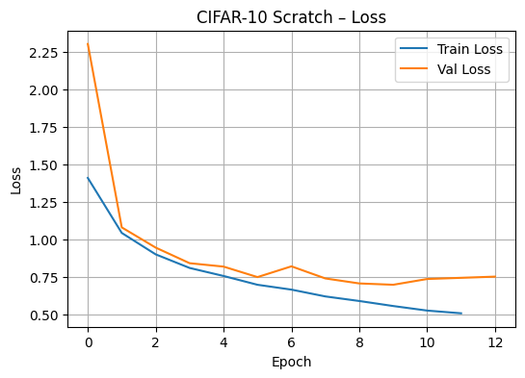
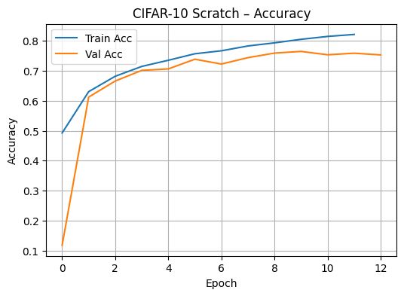
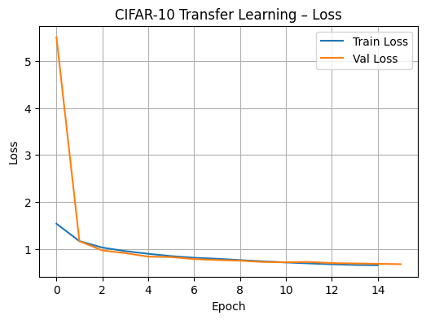
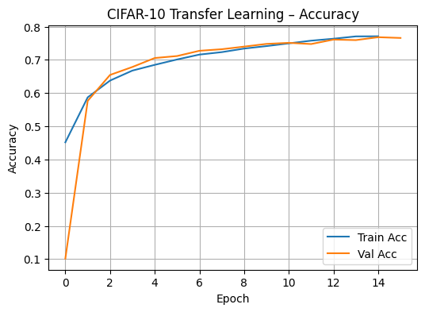

Conclusion:
Fine-tuning the Imagenette-pretrained model improved CIFAR-10 performance compared to training from scratch. The scratch model reached about 75% accuracy, while the fine-tuned model achieved ~76.6%, with a noticeably lower test loss. This shows that pretrained features helped the model learn faster and generalize slightly better, confirming the value of transfer learning.

