#1 help for in built functions

help (sum)

example(sum)

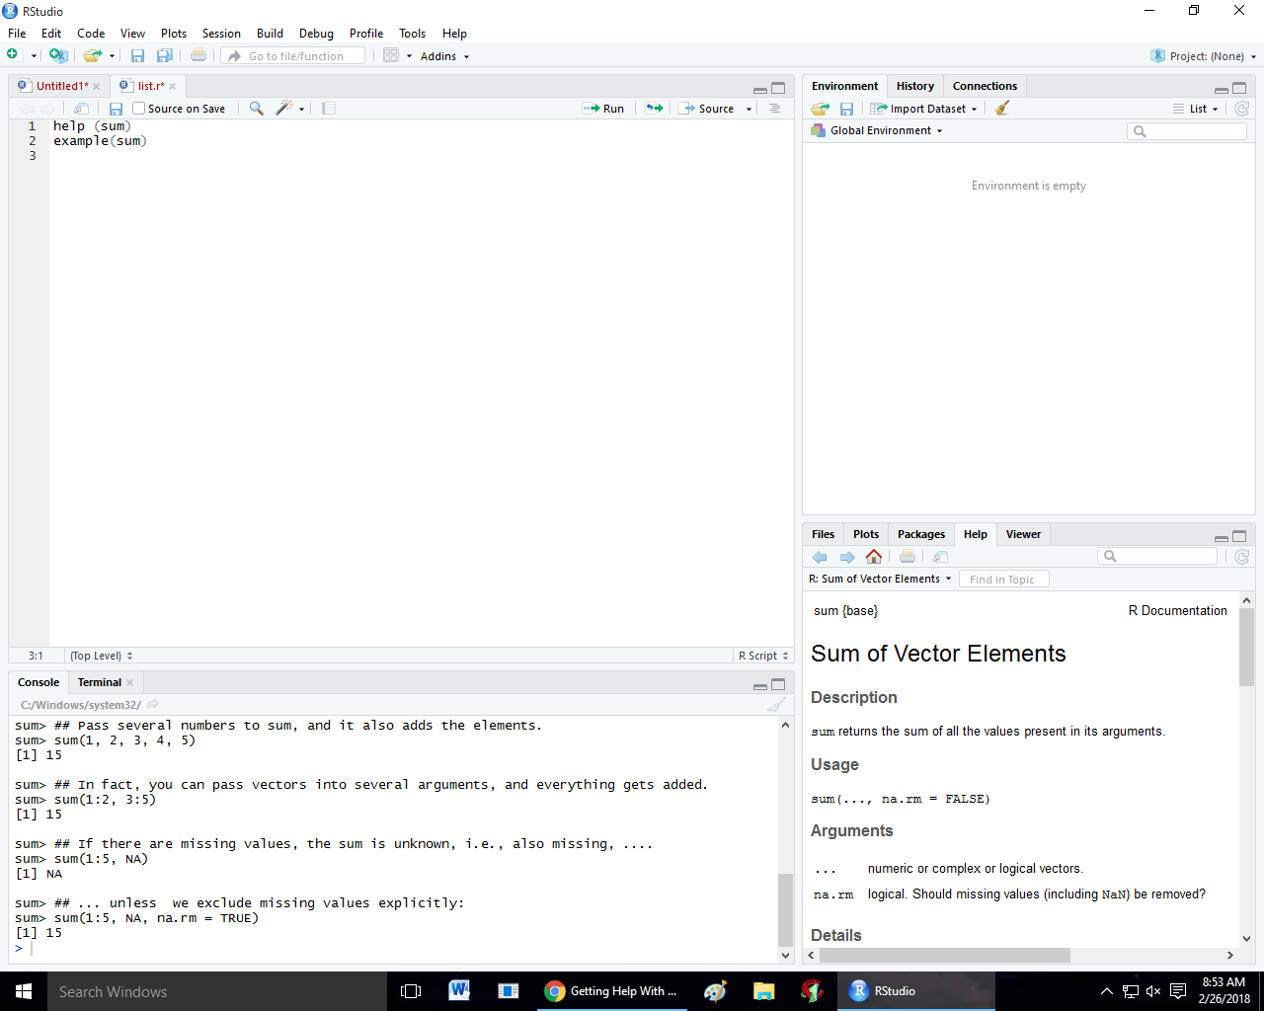

#2 function

hello<-function(name)

{

print(name)

}

hello("diviyansha")

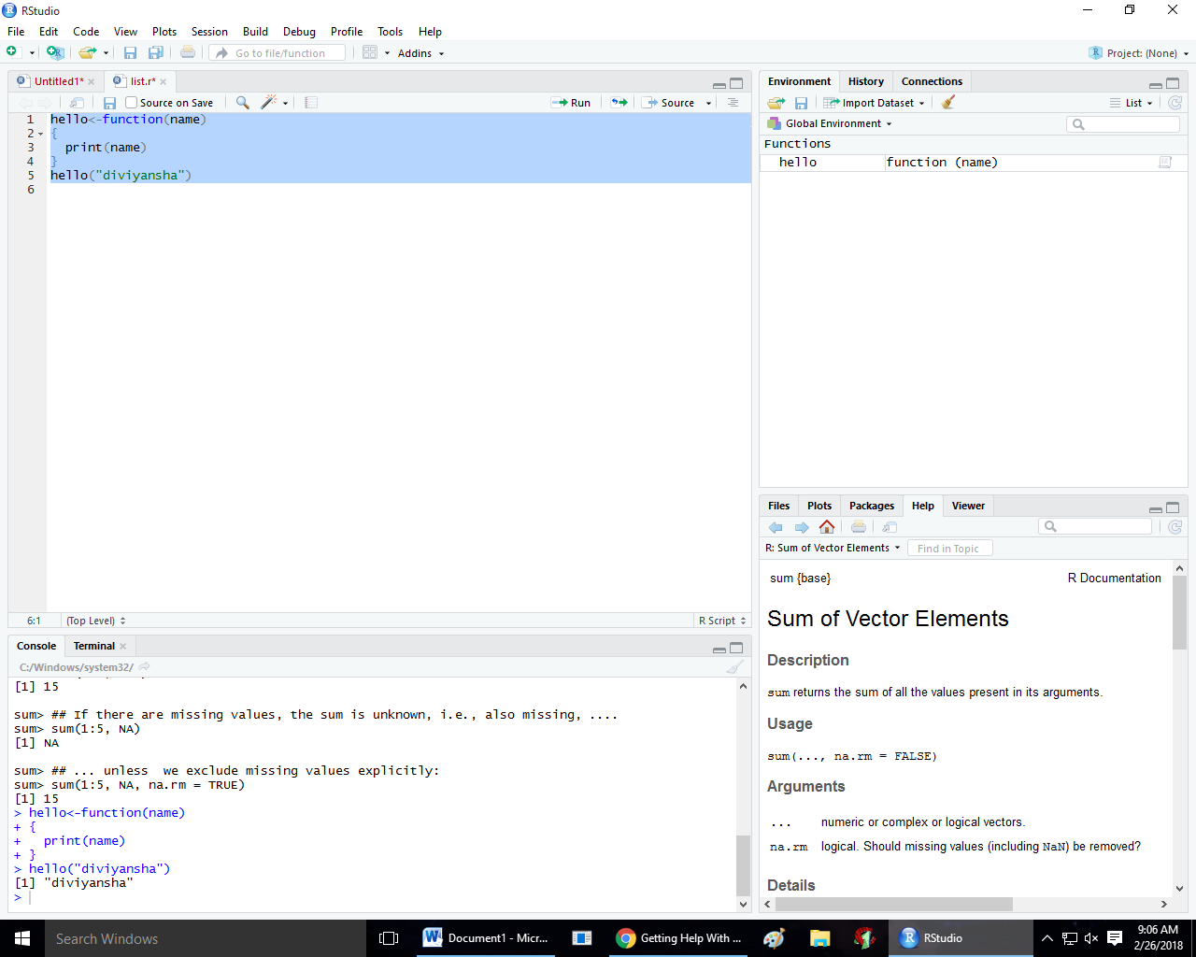

#3 function using default arguments

a<-10

b<-5

mul<-function(x,y)

{

u<- x\*y

print(u)

}

mul(a,b)

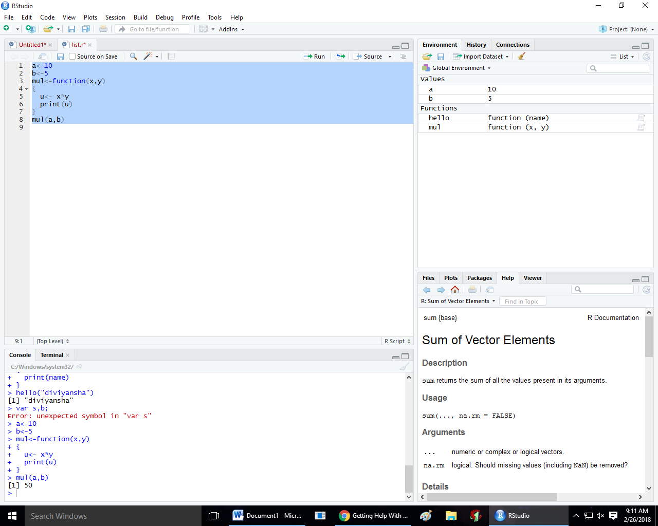

#4 returning values

greetings<- function (name='diviyansha')

{

return (paste('hi', name))

}

greetings('diviyansha')

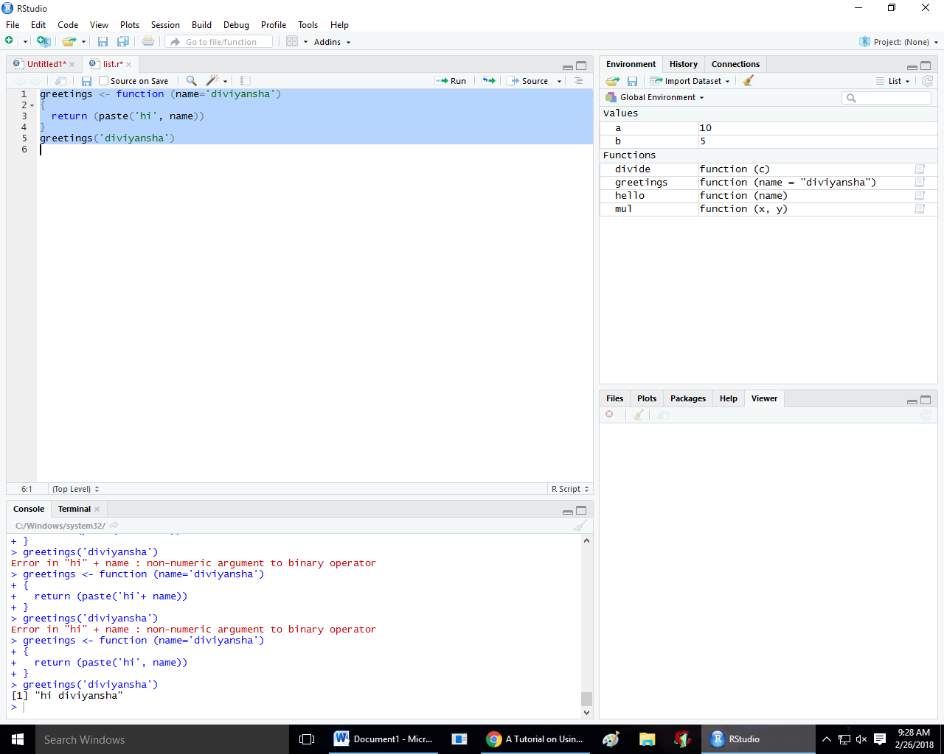

19/02/2018

#1 create a list using vectors,matrix and an inbuilt data frame

df<- data.frame(mtcars)

v<- 1:5

m<-matrix(1:8,nrow=2)

li<-list(v,m,df)

li

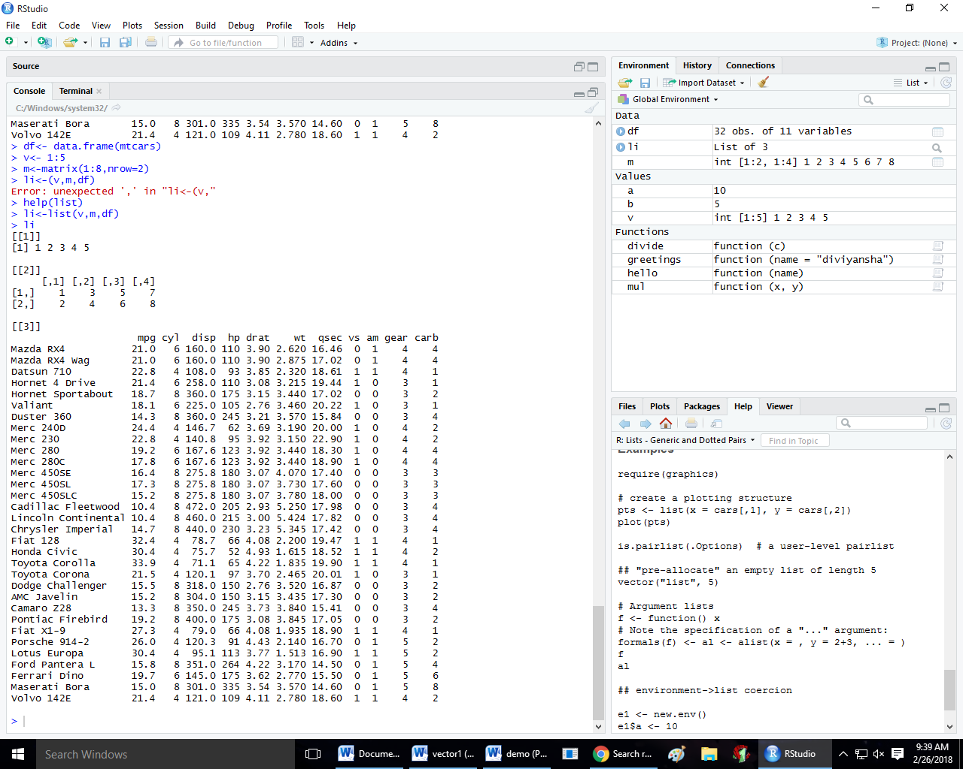

#2 to append two lists

df<- data.frame(mtcars)

v<- 1:5

m<-matrix(1:8,nrow=2)

li<-list(v,m,df)

li

df1<-data.frame(iris)

v1<-6:10

m1<-matrix(9:16,nrow=2)

li1<-list(df1,v1,m1)

append(li,li1)

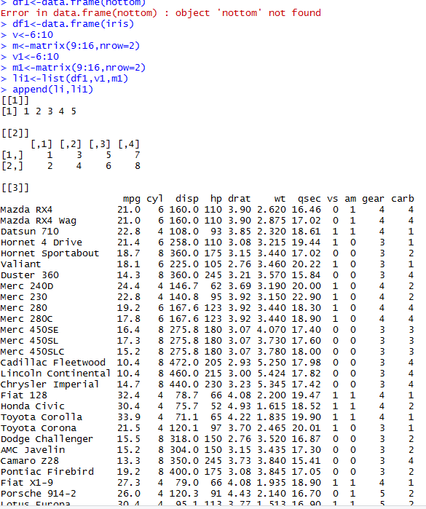

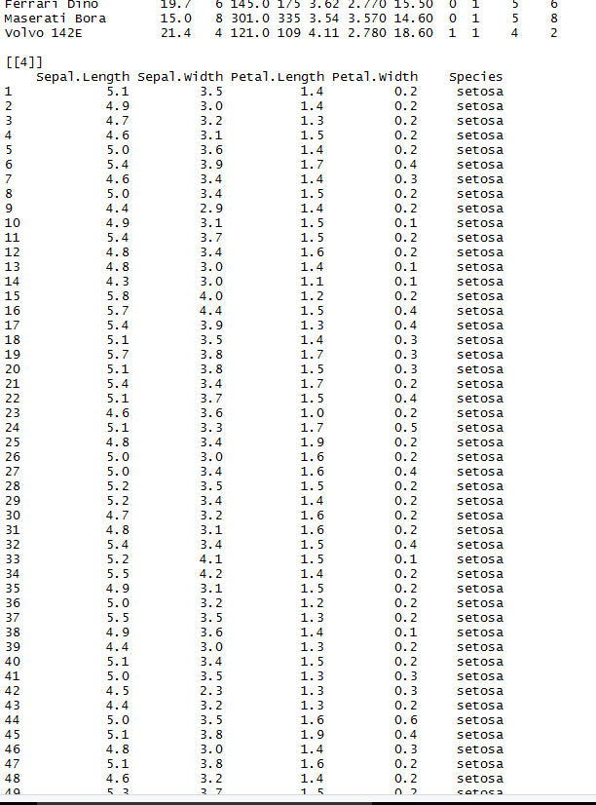

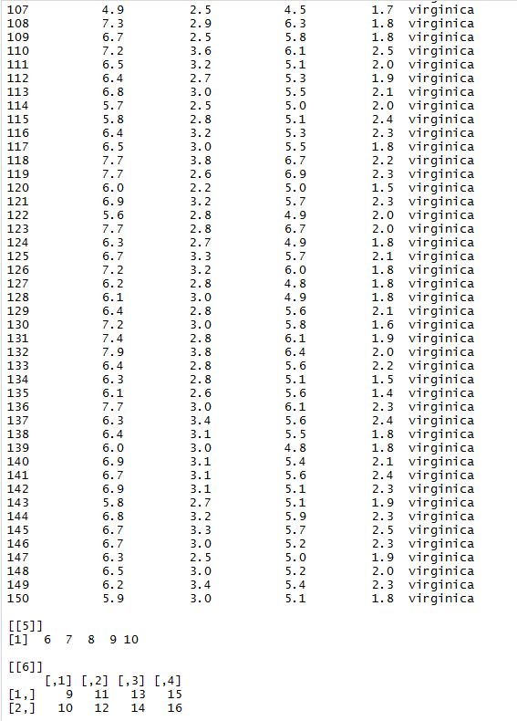

#3 to find the structure of list

str(li)

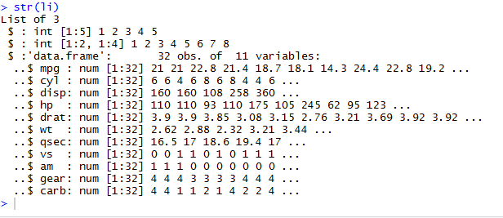

#4 to use different brackets to print the elements of list

li[[1]]

li[[2]]

li[[3]]

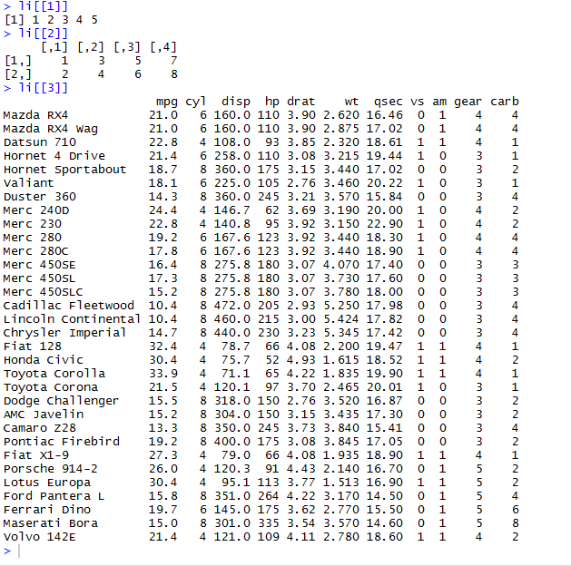

26/02/18

Printing a pattern

for(i in 1:5)

{

for(j in 1:i)

{

cat('\*')

}

cat('\n')

}

