vector1<-c(1,2,3,4,5)

vector2<-c(6,7,8,9,10)

#addition

vector1+vector2

#multiplication

vector1*vector2

#index_addition

vector1[2]+vector2[3]

#condition

vector1[vector1>2]

#standard_deviation

sd(vector1)

sd(vector2)

#variance

var(vector1)

var(vector2)

#maximum_element

max(vector1)

#minimum_element

min(vector2)

output:

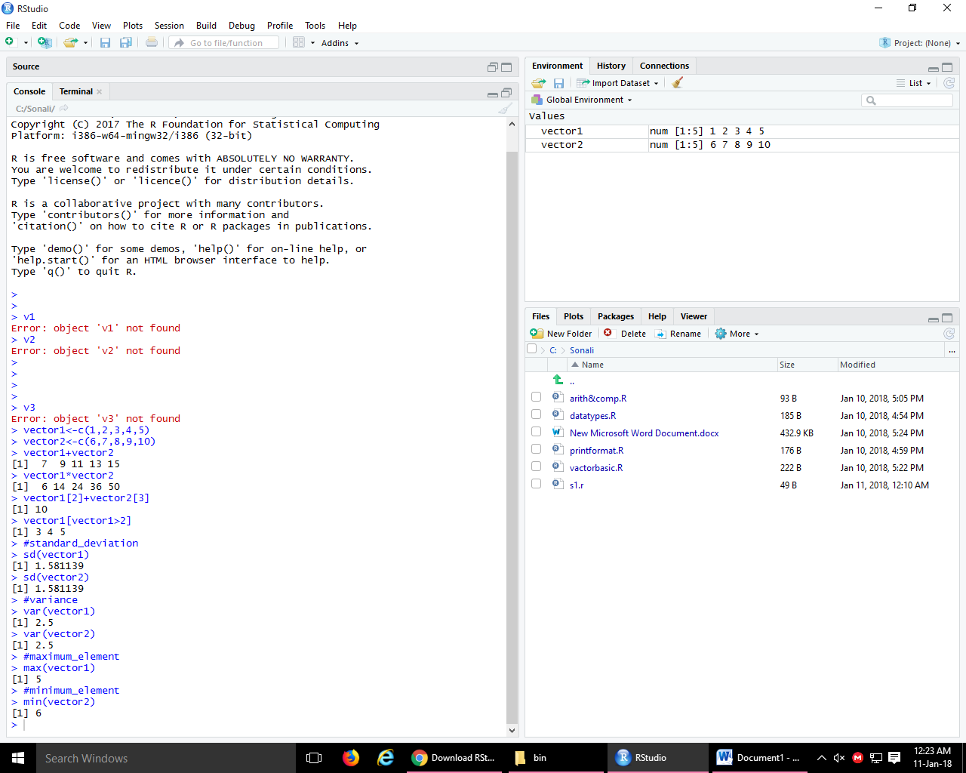

vector1<-c(1,2,3,4,5)

vector2<-c(6,7,8,9,10)

#matrix from vector

matrix(vector1)

matrix(vector2)

# a 3*3 matrix

matrix(1:9,nrow=3)

#stock matrix

titan<-c(250,259,290,280,275)

reliance<-c(102,109,85,91,97)

stocks<-c(titan,reliance)

stockmx<-matrix(stocks,nrow=2,byrow=TRUE)

days<-c('mon','tue','wed','thu','fri')

stock.names<-c('titan','reliance')

colnames(stockmx)<-days

rownames(stockmx)<-stock.names

stockmx

#selection and indexing

matrix1<-matrix(1:50,nrow=10,byrow=TRUE)

matrix1[5,2]

matrix1[1,]

matrix1[1:3,1:3]

