CS3041
Steven Diviney
08462267
Database to manage delivery dockets for a small haulage firm.
The purpose of this database is to store information representing a delivery notice used by a small haulage firm.
I chose this domain because I have a good working knowledge of the area, in both a real world and legal sense. I also implemented a similar but somewhat smaller database and user interface some months back.
The database centers around a user entering in information to be displayed on a printed delivery docket. Rather than have one table to store all the attributes of a single docket several are used to divide it up. The firm carries out a large amount of regularly recurring work. Addresses are used many times, and the same cargo is delivered over and over. When an address is re-used, rather then re-entering it into the database as a new tupple, it’s weight is increased. An unique ID is used as an address entries primary key. A combination of Street, City and County could of been used as the primary key, but this would make the address table redundant. Also, the address is parsed and cleaned by the user application, which also increments the weight when applicable.
The form also has an optional clause. A load may or may not be hazardous. When transporting hazardous goods both the driver and the truck must be ADR certified. For this reason information must be stored about the drivers and trucks utilized by the firm. These two tables are modified by an administrator. All other tables receive data from the user. It is assumed that the user may vary the amount of information they wish to enter with each new form. For this reason the majority of the entries in tables may contain null values.

Functional dependency diagram

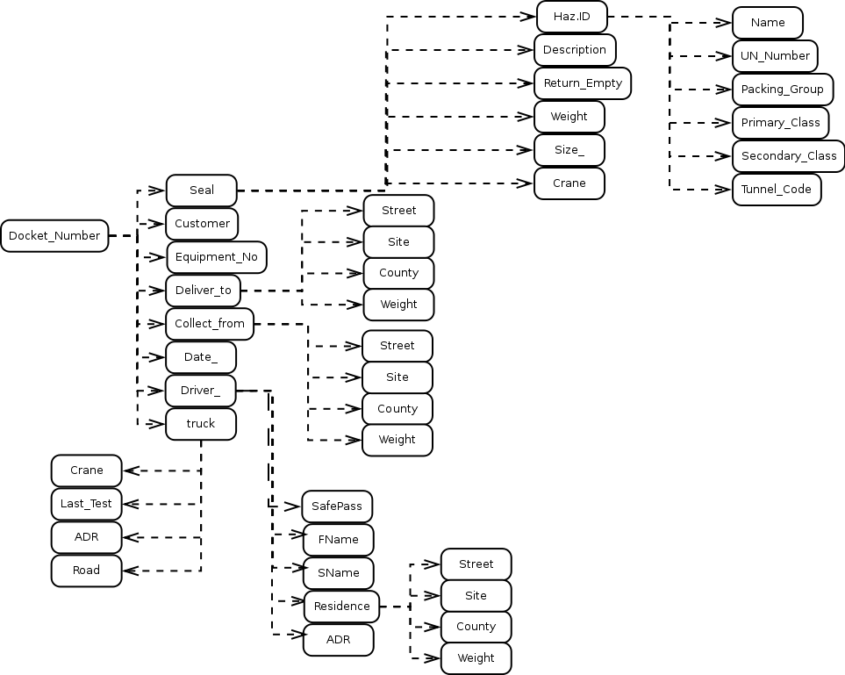

Here every attribute is a candidate identifier or is part of a relation that is dependent on its key and nothing else.

Semantic constraints.
As outlined above, most of the table attributes can be set to null. However, the Driver and Truck tables may not contain any null values. These tables are intended to be maintained by an administrator and the information they hold is vital. Some attributes, ie cargo.Return_Empty, have default values. These values are based on the most frequently used by the firm which are often omited as they are taken to be obvious.

All foreign keys are set inside of named constraints so they may be dropped easily.

Security commands.
The database is intended to have two users. A user and administrator. The user inputs information to be displayed on a delivery docket. A GUI program is used to accomplish this. The program connects to the database with a user level account. The user should be allowed to select, and insert on the tables address, haz, cargo and docket and select on the views used in the database to quickly review past dockets. They should not be allowed to modify existing entries in anyway or view information on other employees. It is of no real concern if they can view information about the trucks used by the firm. The following permissions would be used:

GRANT select, insert ON address, haz, cargo, docket TO user;
GRANT select ON Docket_Summary, docketNoHaz, docketHaz TO user;

The administrator should have full permissions.

GRANT all privileges ON address, haz, cargo, docket, driver, truck Docket_Summary, docketNoHaz, docketHaz TO admin;

List of commands used

There are 3 views, Docket_Summary, docketHaz and docketNoHaz. All three demonstrate a join across multiple tables. Triggers are used to automatically generate unique primary keys for address, haz and driver.

/* Some clean up */
ALTER TABLE cargo DROP CONSTRAINT fk_coloumn_cargo;
ALTER TABLE driver DROP CONSTRAINT fk_coloumn_address;

DROP TABLE docket;
DROP TABLE address;
DROP TABLE haz;
DROP TABLE driver;
DROP TABLE cargo;
DROP TABLE truck;

DROP sequence address_increment;

drop sequence haz_increment;

drop sequence driver_increment;

drop sequence docket_increment;

CREATE TABLE address(
ID INT,
Street varchar(100) NULL,
City varchar(30) NULL,
County varchar(20) NULL,
Site char(1) default 'N',
weight INT NOT NULL,
PRIMARY KEY (ID)
)
;

create sequence address_increment start with 1;

create or replace trigger address_inrc_trigger
before insert on address
for each row
begin
select address_increment.nextval into :new.ID from dual;
end;
/

/*create or replace trigger address_weight
before insert on address
declare
tempID INT;
begin
select count(ID) into tempID from address where Street = :new.Street;
if tempID = 0 then
select address_increment.nextval into :new.ID from dual;
insert into address(ID, Street, City, County, Site) values(:new.ID, :new.Street, :new.City, :new.County, :new.Site);
else
select ID into tempID from address where Street = :new.Street;
update address SET weight = weight+1 where ID = tempID;
end if;
end;
/
Spent ~1 hour trying to get this to work. Come back to later
*/

CREATE TABLE haz(
ID INT,
Name varchar (50) NULL,
UN_Number INT NULL,
Packing_Group varchar(3) NULL,
Primary_Class number NULL,
Secondary_Class number NULL,
Tunnel_code varchar (7) NULL,
PRIMARY KEY (ID)
)
;

create sequence haz_increment start with 1;

create trigger haz_inc_trigger
before insert on haz
for each row
begin
select haz_increment.nextval into :new.ID from dual;
end;
/

CREATE TABLE driver(
ID INT,
FName varchar (15) NOT NULL ,
SName varchar (15) NOT NULL,
Residence INT ,
ADR char(1) default 'Y',
SafePass char(1) default 'N',
PRIMARY KEY (ID),
Constraint fk_coloumn_address
FOREIGN KEY(Residence) References address
)
;

create sequence driver_increment start with 1;

create trigger driver_incr_trigger
before insert on driver
for each row
begin
select driver_increment.nextval into :new.ID from dual;
end;
/

CREATE TABLE cargo(
Seal varchar(10),
Description varchar(200) NULL,
Return_Empty char(1) default 'Y',
Weight INT NULL,
Size_ varchar(20) NULL,
Haz INT NULL,
Crane char(1) NULL,
PRIMARY KEY (Seal),
Constraint fk_coloumn_cargo
FOREIGN KEY(Haz) References haz
)
;

CREATE TABLE truck(
Reg varchar(10),
Crane char(1) NOT NULL, /* Is the truck equipped to control the special trailer with a crane attatched to it */
ADR char(1) NOT NULL, /* Is the truck certified to haul hazardous goods */
Road char(1) NOT NULL, /* Is the truck road legal or not (ie, just used for shunting around the yard */
Last_test Date NOT NULL,
PRIMARY KEY (Reg)
)
;

CREATE TABLE docket(
Docket_Number INT,
Equipment_No varchar (30) NULL,
Customer varchar(30) NULL,
Seal varchar (20) NULL,
Deliver_to INT NULL,
Collect_from INT NULL,
Date_ DATE NOT NULL,
Driver_ INT NULL,
Truck varchar(10) NULL,
PRIMARY KEY (Docket_Number),
Constraint fk_column
FOREIGN KEY(Deliver_to) References address,
FOREIGN KEY(Collect_from) References address,
FOREIGN KEY(Driver_) References driver,
FOREIGN KEY(Truck) References truck,
FOREIGN KEY(Seal) References cargo
)
;

create sequence docket_increment start with 1;

create trigger docker_incr_trigger
before insert on docket
for each row
begin
select docket_increment.nextval into :new.Docket_Number from dual;
end;
/

insert into truck (Reg, Crane, ADR, Road, Last_test) values('00D3452', 'N', 'N', 'Y', '21-feb-09');
insert into truck (Reg, Crane, ADR, Road, Last_test) values('05D312', 'N', 'Y', 'Y', '21-feb-09');
insert into truck (Reg, Crane, ADR, Road, Last_test) values('07KE4738', 'Y', 'N', 'Y', '21-feb-09');
insert into truck (Reg, Crane, ADR, Road, Last_test) values('03D3119', 'Y', 'Y', 'Y', '21-feb-09');
insert into truck (Reg, Crane, ADR, Road, Last_test) values('03D5341', 'Y', 'Y', 'N', '11-nov-08');

insert into address (Street, City, County, Site, weight) values('23 Cove Drive', 'Howth', 'Dublin 13', 'N', 0);
insert into address (Street, City, County, Site, weight) values('56 Balkhill Park', 'Howth', 'Dublin 13', 'N', 0);
insert into address (Street, City, County, Site, weight) values('154 Bettyglen', 'Raheny', 'Dublin 5', 'N', 0);
insert into address (Street, City, County, Site, weight) values('67 Oak Avenue', 'Bray', 'Dublin, South', 'N', 0);

insert into address (Street, City, County, Site, weight) values('Maxol', 'Tolka Quay', 'Dublin 1', 'N', 0);
insert into address (Street, City, County, Site, weight) values('Indaver Ltd', 'Tolka Quay', 'Dublin 1', 'N', 0);
insert into address (Street, City, County, Site, weight) values('Unit 23 Rosemount Business Park', 'Tyrellstown', 'Dublin 11', 'Y', 0);
insert into address (Street, City, County, Site, weight) values('Heatons', 'East Wall Road', 'Dublin 1', 'N', 0);
insert into address (Street, City, County, Site, weight) values('P and O', 'Littlerath', 'Dublin 1', 'N', 0);
insert into address (Street, City, County, Site, weight) values('Trim Transport Ltd', 'Tolka Quay', 'Dublin 1', 'N', 0);

insert into haz (Name, UN_Number, Packing_Group, Primary_class, Tunnel_code) values('Petrol', 1203, 2, 3, 'D/E');
insert into haz (Name, UN_Number, Packing_Group, Primary_class, Secondary_class, Tunnel_code) values('Sodium Methylate', 1431, 2, 4.2, 8, 'D/E');
insert into haz (Name, UN_Number, Packing_Group, Primary_class, Tunnel_code) values('Triisopropyl Borate', 2616, 3, 3, 'D/E');
insert into haz (Name, UN_Number, Packing_Group, Primary_class, Tunnel_code) values('Organophosphorus Pesticide, Solid, Toxic', 2783, 3, 6.1, 'E');
insert into haz (Name, UN_Number, Packing_Group, Primary_class, Tunnel_code) values('Toxic Liquid, Organic, N.O.S', 2810, 2, 6.1, 'D/E');

insert into driver(FName, SName, Residence, ADR, SafePass) values('Eoin', 'McCarthy', 1, 'Y', 'Y');
insert into driver(FName, SName, Residence, ADR, SafePass) values('Paul', 'Murphy', 1, 'Y', 'N');
insert into driver(FName, SName, Residence, ADR, SafePass) values('Richard', 'Delaney', 2, 'N', 'Y');
insert into driver(FName, SName, Residence, ADR, SafePass) values('Conor', 'McEvoy', 3, 'N', 'N');
insert into driver(FName, SName, Residence, ADR, SafePass) values('Steven', 'Diviney', 4, 'Y', 'Y');

insert into cargo(Seal, Description, Return_Empty, Weight, Size_, Haz, Crane) values('u45bfg', '30 Drums of waste from Repo.', 'N', 15000, '45ft', 5, 'Y');
insert into cargo(Seal, Description, Return_Empty, Weight, Size_, Crane) values('35hgjk', 'Bags of cement', 'Y', 20000, '45ft', 'Y');
insert into cargo(Seal, Description, Return_Empty, Weight, Size_, Crane) values('hea454', 'Timber', 'N', 5000, '45ft Tautliner', 'N');
insert into cargo(Seal, Description, Return_Empty, Weight, Size_, Haz, Crane) values('4jkde3', 'Borate for China', 'N', 2000, '20ft', 3, 'N');
insert into cargo(Seal, Description, Return_Empty, Weight, Size_, Haz, Crane) values('435jn4', '30 Pallets', 'Y', 15000, '45ft', 2, 'Y');

insert into docket(Equipment_No, Customer, Date_, Seal, Deliver_to, Collect_from, Driver_, Truck) values('TRIM1', 'Heatons', '13-feb-10', 'hea454', 8, 10, 1, '00D3452');
insert into docket(Equipment_No, Customer, Date_, Seal, Deliver_to, Collect_from, Driver_, Truck) values('3562', 'Irish Concrete', '14-may-10', '35hgjk', 7, 9, 3, '07KE4738');
insert into docket(Equipment_No, Customer, Date_, Seal, Deliver_to, Collect_from, Driver_, Truck) values('2231', 'Indaver', '26-jul-10', 'u45bfg', 6, 10, 5, '03D3119');
insert into docket(Equipment_No, Customer, Date_, Seal, Deliver_to, Collect_from, Driver_, Truck) values('3321', 'Sas Cem.', '27-oct-10', '435jn4', 10, 5, 1, '03D3119');
insert into docket(Equipment_No, Customer, Date_, Seal, Deliver_to, Collect_from, Driver_, Truck) values('1224', 'P and O', '18-sep-10', '4jkde3', 9, 10, 2, '05D312');

/* Examples of view creation, select, table join and update statements */
create or replace view Docket_Summary(Docket_Number, Date_, Customer, Del_Street, Col_Street, Equipment, Seal, Size_, DriverS, Truck) AS
select doc.Docket_Number, doc.date_, doc.Customer, a.Street, a2.Street, doc.Equipment_No, doc.Seal, c.Size_, driver.SName, doc.Truck
from docket doc, address a, address a2, cargo c, driver
where doc.Deliver_to = a.ID AND doc.Collect_from = a2.ID AND doc.Seal = c.Seal AND doc.Driver_ = driver.ID
order by doc.Docket_Number;

create or replace view docketNoHaz (Docket_Number, Date_, Del_Street, Del_City, Del_County, Del_Site, Customer, Col_Street, Col_City, Col_Count, Col_Site, Equipment,
Seal, Description, Return_Empty, Weight, Size_, Crane, DriverS, DriverF, Truck) AS
select doc.Docket_Number, doc.Date_, a.Street, a.City, a.County, a.Site, doc.Customer, a2.Street, a2.City, a2.County, a2.Site , doc.Equipment_No, doc.Seal,
c.Description, c.Return_Empty, c.Weight, c.Size_, c.Crane, dr.SName, dr.FName, truck.Reg
from docket doc, address a, address a2, cargo c, driver dr, truck
where doc.Deliver_to = a.ID AND doc.Collect_from = a2.ID AND doc.Seal = c.Seal AND c.Haz IS NULL AND doc.Driver_ = dr.ID AND doc.Truck = truck.Reg
order by doc.Docket_Number;

create or replace view docketHaz (Docket_Number, Date_, Del_Street, Del_City, Del_County, Del_Site, Customer, Col_Street, Col_City, Col_Count, Col_Site, Equipment,
Seal, Description, Return_Empty, Weight, Size_, Crane, DriverS, DriverF, Truck, Haz_Name, UN_No, PG, Primary, Secondary, Tunnel) AS
select doc.Docket_Number, doc.Date_, a.Street, a.City, a.County, a.Site, doc.Customer, a2.Street, a2.City, a2.County, a2.Site , doc.Equipment_No, doc.Seal,
c.Description, c.Return_Empty, c.Weight, c.Size_, c.Crane, dr.SName, dr.FName, truck.Reg, h.Name, h.UN_Number, h.Packing_Group,
h.Primary_Class, h.Secondary_Class, h.Tunnel_Code
from docket doc, address a, address a2, cargo c, haz h, driver dr, truck
where doc.Deliver_to = a.ID AND doc.Collect_from = a2.ID AND doc.Seal = c.Seal AND c.Haz = h.ID AND doc.Driver_ = dr.ID AND doc.Truck = truck.Reg
order by doc.Docket_Number;

-- Update the trucks after passing an NCT
update truck set LAST_TEST = '13-NOV-10' where LAST_TEST = '21-feb-09';

-- Paul has moved out of Eoins house to live in Richards house
update driver set Residence = 2 where SName = 'Murphy';

-- Paul was ment to deliver a load but Eoin had to instead
update docket set Driver_ = 1 where Driver_ = 2 AND Date_ = '18-sep-10';

