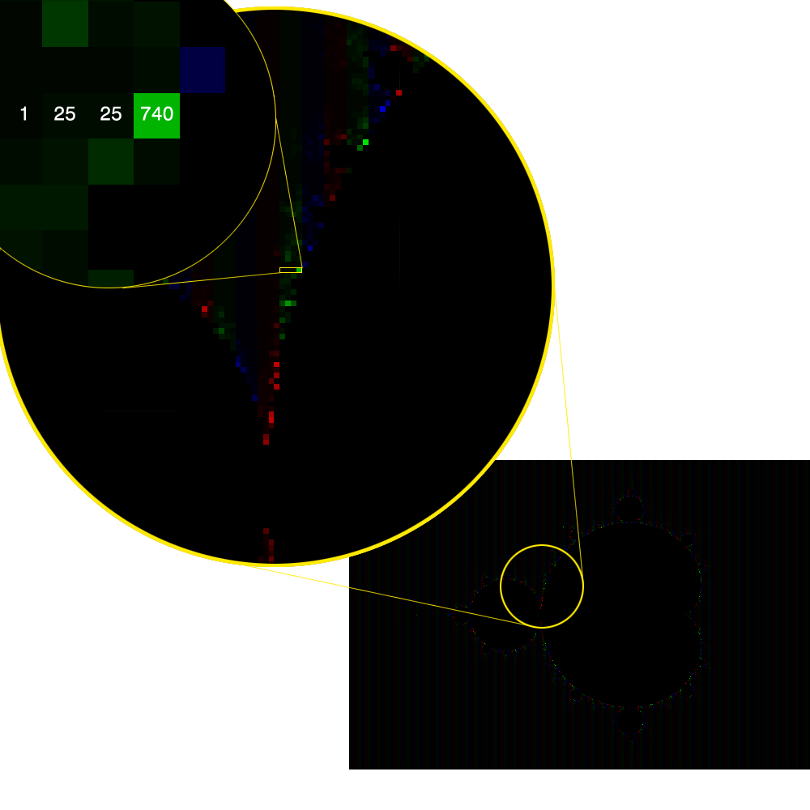
:Figure 1.

Render No : 1
Zoom: 1
Time: 303757 Microseconds

The numbers represent a rough approximation of the amount of iterations to rule out each respective pixels membership in the set. The brighter the colour, the more iterations. This input would not be suited to vectorization as the huge gaps in the iteration counts would negate any benefit.

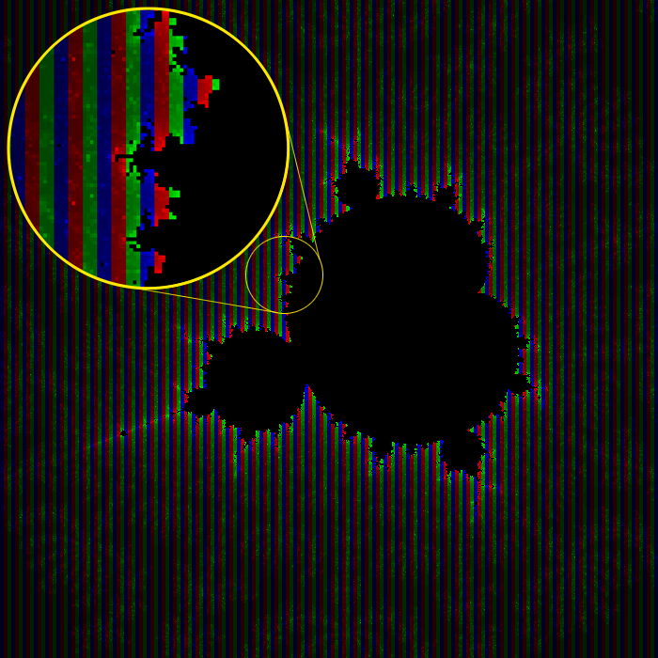

Figure 2.
Render No: 13
Zoom: 9323.26
Time: 468621 Microseconds

From observation it is clear that the number of iterations need to rule out membership for each pixel is close to that of its neighbour. This input set would be well suited to vectorization.

