PROJECT REPORT
ON
“CYBERSECURITY RISK ASSESSMENT FRAMEWORK FOR SMEs”

Internship Project Report Submitted for
Cyber Security Internship Program

Submitted By
Divya Gunvant Khodankar

Submitted To
Naviotech Solution Pvt. Ltd.

Academic Head
Naviotech Solution Pvt. Ltd.

College Name
P.R.Pote Patil College Of Engineering and Management, Amaravati
Submission Date
15 May 2026
Abstract

This project presents a cybersecurity risk assessment framework designed for small and medium enterprises (SMEs). The project identifies common cybersecurity threats such as phishing, ransomware, malware, weak passwords, and insider threats. A risk assessment matrix was developed to evaluate threats based on likelihood and impact. The project also applies the NIST Cybersecurity Framework to propose effective mitigation strategies including firewall protection, antivirus software, multi-factor authentication, secure network configurations, and employee cybersecurity awareness training. Case studies were conducted on different SMEs to analyze cybersecurity vulnerabilities and recommend appropriate security measures.

TABLE OF CONTENTS
Sr. No. | Contents | Page No.
 | Abstract | 2
1 | Introduction | 4
2 | Objectives | 4
3 | NIST Cybersecurity Framework | 5
4 | Risk Assessment Matrix | 6
5 | Case Studies | 7
 | 5.1 Case Study: Medical Shop | 7
 | 5.2 Case Study: Clothing Store | 9
 | 5.3 Case Study: Coaching Institute | 10
6 | Best Practices for SME Cybersecurity | 13
7 | Conclusion | 14
8 | References | 14

LIST OF TABLES

Table Number | Table Title | Page No.
Table 1 | Core Functions of the NIST Cybersecurity Framework | 5
Table 2 | Cybersecurity Risk Assessment Matrix | 6
Table 3 | Cybersecurity Risk Analysis of Medical Shop | 8
Table 4 | Cybersecurity Risk Analysis of Clothing Store | 10
Table 5 | Cybersecurity Risk Analysis of Coaching Institute | 11
Table 6 | Comparative Analysis of Cybersecurity Risks in SMEs | 12

LIST OF FIGURES

Figure No. | Figure Title | Page No.
Figure 1 | Cybersecurity Threat Severity Analysis | 7
Figure 2 | Windows Defender Firewall Protection | 9
Figure 3 | Windows Virus and Threat Protection Dashboard | 10
Figure 4 | Google 2-Step Verification Security Setting | 12

- Introduction
Cybersecurity has become one of the most important concerns for modern businesses due to the increasing number of cyberattacks and data breaches. Small and medium enterprises (SMEs) are highly vulnerable to cybersecurity threats because they often lack strong security infrastructure, technical expertise, and cybersecurity awareness. Cyberattacks such as phishing, ransomware, malware, and unauthorized access can cause financial losses, operational disruption, and reputational damage. Therefore, organizations must identify cybersecurity risks and implement effective security controls to protect sensitive information and business systems.

- Objectives
• To identify common cybersecurity threats affecting SMEs.
• To develop a cybersecurity risk assessment framework.
• To evaluate cybersecurity risks using a risk matrix model.
• To recommend mitigation strategies for improving cybersecurity.
• To analyze cybersecurity challenges through case studies.
• To promote cybersecurity awareness and best practices.

- NIST Cybersecurity Framework
The National Institute of Standards and Technology (NIST) developed the NIST Cybersecurity Framework to help organizations identify, manage, and reduce cybersecurity risks. The framework provides a structured approach that helps businesses strengthen their cybersecurity posture and respond effectively to cyber threats.
The NIST Cybersecurity Framework is widely used by organizations because it provides clear guidelines for protecting systems, networks, and sensitive business information. It consists of five core functions that work together to improve cybersecurity management and risk handling within organizations.
For small and medium enterprises (SMEs), the framework helps in identifying vulnerabilities, implementing protective security controls, detecting cyber incidents, responding to attacks, and recovering from security breaches efficiently.
Table 1: Core Functions of the NIST Cybersecurity Framework
Function | Purpose
Identify | Identify cybersecurity risks
Protect | Implement security controls
Detect | Detect cyber threats
Respond | Respond to incidents
Recover | Restore operations after attack

In this project, the NIST framework was used as the foundation for evaluating cybersecurity risks and proposing mitigation strategies for SMEs.

- Risk Assessment Matrix

The risk assessment matrix was designed to analyze the most common cybersecurity threats affecting small and medium enterprises (SMEs). Each threat was evaluated based on two important factors: likelihood and impact. Likelihood represents the probability of a cyberattack occurring, while impact represents the level of damage it may cause to business operations, financial records, or sensitive information. By calculating the risk score, organizations can identify critical threats and prioritize cybersecurity measures accordingly.

The risk score was calculated using the following formula:
Risk Score = Likelihood × Impact
The calculated risk score helps organizations prioritize cybersecurity threats based on their severity and potential business impact.
Table 2: Cybersecurity Risk Assessment Matrix
Threat | Likelihood | Impact | Risk Score | Severity
Phishing | 5 | 4 | 20 | Critical
Ransomware | 4 | 5 | 20 | Critical
Weak Passwords | 5 | 3 | 15 | High
Malware | 4 | 4 | 16 | High
Insider Threat | 3 | 5 | 15 | High
Unsecured Wi-Fi | 3 | 4 | 12 | Medium

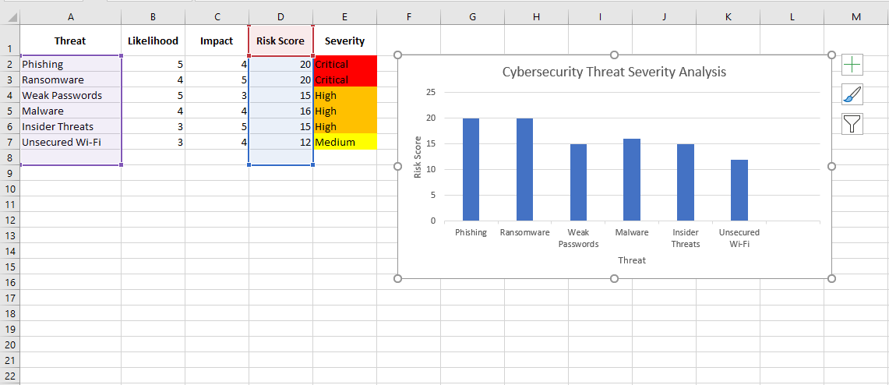

Figure 1: Cybersecurity Threat Severity Analysis

The analysis shows that phishing attacks and ransomware represent the highest cybersecurity risks for SMEs due to their high likelihood and severe impact on business operations and sensitive data.

- Case Study

The following case studies demonstrate how cybersecurity threats can affect different types of SMEs and how appropriate mitigation strategies can reduce organizational security risks.
  - Case Study: Medical Shop

The medical shop stores customer billing records and medicine inventory data on a shared computer system used by multiple employees.
Problems:
The shop uses weak passwords that are easy to guess. Multiple employees use the same system without proper login security. No antivirus software is installed on the computer system.
Risks:
Weak security practices can allow attackers to steal customer data or infect the system with ransomware. Since the computer is shared, unauthorized access becomes easier.
Mitigation:
To improve cybersecurity, the shop should install antivirus software, enable firewall protection, use strong passwords, and implement multi-factor authentication (MFA). Employees should also receive basic cybersecurity awareness training.
Table 3: Cybersecurity Risk Analysis of Medical Shop
Category | Details
Business Type | Medical Shop
Main Threat | Ransomware
Risk Level | High
Recommended Solution | MFA and Antivirus

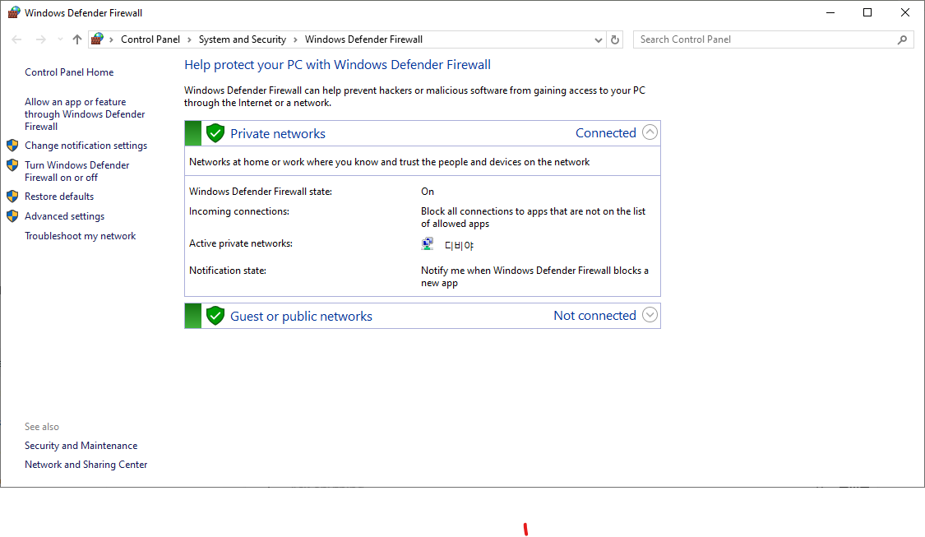

Figure 2: Windows Defender Firewall Protection

  - Case Study: Clothing Store

The clothing store uses online payment systems and provides WiFi access for business operations.
Problems:
The store uses an unsecured WiFi network without proper monitoring tools or firewall configuration.

Risks:
Hackers connected to the same network may intercept payment information or access store systems illegally.
Mitigation:
The business should secure the WiFi router using WPA2/WPA3 encryption, change default passwords, install firewall protection, and use VPN services for secure communication.
Table 4: Cybersecurity Risk Analysis of Clothing Store
Category | Details
Business Type | Clothing Store
Main Threat | Payment Theft
Risk Level | Medium
Recommended Solution | Secure WiFi and VPN
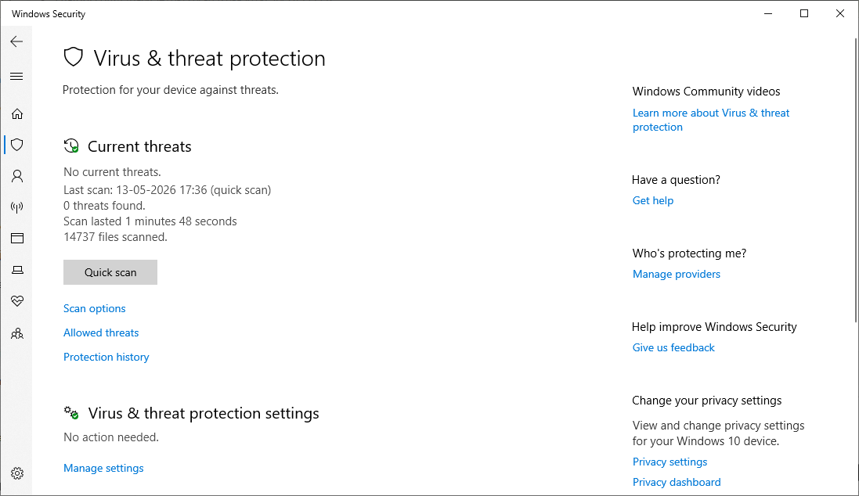
Figure 3: Windows Virus and Threat Protection Dashboard
  - Case Study: Coaching Institute

The coaching institute stores student records, fees data, and study material on shared systems and cloud platforms.
Problems:
Multiple staff members use shared login credentials to access administrative systems and cloud storage.
Risks:
Shared access increases the chances of data leakage, accidental file deletion, and unauthorized modification of student information.
Mitigation:
The institute should implement role-based access control, use separate login credentials for employees, enable strong password policies, and conduct cybersecurity awareness sessions.
Table 5: Cybersecurity Risk Analysis of Coaching Institute
Category | Details
Business Type | Coaching Institute
Main Threat | Data Breach
Risk Level | High
Recommended Solution | Access Control

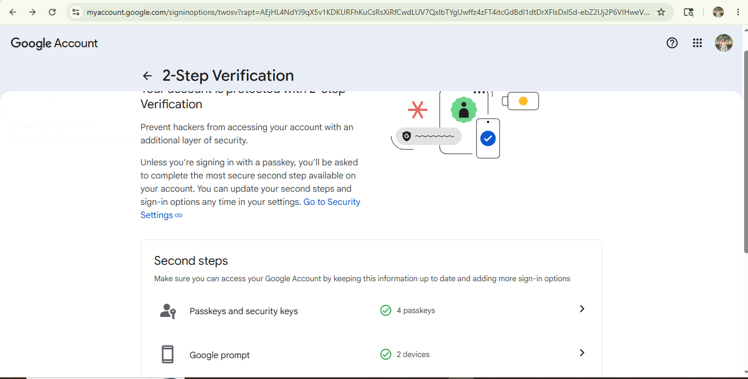
Figure 4: Google 2-Step Verification Security Setting

Table 6: Comparative Analysis of Cybersecurity Risks in SMEs
Business | Main Risk | Severity | Mitigation
Medical Shop | Ransomware | High | MFA + Antivirus
Clothing Store | Payment Theft | Medium | VPN + Secure WiFi
Coaching Institute | Data Breach | High | Access Control

These case studies demonstrate how cybersecurity threats can significantly impact small and medium enterprises (SMEs) and highlight the importance of proactive security measures.

- Best Practices for SME Cybersecurity
- Use strong and unique passwords.
- Enable multi-factor authentication (MFA).
- Regularly update operating systems and software.
- Install antivirus and firewall protection.
- Conduct employee cybersecurity awareness training.
- Secure Wi-Fi networks using WPA2/WPA3 encryption.
- Regularly back up important business data.
- Restrict unauthorized system access.

- Conclusion
Cybersecurity threats are rapidly increasing among small and medium enterprises (SMEs) due to limited security awareness and inadequate cybersecurity infrastructure. This project developed a cybersecurity risk assessment framework based on the NIST Cybersecurity Framework to identify common cybersecurity threats, evaluate risks, and recommend effective mitigation strategies. The findings demonstrate that implementing proactive security measures such as firewalls, antivirus software, multi-factor authentication, secure network configurations, and employee awareness training can significantly improve the cybersecurity posture of SMEs and reduce potential cyber risks.

- References
- National Institute of Standards and Technology (NIST) Cybersecurity Framework
- Microsoft Security Documentation
- Google Account Security Documentation
- Cybersecurity and Infrastructure Security Agency (CISA)
- Research articles on SME cybersecurity risks and mitigation strategies

