Project Report

PHISHING AWARENESS SIMULATION USING SOCIAL ENGINEERING TECHNIQUES

Submitted By
Divya Gunvant Khodankar

Internship Domain
Cyber Security

Submitted To
Naviotech Solution Pvt. Ltd.
College Name
P.R.Pote Patil College Of Engineering And Management, Amaravati
Date of Submission
15.05.2026

ABSTRACT
Phishing attacks are one of the most common cyber threats that exploit human psychology to steal sensitive information such as usernames, passwords, and financial data. This project demonstrates a controlled phishing awareness simulation designed for educational and cybersecurity awareness purposes. The project includes a simulated phishing email, a fake login webpage, a user awareness survey, and analysis of user behavior regarding phishing attacks.
A phishing simulation website was developed using HTML, CSS, and JavaScript and hosted using GitHub Pages. The project also involved creating a phishing awareness email template and a Google Form survey to analyze user awareness and reactions to phishing attempts. The results highlight the importance of cybersecurity awareness training and preventive security measures.
This project was conducted strictly for educational purposes. No real credentials were collected, stored, or misused during the simulation.

TABLE OF CONTENTS
Sr.No | Contents | Page No.
 | Abstract
1. | Introduction | 5
2. | Objectives | 5
3. | Phishing Techniques | 6
4. | Fake Email Design | 8
5. | Phishing Webpage Simulation | 10
6. | GitHub Website Deployment | 13
7. | User Awareness Survey | 14
8. | Results and Analysis | 16
9. | Preventive Measures | 18
10. | Ethical Considerations | 19
11. | Conclusion | 20
12. | References | 21

LIST OF TABLES
Table No. | Table Title | Page No.
Table 1 | Common Phishing Techniques | 7
Table 2 | Simulated Phishing Email Components | 8
Table 3 | Technologies Used in the Project | 10
Table 4 | GitHub Deployment Information | 13
Table 5 | Google Form Survey Questions | 14
Table 6 | Sample Phishing Awareness Analysis | 16
Table 7 | Phishing Prevention Strategies | 18

LIST OF FIGURES
Figure No. | Figure Title | Page No.
Figure 1 | Phishing Awareness Email Template | 10
Figure 2 | Phishing Simulation Website | 10
Figure 3 | VS Code Development Environment | 11
Figure 4 | Awareness Message After Login Attempt | 12
Figure 5 | GitHub Pages Deployment | 13
Figure 6 | Google Form Survey | 15
Figure 7 | Survey Response Analysis | 17

- INTRODUCTION
Phishing is a social engineering attack in which attackers impersonate trusted organizations or individuals to trick users into revealing sensitive information. Cybercriminals commonly use fake emails, fraudulent login pages, malicious links, and deceptive messages to manipulate users.
Phishing attacks continue to increase globally because they target human psychology rather than technical system vulnerabilities. Many users unknowingly click malicious links or provide credentials to fake websites due to lack of awareness.
This project demonstrates a phishing awareness simulation designed to educate users about phishing techniques and improve cybersecurity awareness. The simulation includes a phishing email template, a fake login webpage, a user awareness survey, and analysis of user behavior.
The project was developed ethically and strictly for educational purposes. No real credentials were collected or stored.

- OBJECTIVES
The main objectives of this project are:
• To understand phishing attack techniques and social engineering methods.
• To simulate a realistic phishing email attack in a controlled environment.
• To create a fake login webpage for educational demonstration.
• To analyze user awareness regarding phishing attacks.
• To study preventive measures and cybersecurity awareness strategies.
• To demonstrate ethical phishing awareness practices.
- PHISHING TECHNIQUES
Phishing attacks use various techniques to manipulate users and steal sensitive information. Some common phishing methods are:
1. Email Phishing
- Attackers craft emails that look like they come from trusted organizations such as banks, universities, or companies.
- These emails often contain urgent messages like “Your account will be suspended unless you act immediately”.
- The goal is to trick recipients into clicking malicious links, downloading attachments, or providing sensitive information.
- Example: A fake email from a bank asking you to “verify your account details” by clicking a link.
2. Fake Login Pages
- Victims are redirected to websites that mimic legitimate login portals (e.g., Gmail, Office 365, or online banking).
- The design, logos, and layout are copied to appear authentic.
- When users enter their credentials, attackers capture usernames and passwords.
- Example: A phishing email with a link to a “Microsoft login page” that is actually hosted on a fraudulent domain.
3. Social Engineering
- Instead of relying solely on technical tricks, attackers exploit human psychology.
- They use fear (“Your account has been compromised”), urgency (“Act now or lose access”), or curiosity (“See attached invoice”).
- This manipulation increases the likelihood that users will click links or share information.
- Example: An email claiming to be from HR with a “salary revision document” attached.
4. Credential Theft
- Closely tied to fake login pages, this technique focuses on stealing usernames, passwords, and other authentication data.
- Attackers may also use keyloggers or malicious scripts embedded in websites.
- Once credentials are stolen, they can be used for identity theft, financial fraud, or unauthorized access to systems.
- Example: A phishing page that asks for both your email and two-factor authentication code.
5. Malicious Links
- Emails often contain hyperlinks disguised as legitimate URLs.
- The visible text may look safe (e.g., www.bank.com), but the actual link redirects to a fraudulent site.
- Attackers may also use shortened URLs to hide the true destination.
- Example: A “click here to reset your password” link that leads to a phishing site instead of the real service.
Table 1: Common Phishing Techniques
Technique | Description
Email Phishing | Fake emails requesting user action
Fake Login Pages | Fraudulent websites collecting credentials
Social Engineering | Psychological manipulation of users
Credential Theft | Stealing usernames and passwords
Malicious Links | Redirecting users to fake websites

- FAKE EMAIL DESIGN
A phishing awareness email template was created to simulate a fake password reset request. The email was designed to resemble a legitimate college IT support message.
The simulated email included:
- Urgent subject line
- Password reset request
- Website verification link
- Educational awareness disclaimer
The purpose of the email was to study how users react to phishing-style communication and identify suspicious indicators.
Table 2: Simulated Phishing Email Components
Component | Purpose
Subject Line | Create urgency
Verification Link | Redirect user to fake portal
IT Support Signature | Increase authenticity
Educational Disclaimer | Ethical awareness notice
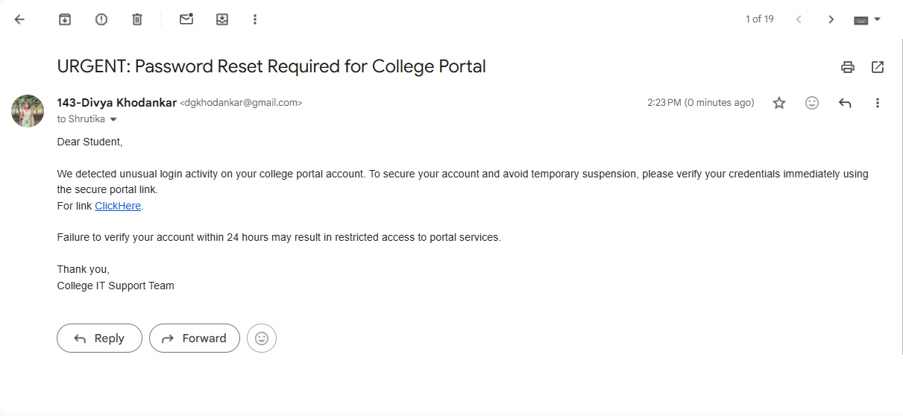
Figure 1: Phishing Awareness Email Template

- PHISHING WEBPAGE SIMULATION
A fake login webpage named “College Portal Login” was developed using HTML, CSS, and JavaScript in Visual Studio Code (VS Code). The webpage simulated a student authentication system for educational phishing awareness purposes.
The webpage included:
- Login form
- Email and password fields
- Forgot password option
- Educational awareness disclaimer
- Cybersecurity warning message
- Awareness popup after login attempt
The website used a modern dark cybersecurity theme with glassmorphism design elements to resemble a professional login portal.
Table 3: Technologies Used in the Project
Technology | Purpose
HTML | Webpage structure
CSS | Styling and design
JavaScript | Awareness popup functionality
VS Code | Code development
GitHub Pages | Website hosting

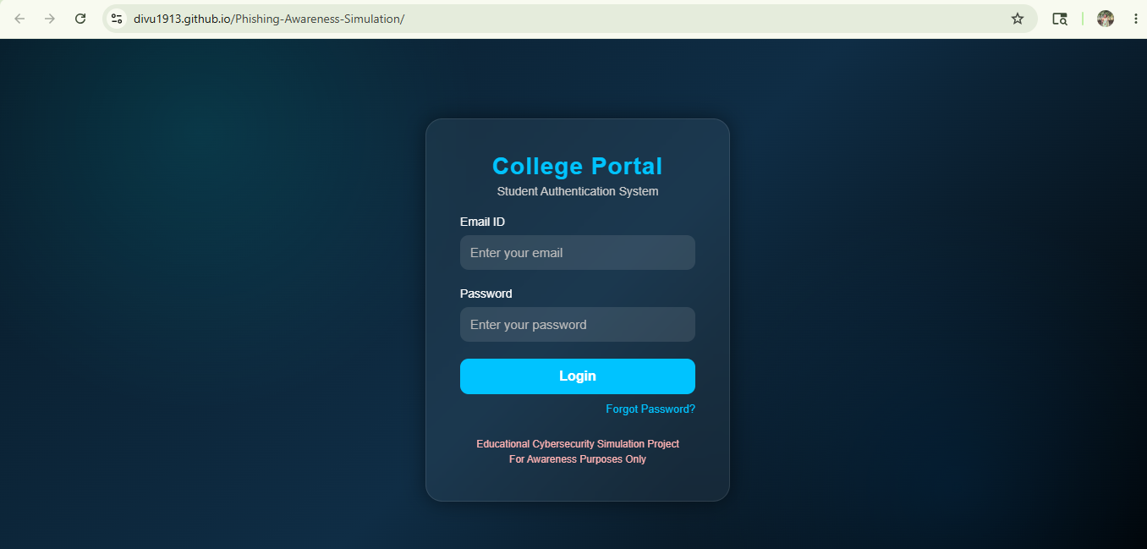
Figure 2: Phishing Simulation Website
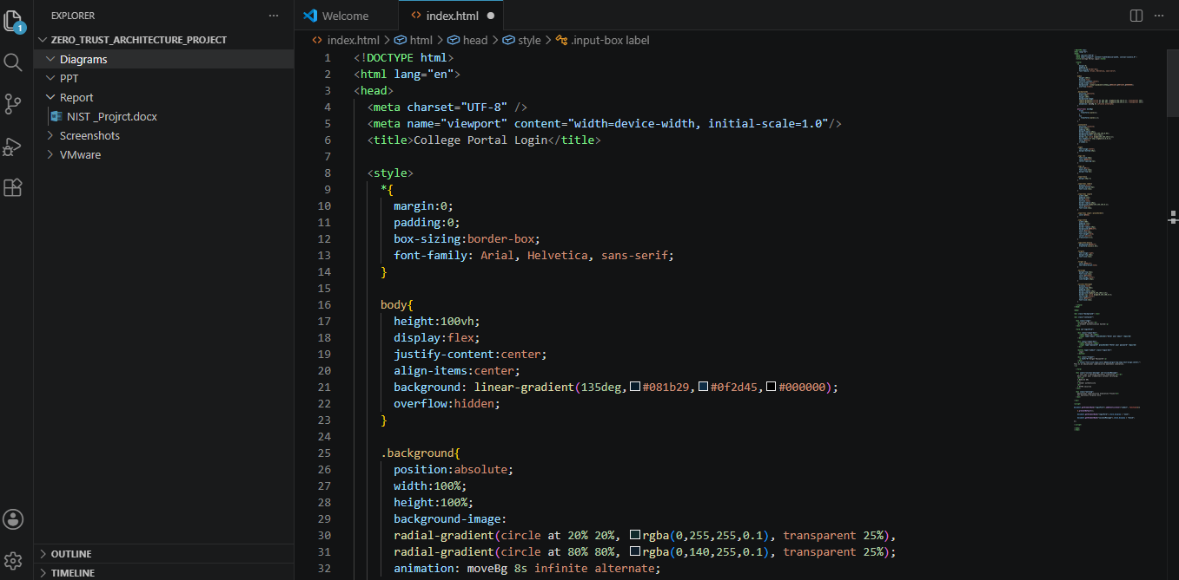
Figure 3: VS Code Development Environment
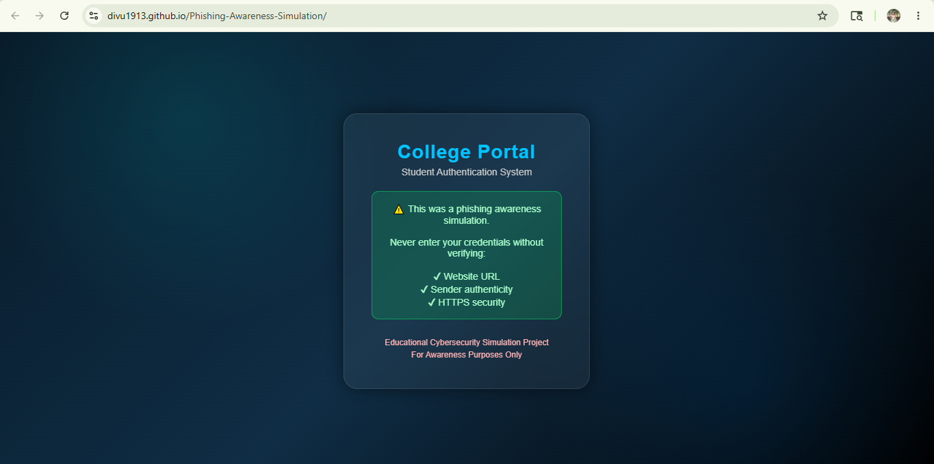
Figure 4: Awareness Message After Login Attempt

- GITHUB WEBSITE DEPLOYMENT
The phishing awareness simulation website was hosted using GitHub Pages to demonstrate website deployment and practical cybersecurity project implementation.
A public GitHub repository named “Phishing-Awareness-Simulation” was created. The HTML project files were uploaded to the repository and GitHub Pages was enabled to generate a live website link. The hosted website allowed demonstration of phishing simulation techniques in a controlled educational environment.
Table 4: GitHub Deployment Information
Component | Details
Repository Name | Phishing-Awareness-Simulation
Hosting Platform | GitHub Pages
Website Type | Static HTML Website
Deployment Status | Successfully Hosted
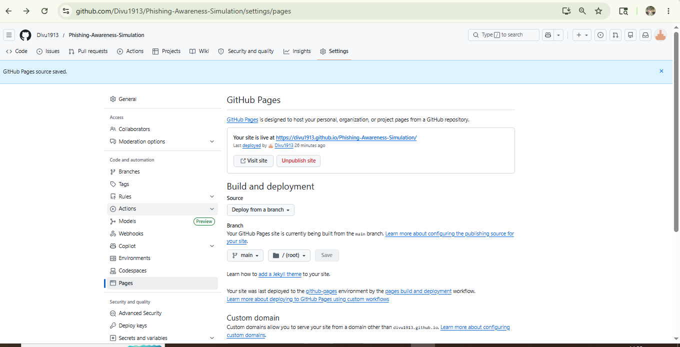
Figure 5: GitHub Pages Deployment
- USER AWARENESS SURVEY
A Google Form survey was created to study user awareness regarding phishing attacks and online security practices.
The survey included questions related to:
- Identifying suspicious emails
- Clicking unknown links
- Awareness of phishing attacks
- Online security habits
- Detection of suspicious indicators
The survey responses were analyzed to understand how users react to phishing-related situations.
Table 5: Google Form Survey Questions
Question | Purpose
Did the email appear legitimate? | Analyze trust perception
Would you click the link? | Measure phishing susceptibility
Did you notice suspicious indicators? | Awareness analysis
Have you received phishing emails before? | User experience analysis
Security precautions followed online | Cybersecurity awareness
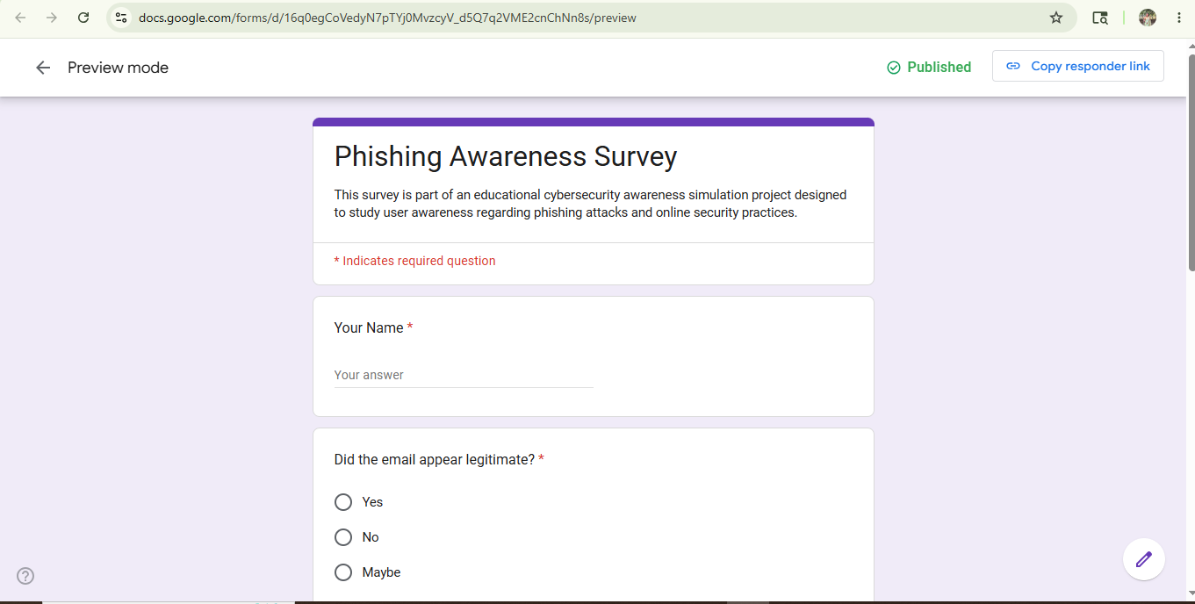
Figure 6: Google Form Survey

- RESULTS AND ANALYSIS
The phishing awareness simulation demonstrated how users may react to phishing emails and fake login portals. Some users identified suspicious indicators, while others were willing to click phishing-style links.
The results indicate that many users still lack sufficient cybersecurity awareness regarding phishing attacks and social engineering techniques.
The project also demonstrated the importance of:
- Cybersecurity awareness training
- Email verification
- URL verification
- Multi-factor authentication
- Secure browsing practices
Sample survey analysis data:
Table 6: Sample Phishing Awareness Analysis
Users | Clicked Link | Attempted Login | Reported Email
10 | 6 | 3 | 2

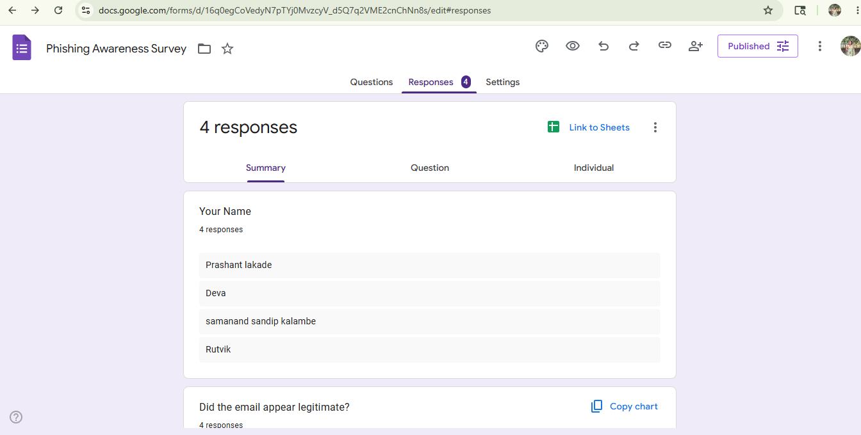
Figure 7: Survey Response Analysis

- PREVENTIVE MEASURES
The following cybersecurity practices can help prevent phishing attacks:
• Verify website URLs before entering credentials.
• Avoid clicking suspicious email links.
• Enable Multi-Factor Authentication (MFA).
• Use updated antivirus and firewall protection.
• Conduct cybersecurity awareness training.
• Report suspicious emails immediately.
• Avoid sharing sensitive information through email.
• Check sender authenticity carefully.
Table 7: Phishing Prevention Strategies
Security Measure | Benefit
MFA | Additional account protection
URL Verification | Detect fake websites
Employee Awareness | Reduce phishing success
Antivirus Protection | Detect malicious threats
Email Filtering | Block suspicious emails

- ETHICAL CONSIDERATIONS
This project was conducted strictly for educational and cybersecurity awareness purposes. No real credentials were collected, stored, or misused during the simulation.
All phishing simulations were controlled and designed only to educate users regarding phishing threats and safe online practices.
The project followed ethical cybersecurity guidelines and focused on awareness rather than exploitation.

- CONCLUSION
Phishing attacks remain one of the most dangerous cybersecurity threats because they target human behavior and psychology. This project successfully demonstrated a phishing awareness simulation using a fake login webpage, phishing email template, and user awareness survey.
The project highlighted the importance of cybersecurity awareness, email verification, URL checking, and secure online practices. The hosted phishing simulation website and survey analysis demonstrated how users may react to phishing attempts.
Overall, this project helped in understanding phishing techniques, social engineering attacks, and preventive cybersecurity strategies in a practical and ethical manner.

- REFERENCES
- Official GitHub Documentation – https://docs.github.com/
- Google Forms – https://forms.google.com/
- OWASP Phishing Guidelines – https://owasp.org/
- Cybersecurity & Infrastructure Security Agency (CISA) – https://www.cisa.gov/
- HTML, CSS, and JavaScript Documentation – https://developer.mozilla.org/
- NIST Cybersecurity Framework – https://www.nist.gov/cyberframework

- APPENDIX / PROJECT LINKS

Live Website Link
https://divu1913.github.io/Phishing-Awareness-Simulation/

GitHub Repository
https://github.com/Divu1913/Phishing-Awareness-Simulation

