WDM- CE803D‐N Batch: CE-D2 222SBECE30013

CERTIFICATE

This is to certify that Mr./Miss

Enrollment. No. of Information Technology Engineering

Class Division Batch has satisfactorily completed the

Course in: Web Data Management (CE803D-N)

at LDRP INSTITUTE OF TECHNOLOGY AND RESEARCH,

Gandhinagar

Date of Submission:

Concern Faculty:
Head of Department: Prof. (Dr.) Ashish Patel

KADI SARVA VISHWAVIDYALAYA

LDRP Institute of Technology and Research, Gandhinagar
Practical Index

Subject Code: CE803D‐N
Subject Title: Web Data Management
Sr.  No | Name of Experiment | Practical  Date | Faculty Sign  with Date
1 | Create an XML file defining a result of student.
2 | Create an XML file containing list of students. Also create style sheet file to display list in an HTML format.
3 | Create an XML file containing list of students. Using XPath display following information:  - Information of a student with ID No : 101  - All the student in the sorted order according to their CGPA
4 | Create an XForm to collect information from staff member regarding their publications. Details like Year of Publication,  National,International,Title, Conference/Journal etc.Using XQuery find out the number of publication in a specific year.
5 | Demonstrate the use of AJAX.
6 | Study of RDF (Resource Description Framework)
7 | Discuss features of BaseX tool.
8 | Study of RSS Feed.

PRACTICAL: 1

AIM: - Create an XML file which contains the result of every semester for an individual student. Your XML document must contain basic information of student and all the result (MID, FINAL and ATKT (if any)) You are required to submit the XML file. XML must contain the result up to semester 5.

Ans:

PRACTICAL CODE

<?xml version="1.0" encoding="UTF-8"?>

<result>

<student>
<sem>

<Subject>
<Semester>Sem:1</Semester>
<Subject_name>FOP</Subject_name>
<MID_marks>30</MID_marks>
<Final_grade>A-</Final_grade>
</Subject>
<Subject>
<Subject_name>ECE</Subject_name>
<MID_marks>23</MID_marks>
<Final_grade>A</Final_grade>
</Subject>
<Subject>
<Subject_name>EG</Subject_name>
<MID_marks>30</MID_marks>
<Final_grade>A-</Final_grade>
</Subject>
<Subject>
<Subject_name>Engg. Maths-

I</Subject_name>

Physics</Subject_name>

<MID_marks>30</MID_marks>
<Final_grade>A+</Final_grade>
</Subject>
<Subject>
<Subject_name>ES</Subject_name>
<MID_marks>20</MID_marks>
<Final_grade>A-</Final_grade>
</Subject>
<Subject>
<Subject_name>Engg.

<MID_marks>29</MID_marks>
<Final_grade>A</Final_grade>
<Performance>
SPI=8.76 CPI=8.76

</sem>
<sem>

II</Subject_name>

</sem>
<sem>
</Performance>
</Subject>

<Subject>
<Semester>Sem:2</Semester>
<Subject_name>OOPC</Subject_name>
<MID_marks>27</MID_marks>
<Final_grade>A</Final_grade>
</Subject>
<Subject>
<Subject_name>Engg. Maths-

<MID_marks>30</MID_marks>
<Final_grade>A</Final_grade>
</Subject>
<Subject>
<Subject_name>BEEE</Subject_name>
<MID_marks>25</MID_marks>
<Final_grade>A</Final_grade>
</Subject>
<Subject>
<Subject_name>BCPS</Subject_name>
<MID_marks>23</MID_marks>
<Final_grade>A-</Final_grade>
</Subject>
<Subject>
<Subject_name>Workshop</Subject_name>
<MID_marks>-</MID_marks>
<Final_grade>A+</Final_grade>
</Subject>
<Subject>
<Subject_name>ICT</Subject_name>
<MID_marks>27</MID_marks>
<Final_grade>A-</Final_grade>
</Subject>
<Subject>
<Subject_name>FME</Subject_name>
<MID_marks>21</MID_marks>
<Final_grade>B+</Final_grade>
<Performance>
SPI=8.44 CPI=8.60
</Performance>
</Subject>

<Subject>
<Semester>Sem:3</Semester>

<Subject_name>Discrete Mathematics</Subject_name>
<MID_marks>29</MID_marks>
<Final_grade>A</Final_grade>
</Subject>
<Subject>
<Subject_name>DSA</Subject_name>
<MID_marks>23</MID_marks>
<Final_grade>A-</Final_grade>
</Subject>
<Subject>
<Subject_name>DE</Subject_name>
<MID_marks>25</MID_marks>
<Final_grade>A-</Final_grade>
</Subject>
<Subject>
<Subject_name>IT

Workshop</Subject_name>

</sem>
<sem>

<MID_marks>22</MID_marks>
<Final_grade>A-</Final_grade>
</Subject>
<Subject>
<Subject_name>DBMS</Subject_name>
<MID_marks>20</MID_marks>
<Final_grade>B+</Final_grade>
<Performance>
SPI=7.92 CPI=8.38
</Performance>
</Subject>

<Subject>
<Semester>Sem:4</Semester>
<Subject_name>POM</Subject_name>
<MID_marks>27</MID_marks>
<Final_grade>B</Final_grade>
</Subject>
<Subject>
<Subject_name>PSNM</Subject_name>
<MID_marks>30</MID_marks>
<Final_grade>A+</Final_grade>
</Subject>
<Subject>
<Subject_name>COA</Subject_name>
<MID_marks>22</MID_marks>
<Final_grade>A-</Final_grade>
</Subject>
<Subject>

JAVA</Subject_name>

</sem>
<sem>
<Subject_name>OS</Subject_name>
<MID_marks>26</MID_marks>
<Final_grade>A-</Final_grade>
</Subject>
<Subject>
<Subject_name>OOP with

<MID_marks>28</MID_marks>
<Final_grade>B+</Final_grade>
<Performance>
SPI=7.96 CPI=8.28
</Performance>
</Subject>

<Subject>
<Semester>Sem:5</Semester>
<Subject_name>SE</Subject_name>
<MID_marks>23</MID_marks>
<Final_grade>B+</Final_grade>
</Subject>
<Subject>
<Subject_name>SOA</Subject_name>
<MID_marks>20</MID_marks>
<Final_grade>A-</Final_grade>
</Subject>
<Subject>
<Subject_name>FLAT</Subject_name>
<MID_marks>27</MID_marks>
<Final_grade>A-</Final_grade>
</Subject>
<Subject>
<Subject_name>FOA</Subject_name>
<MID_marks>19</MID_marks>
<Final_grade>A-</Final_grade>
</Subject>
<Subject>
<Subject_name>Advance JAVA

programming</Subject_name>

<MID_marks>28</MID_marks>
<Final_grade>A-</Final_grade>

</Subject>
<Subject>
<Subject_name>DCN</Subject_name>
<MID_marks>22</MID_marks>
<Final_grade>A-</Final_grade>
<Performance>
SPI=7.83

CPI=8.19
</Performance>
</Subject>

</sem>
</result> </student>

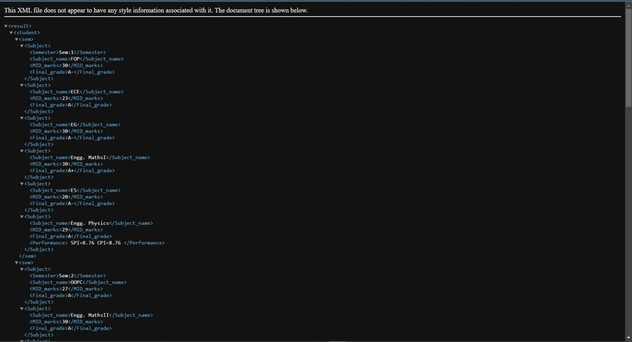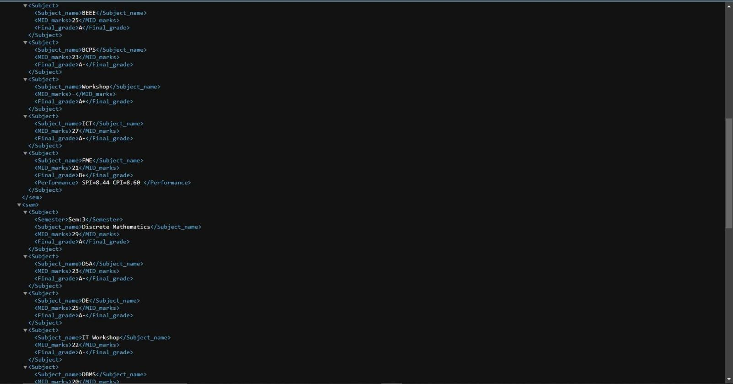

OUTPUT:-

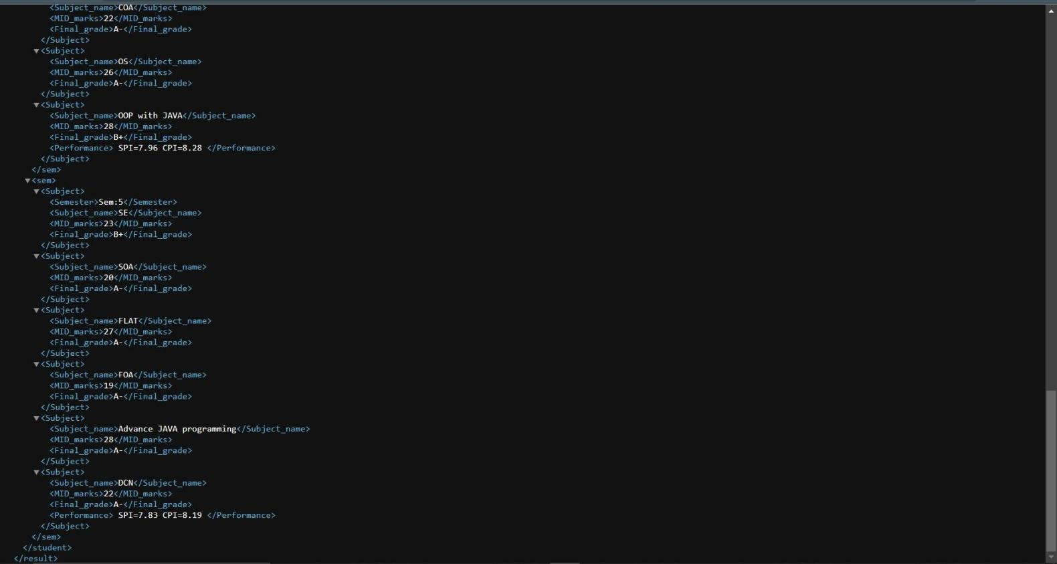

PRACTICAL: 2

AIM : Implement the concept of XSLT in the file of XML ( which you have created in Practical-1) for better representation.

Ans:

PRACTICAL CODE
<?xml version="1.0" encoding="UTF-8"?>
<xsl:stylesheet version="1.0" xmlns:xsl="http://www.w3.org/1999/XSL/Transform">
<xsl:template match="/">
<html>
<body>
<h1 align="center">Shreyash </h1>
<h1 align="center">221SBEIT30010</h1>
<table border="3" align="center" >
<tr>

</tr>
<th>Semester</th>
<th>Subject</th>
<th>Mid-marks</th>
<th>Grades</th>
<th>Performance</th>

<tr>

</tr>

</body>
</html>
<xsl:for-each select="result/student/sem/Subject">

<td><xsl:value-of select="Semester"/></td>
<td><xsl:value-of select="Subject_name"/></td>
<td><xsl:value-of select="MID_marks"/></td>
<td><xsl:value-of select="Final_grade"/></td>
<td><xsl:value-of select="Performance"/></td>

</xsl:for-each>
</table>

</xsl:template>
</xsl:stylesheet>

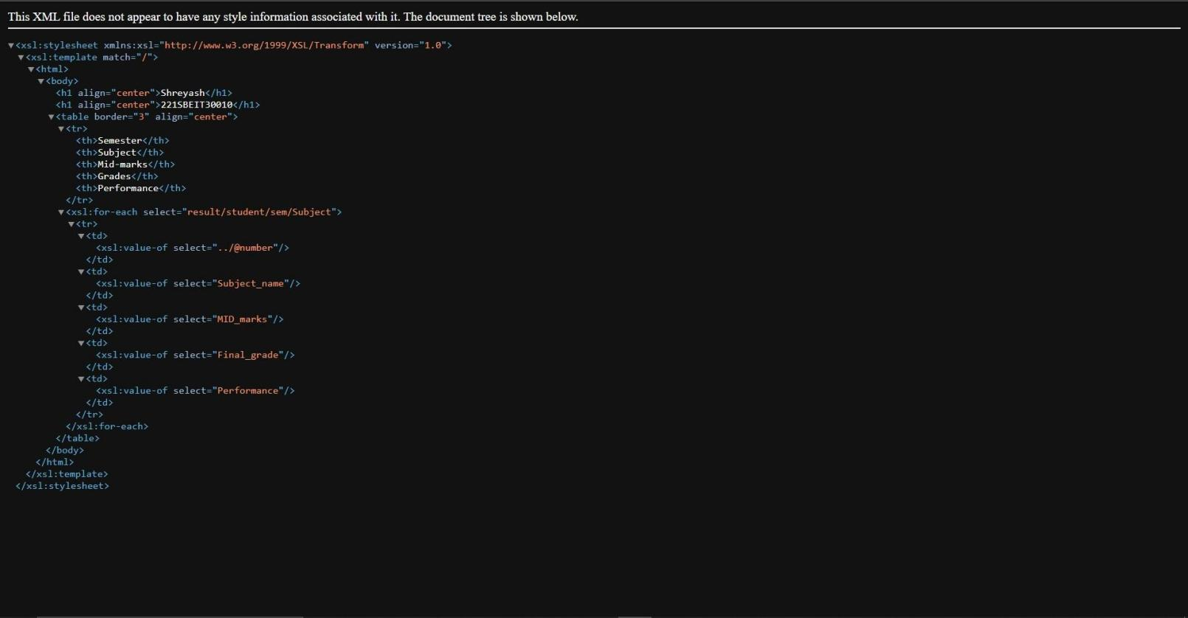

OUTPUT:-

PRACTICAL: 3

AIM : Perform the following task performing XQuery on XML document.
- Find students who have passed Python with grade > 24

Find students with average grade > 45
- Find students who have passed more exams in the 2nd year than in the 3rd year

For each student, return distinct couples of exams passed with the same grade.
- Return students who improved their average grade in the 3rd year with respect to the 2nd.

In all queries you are required to fetch student basic detail.

Instruction regarding XML file:

You are required to write your detail in an XML File
- The structure of the XML file must be same as mentioned.

You can consider the grade/percentage
- In query year means semester, so you have to create up to 6 semesters.

You are required to keep details of minimum 5 students.

PRACTICAL CODE

XML FILE:
<?xml version="1.0" encoding="UTF-8"?>
<students>
<student>
<firstName>Shreyash</firstName>
<lastName>M</lastName>
<id>IT18</id>
<courses sem="1">
<course>
<name> Fundamentals Of Programming </name>
<shortName>FOP</shortName>
<grade>58</grade>
<date>13/01/18</date>
</course>
<course>
<name>ECE</name>
<shortName>ECE</shortName>
<grade>60</grade>
<date>14/01/18</date>
</course>
<course>
<name>Engg. Graphics</name>
<shortName>EG</shortName>
<grade>69</grade>
<date>23/01/18</date>
</course>

<course>

<name>Engg. Maths-I</name>
<shortName>Maths-I</shortName>
<grade>69</grade>
<date>16/01/18</date>

</course>
<course>
<name>Environmental Studies</name>
<shortName>ES</shortName>
<grade>64</grade>
<date>26/01/18</date>
</course>
<course>
<name>Engg. Physics</name>
<shortName>Physics</shortName>
<grade>63</grade>
<date>11/01/18</date>
</course>
</courses>
<courses sem="2">
<course>
<name>OOP with C</name>
<shortName>C++</shortName>
<grade>63</grade>
<date>16/05/18</date>
</course>
<course>
<name>Engg. Maths-II</name>
<shortName>Maths-II</shortName>
<grade>62</grade>
<date>26/05/18</date>
</course>
<course>
<name>BEEE</name>
<shortName>BEEE</shortName>
<grade>56</grade>
<date>23/05/18</date>
</course>
<course>
<name>BCPS</name>
<shortName>BCPS</shortName>
<grade>52</grade>
<date>17/05/18</date>
</course>
<course>
<name>Departmental Workshop</name>
<shortName>Workshop</shortName>
<grade>67</grade>
<date>20/05/18</date>
</course>

<course>

<name>Info and Comm. Technology</name>
<shortName>ICT</shortName>
<grade>56</grade>
<date>24/05/18</date>

</course>
<course>
<name>FME</name>
<shortName>FME</shortName>
<grade>50</grade>
<date>27/05/18</date>
</course>
</courses>
<courses sem="3">
<course>
<name>Discrete Mathematics</name>
<shortName>Maths-III</shortName>
<grade>64</grade>
<date>24/11/18</date>
</course>
<course>
<name>DSA</name>
<shortName>DSA</shortName>
<grade>50</grade>
<date>20/11/18</date>
</course>
<course>
<name>Digital Electronics</name>
<shortName>DE</shortName>
<grade>53</grade>
<date>17/11/18</date>
</course>
<course>
<name>IT Workshop</name>
<shortName>ITW</shortName>
<grade>59</grade>
<date>22/11/18</date>
</course>
<course>
<name>DBMS</name>
<shortName>DBMS</shortName>
<grade>45</grade>
<date>16/11/18</date>
</course>
</courses>
<courses sem="4">
<course>
<name>POM</name>
<shortName>POM</shortName>
<grade>43</grade>

<date>24/05/19</date>
</course>
<course>
<name>PSNM</name>
<shortName>PSNM</shortName>
<grade>65</grade>
<date>20/05/19</date>
</course>
<course>
<name>COA</name>
<shortName>COA</shortName>
<grade>57</grade>
<date>21/05/19</date>
</course>
<course>
<name>Operating System</name>
<shortName>OS</shortName>
<grade>59</grade>
<date>25/05/19</date>
</course>
<course>
<name>OOP with JAVA</name>
<shortName>OOPJ</shortName>
<grade>56</grade>
<date>22/05/19</date>
</course>
</courses>
<courses sem="5">
<course>
<name>Software Enginnering</name>
<shortName>SE</shortName>
<grade>52</grade>
<date>30/11/19</date>
</course>
<course>
<name>SOA</name>
<shortName>SOA</shortName>
<grade>60</grade>
<date>02/12/19</date>
</course>
<course>
<name>FLAT</name>
<shortName>FLAT</shortName>
<grade>63</grade>
<date>29/11/19</date>
</course>
<course>
<name>Fundamental Of Algorithms</name>
<shortName>FOA</shortName>
<grade>60</grade>

<date>03/12/19</date>
</course>
<course>
<name>Advance JAVA programming</name>
<shortName>AJP</shortName>
<grade>58</grade>
<date>04/12/19</date>
</course>
<course>
<name>DCN</name>
<shortName>DCN</shortName>
<grade>62</grade>
<date>27/11/19</date>
</course>
</courses>
<courses sem="6">
<course>
<name>Artificial Intelligence</name>
<shortName>AI</shortName>
<grade>67</grade>
<date>27/05/20</date>
</course>
<course>
<name>Information Security</name>
<shortName>IS</shortName>
<grade>60</grade>
<date>29/05/20</date>
</course>
<course>
<name>Data Compression</name>
<shortName>DC</shortName>
<grade>59</grade>
<date>01/06/20</date>
</course>
<course>
<name>Machine Learning</name>
<shortName>ML</shortName>
<grade>66</grade>
<date>02/06/20</date>
</course>
<course>

</student>
<student>
<name>Soft Computing</name>
<shortName>SC</shortName>
<grade>69</grade>
<date>03/06/20</date>
</course>
</courses>

<firstName>Maharshi</firstName>

<lastName>Patel</lastName>
<id>IT03</id>
<courses sem="1">
<course>
<name> Fundamentals Of Programming </name>
<shortName>FOP</shortName>
<grade>56</grade>
<date>13/01/18</date>
</course>
<course>
<name>ECE</name>
<shortName>ECE</shortName>
<grade>62</grade>
<date>14/01/18</date>
</course>
<course>
<name>Engg. Graphics</name>
<shortName>EG</shortName>
<grade>64</grade>
<date>23/01/18</date>
</course>
<course>
<name>Engg. Maths-I</name>
<shortName>Maths-I</shortName>
<grade>59</grade>
<date>16/01/18</date>
</course>
<course>
<name>Environmental Studies</name>
<shortName>ES</shortName>
<grade>60</grade>
<date>26/01/18</date>
</course>
<course>
<name>Engg. Physics</name>
<shortName>Physics</shortName>
<grade>58</grade>
<date>11/01/18</date>
</course>
</courses>
<courses sem="2">
<course>
<name>OOP with C</name>
<shortName>C++</shortName>
<grade>47</grade>
<date>16/05/18</date>
</course>
<course>
<name>Engg. Maths-II</name>
<shortName>Maths-II</shortName>

<grade>64</grade>
<date>26/05/18</date>
</course>
<course>
<name>BEEE</name>
<shortName>BEEE</shortName>
<grade>54</grade>
<date>23/05/18</date>
</course>
<course>
<name>BCPS</name>
<shortName>BCPS</shortName>
<grade>52</grade>
<date>17/05/18</date>
</course>
<course>
<name>Departmental Workshop</name>
<shortName>Workshop</shortName>
<grade>59</grade>
<date>20/05/18</date>
</course>
<course>
<name>Info and Comm. Technology</name>
<shortName>ICT</shortName>
<grade>29</grade>
<date>24/05/18</date>
</course>
<course>
<name>FME</name>
<shortName>FME</shortName>
<grade>55</grade>
<date>27/05/18</date>
</course>
</courses>
<courses sem="3">
<course>
<name>Discrete Mathematics</name>
<shortName>Maths-III</shortName>
<grade>62</grade>
<date>24/11/18</date>
</course>
<course>
<name>DSA</name>
<shortName>DSA</shortName>
<grade>56</grade>
<date>20/11/18</date>
</course>
<course>
<name>Digital Electronics</name>
<shortName>DE</shortName>

<grade>57</grade>
<date>17/11/18</date>
</course>
<course>
<name>IT Workshop</name>
<shortName>ITW</shortName>
<grade>58</grade>
<date>22/11/18</date>
</course>
<course>
<name>DBMS</name>
<shortName>DBMS</shortName>
<grade>42</grade>
<date>16/11/18</date>
</course>
</courses>
<courses sem="4">
<course>
<name>POM</name>
<shortName>POM</shortName>
<grade>54</grade>
<date>24/05/19</date>
</course>
<course>
<name>PSNM</name>
<shortName>PSNM</shortName>
<grade>60</grade>
<date>20/05/19</date>
</course>
<course>
<name>COA</name>
<shortName>COA</shortName>
<grade>57</grade>
<date>21/05/19</date>
</course>
<course>
<name>Operating System</name>
<shortName>OS</shortName>
<grade>48</grade>
<date>25/05/19</date>
</course>
<course>
<name>OOP with JAVA</name>
<shortName>OOPJ</shortName>
<grade>55</grade>
<date>22/05/19</date>
</course>
</courses>
<courses sem="5">
<course>

<name>Software Enginnering</name>
<shortName>SE</shortName>
<grade>59</grade>
<date>30/11/19</date>
</course>
<course>
<name>SOA</name>
<shortName>SOA</shortName>
<grade>60</grade>
<date>02/12/19</date>
</course>
<course>
<name>FLAT</name>
<shortName>FLAT</shortName>
<grade>58</grade>
<date>29/11/19</date>
</course>
<course>
<name>Fundamental Of Algorithms</name>
<shortName>FOA</shortName>
<grade>57</grade>
<date>03/12/19</date>
</course>
<course>
<name>Advance JAVA programming</name>
<shortName>AJP</shortName>
<grade>62</grade>
<date>04/12/19</date>
</course>
<course>
<name>DCN</name>
<shortName>DCN</shortName>
<grade>58</grade>
<date>27/11/19</date>
</course>
</courses>
<courses sem="6">
<course>
<name>Artificial Intelligence</name>
<shortName>AI</shortName>
<grade>54</grade>
<date>27/05/20</date>
</course>
<course>
<name>Information Security</name>
<shortName>IS</shortName>
<grade>60</grade>
<date>29/05/20</date>
</course>
<course>

<name>Data Compression</name>
<shortName>DC</shortName>
<grade>49</grade>
<date>01/06/20</date>
</course>
<course>
<name>Machine Learning</name>
<shortName>ML</shortName>
<grade>62</grade>
<date>02/06/20</date>
</course>
<course>
<name>Soft Computing</name>
<shortName>SC</shortName>
<grade>65</grade>
<date>03/06/20</date>
</course>
</courses>

</student>
<student>
<firstName>Sujal</firstName>
<lastName>Patel</lastName>
<id>IT37</id>
<courses sem="1">
<course>
<name> Fundamentals Of Programming </name>
<shortName>FOP</shortName>
<grade>60</grade>
<date>13/01/18</date>
</course>
<course>
<name>ECE</name>
<shortName>ECE</shortName>
<grade>62</grade>
<date>14/01/18</date>
</course>
<course>
<name>Engg. Graphics</name>
<shortName>EG</shortName>
<grade>69</grade>
<date>23/01/18</date>
</course>
<course>
<name>Engg. Maths-I</name>
<shortName>Maths-I</shortName>
<grade>61</grade>
<date>16/01/18</date>
</course>
<course>

<name>Environmental Studies</name>
<shortName>ES</shortName>
<grade>66</grade>
<date>26/01/18</date>
</course>
<course>
<name>Engg. Physics</name>
<shortName>Physics</shortName>
<grade>67</grade>
<date>11/01/18</date>
</course>
</courses>
<courses sem="2">
<course>
<name>OOP with C</name>
<shortName>C++</shortName>
<grade>59</grade>
<date>16/05/18</date>
</course>
<course>
<name>Engg. Maths-II</name>
<shortName>Maths-II</shortName>
<grade>64</grade>
<date>26/05/18</date>
</course>
<course>
<name>BEEE</name>
<shortName>BEEE</shortName>
<grade>54</grade>
<date>23/05/18</date>
</course>
<course>
<name>BCPS</name>
<shortName>BCPS</shortName>
<grade>58</grade>
<date>17/05/18</date>
</course>
<course>
<name>Departmental Workshop</name>
<shortName>Workshop</shortName>
<grade>59</grade>
<date>20/05/18</date>
</course>
<course>
<name>Info and Comm. Technology</name>
<shortName>ICT</shortName>
<grade>57</grade>
<date>24/05/18</date>
</course>
<course>

<name>FME</name>
<shortName>FME</shortName>
<grade>60</grade>
<date>27/05/18</date>
</course>
</courses>
<courses sem="3">
<course>
<name>Discrete Mathematics</name>
<shortName>Maths-III</shortName>
<grade>64</grade>
<date>24/11/18</date>
</course>
<course>
<name>DSA</name>
<shortName>DSA</shortName>
<grade>58</grade>
<date>20/11/18</date>
</course>
<course>
<name>Digital Electronics</name>
<shortName>DE</shortName>
<grade>57</grade>
<date>17/11/18</date>
</course>
<course>
<name>IT Workshop</name>
<shortName>ITW</shortName>
<grade>60</grade>
<date>22/11/18</date>
</course>
<course>
<name>DBMS</name>
<shortName>DBMS</shortName>
<grade>52</grade>
<date>16/11/18</date>
</course>
</courses>
<courses sem="4">
<course>
<name>POM</name>
<shortName>POM</shortName>
<grade>60</grade>
<date>24/05/19</date>
</course>
<course>
<name>PSNM</name>
<shortName>PSNM</shortName>
<grade>64</grade>
<date>20/05/19</date>

</course>
<course>
<name>COA</name>
<shortName>COA</shortName>
<grade>59</grade>
<date>21/05/19</date>
</course>
<course>
<name>Operating System</name>
<shortName>OS</shortName>
<grade>58</grade>
<date>25/05/19</date>
</course>
<course>
<name>OOP with JAVA</name>
<shortName>OOPJ</shortName>
<grade>54</grade>
<date>22/05/19</date>
</course>
</courses>
<courses sem="5">
<course>
<name>Software Enginnering</name>
<shortName>SE</shortName>
<grade>64</grade>
<date>30/11/19</date>
</course>
<course>
<name>SOA</name>
<shortName>SOA</shortName>
<grade>54</grade>
<date>02/12/19</date>
</course>
<course>
<name>FLAT</name>
<shortName>FLAT</shortName>
<grade>61</grade>
<date>29/11/19</date>
</course>
<course>
<name>Fundamental Of Algorithms</name>
<shortName>FOA</shortName>
<grade>58</grade>
<date>03/12/19</date>
</course>
<course>
<name>Advance JAVA programming</name>
<shortName>AJP</shortName>
<grade>62</grade>
<date>04/12/19</date>

</course>
<course>
<name>DCN</name>
<shortName>DCN</shortName>
<grade>52</grade>
<date>27/11/19</date>
</course>
</courses>
<courses sem="6">
<course>
<name>Artificial Intelligence</name>
<shortName>AI</shortName>
<grade>61</grade>
<date>27/05/20</date>
</course>
<course>
<name>Information Security</name>
<shortName>IS</shortName>
<grade>57</grade>
<date>29/05/20</date>
</course>
<course>
<name>Data Compression</name>
<shortName>DC</shortName>
<grade>63</grade>
<date>01/06/20</date>
</course>
<course>
<name>Machine Learning</name>
<shortName>ML</shortName>
<grade>66</grade>
<date>02/06/20</date>
</course>
<course>

</student>
<student>
<name>Soft Computing</name>
<shortName>SC</shortName>
<grade>69</grade>
<date>03/06/20</date>
</course>
</courses>

<firstName>Ravi</firstName>
<lastName>Patel</lastName>
<id>IT36</id>
<courses sem="1">
<course>
<name> Fundamentals Of Programming </name>
<shortName>FOP</shortName>
<grade>59</grade>

<name>ECE</name>
<shortName>ECE</shortName>
<grade>62</grade>
<date>14/01/18</date>
</course>
<course>
<name>Engg. Graphics</name>
<shortName>EG</shortName>
<grade>51</grade>
<date>23/01/18</date>
</course>
<course>
<name>Engg. Maths-I</name>
<shortName>Maths-I</shortName>
<grade>68</grade>
<date>16/01/18</date>
</course>
<course>
<name>Environmental Studies</name>
<shortName>ES</shortName>
<grade>52</grade>
<date>26/01/18</date>
</course>
<course>
<name>Engg. Physics</name>
<shortName>Physics</shortName>
<grade>57</grade>
<date>11/01/18</date>
</course>
</courses>
<courses sem="2">
<course>
<name>OOP with C</name>
<shortName>C++</shortName>
<grade>54</grade>
<date>16/05/18</date>
</course>
<course>
<name>Engg. Maths-II</name>
<shortName>Maths-II</shortName>
<grade>56</grade>
<date>26/05/18</date>
</course>
<course>
<name>BEEE</name>
<shortName>BEEE</shortName>
<grade>62</grade>

<name>BCPS</name>
<shortName>BCPS</shortName>
<grade>58</grade>
<date>17/05/18</date>
</course>
<course>
<name>Departmental Workshop</name>
<shortName>Workshop</shortName>
<grade>50</grade>
<date>20/05/18</date>
</course>
<course>
<name>Info and Comm. Technology</name>
<shortName>ICT</shortName>
<grade>62</grade>
<date>24/05/18</date>
</course>
<course>
<name>FME</name>
<shortName>FME</shortName>
<grade>53</grade>
<date>27/05/18</date>
</course>
</courses>
<courses sem="3">
<course>
<name>Discrete Mathematics</name>
<shortName>Maths-III</shortName>
<grade>63</grade>
<date>24/11/18</date>
</course>
<course>
<name>DSA</name>
<shortName>DSA</shortName>
<grade>55</grade>
<date>20/11/18</date>
</course>
<course>
<name>Digital Electronics</name>
<shortName>DE</shortName>
<grade>53</grade>
<date>17/11/18</date>
</course>
<course>
<name>IT Workshop</name>
<shortName>ITW</shortName>
<grade>60</grade>

<date>22/11/18</date>
</course>
<course>
<name>DBMS</name>
<shortName>DBMS</shortName>
<grade>48</grade>
<date>16/11/18</date>
</course>
</courses>
<courses sem="4">
<course>
<name>POM</name>
<shortName>POM</shortName>
<grade>60</grade>
<date>24/05/19</date>
</course>
<course>
<name>PSNM</name>
<shortName>PSNM</shortName>
<grade>64</grade>
<date>20/05/19</date>
</course>
<course>
<name>COA</name>
<shortName>COA</shortName>
<grade>58</grade>
<date>21/05/19</date>
</course>
<course>
<name>Operating System</name>
<shortName>OS</shortName>
<grade>59</grade>
<date>25/05/19</date>
</course>
<course>
<name>OOP with JAVA</name>
<shortName>OOPJ</shortName>
<grade>61</grade>
<date>22/05/19</date>
</course>
</courses>
<courses sem="5">
<course>
<name>Software Enginnering</name>
<shortName>SE</shortName>
<grade>55</grade>
<date>30/11/19</date>
</course>
<course>
<name>SOA</name>

<shortName>SOA</shortName>
<grade>62</grade>
<date>02/12/19</date>
</course>
<course>
<name>FLAT</name>
<shortName>FLAT</shortName>
<grade>65</grade>
<date>29/11/19</date>
</course>
<course>
<name>Fundamental Of Algorithms</name>
<shortName>FOA</shortName>
<grade>58</grade>
<date>03/12/19</date>
</course>
<course>
<name>Advance JAVA programming</name>
<shortName>AJP</shortName>
<grade>61</grade>
<date>04/12/19</date>
</course>
<course>
<name>DCN</name>
<shortName>DCN</shortName>
<grade>54</grade>
<date>27/11/19</date>
</course>
</courses>
<courses sem="6">
<course>
<name>Artificial Intelligence</name>
<shortName>AI</shortName>
<grade>60</grade>
<date>27/05/20</date>
</course>
<course>
<name>Information Security</name>
<shortName>IS</shortName>
<grade>54</grade>
<date>29/05/20</date>
</course>
<course>
<name>Data Compression</name>
<shortName>DC</shortName>
<grade>56</grade>
<date>01/06/20</date>
</course>
<course>
<name>Machine Learning</name>

<shortName>ML</shortName>
<grade>62</grade>
<date>02/06/20</date>
</course>
<course>

</student>
<student>
<name>Soft Computing</name>
<shortName>SC</shortName>
<grade>67</grade>
<date>03/06/20</date>
</course>
</courses>

<firstName>Anand</firstName>
<lastName>Jatapara</lastName>
<id>IT59</id>
<courses sem="1">
<course>
<name> Fundamentals Of Programming </name>
<shortName>FOP</shortName>
<grade>54</grade>
<date>13/01/18</date>
</course>
<course>
<name>ECE</name>
<shortName>ECE</shortName>
<grade>59</grade>
<date>14/01/18</date>
</course>
<course>
<name>Engg. Graphics</name>
<shortName>EG</shortName>
<grade>50</grade>
<date>23/01/18</date>
</course>
<course>
<name>Engg. Maths-I</name>
<shortName>Maths-I</shortName>
<grade>60</grade>
<date>16/01/18</date>
</course>
<course>
<name>Environmental Studies</name>
<shortName>ES</shortName>
<grade>58</grade>
<date>26/01/18</date>
</course>
<course>
<name>Engg. Physics</name>
<shortName>Physics</shortName>

<grade>52</grade>
<date>11/01/18</date>
</course>
</courses>
<courses sem="2">
<course>
<name>OOP with C</name>
<shortName>C++</shortName>
<grade>59</grade>
<date>16/05/18</date>
</course>
<course>
<name>Engg. Maths-II</name>
<shortName>Maths-II</shortName>
<grade>52</grade>
<date>26/05/18</date>
</course>
<course>
<name>BEEE</name>
<shortName>BEEE</shortName>
<grade>54</grade>
<date>23/05/18</date>
</course>
<course>
<name>BCPS</name>
<shortName>BCPS</shortName>
<grade>59</grade>
<date>17/05/18</date>
</course>
<course>
<name>Departmental Workshop</name>
<shortName>Workshop</shortName>
<grade>60</grade>
<date>20/05/18</date>
</course>
<course>
<name>Info and Comm. Technology</name>
<shortName>ICT</shortName>
<grade>62</grade>
<date>24/05/18</date>
</course>
<course>
<name>FME</name>
<shortName>FME</shortName>
<grade>29</grade>
<date>27/05/18</date>
</course>
</courses>
<courses sem="3">
<course>

<name>Discrete Mathematics</name>
<shortName>Maths-III</shortName>
<grade>65</grade>
<date>24/11/18</date>
</course>
<course>
<name>DSA</name>
<shortName>DSA</shortName>
<grade>50</grade>
<date>20/11/18</date>
</course>
<course>
<name>Digital Electronics</name>
<shortName>DE</shortName>
<grade>54</grade>
<date>17/11/18</date>
</course>
<course>
<name>IT Workshop</name>
<shortName>ITW</shortName>
<grade>61</grade>
<date>22/11/18</date>
</course>
<course>
<name>DBMS</name>
<shortName>DBMS</shortName>
<grade>27</grade>
<date>16/11/18</date>
</course>
</courses>
<courses sem="4">
<course>
<name>POM</name>
<shortName>POM</shortName>
<grade>55</grade>
<date>24/05/19</date>
</course>
<course>
<name>PSNM</name>
<shortName>PSNM</shortName>
<grade>62</grade>
<date>20/05/19</date>
</course>
<course>
<name>COA</name>
<shortName>COA</shortName>
<grade>54</grade>
<date>21/05/19</date>
</course>
<course>

<name>Operating System</name>
<shortName>OS</shortName>
<grade>50</grade>
<date>25/05/19</date>
</course>
<course>
<name>OOP with JAVA</name>
<shortName>OOPJ</shortName>
<grade>60</grade>
<date>22/05/19</date>
</course>
</courses>
<courses sem="5">
<course>
<name>Software Enginnering</name>
<shortName>SE</shortName>
<grade>48</grade>
<date>30/11/19</date>
</course>
<course>
<name>SOA</name>
<shortName>SOA</shortName>
<grade>58</grade>
<date>02/12/19</date>
</course>
<course>
<name>FLAT</name>
<shortName>FLAT</shortName>
<grade>65</grade>
<date>29/11/19</date>
</course>
<course>
<name>Fundamental Of Algorithms</name>
<shortName>FOA</shortName>
<grade>50</grade>
<date>03/12/19</date>
</course>
<course>
<name>Python</name>
<shortName>Pyp</shortName>
<grade>60</grade>
<date>04/12/19</date>
</course>
<course>
<name>DCN</name>
<shortName>DCN</shortName>
<grade>52</grade>
<date>27/11/19</date>
</course>
</courses>

<courses sem="6">
<course>
<name>Artificial Intelligence</name>
<shortName>AI</shortName>
<grade>63</grade>
<date>27/05/20</date>
</course>
<course>
<name>Information Security</name>
<shortName>IS</shortName>
<grade>59</grade>
<date>29/05/20</date>
</course>
<course>
<name>Data Compression</name>
<shortName>DC</shortName>
<grade>61</grade>
<date>01/06/20</date>
</course>
<course>
<name>Machine Learning</name>
<shortName>ML</shortName>
<grade>56</grade>
<date>02/06/20</date>
</course>
<course>

</student>
</students>
<name>Soft Computing</name>
<shortName>SC</shortName>
<grade>67</grade>
<date>03/06/20</date>
</course>
</courses>

Queries:
1.) for $x in //student
return (
if($x//course[name="Python"]/grade>"24") then $x/firstName | $x/lastName | $x/id
)

2.) declare variable $ave := "0";
for $x in //students/student[courses] let $ave:=avg($x//grade)
return(
if($ave>40)
then ($x/firstName,$x/lastName,$x/id,<average>{$ave}</average>)
)

3.) for $x in //student
let $a:=count($x/courses[@sem=4]/course[grade>30]) let $b:=count($x/courses[@sem=3]/course[grade>30]) return(
if($a>$b)
then ($x/firstName,$x/lastName, $x/id)
)

4.) for $x in //course for $y in //course
where $y >> $x and $x//grade = $y//grade return(
$x/name,
$x/grade,
$y/name,
$y/grade
)

5.) for $x in //student
let $av3 := avg($x//courses[@sem="3"]//grade) let $av2 := avg($x//courses[@sem="2"]//grade) return(
if($av3 > $av2)
then($x/firstName, $x/lastName, $x/id, <average3>{$av3}</average3>,
<average2>{$av2}</average2>)
)

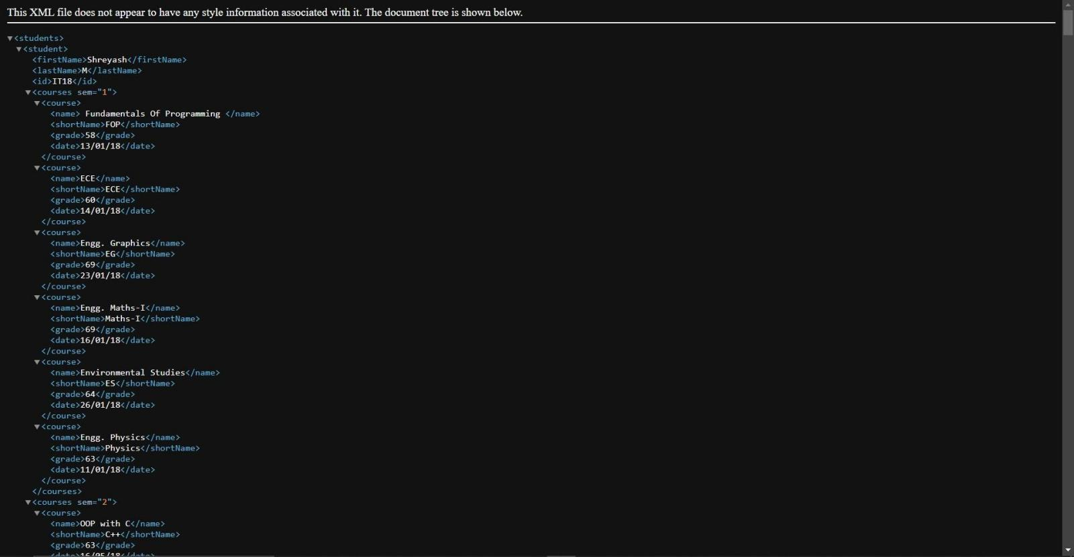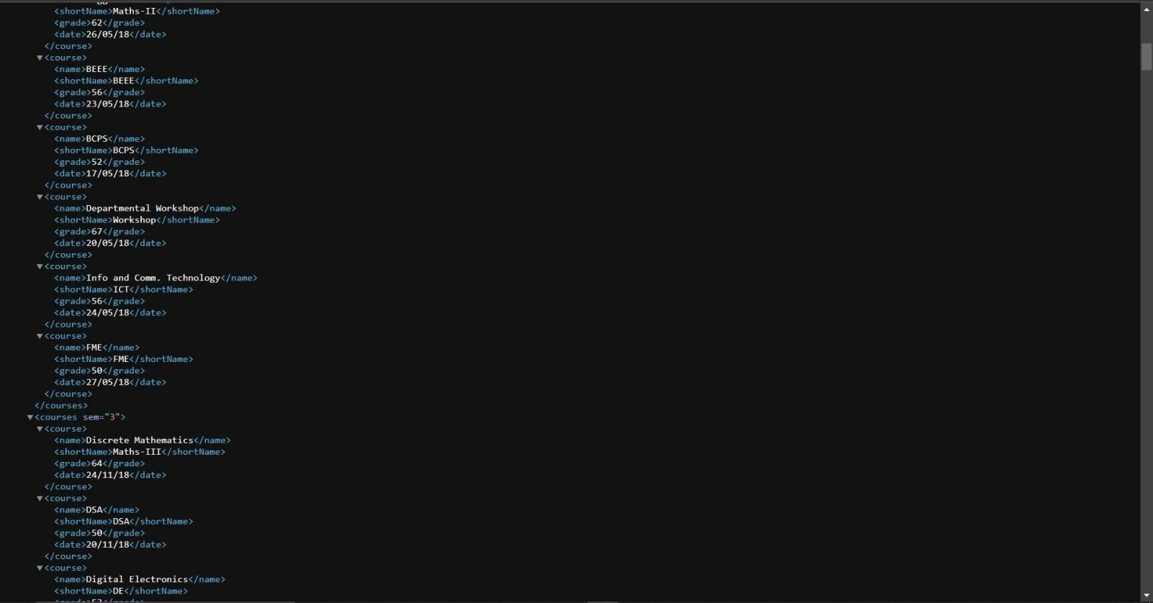

OUTPUT:-

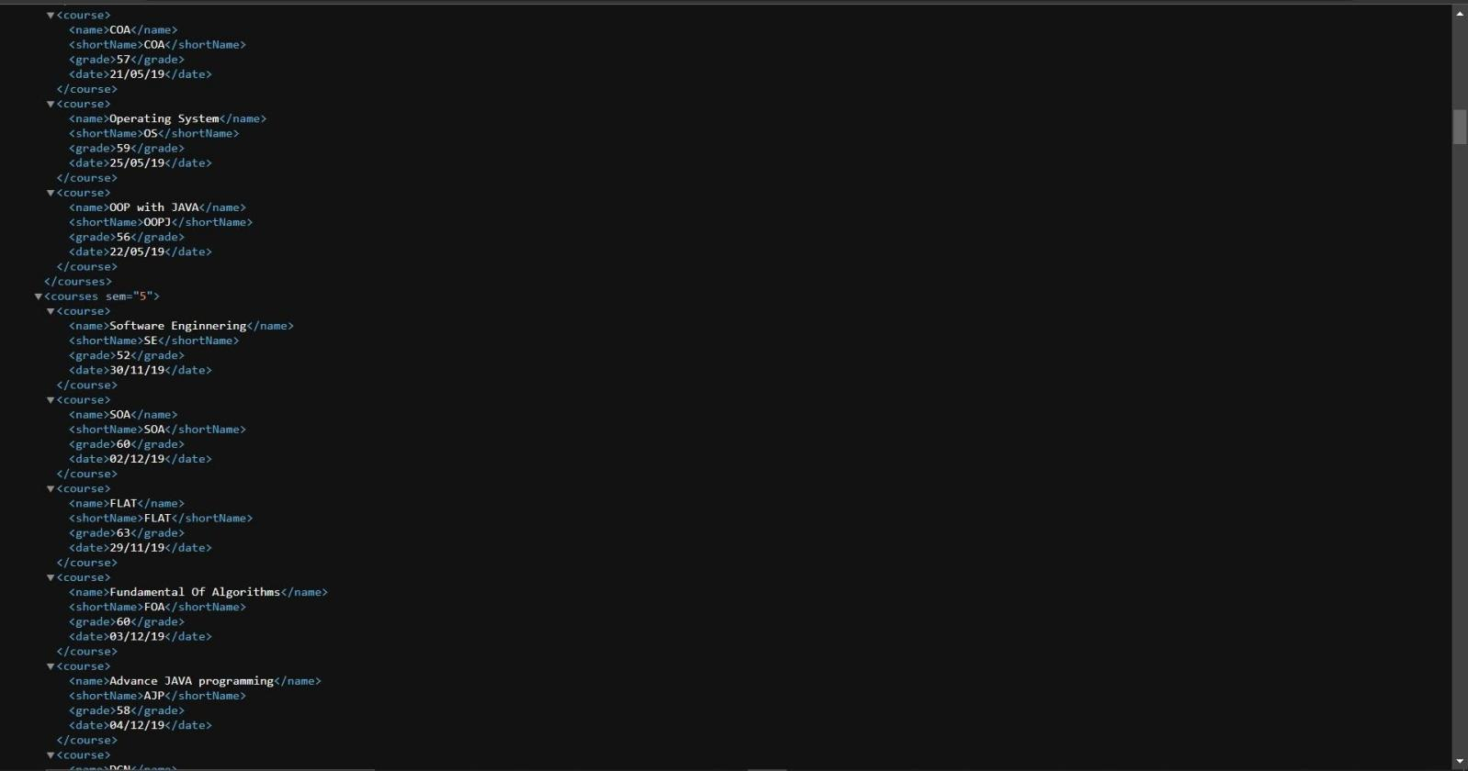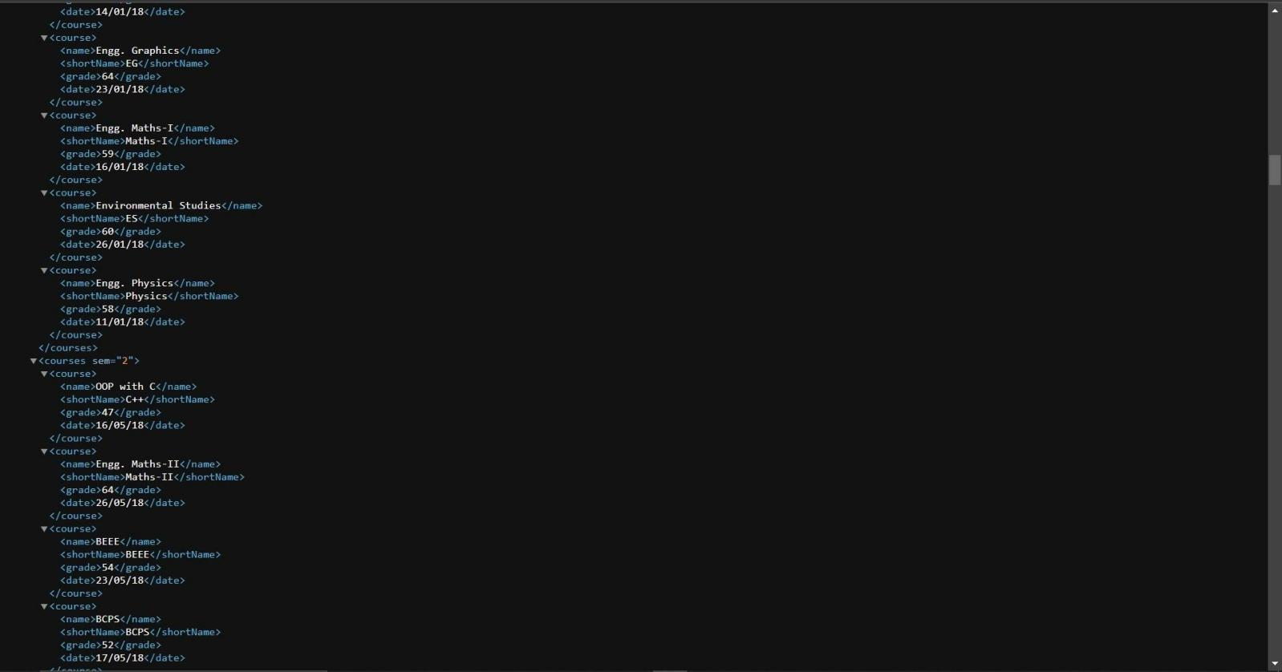

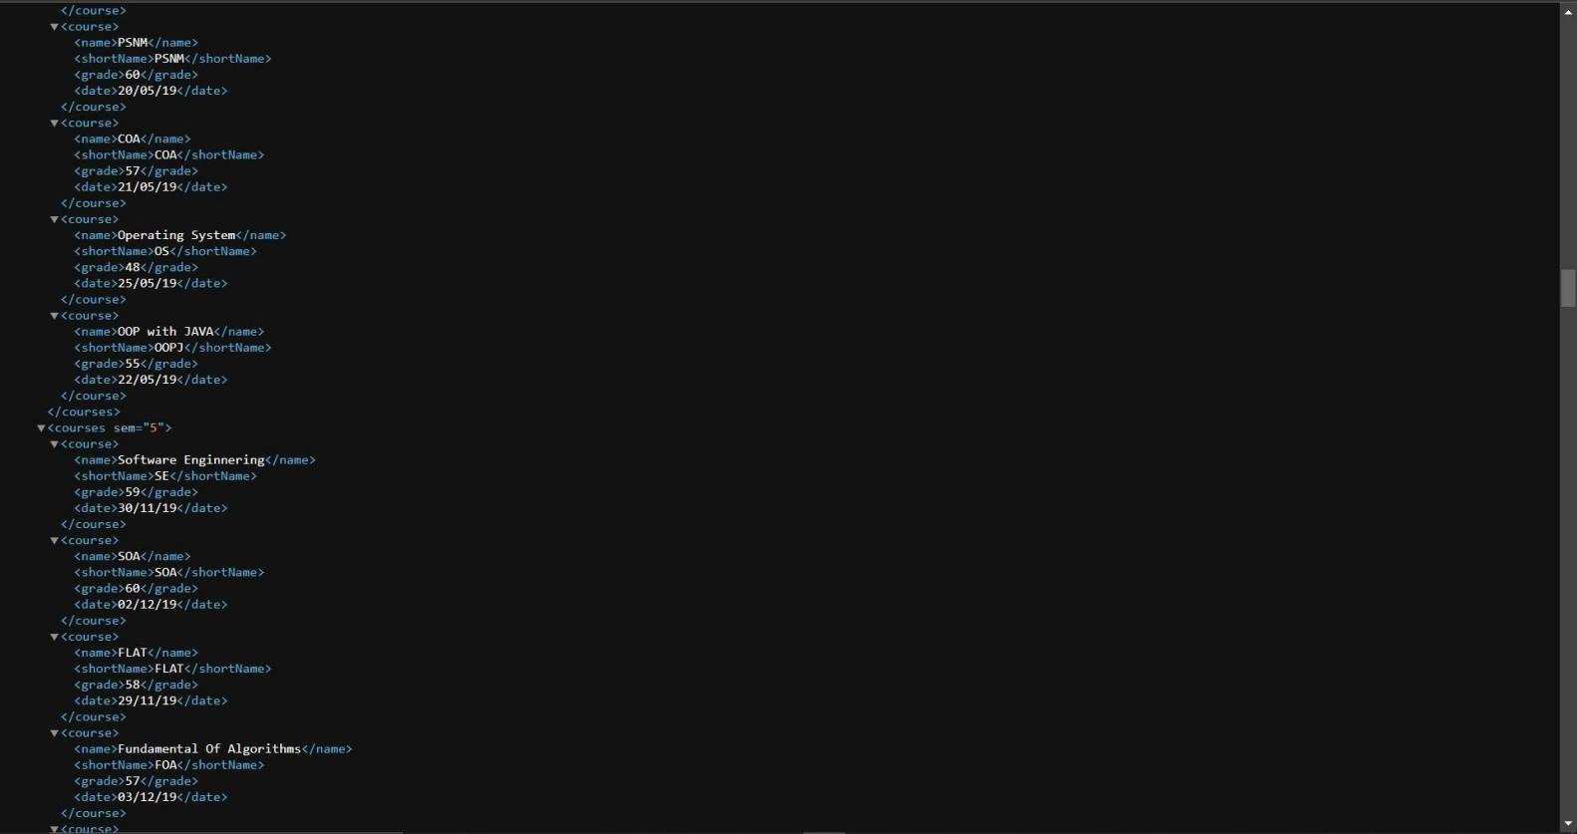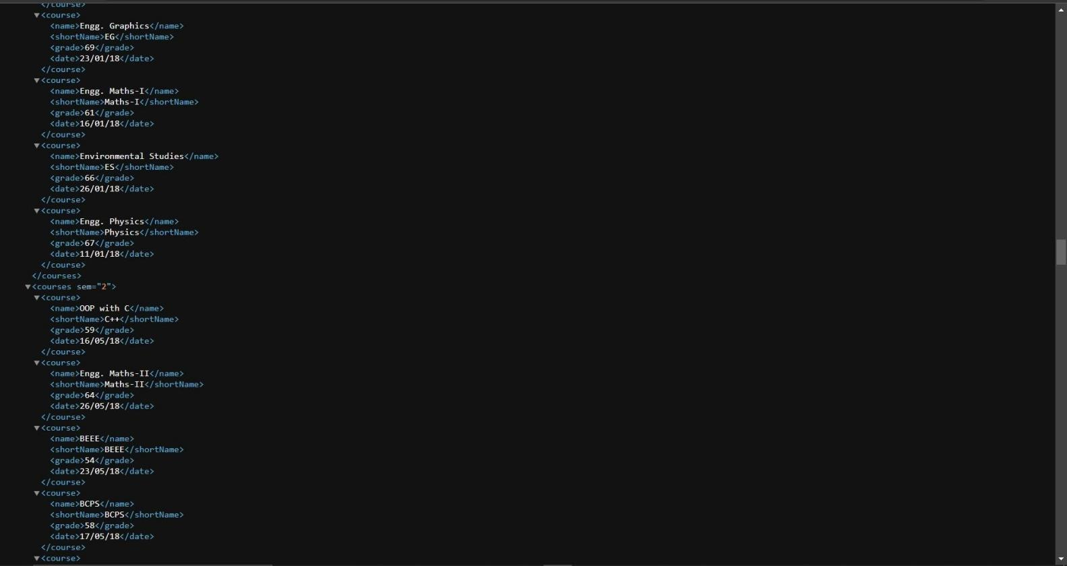

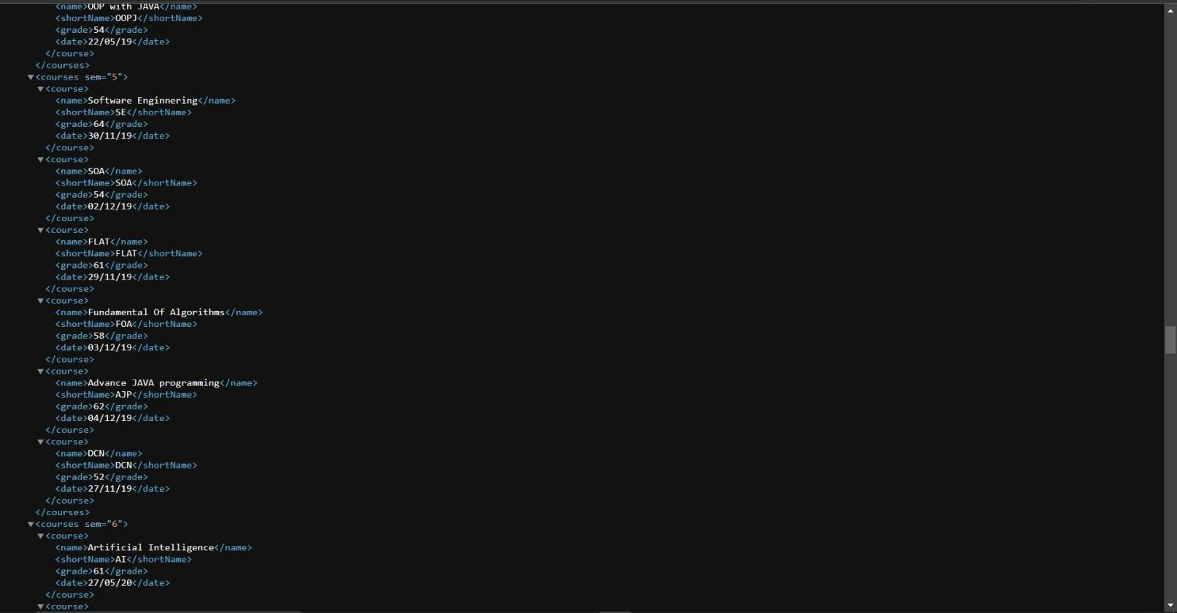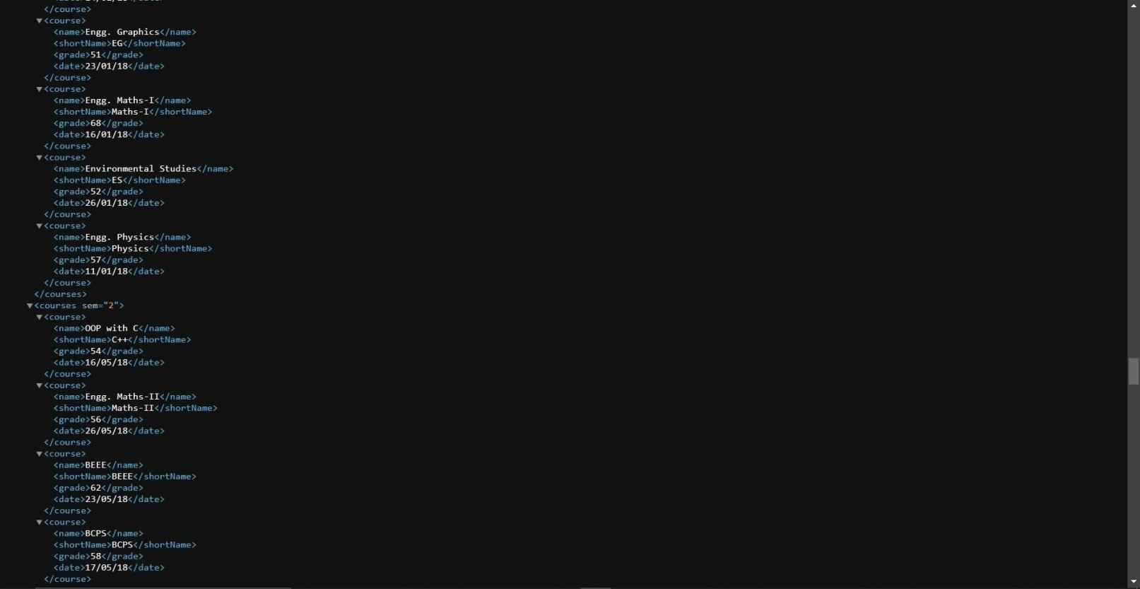

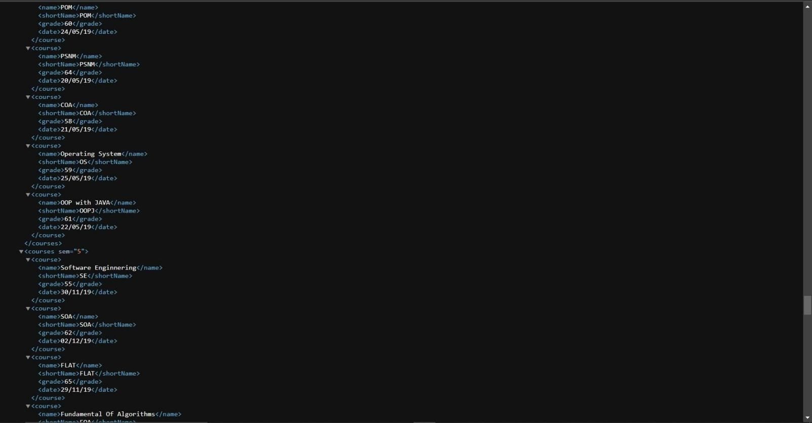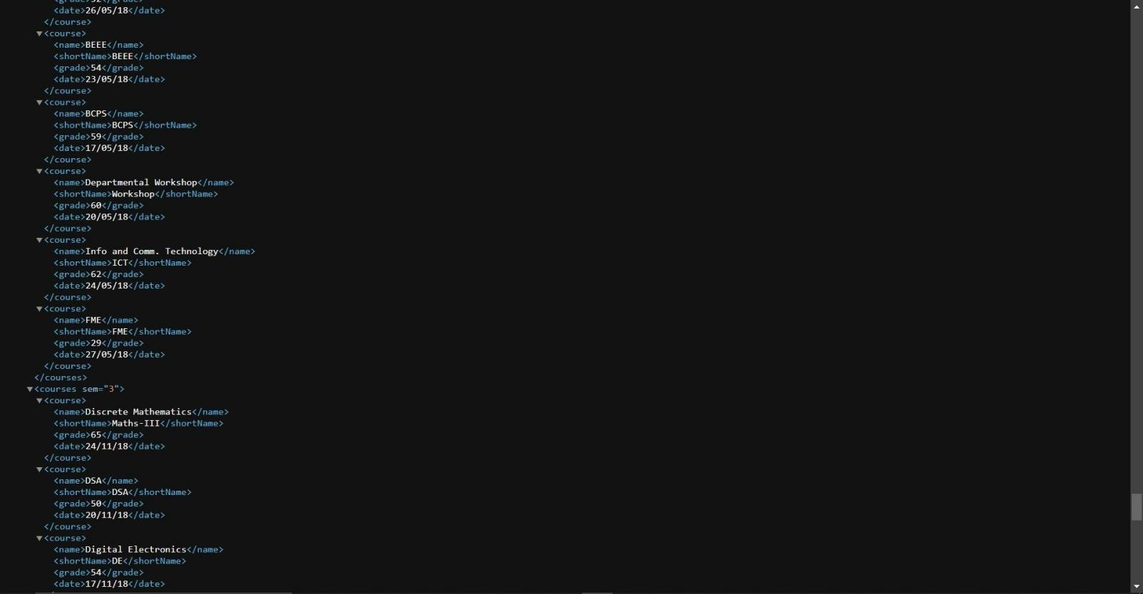

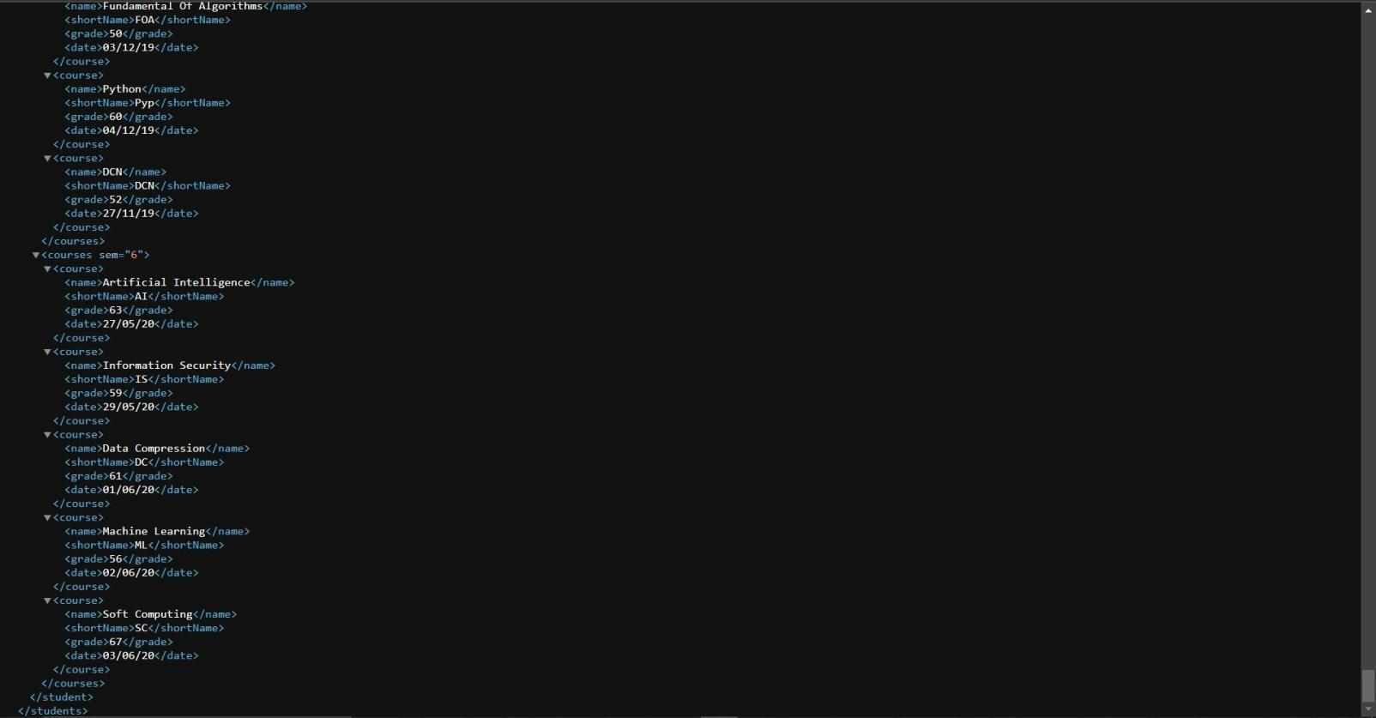

PRACTICAL: 4

AIM: Perform the below mentioned task using Xpath and Xquery on XML document

Fetch the Information of a student with ID No : 101
- Print name of all the student in the sorted order according to CPI

Display the Name and CPI of the students where the name has "hi" keyword
- Display the email address of the student where the first character of name is "t"

Write an expression which gives us the number of subject in a particular semester. ( Use your xml file of Practical no -1 )
- Display the name of subject where the marks of a subject is less than 15

Display the name of the students who are born between the specific range. ( you can take any range as per your XML file)
- Display the name of the students where the email ends with ".in"

Display the total number of students who have scored more than 65 in a particular subject. ( You can take any subject name as per your XML file)
- If passing marks is 30, display the name of the student who have not cleared the highest number of subject.

Ans:
Queries:
1.) //student[Enrollment=&quot;221SBEIT30010&quot;]/(Name,Enrollment,Email)

2.) for $x in //student order by $x/CPI
return $x/Name | $x/Enrollment

3.) for $x in //student
where contains($x/Name,&quot;sh&quot;) return $x/Name | $x/CPI

4.) for $x in //student
where starts-with($x/Name,&quot;R&quot;) return ($x/Email)

5.) for $x in //student[@number=1]
let $a:=count($x/sem[@value=&quot;3&quot;]/Subject) return $a

6.) for $x in //student
return ($x//Subject[MID_marks&lt;15]/Subject_name, $x/Name)

7.) for $x in //student return(
$x[xs:date(./DOB/text()) &lt; xs:date(&quot;2000-06-30&quot;) ][xs:date(./DOB/text()) &gt; xs:date(&quot;1999-12-31&quot;)]/(Name,DOB))

8.) for $x in //student
where ends-with($x/Email,&quot;.in&quot;) return ($x/Name)
9.) let $a:=count(//Subject[Subject_name=&quot;EG&quot; and Final_grade&gt;65]) return ($a)

PRACTICAL: 5

AIM : Demonstrate the use of AJAX.

PRACTICAL CODE
Index.html
<html>
<head>
<title>Practical-6 WDM</title>
</head>
<body>
<div id="context">
<form id="data" action="">
Name: <input type="text" id="name" name="name" placeholder="Enter Name" /><br/><br/>
E-mail: <input type="email" id="email" name="email" placeholder="Enter Email" /><br/><br/>
Mobile: <input type="tel" id="mobile" name="mobile" placeholder="Enter Mobile No." /><br/><br/>
<input type = 'button' onclick = 'showinfo()' value = 'Submit'/>
</form>
<p id="test"></p>
</div>

</body>
<script>
function showinfo(){
var name = document.getElementById("name").value; var email = document.getElementById("email").value; var mobile = document.getElementById("mobile").value; var xhttp;
xhttp = new XMLHttpRequest(); // Obect of xmlhttp request xhttp.onreadystatechange = function() {
if (xhttp.readyState == 4 && xhttp.status == 200) { // Check the status - if everything goes fine
document.getElementById("context").innerHTML = xhttp.responseText; // display the content (response) from the serverside page
}
}
xhttp.open("GET", "Test.php" + "?name="+name+"&email="+email+"&mobile="+mobile, true); // this is the url
xhttp.send();

}
</script>
</html>

Test.php
<?php

$name = $_GET["name"];
$email = $_GET["email"];
$mobile = $_GET["mobile"];

echo "Hello ".$name.".<br>";
echo "We have collected your details:<br>"; echo "Email Address: ".$email."<br>"; echo "Mobile: ".$mobile."<br>";

?>

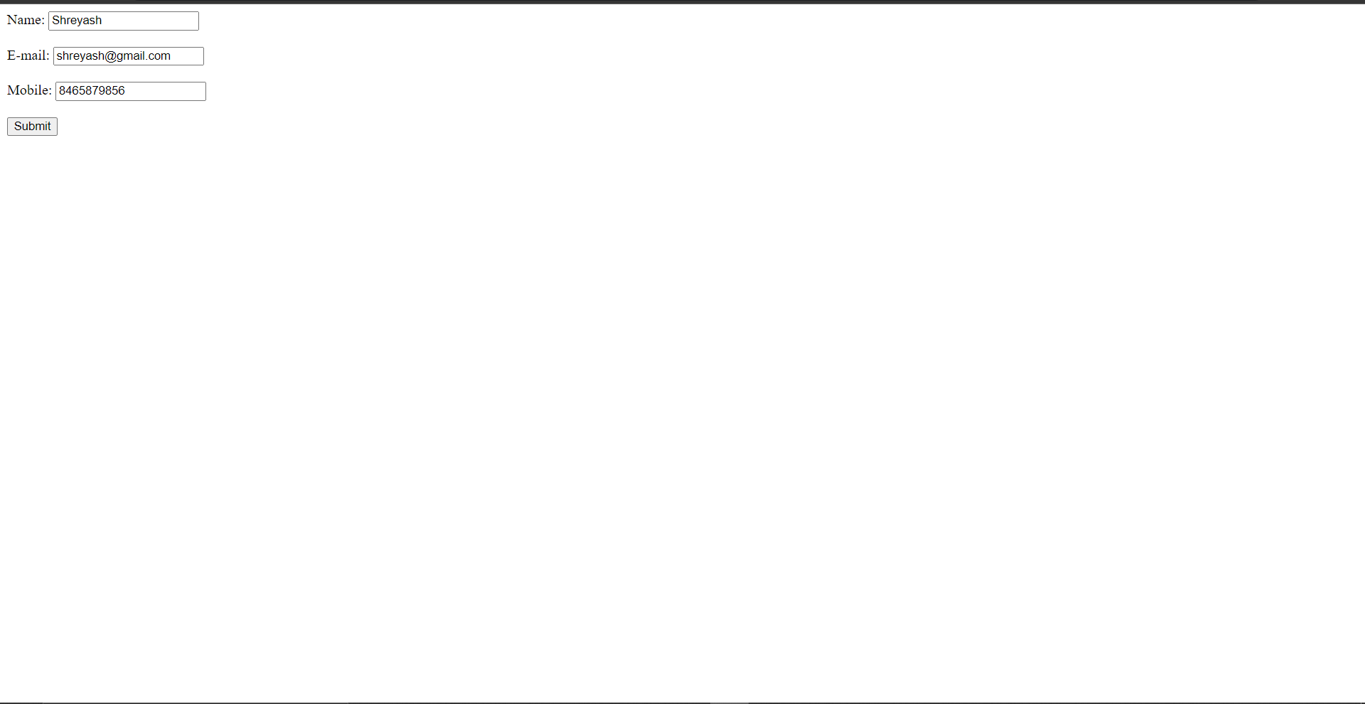

OUTPUT:-

PRACTICAL: 6

AIM: Study of RDF (Resource Description Framework)

- RDF is a standard model for data interchange on the Web. RDF has features that facilitate data merging even if the underlying schemas differ, and it specifically supports the evolution of schemas over time without requiring all the data consumers to be changed.
- RDF extends the linking structure of the Web to use URIs to name the relationship between things as well as the two ends of the link (this is usually referred to as a “triple”). Using this simple model, it allows structured and semi-structured data to be mixed, exposed, and shared across different applications.
- This linking structure forms a directed, labeled graph, where the edges represent the named link between two resources, represented by the graph nodes. This graph view is the easiest possible mental model for RDF and is often used in easy-to-understand visual explanations.
- It is the formal language for describing structured information. The primary goal of RDF is to exchange data on the web while preserving the original meaning of the data. It is a data model that is used to describe resources.
For Example Physical Things, Abstract Concepts, Numbers and Strings.
RDF allows the processing of information. RDF representation can be in the form of triples and graphs. RDF graph is a directed graph which is used to serve as a description language for data on the world wide web and other electronic networks.
Resources are described using triples.
Triples capture the relationship between the subject and the object. Triples have a subject, predicate and an object. Triples are enclosed within angular brackets.
- Example: Delhi is capital of India
The triple generated from this sentence is:
<Delhi> <capital of> <India>.

PRACTICAL 7

AIM: Discuss features of BaseX tool.
INTRODUCTION
  - BaseX is a robust, high-performance XML database engine and a highly compliant XQuery
3.1 processor with full support of the W3C Update and Full Text extensions.
  - It serves as excellent framework for building complex data-intensive web applications. It comes with interactive user interfaces (desktop, web-based) that give you great insight into your data.
  - The GUI provides an XQuery editor for writing complex applications and provides various visualizations to interactively explore data. RESTXQ enables Web Application development in XQuery.

Features of BaseX:

  - BaseX GUI The GUI is the visual interface to the features of BaseX. It can be used to create new databases, perform queries or interactively explore your XML data.

  - BaseX Standalone The Standalone Mode can be used to enter database commands, or execute automated database operations and queries, on command line.

  - BaseX Server The Database Server comes into play if BaseX is to be used by more than one user (client). It handles concurrent read and write transactions, provides user management and logs all user interactions

  - BaseX Client The BaseX Client interface can be used to send commands and queries to the server instance on command line.

  - BaseX HTTP Server The HTTP Server gives access to the REST, RESTXQ and WebDAV Services of BaseX. By default, it starts an instance of the Jetty Web Server, which listens to the port 8984, and the BaseX Server, which listens to 1984

  - The BaseX GUI offers various visualizations, which help you to explore your XML data instances from different perspectives.

  - BaseX also allows to develop the web application with the help of servlet container, maven and standalone applications.

  - XML documents are stored in a proprietary format to speed up XPath axis traversals and update operations, and raw data is stored in its original format in a dedicated sub-directory (called "raw")
PRACTICAL 8

AIM: Study of RSS feed.

ANS:
- An RSS (Really Simple Syndication) feed is an online file that contains details about every piece of content a site has published. Each time a site publishes a new piece of content, details about that content—including the full-text of the content or a summary, publication date, author, link, etc.
- RSS (RDF Site Summary or Really Simple Syndication) is a web feed that allows users and applications to access updates to websites in a standardized, computer-readable format. Subscribing to RSS feeds can allow a user to keep track of many different websites in a single news aggregator, which constantly monitor sites for new content, removing the need for the user to manually check them. News aggregators (or "RSS readers") can be built into a browser, installed on a desktop computer, or installed on a mobile device.
- Websites usually use RSS feeds to publish frequently updated information, such as blog entries, news headlines, episodes of audio and video series, or for distributing podcasts. An RSS document (called "feed", "web feed",^{[4]} or "channel") includes full or summarized text, and metadata like
publishing date and author's name. RSS formats are specified using a generic XML file.

