**GANPAT UNIVERSITY**

**U.V. PATEL COLLEGE OF ENGINEERING**

B.Tech 5th Semester CE

2CEIT5PE4: Software Packages

**Practical – 3**

**Aim :- Core, user defined and third party module.**

1. **Using HTTP and other required core modules, create HTTP server and display the following message to console and on the webpage for different URL entered by the user.**

(1) If user enter “/ ” then display “Home Page”

(2) If the user enters ”/exam” then display the following table.

|  |  |  |
| --- | --- | --- |
| **Date** | **Code** | **Subject** |
| 28/08/2023 | 2CEIT501 | Computer Architecture and Organization |
| 30/08/2023 | 2CEIT503 | Computer Network |
| 01/09/2023 | 2CEIT5PE4 | Software Packages |

(3) If user enter “/exam/semester_end” then redirect user to timetable of “Regular exam”

Note: You can use either switch case or else if statement.

**Code :-**

var http = require('http');

http.createServer(function(req,res){

    if(req.url=='/'){

        res.write('This is Home Page.');

    }

    else if(req.url=='/exam'){

        var code = '<html> <head> <title>Course Schedule</title></head><body><h1>Course Schedule</h1><table border="1"> <tr> <th>Date</th><th>Code</th><th>Subject</th></tr> <tr><td>28/08/2023</td><td>2CEIT501</td><td>Computer Architecture and Organization</td></tr> <tr><td>30/08/2023</td><td>2CEIT503</td><td>Computer Network</td></tr> <tr><td>01/09/2023</td><td>2CEIT5PE4</td><td>Software Packages</td></tr> </table> </body> </html>'

        res.write(code);

    }

    else if(req.url=='/exam/semester_end'){

        res.write('Regular exam.');

    }

    res.end("\n\nDivy Patel_21012011072");

}).listen(1072);

console.log("Connected Successfully.");

**Output :-**

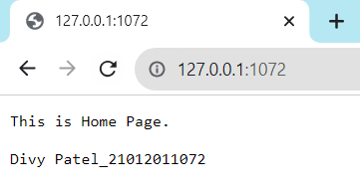

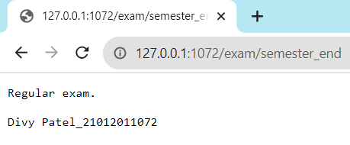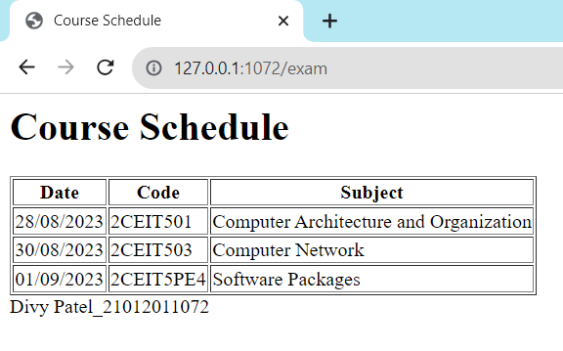

1. **In a given query string of URL, give two parameters num1 and num2 and assign integers values to them and then find the smallest number among those two numbers. [URL:localhost:8080/?num1=14&num2=40]**

**Code :-**

var http = require('http');

var url = require('url');

var server = http.createServer(function (req,res) {

    const q = url.parse(req.url, true).query;

    const num1 = q.num1

    const num2 = q.num2

    if(num1>num2){

        res.write(`${num1} is greater than ${num2}.`);

        res.write('\n\n21012011072_Divy Patel');

        res.end();

    }

    else if(num1 == num2){

        res.write(`${num1} and ${num2} are same.`);

        res.write('\n\n21012011072_Divy Patel');

        res.end();

    }

    else{

        res.write(`${num1} is smaller than ${num2}`);

        res.write('\n\n21012011072_Divy Patel');

        res.end();

    }

});

server.listen(1072);

**Output :-**

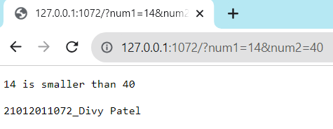

1. **Create a local module named as ‘todoList’ which contains 3 functions for adding, removing and listing tasks. Export it in another file main.js and display their result.**

**Code(P3_3.js) :-**

const tasks = [];

exports.addTask = function(task) {

    tasks.push(task);

}

exports.removeTask = function() {

    tasks.pop();

}

exports.listTasks = function() {

    return tasks;

}

**Code(P3_3-1.js) :-**

const todoList = require('./P3_3.js');

console.log(‘21012011072_Divy Patel’);

todoList.addTask('To do homework');

todoList.addTask('Go for playing cricket');

todoList.addTask('Go for sleep');

const tasks = todoList.listTasks();

console.log(`All tasks : ${tasks}`);

todoList.removeTask();

console.log('---------------After removing tasks---------------');

console.log(`Current tasks : ${tasks}`);

**Output :-**

