

Comprehensive digital marketing for havmor



March 23, 2025

HAVMOR

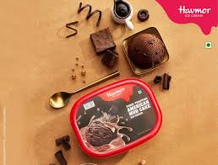

**Title of the project** : Comprehensive digital marketing for havmor

**Collage name:** *Vasavi mahila kalasala*

*Boya Divya Sri* – boyadivyasri05@gmail.com

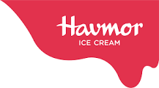

**Havmor was founded in 1944, and its registered office is located in Ahmedabad,** **Gujarat. The company is owned and operated by Lotte Wellfood after its acquisition in 2017. It holds a 12.5% market share in India's ice cream industry and a 35% market share in Gujarat.**

**Creating a comprehensive digital marketing strategy for Havmor, a popular ice cream brand, requires a well-rounded approach across various digital channels. Here's a detailed strategy that encompasses multiple elements to help enhance brand visibility, engage with a larger audience, and drive sales.**

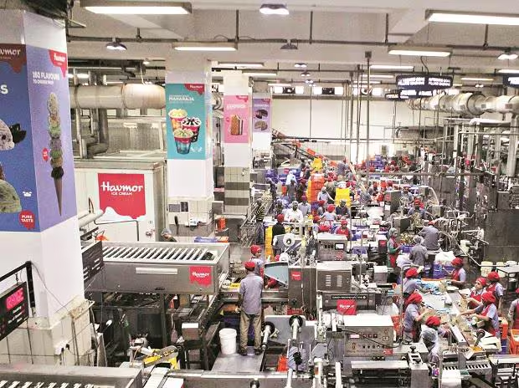

**Dairy is a place where handling of milk and milk  products is done and technology refers to the application of scientificknowledge for practical purposes. Dairy technology has been defend as that branch of dairy science, which deals with the processing of milk and themanufacture of milk products on an industrial scale.The Indian dairy industry has made rapid processsince independence. A large number of modern milk plants and productfactories have since been established. These organized dairies commercial production of pasteurized bottled milk and various western and Indian dairy products with modern knowledge of the protection of milk daily transportation,it became possible to locale dairies where land was less expensive and cropscould be grown more economically.On the basis of surveys in all the 29 states and 6union territories of the country the report announces that Rajasthan, Jammu &Kashmir, Utter Pradesh, Gujarat regions with maximum live stock population.**

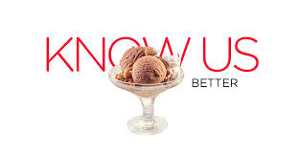

**. Havmor literally meaning H-A-V-E-M-O-R-E**

**. One of the best name for food business was coined by late Shri Stish ChandraChona as a ground engineer in British overseas Aircraft corporation.Havmor ice cream meets with all legal norms specifiedunder the law. ISO 9001:2000 certification signifies that there has been a welldocumented systems followed at every stages of processes during manufacturingof ice cream.Havmor ice-creams are made in a modern stateof the art technology plant at the Naroda Road in Ahmadabad. This plant was setup in 1994 with its co-friendly and hygienic. It is leading brand in ice-creams withgood market share in Gujarat and vast net work of distribution to reach every nook and corner. The ice-cream is available in candies, Big caps, Small caps, topo cones,novelties, family packs, party packs and seasonal flavors.**

**Operations :-**

**Havmor Ice Cream operates in more than 20 states, has 216 exclusive ice cream parlours, and a network of over 60,000 dealers in India. The company has approximately 70,000 selling points across India, catering to urban markets. It has manufacturing plants in**[**Ahmedabad**](https://www.wikiwand.com/en/articles/Ahmedabad)**,**[**Gujarat**](https://www.wikiwand.com/en/articles/Gujarat)**,**[**Faridabad**](https://www.wikiwand.com/en/articles/Faridabad)**,**[**Haryana**](https://www.wikiwand.com/en/articles/Haryana)**and one in**[**Solapur**](https://www.wikiwand.com/en/articles/Solapur)**,**[**Maharashtra**](https://www.wikiwand.com/en/articles/Maharashtra)**, which was launched in 2019. It also established a state-of-the-art facility in**[**Pune**](https://www.wikiwand.com/en/articles/Pune)**, Maharashtra.**

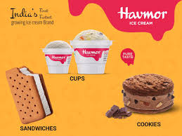

**Marketing :-**

**In 2012, the company launched the Zulu Bar, one of its products, and promoted it through television advertisements. In 2013, Havmor collaborated with the movie**[***Krrish 3***](https://www.wikiwand.com/en/articles/Krrish_3)**to introduce a custom-packaged ice cream range. As part of this campaign, actor**[**Hrithik Roshan**](https://www.wikiwand.com/en/articles/Hrithik_Roshan)**endorsed Havmor ice creams.**

**In 2016, Havmor launched a nationwide campaign with the tagline 'Goodness the World Deserves'. In 2017, it launched the Cool Gaiz animated campaign to highlight its "Made with Real Milk" positioning, which was later revived in subsequent years to promote its diverse range of products. In 2017, it became the official ice cream partner for**[**U Mumba**](https://www.wikiwand.com/en/articles/U_Mumba)**during the**[**Pro Kabaddi League**](https://www.wikiwand.com/en/articles/Pro_Kabaddi_League)**season. Havmor runs 'The Coolest Summer Job,' a program launched in 2017 that gives participants hands-on experience in ice cream making.**

**In September 2020, the company launched a web series titled *Havmor Passport*, starring actor**[**Malhar Thakar**](https://www.wikiwand.com/en/articles/Malhar_Thakar)**and written and directed by**[**Manan Desai**](https://www.wikiwand.com/en/articles/Manan_Desai)**. In 2023, Havmor became one of the sponsors of**[**Gujarat Titans**](https://www.wikiwand.com/en/articles/Gujarat_Titans)**, with cricketer**[**Hardik Pandya**](https://www.wikiwand.com/en/articles/Hardik_Pandya)**as the brand ambassador and launched two TVCs featuring him during the**[**2023 Indian Premier League**](https://www.wikiwand.com/en/articles/2023_Indian_Premier_League)**.**

**Finance :-**

**Havmor reported approximately ₹1,200 crore in revenue for the fiscal year 2023. In the fiscal year 2015–16, the company had a turnover of approximately ₹450 crore, in which 85% of the revenue came from its ice cream business and the remaining 15% from its restaurant and fast-food chain operations.**

**In the FY 2016-17, Havmor reported an annual turnover of approximately ₹500 crore. The majority of its revenue, around 80%, came from the ice cream segment.**

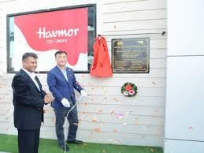

**Havmor company started in the year 1944 in karachi bySatishchandra chona. In the year 1951 the company began to supply ice-cream tothe restaurants. In 1953, the founder buys a place on relief rexes on the condition toserve only vegetarian for a quality product that offers value of money. In the year 1955 the Havmor began in Ahmedabad at Kalupur. After graduation Mr. Pradipchona joined full time business in 1974. Mrs. Rekha chona learnt secret formulaused in mixing of thanks from in low. She is also part of business master auto andMiss Rita will be the next in line to carry on the Havmor name it they with shriChona lifts Pakistan along with his wife smt. Nirmal chona in 1948and reachesAhmedabad via Dehradun and Indoor the founder began the Havmor legened inAhmedabad on the logan**

**“ACHAI, SACHAI,SAFAI”**

**.Today Havmor has also started its own restaurant and parlors. It is growing at a significant rate and has created a name of trust in themarket. The initial investment was five crore approximately. The company has 500dealers in Ahmedabad. The company celebrates its birth anniversary during**

**“DHANTERAS”**

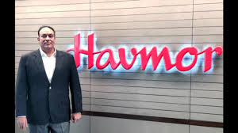

**Objectives of the company :-**

**The objectives of the company is “consumersSatisfaction” “Enhancement of Profit” & “To Earn profit by fulfilling socialobjectives.”**

**This objectives will be achieved by:-**

**1)Ensuring all products of the best quality.**

**2)Continuous innovation & introduction of new products for the benefits of the customers.**

**3)Up gradation of facilities for manufacturing of products of bestquality.**

**4)Reducing wastage & there by achieving lower cost of production.**

**5)To increase market share regionally and nationally.**

**6)To improve production efficiency.**

**“Quality must Always precede quality’’**

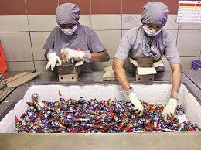

**1)Such a establishing & maintain leadership in Quality not necessarily quality.**

**2)Innovating continually, so that the company has something new to offer toits consumers every season.**

**3)Continuing to earn the respect of consumer and business associates thoughexcellent products.**

**4)Diversifying into related areas of food industry, to offer consumers morecomprehensive taste experiences.**

**5)Fine-blending new technology with market strategy.**

**6)And, by never taking the market for granted.**

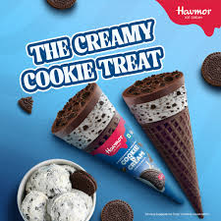

**“Goodness, Truthfulness,Cleanliness”**

**The Succeeding generations at the helm of thecompany translated this axiom into a way of life and business. Only the finestingredients go into the making of Havmor Ice Creams. The wholemanufacturing process conforms to global standards of hygiene. And the company’s trade practices are kept totally transparent.This mission is Based on new generation technologyand house R&D, the company keeps formulating new tastes at frequentintervals, and surprising its consumers. It has also diversified into other food items,through a high profile Restaurant Chain.Today, six decades later, Satish Chona’s simple philosophy still continues to be the corporate axiom of the Havmor Conglomerate.And the Company values its entrepreneurial self-esteem, market image and reputation for financial uprightness above its pure business interests.**

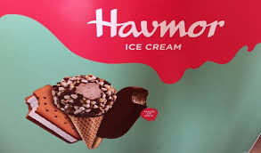

**Creating a comprehensive digital marketing strategy for Havmor, a popular ice cream brand, requires a well-rounded approach across various digital channels. Here's a detailed strategy that encompasses multiple elements to help enhance brand visibility, engage with a larger audience, and drive sales.**

1. **Brand Analysis and Goal Setting**

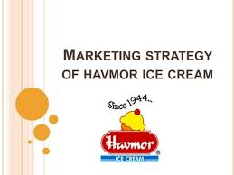

**Before launching any campaign, it's essential to understand Havmor's current positioning, target audience, and goals.**

**Goals might include:**

* **Increase brand awareness**
* **Drive website traffic and sales (online or offline)**
* **Promote new product lines or seasonal offers**
* **Build stronger customer loyalty**

**2. Website Optimization**

**The website should serve as a central hub for all digital marketing activities.**

* **Mobile Optimization: Ensure that the website is mobile-friendly since many users browse on mobile devices.**
* **SEO (Search Engine Optimization): Optimize for relevant keywords like “best ice cream in India,” “Havmor flavors,” or “Havmor ice cream near me.”**

**Focus on both on-page (content, meta tags, image alt texts) and off-page SEO (backlinks, local business listings).**

* **E-commerce Functionality: If not already in place, integrating an e-commerce option for customers to buy directly from the website can increase sales.**
* **Clear Call-to-Actions (CTAs): Implement clear CTAs to encourage users to make a purchase, sign up for newsletters, or locate nearby stores.**

**3. Content Marketing**

**Content marketing can help build brand identity and establish Havmor as a thought leader in the ice cream industry.**

* **Blog Posts & Recipes: Regularly post fun recipes, serving ideas, and nutritional information. Engage with your audience by sharing ice cream-making tips or pairing suggestions.**

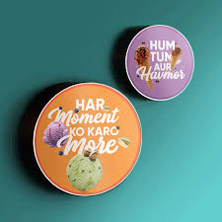

* **User-Generated Content (UGC): Encourage customers to share their experiences with Havmor ice cream via social media posts or videos using branded hashtags like #HavmorDelights or #HavmorLove.**
* **Video Content: Short-form videos showcasing the ice cream-making process, behind-the-scenes footage, or recipe tutorials can resonate well on platforms like YouTube, Instagram Reels, and TikTok.**
* 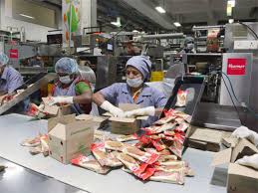
* **Influencer Collaborations: Partner with influencers in the food, lifestyle, or entertainment niche for sponsored posts, giveaways, or product reviews.**

**4. Social Media Marketing**

**Social media platforms are vital for engaging directly with Havmor's target audience.**

* **Instagram: Utilize high-quality images and videos of the ice creams in a visually appealing format. Use features like Stories, Reels, and IGTV to provide more dynamic content.**
* **Facebook: Engage in contests, polls, and discussions. Facebook ads can be used to target specific age groups, geographies, or preferences.**
* **TikTok: Create viral challenges or collaborate with trending content creators to spread the message in a fun and engaging way.**
* **Twitter: Share promotions, respond to customer queries, and join in trending conversations related to ice cream or food.**

**5. Paid Advertising**

**Paid campaigns can complement organic efforts and provide an immediate impact.**

* **Google Ads (Search & Display): Target users searching for ice cream and related products. You can also run display ads on relevant websites and food blogs to attract more attention.**
* **Social Media Ads: Run targeted ads on Facebook, Instagram, or YouTube to reach specific demographics. Use carousel ads to showcase a variety of flavors or product types.** 
  + **Focus on visually appealing content that triggers cravings for ice cream.**
  + **Retarget users who have previously interacted with the website or social media pages.**

**6. Email Marketing**

**Email marketing helps keep the audience engaged and informed about promotions.**

* **Newsletter: Share monthly newsletters that highlight new flavors, seasonal offers, or interesting facts about ice cream.**
* **Personalized Offers: Use customer data to send personalized discounts or birthday offers.**
* **Abandoned Cart Emails: If Havmor offers an e-commerce platform, abandoned cart emails can encourage users to complete their purchases.**

**7. Influencer & Affiliate Marketing**

**Leveraging influencers or affiliates can help expand brand reach and credibility.**

* **Food Bloggers and Instagram Influencers: Collaborate with influencers who have an established following in the food and lifestyle niches to promote Havmor's products.**
* **Affiliate Programs: Set up affiliate partnerships where influencers or affiliates receive a commission for every sale made through their referral link.**
* 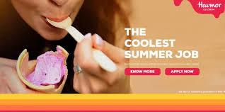

**8. Customer Engagement and Community Building**

**Create a loyal community around the brand for ongoing engagement.**

* **Customer Feedback & Reviews: Encourage reviews and ratings on platforms like Google, Amazon, and Swiggy/Zomato (if applicable). Respond to feedback, both positive and negative, to show that the brand cares.**
* 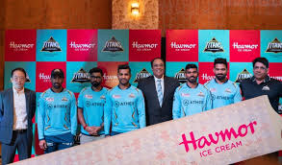
* **Loyalty Programs: Offer incentives such as discounts, special offers, or exclusive flavor releases to repeat customers. You could create a mobile app for easy access to loyalty programs.**
* **Contests & Giveaways: Run social media contests or create challenges where people can win free ice cream for sharing their best experiences with Havmor.**

**9. Local SEO and Listings**

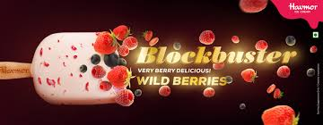

**Optimizing for local search can drive foot traffic to Havmor stores (if applicable).**

* **Google My Business (GMB): Ensure that Havmor's physical locations are listed and optimized with accurate information, photos, and customer reviews.**
* **Local SEO: Use location-based keywords like "ice cream near me" or "best ice cream in [city]."**
* **Partnership with Local Delivery Apps: Partner with apps like Swiggy or Zomato to increase local visibility and drive online sales.**

**10. Analytics & Tracking**

**Measure the performance of all digital marketing efforts to adjust strategies as needed.**

* **Google Analytics: Track website traffic, conversions, and customer behavior to identify successful campaigns.**
* **Social Media Insights: Use built-in analytics from platforms like Instagram and Facebook to understand audience engagement and refine content strategies.**
* **A/B Testing: Regularly test ad copy, landing pages, and social media posts to understand what works best for different customer segments.**

**Good Taste :**

-A Great Business Strategy

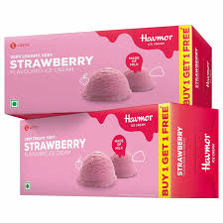

**Founded :-**

1944.

**Current Market Status :**

- Blue Chip Ice Creams brand of Western India. Among the top three in sales

**Dealer Network :-**

5,000-plus. Expansionunderway.

**Main Outlets :-**

Total 8 no of Parlors &Restaurants spread out in Ahmedabad and Vadodara. More in the pipeline.

**Diversification:-** Outdoor catering.

**IceCreams:**

 Candies, Topo Cones, Ready-to-eat-range, novelties,takeaway packs, Kulfis etc.

