**A MINIPROJECT ON**

**e-MAGAZINE**

*Submitted by*

|  |  |
| --- | --- |
| A.CHARAN | 17121A1202 |
| A.MOUNIKA | 17121A1203 |
| B.GOVARDHAN | 17121A1204 |
| B.HARSHA | 17121A1205 |
| B.NAGADIVYA | 17121A1208 |
| G.VENNILA | 17121A1223 |



Department of Information Technology

SREE VIDYANIKETHAN ENGINEERING COLLEGE

(AUTONOMOUS)

(Affiliated to JNTUA Anantapur, Approved by AICTE Accredited by NBA & NAAC with ‘A’ grade)

Sree Sainath Nagar, A.Rangampet, Near Tirupati - 517 102. A.P.

2019-2020

**CONTENTS**

S.NO. TITLE PAGE NO.

ABSTRACT

1. INTRODUCTION 1
2. MODULES 2
3. HARDWARE & SOFTWARE 4

REQUIREMENTS

1. IMPLEMENTATION 5
2. RESULTS 6
3. CONCLUSION 10

REFERENCES 11

**ABSTRACT**

This project describes the concept for an electronic magazine (e-MAGAZINE) based on the World Wide Web. The project aims at creating an electronic magazine as the online version of an already existing printed scientific magazine, which will primarily supply the content.The articles in this e-MAGAZINE contain various types of media, including text, images. A keyword search as well as subscription is supported.

The project gives an overview of the general design of the e-magazine and focuses on some

key aspects of the concept.Keywords electronic multimedia magazine,hypermedia,Web

development.This project on based creating e-MAGAZINE for an institution.This e-

MAGAZINE for an institution.This is e-MAGAZINE consists of all the information of the

Institution.

**INTRODUCTION**

Electronic magazines and newspapers in the World Wide Web have gained a great popularity in the past two or three years. Nearly every major magazine and newspaper has a Web site, where either some selected or all of the articles can be read. e-MAGAZINEs are offering many advantages over conventional printed magazines. Articles can be published without delay and can be instantly accessed from all over the world. Comfortable searching mechanisms and individual collections of articles, depending on the readers interests, can be provided.. In a former project we have created HTML versions of the issues of a printed magazine. The result were static HTML pages, which were linked together and contained exactly the same articles as the printed issues. This approach had some serious disadvantages concerning the conversion process itself, as well as the functionality of the final electronic magazine. Any modification of the templates led to wrong classification of paragraphs, which had to be corrected manually. The manual part of the conversion process grew steadily, while the automatic part remained the same. Further, there was no easy way to add additional articles that were not part of a printed issue. This project on based creating an e-MAGAZINE for an institution.This e-MAGAZINE consists of all the information of the institution.Finally the authors have proposed this e-MAGAZINE to make the work more easy and interesting.

**2.MODULES**

2.1 REGISTRAITON PAGE

Internet of Things can connect devices embedded in various

systems to the internet. When devices/objects can represent themselves

digitally, they can be controlled from anywhere. The connecvity then helps us

capture more data from more places, ensuring more ways of increasing

eciency and improving safety and IoT security.

IoT is a transformaonal force that can help companies improve performance

through IoT analycs and IoT Security to deliver be er results. Businesses in

the ulies, oil & gas, insurance, manufacturing, transportaon, infrastructure

and retail sectors can reap the bene#ts of IoT by making more informed

decisions,

Internet of Things can connect devices embedded in various

systems to the internet. When devices/objects can represent themselves

digitally, they can be controlled from anywhere. The connecvity then helps us

capture more data from more places, ensuring more ways of increasing

eciency and improving safety and IoT security

Internet of Things can connect devices embedded in various

systems to the internet. When devices/objects can represent themselves

digitally, they can be controlled from anywhere. The connecvity then helps us

capture more data from more places, ensuring more ways of increasing

eciency and improving safety and IoT security

Internet of Things can connect devices embedded in various

systems to the internet. When devices/objects can represent themselves

digitally, they can be controlled from anywhere. The connecvity then helps us

capture more data from more places, ensuring more ways of increasing

eciency and improving safety and IoT security

Registration form is a list of fields that a user will input data into and

submit to a company or individual. Here the concepts used for registration form are php,

Bootstrap, html, java-script. Here in this a page a web-cam option is used to take the picture

of the particular user and set as their user profile photo.

2.2 : IOT : Internet of Things can connect devices embedded in various

systems to the internet. When devices/objects can represent themselves

digitally, they can be controlled from anywhere. The connecvity then helps us

capture more data from more places, ensuring more ways of increasing

eciency and improving safety and IoT security.

IoT is a transformaonal force that can help companies improve performance

through IoT analycs and IoT Security to deliver be er results. Businesses in

the ulies, oil & gas, insurance, manufacturing, transportaon, infrastructure

and retail sectors can reap the bene#ts of IoT by making more informed

decisions, aided by the torrent of interaconal and transaconal data at their

disposal

2.2 LOGIN PAGE

Login page is a form of consisting authentication credentials such as username and

password. Here in this page the username and password must be entered to login into the

main page and access the e-MAGAZINE main page. Here the concepts used are php, html,

bootstrap and j-query.

2.3 NEWSFEED PAGE

The newsfeed page is used to upload or post the upcoming events that

are happening in the institution. The users also can post any information regarding the events

that are going to conducted . This page gives the timely information of everything that is

happening in the college. The concepts used are bootstrap database and php.

2.2 : IOT IOT:

Internet of Things can connect devices embedded in various

systems to the internet. When devices/objects can represent themselves

digitally, they can be controlled from anywhere. The connecvity then helps us

capture more data from more places, ensuring more ways of increasing

eciency and improving safety and IoT security.

IoT is a transformaonal force that can help companies improve performance

through IoT analycs and IoT Security to deliver be er results. Businesses in

the ulies, oil & gas, insurance, manufacturing, transportaon, infrastructure

and retail sectors can reap the bene#ts of IoT by making more informed

decisions,

2.4 EVENTS PAGE

Events module shows us the different kinds of events that occur in

our college. The admin can add the event in the website using his login.

Admin has a unique Login Id and Password. After login Admin can create an event.

The triggered event is stored in the database.. The events Stored in the database are dispalyed

to the website users. The concepts used are html, java-script, php and sql.

2.5 CONTACT- US

This contact-us page is used to contact the particular website

administrator for any queries regarding the website or the page . The concepts used are

bootstrap.

Internet of Things can connect devices embedded in various

systems to the internet. When devices/objects can represent themselves

digitally, they can be controlled from anywhere. The connecvity then helps us

capture more data from more places, ensuring more ways of increasing

eciency and improving safety and IoT security.

IoT is a transformaonal force that can help companies improve performance

through IoT analycs and IoT Security to deliver be er results. Businesses in

the ulies, oil & gas, insurance, manufacturing, transportaon, infrastructure

and retail sectors can reap the bene#ts of IoT by making more informed

decisions, aided by the torrent of interaconal and transaconal data at their

disposal

1. **HARDWARE AND SOFTWARE REQUIREMENTS**

Minimum software requirements

1.XAMPP-windows-x64-7.3.10.0-VC15 is installed to run php programs in this project.

2. OS: Windows, Linux, Mac OS etc.

3. BROWSERS: Google chrome, Mozilla fire fox, Safari etc.

Minimum hardware requirements

1.4GB RAM AND 1TB Hard disk more than enough to execute and run this application.

2.32-bit or 64-bit processor is needed to fetch, decode and execute the instructions.

**4.IMPLEMENTATION**

4.1 REGISTRAITON PAGE

Internet of Things can connect devices embedded in various

systems to the internet. When devices/objects can represent themselves

digitally, they can be controlled from anywhere. The connecvity then helps us

capture more data from more places, ensuring more ways of increasing

eciency and improving safety and IoT security.

IoT is a transformaonal force that can help companies improve performance

through IoT analycs and IoT Security to deliver be er results. Businesses in

the ulies, oil & gas, insurance, manufacturing, transportaon, infrastructure

and retail sectors can reap the bene#ts of IoT by making more informed

decisions,

Internet of Things can connect devices embedded in various

systems to the internet. When devices/objects can represent themselves

digitally, they can be controlled from anywhere. The connecvity then helps us

capture more data from more places, ensuring more ways of increasing

eciency and improving safety and IoT security

Internet of Things can connect devices embedded in various

systems to the internet. When devices/objects can represent themselves

digitally, they can be controlled from anywhere. The connecvity then helps us

capture more data from more places, ensuring more ways of increasing

eciency and improving safety and IoT security

Internet of Things can connect devices embedded in various

systems to the internet. When devices/objects can represent themselves

digitally, they can be controlled from anywhere. The connecvity then helps us

capture more data from more places, ensuring more ways of increasing

eciency and improving safety and IoT security

Registration form is a list of fields that a user will input data into and

submit to a company or individual. Here the concepts used for registration form are php,

Bootstrap, html, java-script. Here in this a page a web-cam option is used to take the picture

of the particular user and set as their user profile photo.

2.2 : IOT : Internet of Things can connect devices embedded in various

systems to the internet. When devices/objects can represent themselves

digitally, they can be controlled from anywhere. The connecvity then helps us

capture more data from more places, ensuring more ways of increasing

eciency and improving safety and IoT security.

IoT is a transformaonal force that can help companies improve performance

through IoT analycs and IoT Security to deliver be er results. Businesses in

the ulies, oil & gas, insurance, manufacturing, transportaon, infrastructure

and retail sectors can reap the bene#ts of IoT by making more informed

decisions, aided by the torrent of interaconal and transaconal data at their

disposal

4.2 LOGIN PAGE

Login page is a form of consisting authentication credentials such as username and

password. Here in this page the username and password must be entered to login into the

main page and access the e-MAGAZINE main page. Here the concepts used are php, html,

bootstrap and j-query.

4.3 NEWSFEED PAGE

The newsfeed page is used to upload or post the upcoming events that

are happening in the institution. The users also can post any information regarding the events

that are going to conducted . This page gives the timely information of everything that is

happening in the college. The concepts used are bootstrap database and php.

2.2 : IOT IOT:

Internet of Things can connect devices embedded in various

systems to the internet. When devices/objects can represent themselves

digitally, they can be controlled from anywhere. The connecvity then helps us

capture more data from more places, ensuring more ways of increasing

eciency and improving safety and IoT security.

IoT is a transformaonal force that can help companies improve performance

through IoT analycs and IoT Security to deliver be er results. Businesses in

the ulies, oil & gas, insurance, manufacturing, transportaon, infrastructure

and retail sectors can reap the bene#ts of IoT by making more informed

decisions,

4.4 EVENTS PAGE

Events module shows us the different kinds of events that occur in

our college. The admin can add the event in the website using his login.

Admin has a unique Login Id and Password. After login Admin can create an event.

The triggered event is stored in the database.. The events Stored in the database are dispalyed

to the website users. The concepts used are html, java-script, php and sql.

4.5 CONTACT- US

This contact-us page is used to contact the particular website

administrator for any queries regarding the website or the page . The concepts used are

bootstrap.

|  |  |
| --- | --- |
|  |  |

**5. RESULTS**

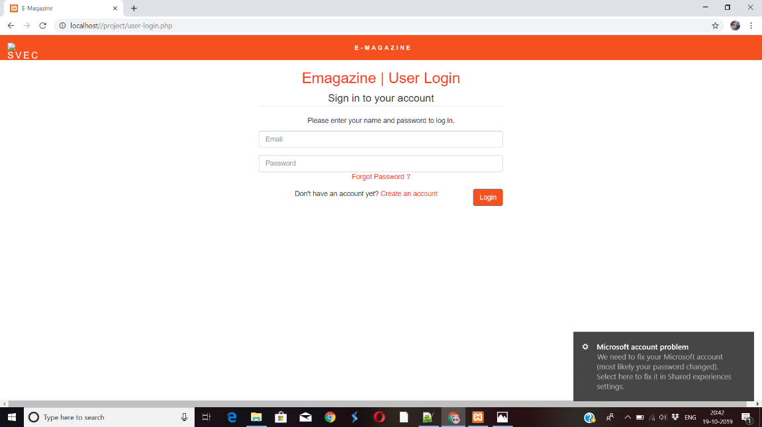

Fig. 5.1 login page for e-MAGAZINE

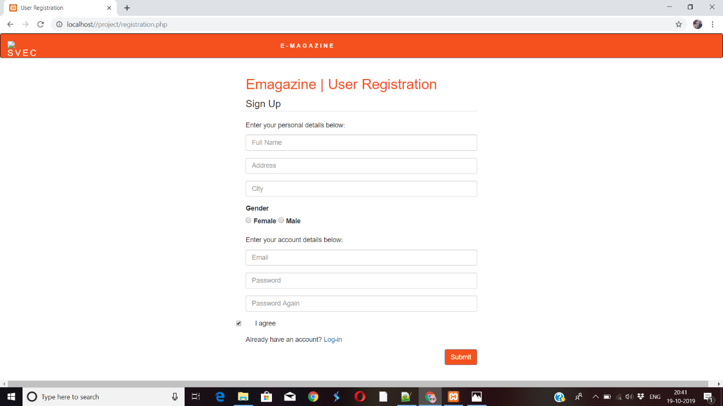

Fig. 5.2 on clicking ‘create an account’ your account will be created if you don’t have one!



Fig. 5.3 after logging into your account main page is displayed!



Fig. 5.4 selecting ‘events’ menu

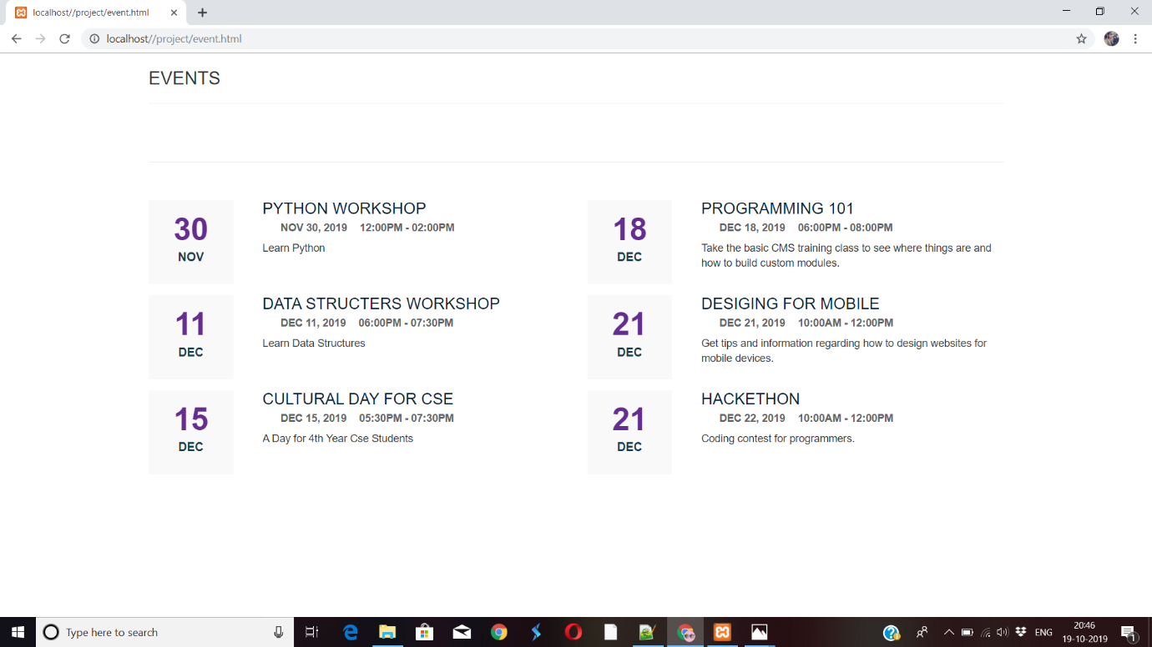

Fig. 5.5 on selecting ‘events’ it shows above page

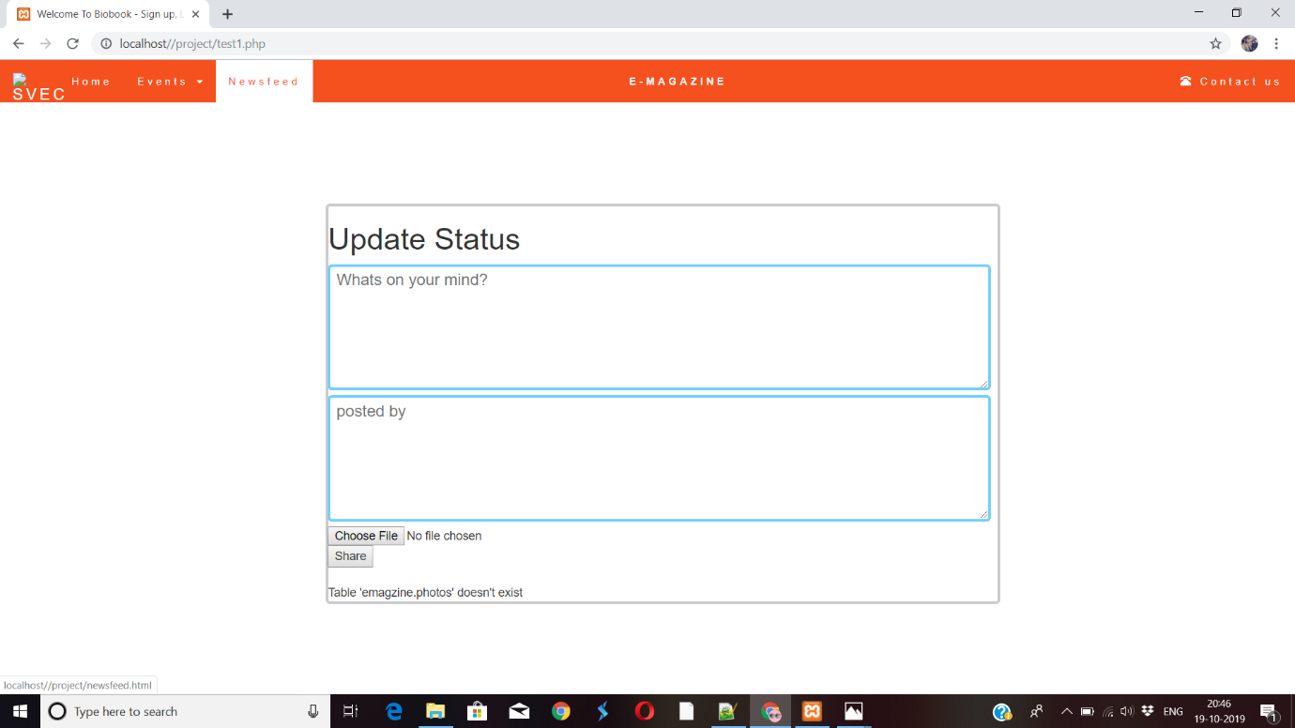

Fig. 5.6 the given page is the newsfeed page

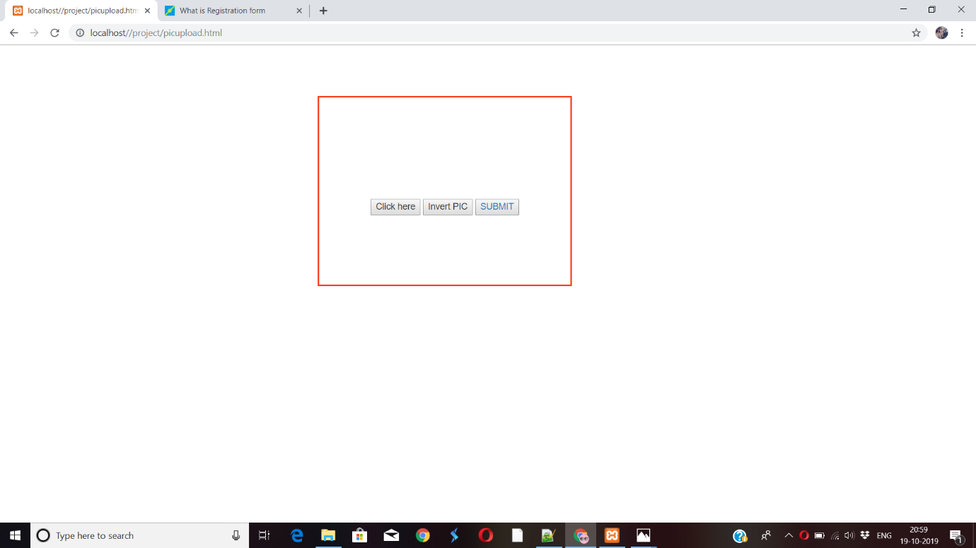

Fig. 5.7 The above given page is the webcam page which inserts the user profile page.

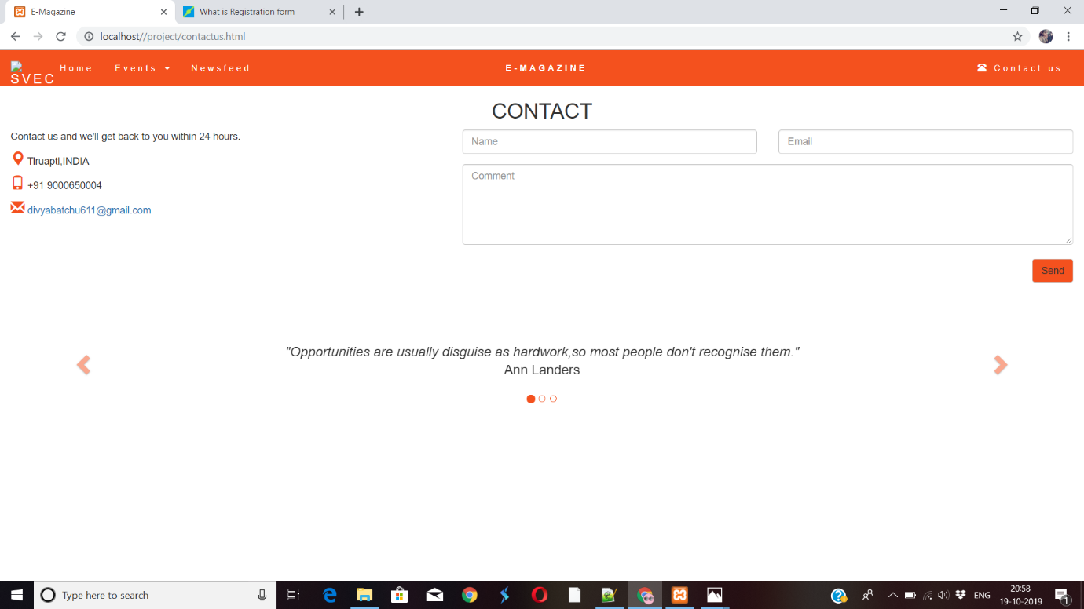

Fig. 5.8 The above page is the contact us page

**6.CONCLUSION**

Here we include all the information needed to the related institution in the e-

MAGAZINE.Now, this makes the the students to know any information related to the

college.By creating this e-MAGAZINE we save time and money by not wasting more

papers and money to print a original hand made Magazine.

**REFERENCES**

TEXTBOOK:

1. Kogent Learning Solutions Inc, HTML 5 Black Book: Covers CSS3, JavaScript, XML, XHTML, AJAX, PHP and JQuery, Dreamtech Press, Second Edition, 2016.
2. . W. Jason Gilmore, Beginning PHP and MySQL, APress, Fourth Edition, 2011.

REFERENCE BOOKS:

1. Snig Bahumik , Bootstrap Essentials, PACKT Publishing, 2015 (e-book).

2. Thomas A. Powell, The Complete Reference: HTML and CSS,Tata McGraw Hill,

Fifth Edition, 2010.

3. Andrea Tarr, PHP and MySQL, Willy India, 2012.