Customer Shopping Behavior
Analytics Project Report

An End-to-End Data Analytics Project
Python • MySQL • Power BI
Prepared by: Divya OS
Date: April 2026

1. Executive Summary
This report presents a comprehensive data analytics project conducted on a retail company's customer shopping behavior dataset containing 3,900 records across 18 variables. The project follows a complete end-to-end analytics pipeline — from raw data ingestion and preprocessing in Python (Jupyter Notebook), through structured SQL analysis in MySQL Workbench, to interactive visualization in Microsoft Power BI.
The central business question driving this project is:
"How can the company leverage consumer shopping data to identify trends, improve customer engagement, and optimize marketing and product strategies?"
Key findings include: 79.9% of customers are loyal (10+ purchases), non-subscribers represent 73% of the customer base and generate $170K in total revenue compared to $63K from subscribers (reflecting volume difference not per-head spend), Clothing is the top revenue-generating category at $104K, and Fall is the peak shopping season at $60K.

2. Project Overview

2.1 Business Objective
The retail company seeks to better understand its customers' shopping behavior in order to:
- Improve sales performance through data-driven product and pricing strategies
- Enhance customer satisfaction by understanding preferences and rating patterns
- Build long-term customer loyalty through targeted subscription and engagement programs
- Optimize marketing spend by identifying high-value customer segments and seasonal patterns

2.2 Dataset Overview
The dataset contains 3,900 customer transaction records with the following key attributes:
Category | Columns | Examples
Demographics | Customer ID, Age, Gender, Location | Age: 18-70, 50 US states
Purchase Info | Item, Category, Amount, Season | $20-$100, 4 seasons, 4 categories
Behavior | Frequency, Previous Purchases, Subscription | 7 frequency types, 1-50 previous purchases
Feedback | Review Rating, Shipping Type, Payment Method | Rating: 2.5-5.0, 6 shipping types

2.3 Technology Stack

Tool | Purpose | Technology | Key Tasks
Python (Jupyter) | Data Preprocessing & Feature Engineering | pandas, numpy, sqlalchemy | Null imputation, column renaming, feature creation, duplicate removal, MySQL export
MySQL Workbench | Data Analysis & SQL Querying | MySQL 8.0 | 10 business queries: CTEs, Window Functions, Subqueries, GROUP BY aggregations
Power BI | Data Visualization & Dashboard | Power BI Desktop | 2-page interactive dashboard with slicers, KPI cards, scatter plot, map, donut charts

3. Python Analysis (Jupyter Notebook)

3.1 Data Loading & Initial Exploration
The dataset was loaded into a pandas DataFrame in Jupyter Notebook for local execution. Initial exploration involved:
- df.shape — confirmed 3,900 rows x 18 columns
- df.info() — identified data types; 13 object columns, 4 integer, 1 float
- df.describe() — statistical summary showing purchase_amount range $20-$100, avg $59.76
- df.isnull().sum() — identified 37 null values only in review_rating column

3.2 Data Preprocessing
Null Value Treatment
The 37 missing values in review_rating (approximately 0.95% of data) were imputed using a group-wise median strategy rather than a simple global median. This approach preserves category-level rating patterns:
df['review_rating'] = df.groupby('Category')['review_rating'].transform(lambda x: x.fillna(x.median()))
Column Standardization
- Column names converted to lowercase with underscores for SQL compatibility
- purchase_amount_(usd) renamed to purchase_amount for cleaner referencing
- Identified that discount_applied and promo_code_used columns contain identical values
- Dropped promo_code_used as a redundant column, reducing dimensionality

3.3 Feature Engineering
Age Group Column
Created an age_group column using pd.qcut() with 4 quantile-based bins: Young Adult, Adult, Middle-aged, Senior. Quantile-based binning ensures equal distribution across segments.
Purchase Frequency Days Column
Mapped the categorical frequency_of_purchases column to numeric purchase_frequency_days (days between purchases) enabling quantitative frequency comparison.

3.4 Data Export to MySQL
The cleaned and engineered DataFrame was exported to MySQL using SQLAlchemy with the PyMySQL connector. The processed table (customer_shopping) was loaded into the customer_shopping_behavior database, making the age_group and purchase_frequency_days columns available for SQL analysis.

4. MySQL Analysis

4.1 Database Setup
A dedicated database named customer_shopping_behavior was created in MySQL Workbench (MySQL 8.0). The preprocessed DataFrame from Python was loaded directly into the customer_shopping table.

4.2 SQL Queries Summary

# | Query | Business Purpose
Q1 | Revenue by Gender | Identifies which gender drives more revenue for targeted marketing
Q2 | High-spend discount users | Finds customers who use discounts but still spend above average
Q3 | Top 5 rated products | Product quality signals for inventory and promotion decisions
Q4 | Shipping type vs spend | Tests if shipping preference correlates with purchase value
Q5 | Subscriber vs non-subscriber spend | Quantifies the revenue impact of subscription program
Q6 | Top discounted products | Identifies which products rely most on discounts to sell
Q7 | Customer segmentation (CTE) | Segments customers into New, Returning, Loyal using purchase history
Q8 | Top 3 products per category (Window) | Uses ROW_NUMBER() to rank products within each category
Q9 | Repeat buyers & subscription | Checks if frequent buyers are also subscribers
Q10 | Revenue by age group | Uses engineered age_group column for demographic revenue analysis

4.3 Key SQL Techniques Used
- Aggregate Functions — SUM(), AVG(), COUNT(), ROUND() for revenue and rating calculations
- Correlated Subquery (Q2) — Filters customers against a dynamically computed average
- Common Table Expression / CTE (Q7, Q8) — Used for customer segmentation and product ranking
- Window Function (Q8) — ROW_NUMBER() OVER (PARTITION BY category) for top-N per group
- CASE WHEN (Q6, Q7) — Conditional logic for discount rate and segment labeling

5. Power BI Dashboard

5.1 Dashboard Structure
The Power BI report consists of two pages, each targeting a specific analytical theme with interactive slicers for Location and Subscription Status filtering.

5.2 Page 1 — Customer Trends & Shopping Behavior
KPI Cards

KPI | Value | KPI | Value | Insight
Total Customers | 3,900 | Avg Purchase Value | $59.76 | Healthy transaction size
Total Revenue | $233K | Average Rating | 3.75 / 5 | Above average satisfaction
Subscribers | 1,050 (27%) | Loyal Customers | 79.9% | Strong retention base

Visuals on Page 1
- Seasonal Shopping Behavior — Fall $60K (peak), Summer $56K (weakest), Spring and Winter ~$59K
- Shopping Behavior by Age Group — Fairly even distribution across Young Adult, Senior, Middle-aged, Adult
- Top 5 Most Rated Products — Jewelry 3.8, Dress/Pants/Blouse 3.7, Shirt 3.6
- Revenue by Product Category — Clothing $104K > Accessories $74K > Footwear $36K > Outerwear $19K
- Purchase by Customer Segment — Loyal $185K, Returning $43K, New $5K
- Customer Distribution by Location — Geographic spread across all 50 US states

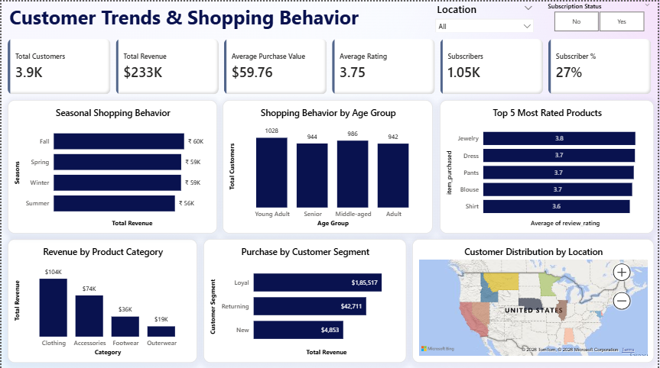

5.3 Page 2 — Engagement, Loyalty & Strategy Insights
- Customer Loyalty Segments (Donut) — Loyal 79.9%, Returning 17.97%, New 2.13%
- Subscription Impact — Non-subscribers $170K (73% of customers) vs Subscribers $63K (27% of customers)
- Discount Effectiveness — No discount $134K vs With discount $99K
- Preferred Payment Methods — Six methods near equally distributed (~16-17% each)
- Revenue by Product & Discount Status — Category-level discount impact comparison
- Total Revenue by Shipping Type — All types $38-41K, confirming no significant variation
- Product Opportunity Matrix — Scatter plot of category performance: avg rating vs total customers
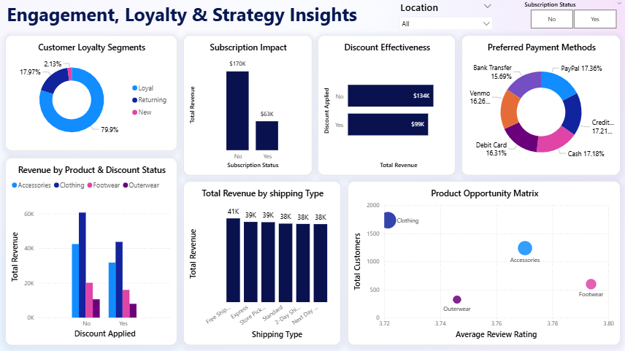

6. Key Business Insights & Recommendations
The following table summarizes the primary findings from the analysis and their corresponding business recommendations. Note: The Subscription Impact row has been corrected to accurately reflect the data.

Note on Subscription Impact Reading
Non-subscribers ($170K) vs Subscribers ($63K) — The higher non-subscriber revenue is purely a volume effect: 2,850 non-subscribers vs 1,050 subscribers. This means the average subscriber actually spends more per head proportionally. The business priority should be growing the subscriber base, not concluding that subscriptions reduce revenue.

Analysis Area | Finding | Business Recommendation
Revenue by Gender | Male customers generate slightly higher revenue than female customers | Target male customers with premium product campaigns; create female-specific promotions to close the gap
Customer Segmentation | 79.9% Loyal (10+ purchases), 17.97% Returning, only 2.13% New customers | Prioritize converting Returning customers to Loyal; launch referral programs to grow the New customer base
Subscription Impact (CORRECTED) | Non-subscribers generate $170K vs subscribers $63K. Non-subscribers are the majority (73%) and dominate total revenue. Subscribers have higher avg spend per head but fewer in number. | The subscription program needs urgent growth strategy. Convert high-spending non-subscribers to subscribers through incentives, trials, and exclusive offers to shift revenue balance
Discount Effectiveness | Non-discounted customers generate $134K vs $99K for discounted customers | Avoid blanket discounting — customers are willing to pay full price. Reserve discounts for re-engagement of lapsing customers only
Seasonal Trends | Fall is peak season ($60K), Summer is weakest ($56K), Spring and Winter are similar (~$59K) | Maximize marketing spend in Fall. Launch Summer-specific campaigns and promotions to boost the weakest season
Product Category Revenue | Clothing $104K > Accessories $74K > Footwear $36K > Outerwear $19K | Expand Clothing and Accessories inventory. Investigate low Outerwear performance — consider seasonal bundling or discontinuing slow SKUs
Top Rated Products | Jewellery leads at 3.8 rating; Dress, Pants, Blouse at 3.7; Shirt at 3.6 | Feature top-rated products on homepage, email campaigns, and recommendation engines. Use ratings as product promotion criteria
Shipping Type | All 6 shipping types generate nearly equal revenue ($38-41K) | Shipping type has no impact on purchase value. Optimize logistics costs by promoting lower-cost shipping options without fear of revenue loss
Payment Methods | All 6 payment methods nearly equally distributed (~16-17% each) | No single payment method dominates — customers have diverse preferences. Maintain all payment options; no checkout friction exists
Age Group Revenue | Revenue distributed fairly evenly across all age groups | Broad demographic appeal is a strength. Personalize product recommendations by age group to increase relevance and conversion

7. Strategic Business Recommendations
Based on the complete analysis across Python, MySQL, and Power BI, the following prioritized recommendations are proposed for the retail company's leadership and marketing teams:

Priority | Recommendation | Detail | Owner | Timeline
HIGH | Subscription Growth Campaign | 73% of customers are non-subscribers yet they drive $170K revenue. Launch a targeted subscription conversion campaign — offer 1-month free trial, exclusive discounts, or early access to new products for subscribers. Goal: convert at least 10% of non-subscribers within 6 months. | Marketing Team | 6 months
HIGH | Loyal Customer Retention Program | 79.9% of customers are loyal but with only 2.13% new customers entering, future growth is at risk. Introduce a tiered loyalty rewards program (Bronze, Silver, Gold) based on previous_purchases to maintain engagement and reward high-value customers. | CRM / Marketing | 3 months
HIGH | Fall Season Campaign | Fall is the peak revenue season at $60K. Allocate 35-40% of annual marketing budget to Fall campaigns. Pre-season teaser campaigns in late Summer can drive early engagement and extend the revenue peak. | Marketing Team | Annual / Q3
MEDIUM | Summer Revenue Boost | Summer is the weakest season at $56K — a 7% gap vs Fall. Launch Summer-exclusive promotions: flash sales, seasonal bundles, or Summer loyalty points multipliers to close the seasonal revenue gap. | Marketing / Product | Q2 each year
MEDIUM | Reduce Blanket Discounting | Discounted customers generate less total revenue ($99K) than non-discounted ($134K). Shift from blanket discounts to personalized offers — target only lapsing or at-risk customers with discount incentives rather than all customers. | Pricing / Marketing | Immediate
MEDIUM | Clothing & Accessories Expansion | Clothing ($104K) and Accessories ($74K) together account for 76% of total revenue. Expand SKU range in these categories, increase inventory depth, and feature them prominently in all marketing channels. | Product / Inventory | 6 months
MEDIUM | Feature Top-Rated Products | Jewelry (3.8), Dress, Pants, Blouse (3.7) have the highest ratings. Create a 'Top Rated' section on the website/app homepage and in email campaigns. Use review ratings as a sorting and recommendation signal. | Product / Tech | 3 months
LOW | Outerwear Performance Review | Outerwear generates only $19K — the lowest of all categories. Conduct product-level analysis to identify whether low performance is due to pricing, seasonality, or product-market fit. Consider bundling with Clothing during Fall/Winter. | Product Team | 3 months
LOW | Optimize Shipping Costs | All shipping types generate similar revenue ($38-41K). Since shipping preference does not affect purchase value, promote Free Shipping or Store Pickup options to reduce operational logistics costs without impacting revenue. | Operations | Ongoing
LOW | New Customer Acquisition | Only 2.13% of customers are New — the pipeline for future loyal customers is thin. Launch referral programs, social media campaigns, and first-purchase offers to grow the new customer base and feed the loyalty funnel. | Marketing Team | 6 months

7.1 Implementation Roadmap
Immediate (0-1 month) | Short-term (1-3 months) | Medium-term (3-6 months) | Long-term (6-12 months)
Stop blanket discounting. Switch to targeted discount strategy for at-risk customers only | Launch loyalty rewards program (Bronze/Silver/Gold tiers). Feature top-rated products on homepage | Run subscription conversion campaign. Expand Clothing and Accessories inventory | Design and execute Fall season mega-campaign. Launch referral program for new customer acquisition

7.2 Expected Business Impact
- Subscription growth from 27% to 35%+ could add approximately $30-40K in additional annual revenue
- Reducing Summer revenue gap by 50% through targeted promotions could recover $2K in seasonal revenue
- Shifting 20% of discount budget to loyalty rewards could improve loyal customer retention and increase average spend
- Promoting top-rated products in campaigns is expected to improve conversion rates by 10-15%

8. Conclusion
This project successfully demonstrates a complete data analytics workflow applied to a real-world retail business problem. The analysis reveals several actionable insights that directly address the business question of leveraging consumer shopping data to identify trends, improve engagement, and optimize strategy.
The most critical finding is the subscription program's under-penetration — with 73% of customers still non-subscribers generating $170K in total revenue, there is a significant opportunity to grow subscriber volume and potentially double subscription-driven revenue within 12 months. The dominance of loyal customers (79.9%) is a strength, but the very low new customer rate (2.13%) signals a future pipeline problem that requires immediate attention through referral and acquisition campaigns.
From a product strategy perspective, Clothing and Accessories should receive the majority of inventory and marketing investment, while the company should investigate Outerwear's underperformance. Top-rated products like Jewelry should be prominently featured in all marketing channels. Seasonal strategy should concentrate maximum spend around Fall and address the Summer revenue dip through targeted promotions.
The technical execution — clean Python preprocessing with intelligent feature engineering, well-structured SQL analysis using advanced query techniques, and a professional two-page Power BI dashboard with interactive filtering — demonstrates the core competencies expected of a data analyst. This project is portfolio-ready and effectively showcases analytical thinking, technical skills, business insight communication, and data storytelling ability.

