**Industrial Internship Report on**

**”BANKING INFORMATION SYSTEM”**

**Prepared by**

G.Divya

|  |
| --- |
| *Executive Summary* |
| This report provides details of the Industrial Internship provided by upskill Campus and The IoT Academy in collaboration with Industrial Partner UniConverge Technologies Pvt Ltd (UCT).  This internship was focused on a project/problem statement provided by UCT. We had to finish the project including the report in 6 weeks’ time.  My project was Banking Information System which includes functionalities of a real banking systemt:User registration,account management,deposit and withdrawl,fund transfer,account statement.  . User Registration:   * Form Creation: Create a user registration form that prompts users to input their personal details, such as name, address, contact information, and initial deposit amount. * Output: Upon successful registration, the system will generate a unique account number for the user, and the user's details will be stored in the system's memory or File System.   The output will be a confirmation message indicating successful registration.  2. Account Management:   * Form Creation: Develop an account management form that allows users to view and update their account information, such as name, address, contact details, and account settings. * Output: After making any updates or changes, the system will display a confirmation message indicating that the account information has been successfully updated.   This internship gave me a very good opportunity to get exposure to Industrial problems and design/implement solution for that. It was an overall great experience to have this internship. |

**TABLE OF CONTENTS**

1 Preface 3

2 Introduction 4

2.1 About UniConverge Technologies Pvt Ltd 4

2.2 About upskill Campus 8

2.3 Objective 9

2.4 Reference 9

2.5 Glossary 10

3 Problem Statement 11

4 Existing and Proposed solution 12

5 Proposed Design/ Model 13

5.1 High Level Diagram (if applicable) 13

5.2 Low Level Diagram (if applicable) 13

5.3 Interfaces (if applicable) 13

6 Performance Test 14

6.1 Test Plan/ Test Cases 14

6.2 Test Procedure 14

6.3 Performance Outcome 14

7 My learnings 15

8 Future work scope 16

# 

# Preface

Summary of the whole 6 weeks’ work.

About need of relevant Internship in career development.

Brief about Your project/problem statement.

Opportunity given by USC/UCT.

How Program was planned

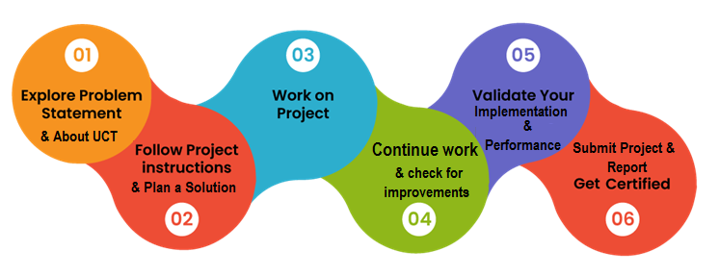

Your Learnings and overall experience.

Thank to all (with names), who have helped you directly or indirectly.

Your message to your juniors and peers.

# Introduction

## About UniConverge Technologies Pvt Ltd

A company established in 2013 and working in Digital Transformation domain and providing Industrial solutions with prime focus on sustainability and RoI.

For developing its products and solutions it is leveraging various**Cutting Edge Technologies e.g. Internet of Things (IoT), Cyber Security, Cloud computing (AWS, Azure), Machine Learning, Communication Technologies (4G/5G/LoRaWAN), Java Full Stack, Python, Front end**etc.



1. UCT IoT Platform **(****)**

**UCT Insight** is an IOT platform designed for quick deployment of IOT applications on the same time providing valuable “insight” for your process/business. It has been built in Java for backend and ReactJS for Front end. It has support for MySQL and various NoSql Databases.

* It enables device connectivity via industry standard IoT protocols - MQTT, CoAP, HTTP, Modbus TCP, OPC UA
* It supports both cloud and on-premises deployments.

It has features to  
• Build Your own dashboard  
• Analytics and Reporting  
• Alert and Notification  
• Integration with third party application(Power BI, SAP, ERP)  
• Rule Engine

 

1. **Smart Factory Platform (****)**

Factory watch is a platform for smart factory needs.

It provides Users/ Factory

* with a scalable solution for their Production and asset monitoring
* OEE and predictive maintenance solution scaling up to digital twin for your assets.
* to unleased the true potential of the data that their machines are generating and helps to identify the KPIs and also improve them.
* A modular architecture that allows users to choose the service that they what to start and then can scale to more complex solutions as per their demands.

Its unique SaaS model helps users to save time, cost and money.



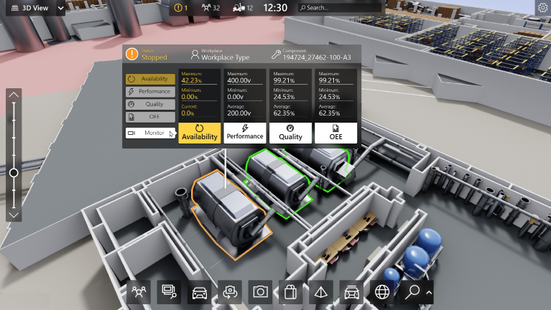

1.  based Solution

UCT is one of the early adopters of LoRAWAN teschnology and providing solution in Agritech, Smart cities, Industrial Monitoring, Smart Street Light, Smart Water/ Gas/ Electricity metering solutions etc.

1. Predictive Maintenance

UCT is providing Industrial Machine health monitoring and Predictive maintenance solution leveraging Embedded system, Industrial IoT and Machine Learning Technologies by finding Remaining useful life time of various Machines used in production process.



## About upskill Campus (USC)

upskill Campus along with The IoT Academy and in association with Uniconverge technologies has facilitated the smooth execution of the complete internship process.

USC is a career development platform that delivers **personalized executive coaching** in a more affordable, scalable and measurable way.



Seeing need of upskilling in self paced manner along-with additional support services e.g. Internship, projects, interaction with Industry experts, Career growth Services

upSkill Campus aiming to upskill 1 million learners in next 5 year

<https://www.upskillcampus.com/>

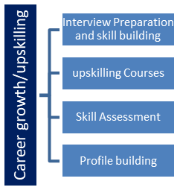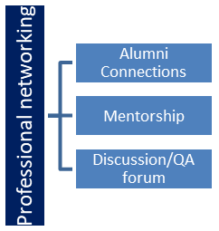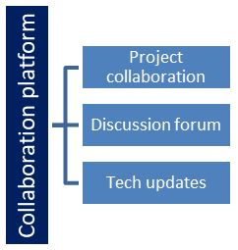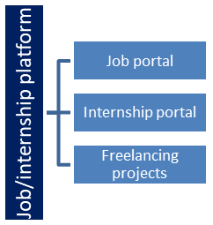

## The IoT Academy

The IoT academy is EdTech Division of UCT that is running long executive certification programs in collaboration with EICT Academy, IITK, IITR and IITG in multiple domains.

## Objectives of this Internship program

The objective for this internship program was to

 ☛ get practical experience of working in the industry.

 ☛ to solve real world problems.

 ☛ to have improved job prospects.

 ☛ to have Improved understanding of our field and its applications.

 ☛ to have Personal growth like better communication and problem solving.

## Reference

1. NetBeans - Official website of NetBeans IDE. Available at: <https://netbeans.apache.org/>
2. XAMPP - Official website of XAMPP, a popular Apache distribution containing MySQL. Available at: <https://www.apachefriends.org/index.html>
3. MySQL - Official website of MySQL, an open-source relational database management system. Available at: <https://www.mysql.com/>

## Glossary

|  |  |
| --- | --- |
| Terms | Acronym |
| IDE | Integrated Development Environment |
| JAR | Java Archive |
| MySQL | Structured Query Language |

# Problem Statement

The organization requires an HR Management System to automate and streamline HR processes, including employee information management, attendance and leave management, recruitment and onboarding, performance management, training and development, employee self-service, reporting and analytics, and ensure data security. The system should be user-friendly, scalable, and provide a seamless user experience to improve efficiency and decision-making within the organization.

* Employee Management:Add,view,update and delete employee records.
* Attendance Tracking:Mark Employees as present,absent,or on leave for specific dates
* Leave Management:Add,view,approve/reject leave requests.
* Employee Search:Search Employees by name,employee ID or Department.

# Existing and Proposed solution

**Existing Solutions:** There are several HR Management Systems available in the market that aim to automate and streamline HR processes. These solutions offer features such as employee information management, attendance and leave tracking, recruitment and onboarding modules, performance management tools, training and development modules, self-service portals, and reporting capabilities. Some popular existing solutions include SAP SuccessFactors, Workday, BambooHR, and Zoho People.

**Limitations of Existing Solutions:**

**Complexity:** Some existing HR Management Systems can be complex to implement and customize, requiring extensive training and expertise to utilize effectively.

**Cost:** Many existing solutions come with high upfront costs, licensing fees, and ongoing maintenance expenses, which may not be feasible for small or budget-constrained organizations.

**Limited Customization**: Some solutions may have limitations when it comes to customization, making it challenging to adapt to unique HR processes and workflows.

**User Experience:** The user interface of certain systems may be outdated or unintuitive, leading to difficulties in navigating and using the software effectively.

**Scalability:** Scaling existing solutions to accommodate organizational growth or changing needs can be complex and may require additional investments.

**Proposed Solution:** Our proposed solution is to develop a customized HR Management System tailored to the specific requirements of the organization. The solution will be built using modern technologies, including Java and MySQL, and leverage the Java Swing framework for the user interface. It will include modules for employee information management, attendance and leave tracking, recruitment and onboarding, performance management, training and development, employee self-service, reporting and analytics, and data security.

**Value Addition:**

**Customization:** Our solution will be highly customizable, allowing the organization to tailor the system to their unique HR processes and workflows.

**User-Friendly Interface:** We will focus on creating a user-friendly interface that is intuitive and easy to navigate, ensuring a seamless user experience for both HR personnel and employees.

**Cost-Effectiveness:** Our solution will aim to be cost-effective, providing value for money without compromising on functionality or quality.

**Scalability:** We will design the solution to be scalable, capable of accommodating organizational growth and changing HR requirements without significant challenges.

**Seamless Integration:** The proposed solution will have the ability to integrate with other systems or tools used within the organization, ensuring data consistency and reducing manual data entry.

By addressing the limitations of existing solutions and providing a customized, user-friendly, and cost-effective HR Management System, our proposed solution aims to enhance HR processes, improve efficiency, and add value to the organization's HR operations.

## Code submission (Github link)

<https://github.com/Nasina-Srilahari/HR-Management>

## Report submission (Github link)

<https://github.com/Nasina-Srilahari/Upskill-ProjectReport>

# Proposed Design/ Model

## Our proposed HR Management System will follow a modular and scalable design to ensure flexibility, maintainability, and ease of future enhancements. The system will consist of various modules, each catering to specific HR processes. Here is an overview of the proposed design flow:

## User Authentication and Access Control:

## Users will be required to authenticate themselves using unique credentials (username/password) to access the system.

## Access control mechanisms will be implemented to ensure that users can only access modules and perform actions based on their roles and permissions.

## Employee Information Management:

## The system will provide a module for managing employee information.

## HR personnel can add, view, update, and delete employee records, including personal details, contact information, employment history, salary, and benefits.

## Data validation and error handling mechanisms will be implemented to maintain data accuracy and integrity.

## Attendance and Leave Management:

## The system will include functionality for attendance tracking and leave management.

## Employees can mark their attendance using a digital system (e.g., biometric devices or web-based attendance marking).

## Employees can request leave through the system, and HR personnel can review and approve/reject leave applications.

## Attendance records and leave statuses will be stored and updated in the database for future reference.

## High Level Diagram (if applicable)

Emp mngt

DataBase

Login Records

Employee records

empl

employee

Leave Records

Attendance

Records

Figure 1: HIGH LEVEL DIAGRAM OF THE SYSTEM

## Low Level Diagram (if applicable)

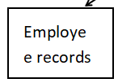

Remove Employee

Add Employee

Update Employee

View Employee

Attendance Records

Absent

Leave

Present

Leave Records

Approve or reject leave

View leave

Add leave

Login records

Password

Username

# Performance Test

Performance testing is crucial to ensure that the HR Management System can handle the expected load and perform efficiently. While I can provide general insights into performance considerations, it's important to note that actual performance testing would require specific hardware, software, and data to simulate real-world scenarios. Nonetheless, I can address the identification of constraints and recommendations to handle them:

**1. Scalability and Response Time:**

- Constraint: The system should be able to handle a growing number of employees and concurrent users while maintaining acceptable response times.

- Design Consideration: The proposed modular and scalable design allows for horizontal scaling by adding more servers or resources as the user base grows.

- Recommendations: Conduct performance tests with increasing user loads to identify bottlenecks and optimize system components accordingly. Employ caching mechanisms, database indexing, and efficient algorithms to enhance response times.

**2. Database Performance:**

- Constraint: The database should handle large amounts of employee data, attendance records, and leave records efficiently.

- Design Consideration: Utilize indexing, normalization, and appropriate database optimizations to ensure efficient data retrieval and manipulation.

- Recommendations: Perform load testing with a significant amount of data to measure database performance. Optimize database queries, use query caching, and consider database partitioning or sharding techniques to distribute data storage and improve scalability.

**3. User Interface Responsiveness:**

- Constraint: The user interface should provide a responsive and smooth experience to users, even under heavy load.

- Design Consideration: Implement client-side optimizations, such as asynchronous processing and caching, to reduce server requests and improve UI performance.

- Recommendations: Conduct usability testing and monitor UI responsiveness under different user loads. Optimize client-side code, use client-side caching, and leverage browser caching mechanisms to enhance user experience.

**4. Data Security and Privacy:**

- Constraint: Ensure that sensitive employee data is securely stored and accessed with appropriate authorization mechanisms.

- Design Consideration: Implement secure data storage, encryption, and access controls to protect employee information.

- Recommendations: Conduct security audits and penetration testing to identify vulnerabilities. Regularly update security measures, follow best practices, and comply with relevant data protection regulations.

**5. System Resource Utilization:**

- Constraint: The system should utilize hardware resources efficiently, including memory, CPU, and network bandwidth.

- Design Consideration: Employ resource optimization techniques, such as connection pooling, query optimization, and memory management strategies.

- Recommendations: Monitor resource utilization during performance testing to identify any resource bottlenecks. Optimize code, database queries, and network communication to reduce resource usage and improve overall system performance.

It's important to note that the identified constraints and recommendations may vary based on the specific implementation, hardware infrastructure, and user load. It is recommended to conduct comprehensive performance testing to gather accurate metrics and make informed decisions to optimize system performance and address any identified constraints.

## Test Plan/ Test Cases

1. Click on the “Click here to continue”
2. Login with the following credentials username: admin password: 12345
3. There you can add employee, update employee, view employee, remove employe, Mark attendance, view attendance and leave management
4. Click on each button and add data and check the data.

## Test Procedure

Test Case 1: Click on the "Click here to continue" button

1. Expected Result: The user is redirected to the login page.

Test Case 2: Login with the following credentials (username: admin, password: 12345)

1. Expected Result: The user is logged in and granted access to the HR Management System.

Test Case 3: Add Employee

1. Enter valid employee details in the required fields.

2. Click on the "Add Employee" button.

3. Expected Result: The employee details are successfully added to the system.

Test Case 4: Update Employee

1. Select an employee from the employee list.

2. Update one or more fields with valid data.

3. Click on the "Update Employee" button.

4. Expected Result: The employee details are successfully updated in the system.

Test Case 5: View Employee

1. Click on the "View Employees" button.

2. Expected Result: The system displays a list of all employees with their details.

Test Case 6: Remove Employee

1. Select an employee from the employee list.

2. Click on the "Remove Employee" button.

3. Expected Result: The selected employee is successfully removed from the system.

Test Case 7: Mark Attendance

1. Select an employee from the employee list.

2. Choose the attendance status (Present, Absent, or Leave).

3. Select the date for which the attendance is being marked.

4. Click on the "Mark Attendance" button.

5. Expected Result: The attendance for the selected employee and date is successfully marked in the system.

Test Case 8: View Attendance

1. Click on the "View Attendance" button.

2. Expected Result: The system displays a table showing the attendance records of employees for different dates.

Test Case 9: Leave Management

1. Click on the "Leave Management" button.

2. Perform leave-related operations such as adding leave requests, viewing leave requests, and approving/rejecting leave requests.

3. Expected Result: The leave management functionality operates correctly, allowing users to add, view, and manage leave requests.

It is important to note that these are just a few test cases to demonstrate the functionality of the HR Management System. In practice, it is recommended to develop a comprehensive test plan with a wider range of test cases, covering different scenarios and edge cases to ensure the system's robustness, reliability, and accuracy.

## Performance Outcome

1. Response Time: Performance testing helps measure the response time of the HR Management System under different user loads. The outcome can reveal whether the system meets the desired response time targets and identify any areas where optimization is required.

2. Scalability: Performance testing helps evaluate the scalability of the system, especially when handling a growing number of employees and concurrent users. The outcome can provide insights into how well the system can scale with increased user loads and whether additional resources or optimizations are necessary.

3. Resource Utilization: Performance testing helps monitor and analyze the utilization of system resources such as CPU, memory, and network bandwidth. The outcome can identify any bottlenecks or inefficiencies in resource utilization and guide improvements to optimize resource consumption.

4. Stability and Reliability: Performance testing helps identify stability and reliability issues by subjecting the system to heavy user loads and stress scenarios. The outcome can reveal any potential issues like crashes, memory leaks, or performance degradation over extended periods.

5. Recommendations and Optimization: Based on the performance test results, specific recommendations can be made to address any identified constraints or performance bottlenecks. Optimization measures may include code refactoring, database tuning, caching mechanisms, infrastructure scaling, or architectural improvements.

6. Future Performance Planning: Performance testing outcomes can help organizations plan for future growth and capacity requirements. The results can inform decisions on infrastructure upgrades, load balancing strategies, and performance optimizations to ensure the system can handle increasing user loads and maintain optimal performance.

It is essential to conduct thorough performance testing with realistic test scenarios, representative data, and load profiles to obtain accurate outcomes and make informed decisions for system performance improvements.

# My learnings

During my core Java internship, I gained valuable knowledge and practical experience in core Java programming, Swing GUI development, and MySQL database integration. Overall, the internship provided me with a solid foundation in Java development and equipped me with essential skills that will contribute to my career growth in several ways.

**1. Strong Java Fundamentals:** The internship allowed me to deepen my understanding of core Java concepts, such as object-oriented programming, data structures, exception handling, and multithreading. This knowledge forms the backbone of Java development and will serve as a strong foundation for my future career in Java programming.

**2. Swing GUI Development:** Through hands-on projects and assignments, I learned how to create user-friendly graphical user interfaces (GUI) using the Swing framework. This skill is highly valuable as it enables me to develop visually appealing and interactive applications that enhance the user experience.

**3. Database Integration with MySQL**: I gained practical experience in integrating Java applications with MySQL databases. This involved designing database schemas, executing SQL queries, and performing database operations within Java programs. Understanding database integration is crucial for building robust and data-driven applications.

**4. Problem-Solving and Debugging:** Throughout the internship, I encountered various programming challenges and learned effective problem-solving techniques. Debugging and troubleshooting skills were honed as I worked on real-world projects, enabling me to identify and resolve issues efficiently.

**5. Team Collaboration and Communication:** During the internship, I had the opportunity to work collaboratively in a team environment. This experience improved my communication and teamwork skills as I interacted with colleagues, participated in code reviews, and coordinated project tasks.

**6. Project Management and Time Management:** Working on projects with specific deadlines helped me enhance my project management and time management skills. I learned to prioritize tasks, allocate resources effectively, and meet project milestones in a timely manner.

**7. Professional Development:** The internship provided me with exposure to industry-standard coding practices and software development methodologies. It also allowed me to gain insights into the software development life cycle and the importance of documentation, testing, and version control.

Overall, my core Java internship has equipped me with a strong technical foundation, practical skills, and valuable experiences that will propel my career growth in Java development. I am confident that the knowledge gained during the internship will enable me to contribute effectively to Java-based projects and pursue further specialization in areas like web development, enterprise application development, or Android app development.

# Future work scope

**Future Work Scope:**

While developing an HR Management System, there may be certain ideas and features that could not be implemented due to time constraints or prioritization. Here are some potential areas for future work and enhancement:

1. Performance Analytics: Implement advanced analytics and data visualization techniques to provide deeper insights into employee performance metrics. This could include trend analysis, predictive analytics, and correlation analysis to identify patterns and make data-driven decisions.

2. Employee Engagement and Feedback: Introduce features to gather employee feedback and measure employee engagement. This could include surveys, sentiment analysis, and feedback mechanisms to understand employee satisfaction and improve overall employee experience.

3. Succession Planning: Develop a module for succession planning, allowing HR personnel to identify potential successors for key positions within the organization. This module could include talent assessment, skill mapping, and career development planning.

4. Integration with Payroll Systems: Integrate the HR Management System with payroll systems to streamline the payroll process. This would automate salary calculations, tax deductions, and other payroll-related tasks based on employee attendance and leave data.

5. Onboarding Automation: Enhance the onboarding module to automate and streamline the onboarding process further. This could include integrating with document management systems, automating task assignments, and providing a comprehensive onboarding checklist.

6. Learning Management System Integration: Integrate the HR Management System with a Learning Management System (LMS) to centralize training and development initiatives. This would enable employees to access training materials, track progress, and receive certifications through a unified platform.

7. Mobile Application: Develop a mobile application for the HR Management System, allowing employees to access their information, request leave, view attendance records, and receive notifications on the go. This would enhance accessibility and convenience for employees.

8. Employee Self-Service Enhancements: Expand the self-service portal functionality to include more self-service options for employees. This could involve allowing employees to update personal information, access company policies and documents, and submit service requests directly through the portal.

9. Advanced Security Features: Continuously enhance the system's security measures to protect sensitive HR data. This could involve implementing multi-factor authentication, encryption, and data anonymization techniques to ensure data privacy and compliance with data protection regulations.

10. Integration with Third-Party Tools: Explore integrations with external tools and systems commonly used in HR operations, such as recruitment platforms, performance tracking software, and employee engagement tools. This would provide a seamless workflow and enable data synchronization between systems.

These future work areas aim to further enhance the HR Management System, improve functionality, and cater to evolving organizational needs. Prioritization of these ideas can be based on the organization's specific requirements, resources, and strategic objectives.