Step 1:

Make sure M1_XYZ.mat file is in pwd/Montages. Currently, this file supports only 64-channel settings.

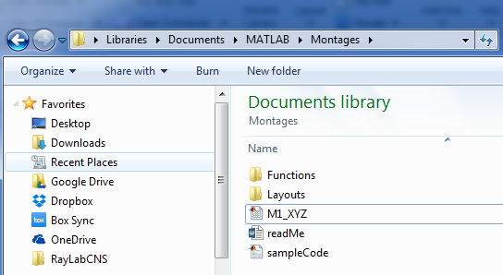

Step 2:

Add a .mat file in the format [*capName* ‘Labels.mat’] in the folder pwd/Montages/Layouts/*capName* folder.

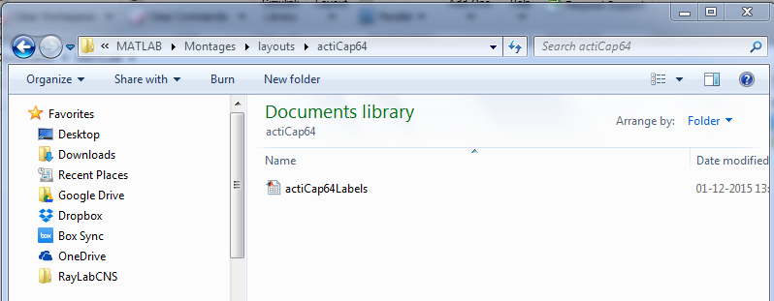

This is an nX2 cell with the variable name *montageLabels*, where n represents the no. of electrodes, 1st column is the physical number of the electrode, and 2nd column is the standard label of the electrode. The label should be in the international system and be present in M1_XYZ.mat file.

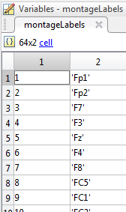

Step 3:

Run the sample code for unipolar reference to generate *capName*.mat and *capName*.xyz in the cap’s directory.

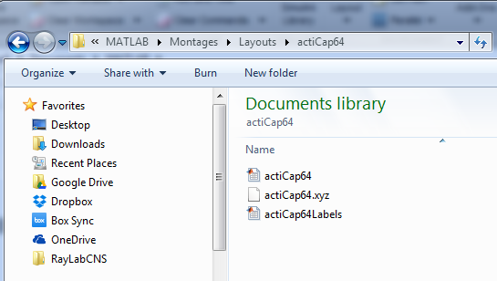

Step 4:

Add a file [‘bipChInfo’ upper(*capName*(1)) capName(2:end) ‘.mat’] in the cap’s folder.

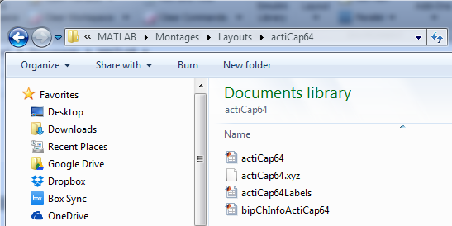

This is an nX2 matrix. Each row represents the physical number of the new bipolar electrode, with physical numbers of the two participating unipolar electrodes specified in column 1 and column 2. This matrix has a variable name *bipolarLocs*.

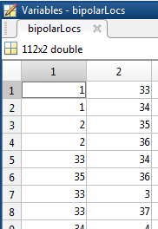

Step 5:

Run the sample code for bipolar channels. This generates [‘bipolarChanlocs’ upper(*capName*(1)) capName(2:end) ‘.mat’] and [‘bipolarChanlocs’ upper(*capName*(1)) capName(2:end) ‘.xyz’] in the cap’s folder.

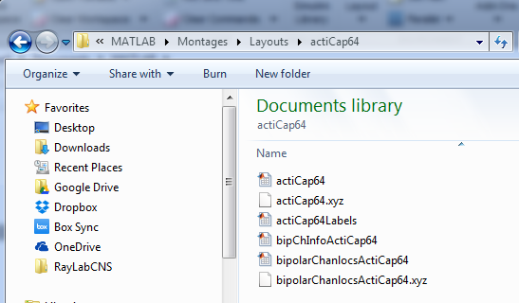

So, bingo... It is ready… .xyz format could be used in EEGLAB. .mat format could be passed as the *chanlocs* argument for topoplot.m function.

Do report any bugs/suggestions to MD at [murtydinavahi@gmail.com](mailto:murtydinavahi@gmail.com)