TRACE
Tool for Reviewing Algorithms, Complexity & Efficiency

1. The Problem — Why DSA Students & Practicing Developers Struggle

Millions of junior developers and students solve algorithmic coding problems on platforms daily to prepare for upcoming technical interviews. However, standard testing environments only verify if a code block passes basic predefined test inputs—they completely fail to teach the developer why their code logic is inherently inefficient or how their recurring structural coding habits appear to real-world engineering teams.

The Real User Pain Points

User Pain Point | Real-World Learning Sabotage
"Green Checkmark"  False Security | A solution passes test cases, so the user stops editing. They do not realize they wrote a poorly optimized O(n²) loop sequence when a clean O(n) alternative exists.
Blind Code Copying  Culture | Standard chat assistants simply output fully rewritten blocks of replacement code. The student copies it directly without mastering the structural flaws of their original logic.
Volatile, Scattered  History | When paste-prompting code snippets into generalized AI chat apps, feedback lines are scattered across isolated browser threads. There is no historical progression index.
Unnoticed Anti-  Pattern Cycles | Users repeatedly apply bad habits (e.g., redundant allocations, broken naming scales, global mutations) because typical compilers do not flag recurring behavioral anti-patterns.

2. Platform Scope & System Architecture Solution

To solve these user frustrations while establishing an enterprise-ready infrastructure, Trace is built as a secure, decoupled, multi-tenant software system. The platform shifts the AI relationship from a lazy Code Replacer to a rigorous, schema-enforced Architectural Code Reviewer that forces incremental learning.

2.1 Core Engineering Principles
- Decoupled State Machine: Resolves backend resource blocking. The primary API layer registers ingress code items instantly, dropping the client HTTP connection line while processing heavy AI analytics out of bounds.
- Hint-Driven Review Framework: Prompts explicitly forbid the AI model from providing complete code rewrites, forcing it to provide granular conceptual corrections that require the student to code solutions themselves.
- Hybrid Document Storage Layout: Implements an industry-standard relative-embedded collection balance in MongoDB, eliminating complex relational lookups during heavy dashboard reads.

3. How It Replaces Old Learning Methods

User Scenario | Old Method (Standard Checkers &  Shared AI) | The Trace Way
Assessing Logic  Quality | Approves brute-force logic if parameters remain below absolute timeout thresholds. | Formally identifies and reports explicit asymptotic Big-O time and space properties.
Leveraging AI  Assistance | Replaces user code entirely, driving passive reliance. | Pinpoints specific architectural anti-patterns inside the user's native logic block.
Visualizing  Performance | Scattered history data logs across browser cache files. | Unified tracking dashboard synthesizing continuous learning metrics over multiple submissions.

4. MERN-MongoDB Data Schema Structure

The backend utilizes exactly two collections. To optimize query speeds for the user's dashboard, the analysis feedback is maintained as an Embedded Sub-document inside the core submission log. This eliminates the need for expensive database lookups and guarantees atomic database updates.
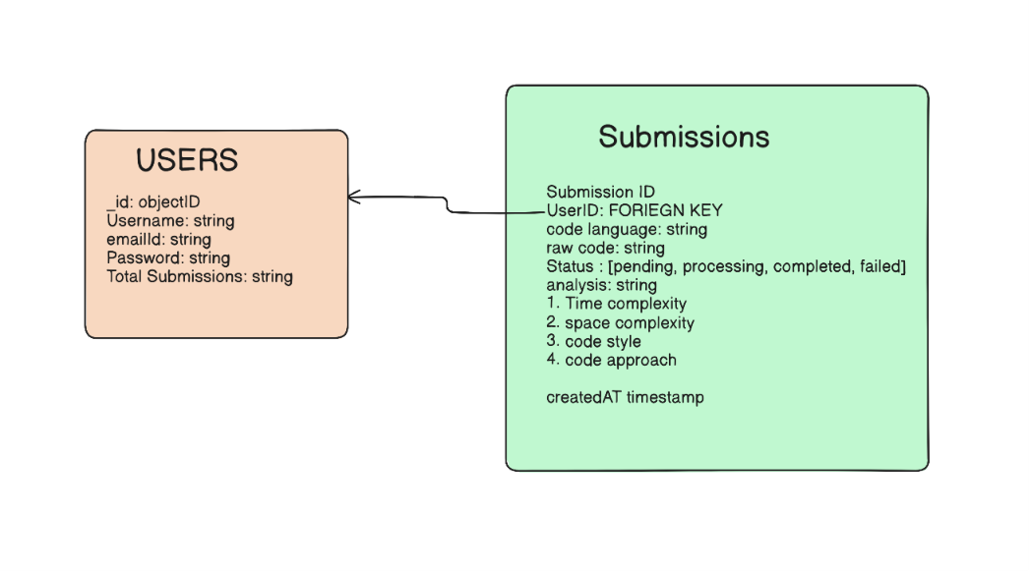

5. System Architecture & Event Pipeline
Trace utilizes a Decoupled Asynchronous Job Pattern to ensure high availability and non-blocking performance. Instead of forcing the main web server to wait on slow AI API calls, the system isolates user traffic from computation overhead using a state-driven queue flow.
[ React Client ]
│ (1) POST /api/analyze (Raw Code)
▼
[ Express.js Server ] ────(2) Save 'PENDING' Record ───► [ MongoDB Atlas ]
│ ▲
├─(3) Trigger Async Background Worker Daemon │ (5) $set 'COMPLETED'
▼ │ & Save Analytics
[ Background Worker Engine ] ──(4) Request Telemetry ──► [ Gemini API ]
5.1 The Step-by-Step Data Lifecycle Pipeline
- Ingress Phase: The user submits a code snippet from the React frontend. The Express server accepts the payload, authorizes the user via JWT middleware, and immediately writes a new tracking entry into MongoDB with a status of PENDING.
- Immediate Acknowledgment: The backend drops the client connection instantly by issuing an HTTP 202 Accepted response back to the React app along with the submission's unique _id. This keeps the UI responsive.
- Out-of-Bounds Processing: The background execution daemon picks up the processing task. It formats a structured prompt and triggers a secure API request to the Gemini engine.
- Schema Enforcement & Storage: The AI returns a structured JSON block containing the approach, complexities, and code style. The worker catches this text and fires an atomic $set command to update the status to COMPLETED and append the analysis sub-document in MongoDB.
- Dashboard Synthesis: The client UI pulls the status via polling (or WebSockets). Once marked COMPLETED, the unified dashboard renders the code review and analytics history graphs.

6. Core Technology Stack Rationalization
Layer | Component | Technical Selection Justification
Frontend UI | React.js | Powers a single-page, component-driven architecture. Handles state updates efficiently to provide real-time updates while polling background task statuses.
Backend API Gateway | Node.js + Express.js | Single-threaded event loop setup allows it to process high volumes of concurrent concurrent API connection requests without running out of server threads.
Data Orchestration | MongoDB (via Mongoose) | Document-oriented storage natively supports dynamic nested subschemas, allowing the submission history and AI results to be retrieved together in a quick $O(1)$ look-up.
Intelligence Engine | Gemini API | Selected for its fast response speeds and strict structural schema handling, ensuring feedback is always returned as valid, scannable JSON.

7. Core API Endpoints Matrix
- POST /api/analyze: Authenticated entry point. Saves incoming code data and kicks off the background task.
- GET /api/status/:id: Authenticated endpoint to track background worker progress.
- GET /api/intelligence/insights: Gathers past telemetry logs to summarize and highlight recurring coding patterns.

- Will use pagination:::
This works exactly like turning pages in a book. Your frontend sends a page number and a limit (items per page) to your Express API.
- The "Smart History" Dashboard Concept
Instead of just listing past submissions statically, your dashboard can have two clean sections:
1. The Submission History List
A clean, paginated table or list showing their past code submissions. When a user clicks on a past submission, it expands to show the structured JSON analysis already saved in MongoDB (the approach, time complexity, and code style). This costs zero extra API overhead because the data is already stored.
2. The AI "Code Coach" Panel (The Game Changer)
Add a single, prominent component at the top of the dashboard called something like "AI Progress Insights." * How it works: You create a specialized background cron job (or an on-demand button click) that fetches the metadata of the user's last 5–10 submissions (e.g., their common language, frequent time complexities, and recurring code style notes).
The Prompt: You pass this historical summary to the LLM and ask it to find patterns. For example: "Reviewing your last 5 Java submissions, you frequently use nested loops resulting in $O(n^2)$ time complexity. Focus on mastering the Hash Map pattern to optimize these to $O(n)$."

