Hospital Management System

The main objective of the Hospital Management System is to manage the details of Hospital, Doctor, Employee, Test, Medicine. It manages all the information about Hospital, Patient, Medicine, Hospital. The purpose of the project is to built an application program to reduce manual work for managing the Hospital, Doctor, Patient, Employee. It tracks all the details about the Employee, Test, Medicine.It also track the details of ambulance, its driver.

Admin Features:
1.Provides the searching facilities based on various factors. Such as Hospital,Patient, Employee, Test.
2.Hospital Management System also manage the Medicine details, Test details, Employee details.
3.It tracks all the information of Doctors, Medicine, Nurse, Tests, Rooms of Hospital.
4.Integration of all records of test.5.Editing, adding and updating of Records is improved which results in proper resource management of Hospital data.
5.Add, edit, delete entries of all the tables and add user onto the system.

User Features:
1.Provides the searching facilities based on various factors. Such as Hospital,Patient, Employee, Test.
2.Hospital Management System also manage the Medicine details, Test details, Employee details.
3.It tracks all the information of Doctors, Medicine, Nurse, Tests, Rooms of Hospital.
4.Integration of all records of test.5.Editing, adding and updating of Records is improved which results in proper resource management of Hospital data.
5.Add data into the all table and view data of all the table.

Front End: PHP Code Igniter

Back End : PHP and MySql

Git Link : https://github.com/Divya-Kharode/DBMS_mini_project

Relational Schema :

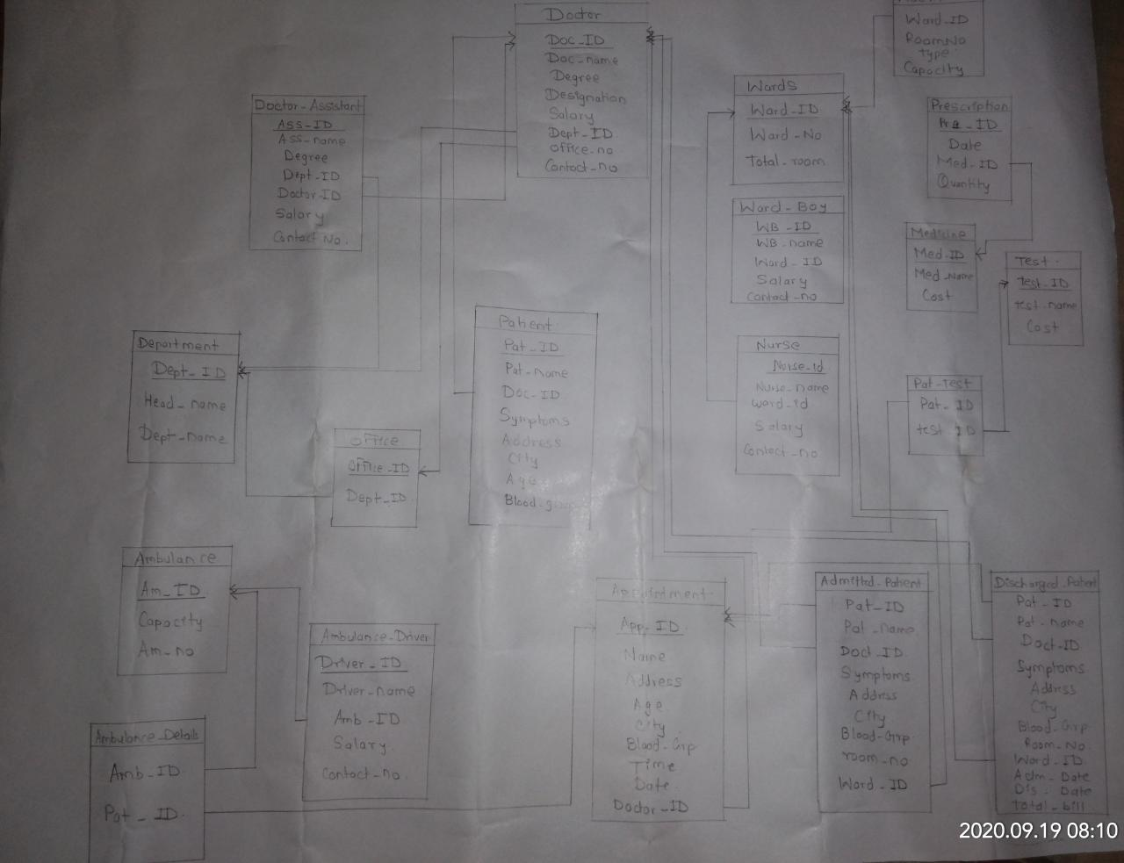

ER Diagram:



