SMART PANTRY MANAGER

DIVYA KIRTHI RAMDHANEY
402411120
MOBILE APP DEVELOPMENT 700
30 SEPTEMBER 2026

Table of Contents
SMART PANTRY MANAGER 1
Introduction 2
System design 2
Screenshots of outputs 4
Key code snippets 7
Challenges and solutions 10
Conclusion and reflection 10
References 10

Introduction
This app is designed to reduce the amount of ingredients that are wasted. These ingredients are wasted because people cannot find recipes that use the ingredients or because the ingredients expire without them knowing. Most people have to find a recipe and then purchase the items that they don’t have. This app allows users to use ingredients that they already have to make meals. It only displays meals that strictly match the ingredients that they already have. This app also helps keep track of when ingredients are expiring and allows users to enable notifications if an item is expiring soon. This app can be used for anyone who likes to make meals but do not have a lot of ingredients in their home. It simply allows the users to insert the ingredients that they have, and a recipe is provided. The link below is the github repository.
Divya-Kirthi-Ramdhaney/Smart-Pantry-Manager: The Smart Pantry Manager helps a user reduce food waste by tracking the ingredients they actually have at home (their "pantry") and suggesting recipes they can cook using strictly those leftover ingredients - no shopping trip required, and no recipe suggested unless the user genuinely already has everything it needs.

System design

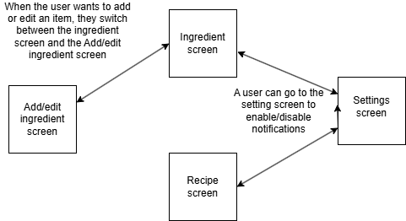

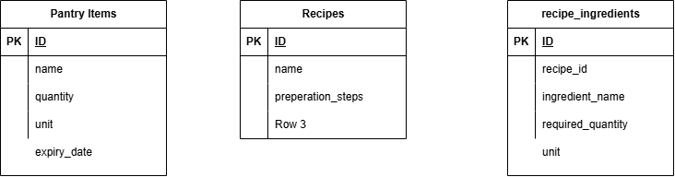

SQLite was chosen as a database because it does not require a third-party app or cloud platform to store data. It runs locally, which is simple and convenient for a single user. It is also simple to use with Java and android studio. (Klie, 2025)

Screenshots of outputs
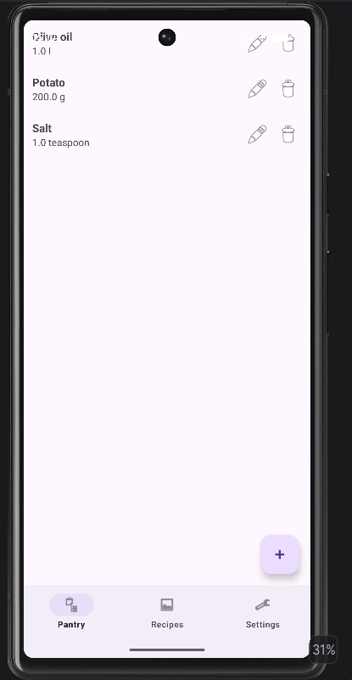
This is the screen when the app is opened. It shows a list of the ingredients available. The user has an option to add, edit or delete ingredients.

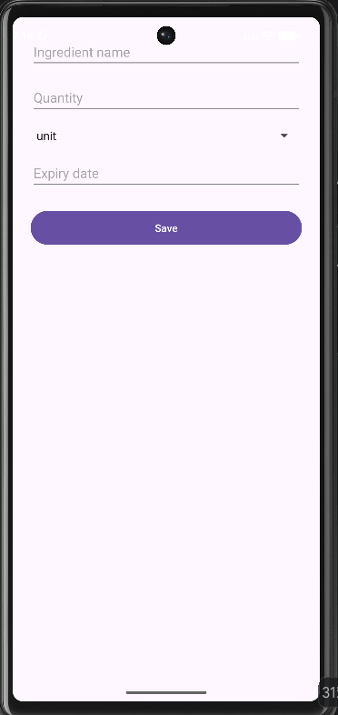
This is the screen where a user wants to add or edit an item.

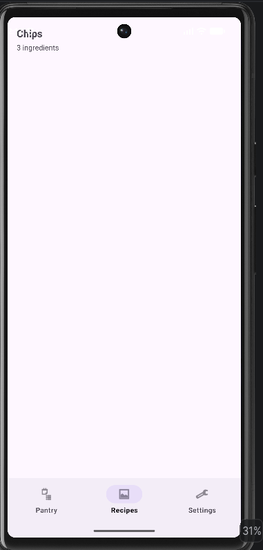
This screen shows a list of recipes that a user can use to make meals with the available ingredients that they have. (Jawad, 2026)

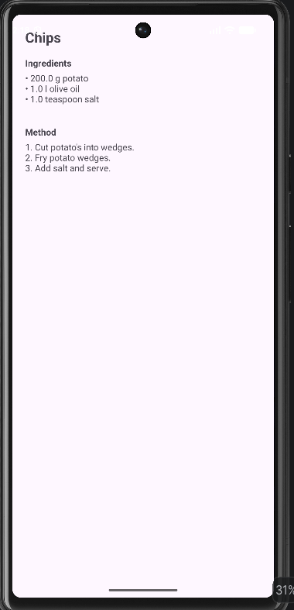
This screen shows the recipe, what ingredients are used and how to prepare the meal.

Key code snippets

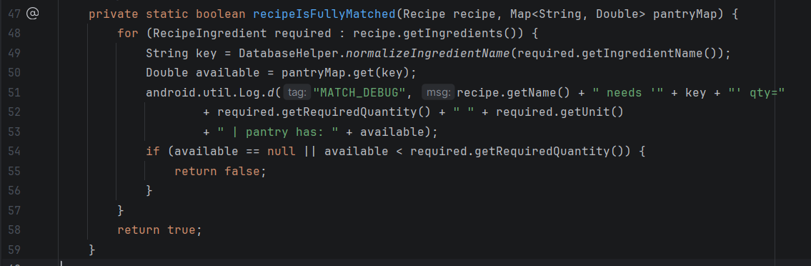
This checks that the ingredients match the recipes exactly. If an ingredient that is in the recipe but not in the ingredients list, then it will return false.

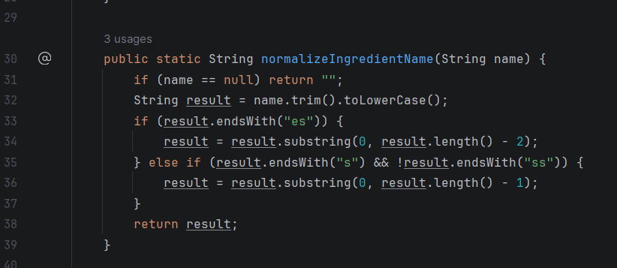
This ensures that when a user inputs an ingredient, it is normalized to lowercase, without spaces, and plurals are removed.

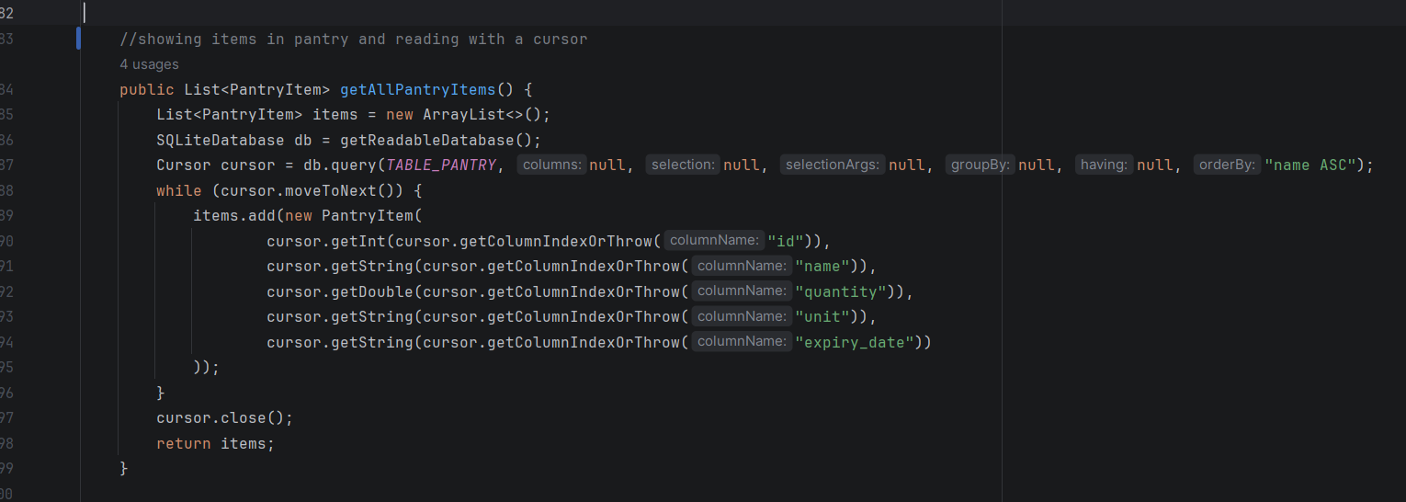
This piece of code allows for the database to be read one row at a time. It is important to close the cursor. It also ensures that the data remains after the app is closed and opened.

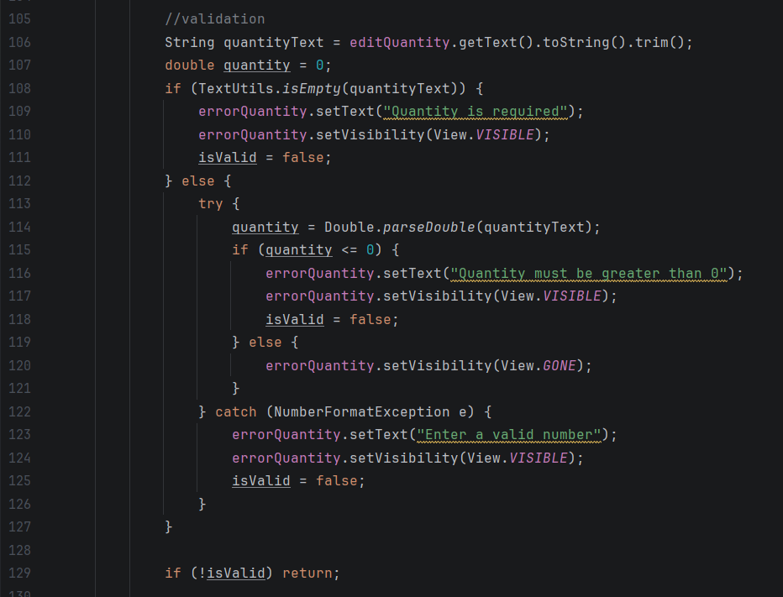
This is the validation portion of the app. It ensures that the items input to the database is accurate. It makes sure that a user inputs a quantity of the ingredient, and that it is a valid number being input.

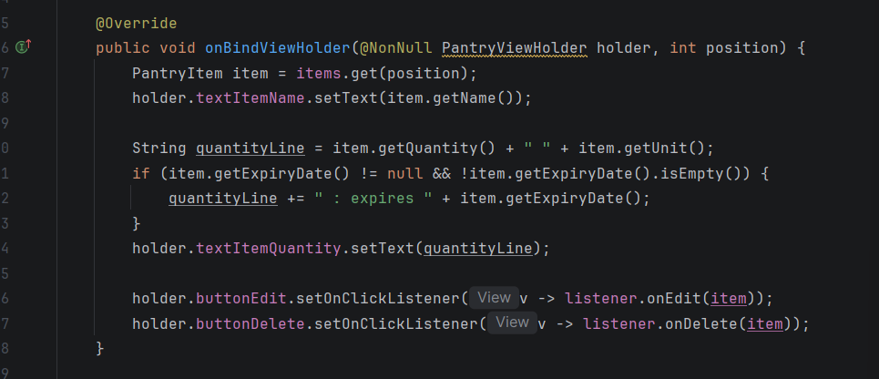
This is the recyclerview (Elliott, 2022) that allows the user to scroll and view the list of items on screen.

Challenges and solutions
- I experienced issues with the app not installing on the emulator. I kept receiving an “Unknown error” error message. This was a result of the emulator not booting correctly (Anonymous, 2024). I completely uninstalled the emulator. Reinstalled it. And then I booted it and relaunched my app. It solved the issue.
- I had trouble setting up the navigation bar. I was missing a root tag. I added it and the problem was solved. There were similar issues with importing packages. Android studio helped me import the packages.
- I had trouble using github and creating branches to complete tasks (CodeWithChris, 2025). It deleted all my progress so I had to use a previous version that was saved on the main branch in github to redo some parts of the project. This also created merge conflicts, which were resolved by deleting the branches and working on the main branch.

Conclusion and reflection
I learned how to use Android Studio as a first-time user. I learnt more about how databases connect within the app itself. I also learned about version control, best practices and why it is important to have code backed up. Some things that I would like to improve is adding the additional screen. I would allow users to add their own recipes. I would also want to add a more unform formatting so that recipes can be consistent, allowing for more resourceful use of ingredients.

References
Anonymous, 2024. Restarting an Android Emulator: A Comprehensive Guide. [Online]
Available at: https://www.repeato.app/blog/tech-help/how-to-restart-an-android-emulator/
[Accessed 29 September 2026].
CodeWithChris, 2025. GitHub Branches Tutorial (Beginner Friendly). [Online]
Available at: https://youtu.be/0vzYWyHmcY8?si=i02rxnWTvSGLLQUr
[Accessed 20 September 2026].
Elliott, T., 2022. Implementing a RecyclerView in Android with Java. [Online]
Available at: https://dev.to/theplebdev/implementing-a-recyclerview-in-android-with-java-1jf5
[Accessed 29 September 2026].
Jawad, Y., 2026. 36 Big Flavor Recipes With Just A Handful Of 5 Ingredients or Less. [Online]
Available at: https://feelgoodfoodie.net/recipes-with-5-ingredients/
[Accessed 5 September 2026].
Klie, F. R., 2025. SQLite Database: A Complete Guide for Developers (Architecture, Internals, and Everything You Must Know). [Online]
Available at: https://dev.to/farhadrahimiklie/a-comprehensive-guide-to-sqlite-database-lightweight-powerful-and-easy-to-use-21po
[Accessed 29 September 2026].

