**A**

**Project Report**

on

**“EARLY FLOOD DETECTATION SYSTEM”**

**Submitted by:-**

|  |  |  |  |  |
| --- | --- | --- | --- | --- |
| Sl No. | Name of the student | Roll No. | USN | Signature |
| 1 | Divya Nadkarni | H31 | 2GI21CS056 |  |
| 2 | Ishan Dhotre | H32 | 2GI21CS072 |  |
| 3 | Rohit kolkar | H33 | 2GI21CS128 |  |
| 4 | H C Srihari | H34 | 2GI21CS065 |  |
| **5** | **Omkar Patil** | **H35** | **2GI21CS106** |  |



### Department of idea to innovation lab

### KLS Gogte Institute of Technology,

### Udyambag, Belagavi - 590008, Karnataka, India

**Academic year 2021-22**

### **Problem statement**

As we all know that Flood is one of the major well known Natural Disasters. When water level suddenly rises in dams, river beds etc. Alot of Destruction happens at surrounding places. It causes a huge amount of loss to our environment and living beings as well. So in these case, it is very important to get emergency alerts of the water level situation in different conditions in the river bed.

**solution - photo of our project with title 'early flood detection system '**

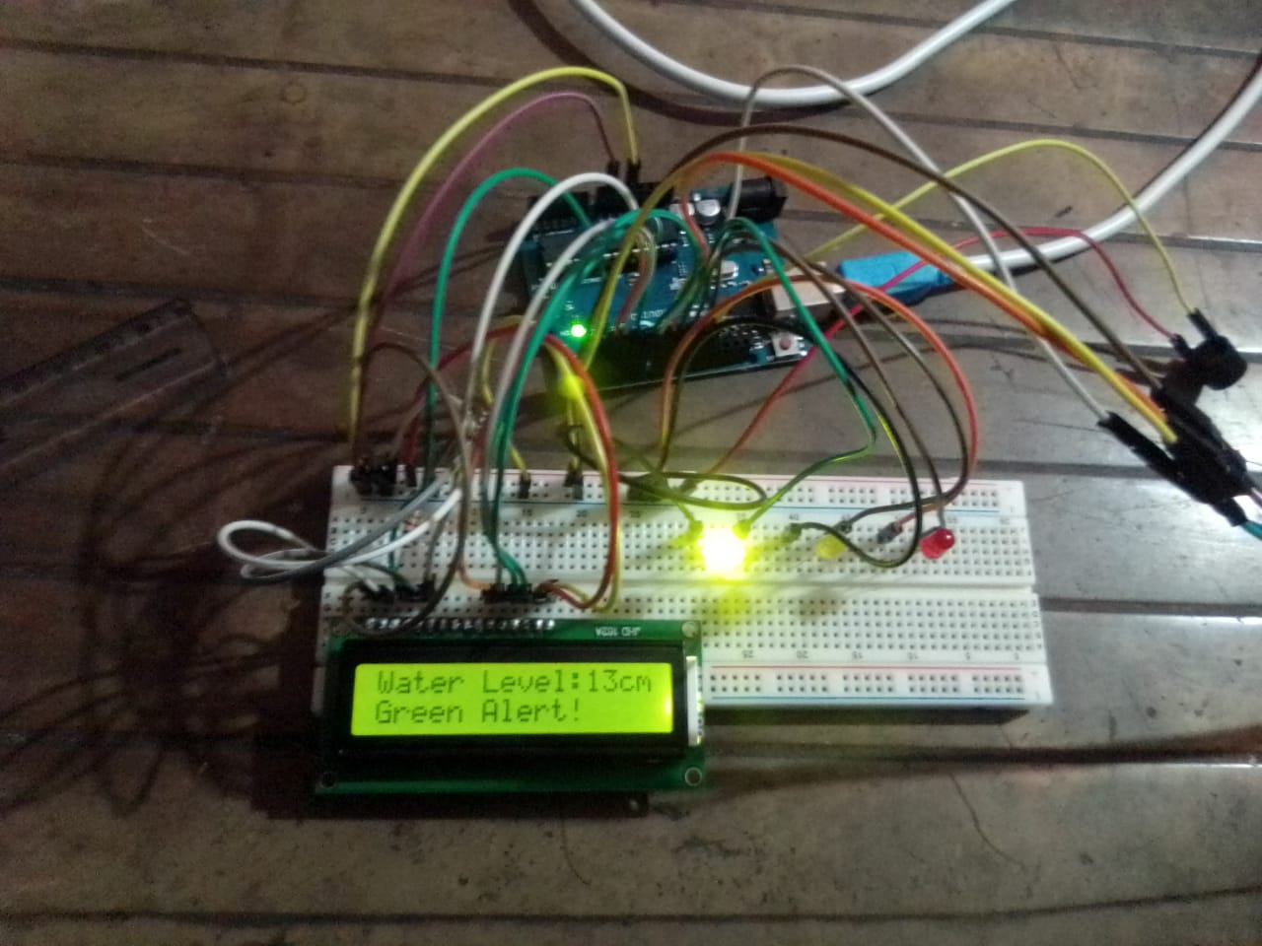

**ABOUT THIS PROJECT:**

The purpose of this project is to sense the water level in river beds and check if they are in normal condition. If they reach beyond the limit, then it alerts people through LED signals and buzzer sound.

**Hardware components -**

1.Breadboard

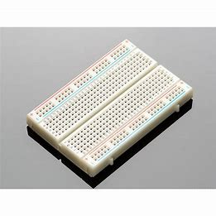

2. Arduino Uno

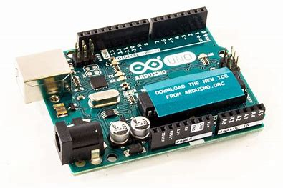

3. Ultrasonic sensor

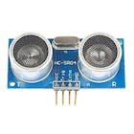

4. 16*2 LCD display

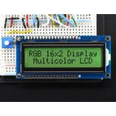

5. Buzzer

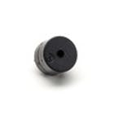

6. LED lights

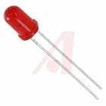

**Software components -**

**Arduino IDE**

**Code:-**

//IOT Based Flood Monitoring And Alerting System.

#include<LiquidCrystal.h>

LiquidCrystal lcd(2,3,4,5,6,7);

const int in=8;

const int out=9;

const int green=10;

const int orange=11;

const int red=12;

const int buzz=13;

void setup(){

Serial.begin(9600);

lcd.begin(16,2);

pinMode(in, OUTPUT);

pinMode(out, INPUT);

pinMode(green, OUTPUT);

pinMode(orange, OUTPUT);

pinMode(red, OUTPUT);

pinMode(buzz, OUTPUT);

digitalWrite(green,LOW);

digitalWrite(orange,LOW);

digitalWrite(red,LOW);

digitalWrite(buzz,LOW);

lcd.setCursor(0,0);

lcd.print("Flood Monitoring");

lcd.setCursor(0,1);

lcd.print("Alerting System");

delay(2000);

lcd.clear();

}

void loop()

{

long distance,duration;

digitalWrite(8,LOW);

delayMicroseconds(2);

digitalWrite(8,HIGH);

delayMicroseconds(10);

digitalWrite(8,LOW);

duration = pulseIn(9,HIGH);

distance = (duration/2) / 29.1;

Serial.println(String(distance));

lcd.setCursor(0,0);

lcd.print("Water Level:");

lcd.print(String(distance));

lcd.print("cm ");

if(distance<=5) //MAX Level of Water--Red Alert!

{

lcd.setCursor(0,1);

lcd.print("Red Alert! ");

digitalWrite(red,HIGH);

digitalWrite(green,LOW);

digitalWrite(orange,LOW);

digitalWrite(buzz,HIGH);

delay(2000);

digitalWrite(buzz,LOW);

delay(1000);

digitalWrite(buzz,HIGH);

delay(1000);

digitalWrite(buzz,LOW);

delay(1000);

}

else if(distance<=12) //Intermedite Level of Water--Orange Alert!

{

lcd.setCursor(0,1);

lcd.print("Orange Alert! ");

digitalWrite(orange,HIGH);

digitalWrite(red,LOW);

digitalWrite(green,LOW);

digitalWrite(buzz,HIGH);

delay(1000);

digitalWrite(buzz,LOW);

delay(1000);

}else //MIN/NORMAL level of Water--Green Alert!

{

lcd.setCursor(0,1);

lcd.print("Green Alert! ");

digitalWrite(green,HIGH);

digitalWrite(orange,LOW);

digitalWrite(red,LOW);

digitalWrite(buzz,LOW);

}

delay(500);

}

**Working :-**

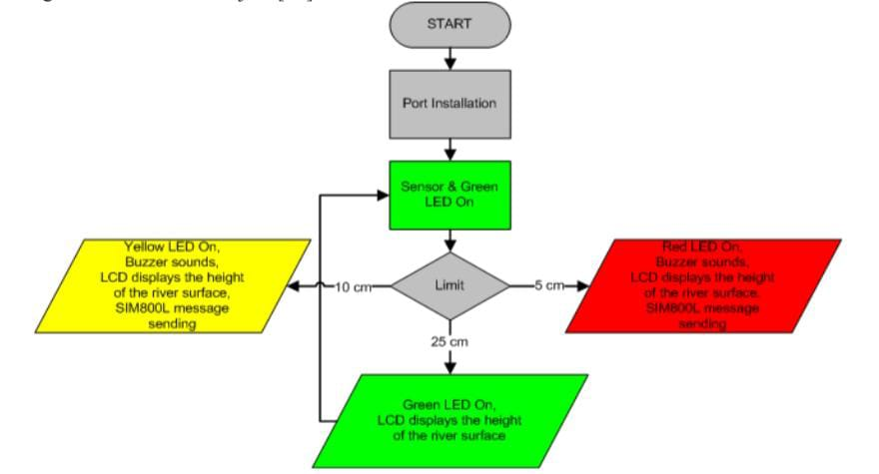

### **Conclusion:-**

Nowadays the Internet Of things (IoT) is broadly used in worldwide, this system will display the data of the water level measured on lcd display. This project can be very helpful to the Meteorological Department to continuously monitor the dams and river beds water level. With this project it can save many people lives by giving alerts when the water level crosses beyond the limit. This project is very cost-effective, flexible and productive in areas where flood conditions happens everytime.