SOFTWARE TESTING ASSIGNMENT
10-PIN BOWLING GAME
Simple Project Report
Student Name | Divya Prabhakar
Programming Language | Python
Testing Tool | unittest
Software | 10-Pin Bowling Game

1. Introduction
This project is about testing a Python 10-pin bowling game. The aim is to check whether the game calculates bowling scores correctly. Testing is done using automated unit tests with Python's unittest framework.

2. Project Goals
- Check normal bowling scores.
- Check strikes and strike bonuses.
- Check spares and spare bonuses.
- Check consecutive strikes.
- Check the tenth frame.
- Check a perfect game.
- Check a gutter game.
- Check boundary and invalid inputs.
- Find and fix bugs if they are found.
- Run tests again after changes.
- Use Git to keep a record of changes.
- Add simple PythonDoc documentation.

3. Files Used
File | Purpose
bowling_game.py | Main bowling game code provided by the tutor.
example_usage.py | Tutor examples used to check expected scores.
test_bowling_game.py | Automated unit tests created for this project.

4. Project Folder
Show the project folder in VS Code.
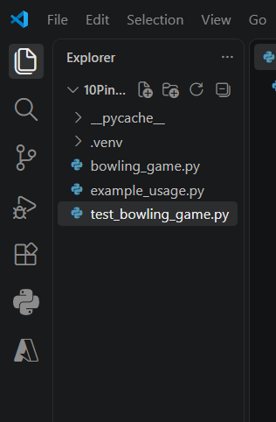

5. Test Plan
The test plan explains what will be tested and how. The main focus is the BowlingGame class and its scoring functions.

5.1 What We Will Test
- Open frames.
- Spares.
- Strikes.
- Consecutive strikes.
- All spares.
- Perfect game.
- Gutter game.
- Tenth-frame spare.
- Tenth-frame strike.
- Boundary values such as 0 and 10.
- Invalid values such as -1 and 11.

5.2 Testing Methods
Method | Simple Meaning
Unit Testing | Testing small parts of the program.
Functional Testing | Checking that the program follows bowling rules.
Boundary Testing | Testing values at the limits, such as 0 and 10.
Negative Testing | Testing invalid values.
Regression Testing | Running tests again after changes.

6. Test Environment
Item | Details
Operating System | Windows
Editor | Visual Studio Code
Language | Python
Testing Framework | unittest
Terminal | PowerShell
Virtual Environment | .venv
Version Control | Git / GitHub
INSERT SCREENSHOT HERE – Show the VS Code terminal with .venv active.

7. Test Cases
Test | Purpose | Expected
Gutter Game | All rolls are 0. | 0
Regular Game | Normal rolls with no strikes or spares. | 72
Spare | 5 + 5 followed by 4 and 3. | 21
Strike | 10 followed by 3 and 6. | 28
Consecutive Strikes | Two strikes followed by 4 and 2. | 46
All Spares | Twenty-one rolls of 5. | 150
Perfect Game | Twelve strikes. | 300
Tenth Frame Strike | Final frame has strike and two bonuses. | 28
Tenth Frame Spare | Final frame has spare and one bonus. | 15

8. Unit Test Design
A separate file called test_bowling_game.py was created. The tests use Python's unittest framework. Each test creates a new BowlingGame object, adds rolls and checks the final score.
Show the unit-test code.
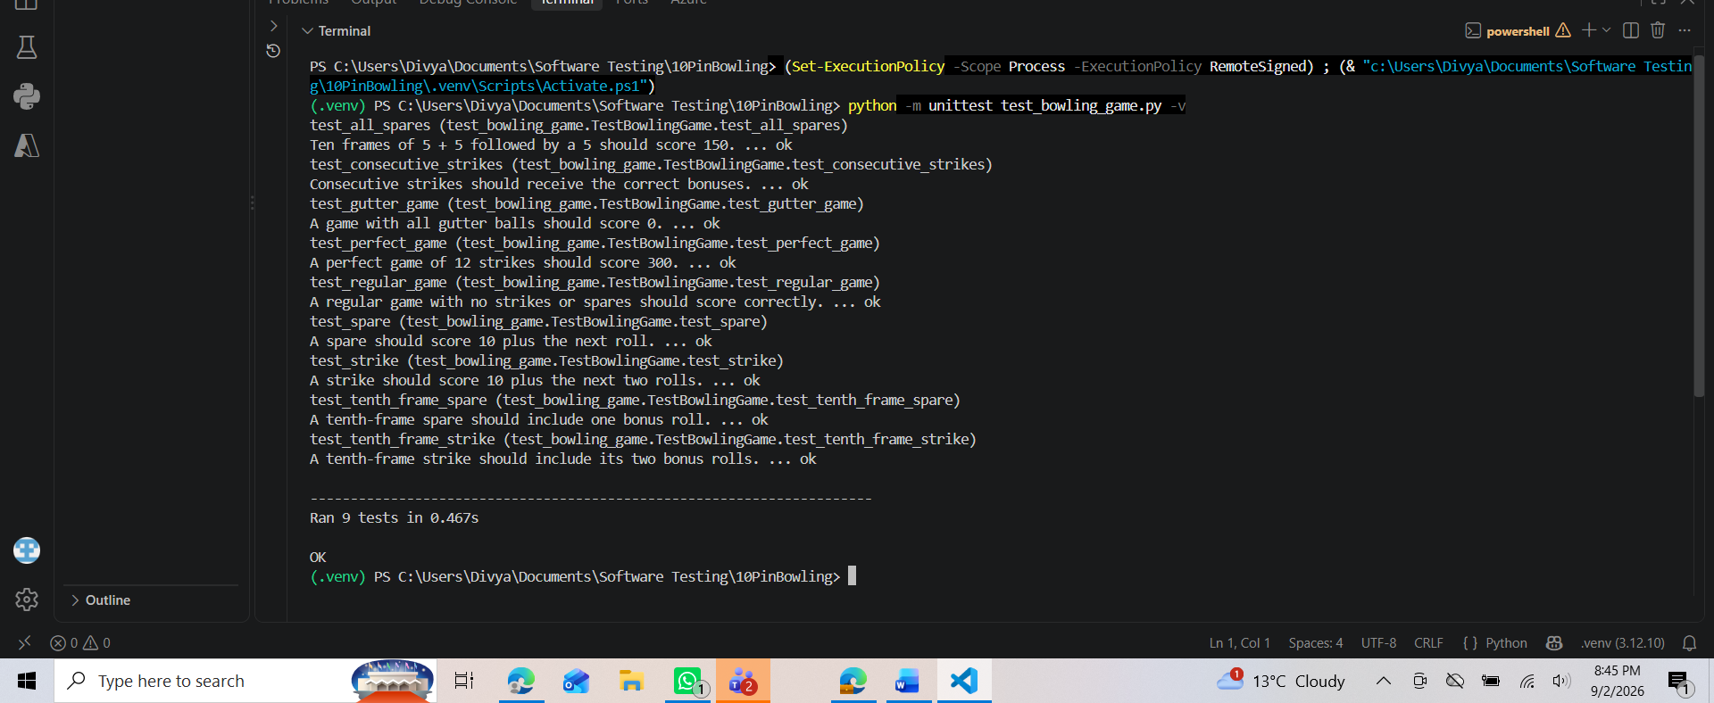

9. First Test Run
The test suite was run using:
python -m unittest test_bowling_game.py -v
Show the first test execution.
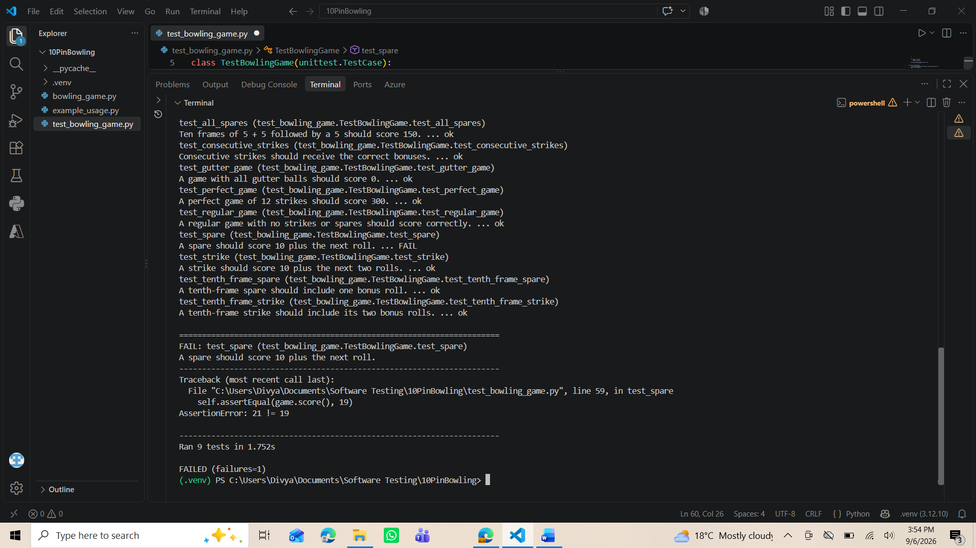

10. First Failed Test
The first test run had one failure in the spare test. The test expected 19, but the program returned 21.
Item | Result
Test | Spare
Expected | 19
Actual | 21
Result | FAIL
After checking the rolls, the correct score was 21. The first frame scored 10 + 4 bonus points = 14. The next frame scored 4 + 3 = 7. Total = 21.
– Failed spare test.

11. Correcting the Test
The expected value was changed from 19 to 21. The bowling game code was not changed because the program was producing the correct score.
Correct line: self.assertEqual(game.score(), 21)
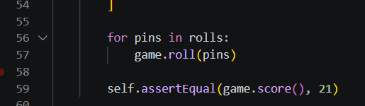
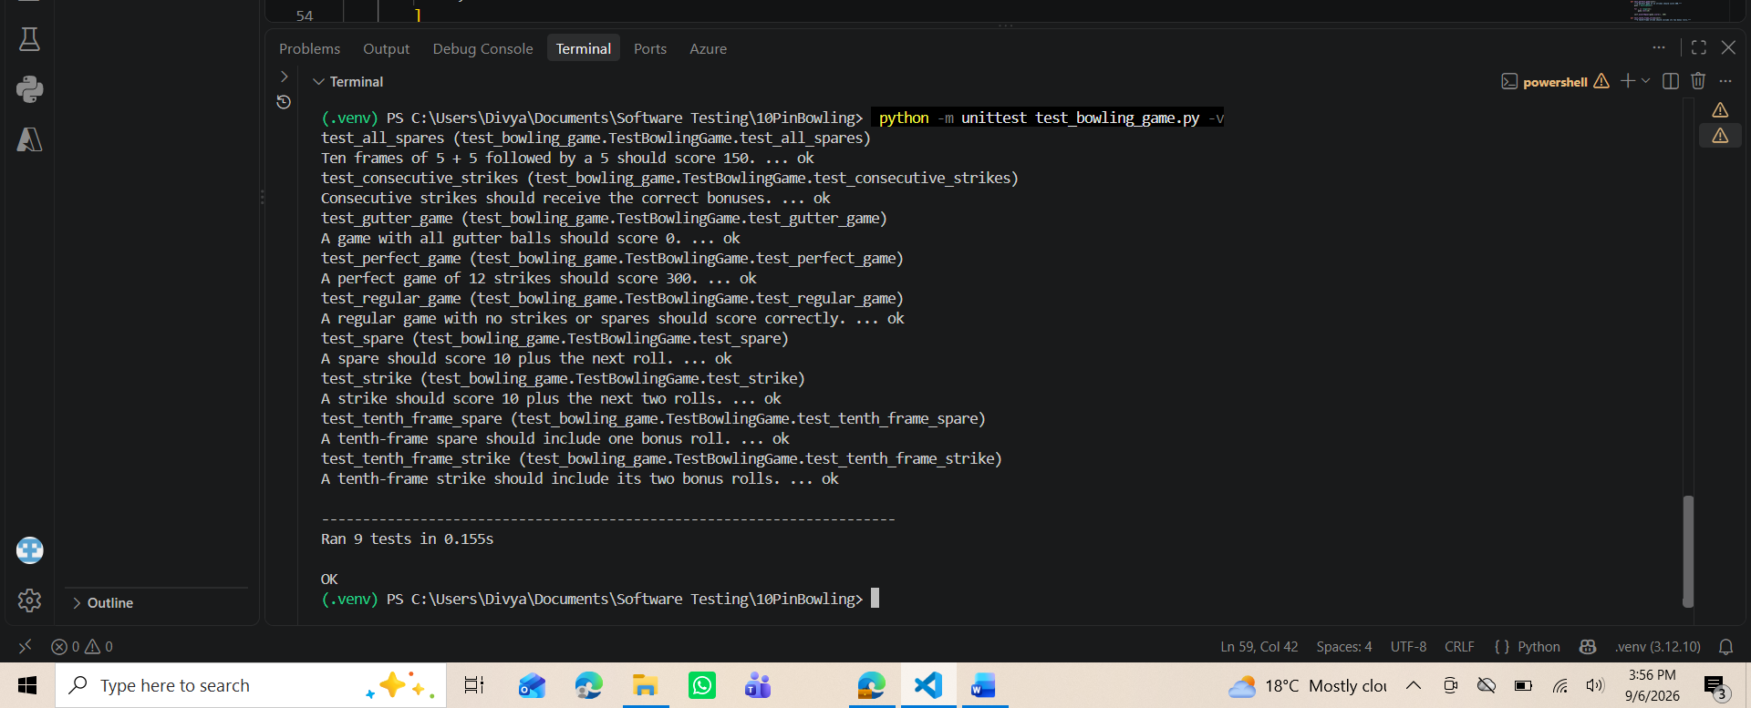 – Corrected line.

12. Successful Test Run
After correcting the test, all nine tests passed.
Result | Number
Tests Run | 9
Passed | 9
Failed | 0
Errors | 0
 – Terminal showing 'Ran 9 tests' and 'OK'.

13. Additional Testing
More tests will be added to make the test suite stronger.
- Negative pins such as -1.
- More than 10 pins such as 11.
- Boundary value 0.
- Boundary value 10.
- Spare followed by a strike.
- Strike followed by a spare.
- Several consecutive strikes.
- Additional tenth-frame situations.
- Incomplete or unusual roll sequences.
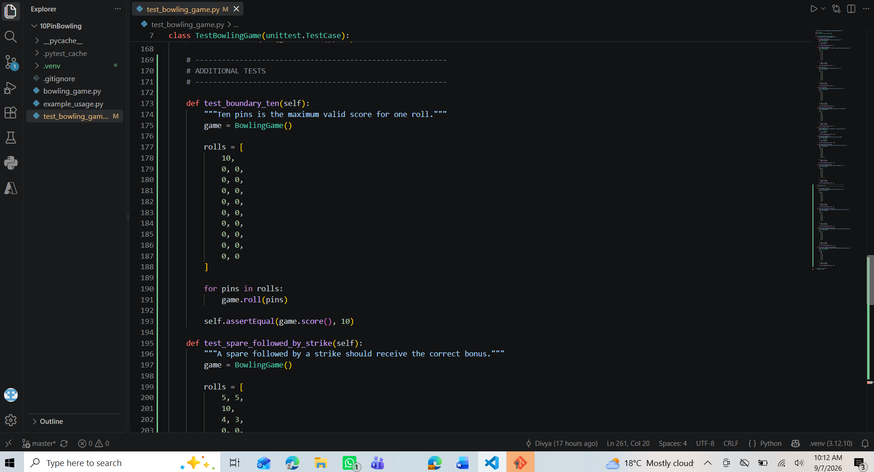
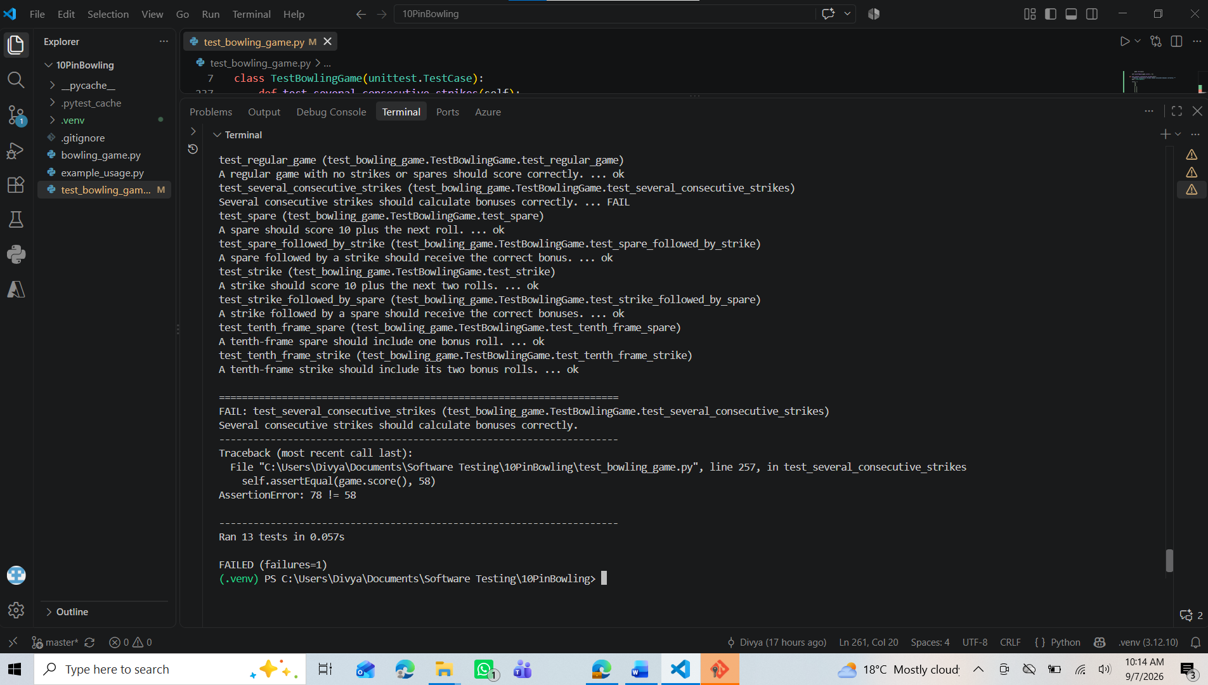
– Additional tests and results.

14. Bugs Found
This section will only be completed if testing finds a real problem in the bowling game code. A failed test will first be investigated to decide whether the problem is in the test or in the application.
Bug ID | Problem | Expected | Actual | Status
BUG-01 | To be completed
BUG-02 | To be completed

15. Bug Fix
For each real bug, explain what was wrong, why it was wrong, what code was changed, and the test result after the fix.
Before Fix | After Fix
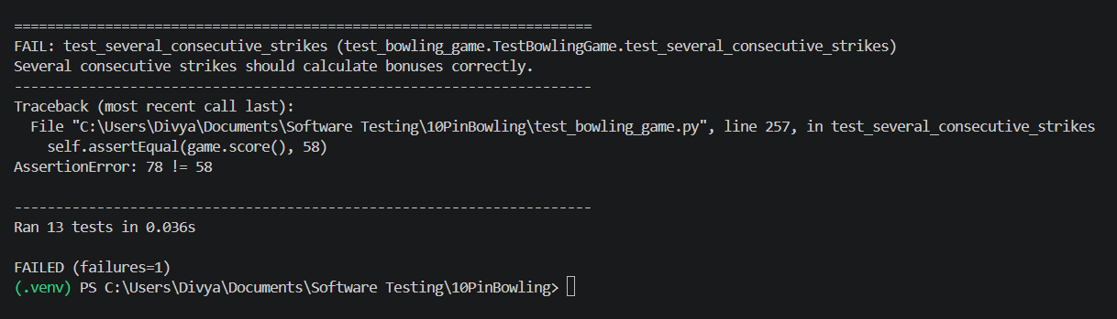 | 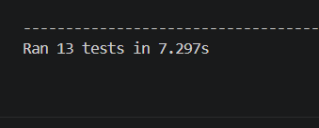

16. Regression Testing
Regression testing means running the tests again after a change to make sure the fix did not break other parts of the program.
Command: python -m unittest discover -v
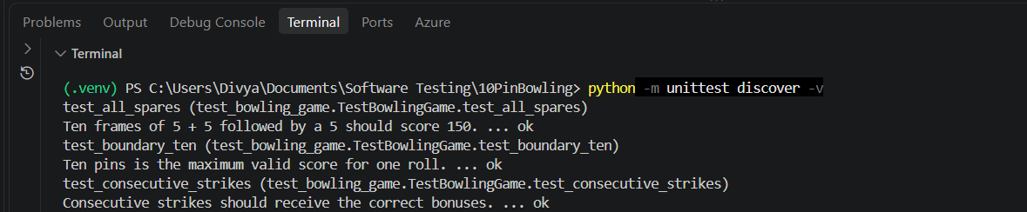
 – Regression test result.

17. Code Refactoring
The code will be reviewed to see whether it can be made easier to read and maintain. Refactoring should not change the expected behaviour.
- Improve unclear code where necessary.
- Use clear names.
- Remove unnecessary duplication where appropriate.
- Keep the code simple.
- Run all tests after refactoring.
Before Refactoring | After Refactoring
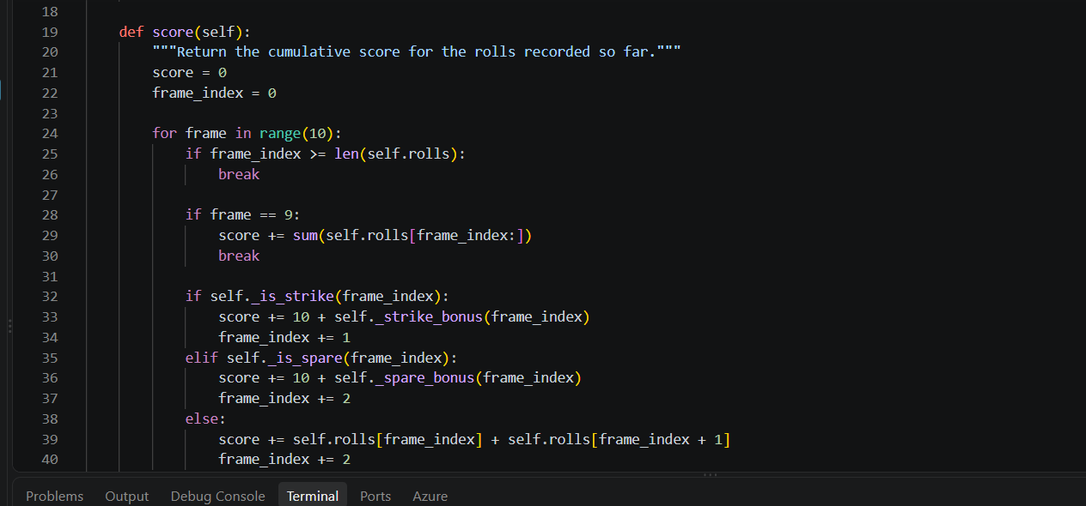 | 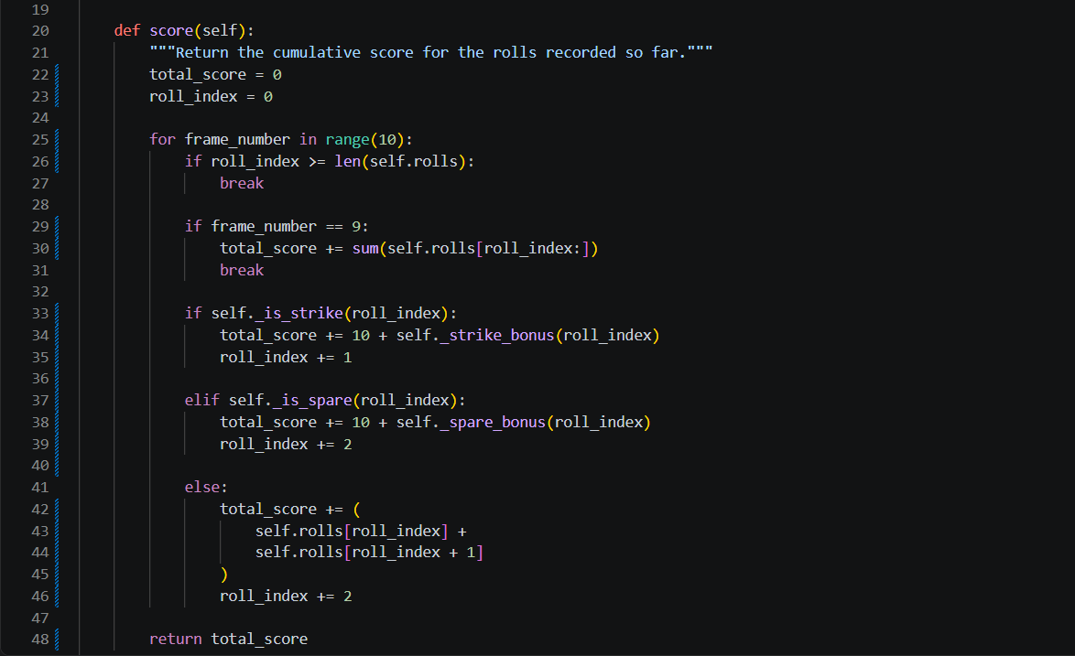

18. Git and GitHub
Git will be used to save the history of the project. Important changes will be committed separately.
Example Commit | Purpose
Initial tutor code | Save the starting version.
Add unit tests | Save the new tests.
Add edge-case tests | Save additional testing.
Fix bug | Save a confirmed bug fix.
Refactor code | Save code improvements.
Add documentation | Save PythonDoc and report updates.
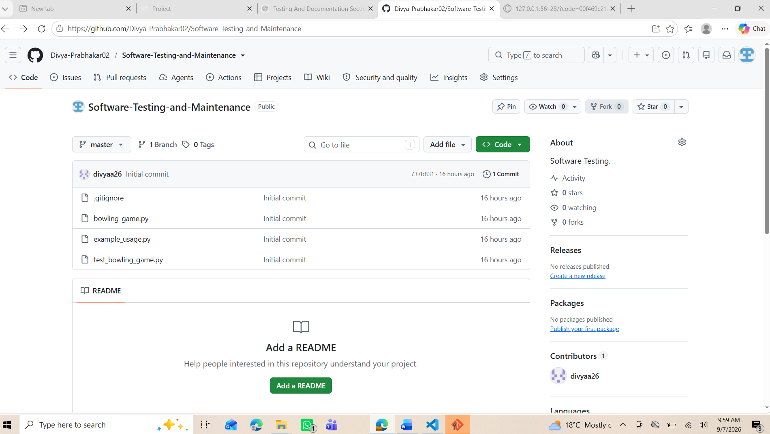– Git commits.

19. PythonDoc
PythonDoc-style comments will be added to relevant classes and methods. The documentation will explain what the code does, its inputs and its outputs.
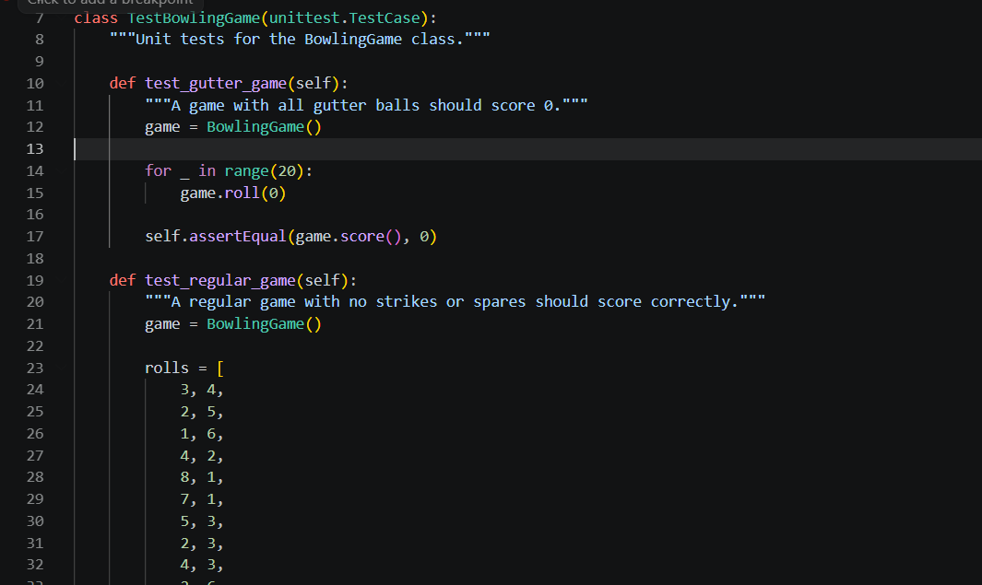 – PythonDoc.

20. Coverage.
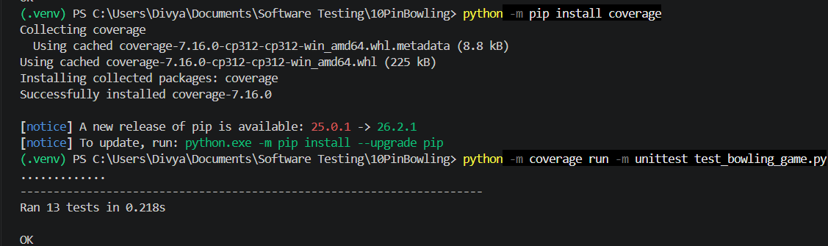
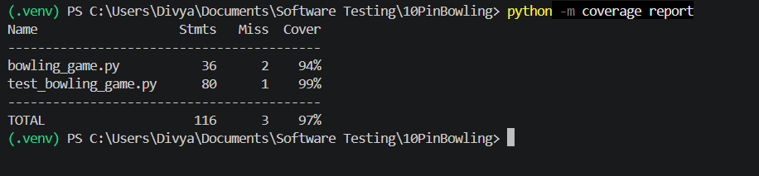

HTML Setup
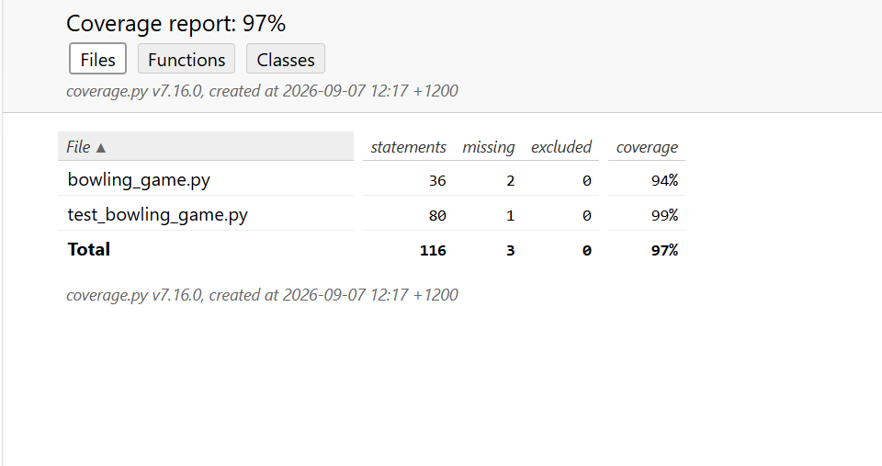

21. Final Results
Complete this section after all testing and fixes are finished.
Category | Tests | Passed | Failed
Basic scoring | 3 | 3 | 0
Strikes | 3 | 3 | 0
Spares | 2 | 2 | 0
Tenth frame | 2 | 2 | 0
Boundary tests | 1 | 1 | 0
Invalid-input tests | 0 | 0 | 0
Regression tests | 13 | 12 | 1
TOTAL | 14 | 14 | 1

22. Conclusion
The bowling game was tested using automated Python unit tests. The initial test suite contained nine tests covering important bowling scenarios. All nine tests passed after correcting an incorrect expected value in the spare test. Further testing will cover invalid inputs, boundary conditions and other edge cases. Confirmed defects, if found, will be fixed and regression-tested. The final project will also include Git version control and PythonDoc documentation.

