# REGRESSION ASSIGNMENT

**Logistic Regression for Bank Loan modeling**

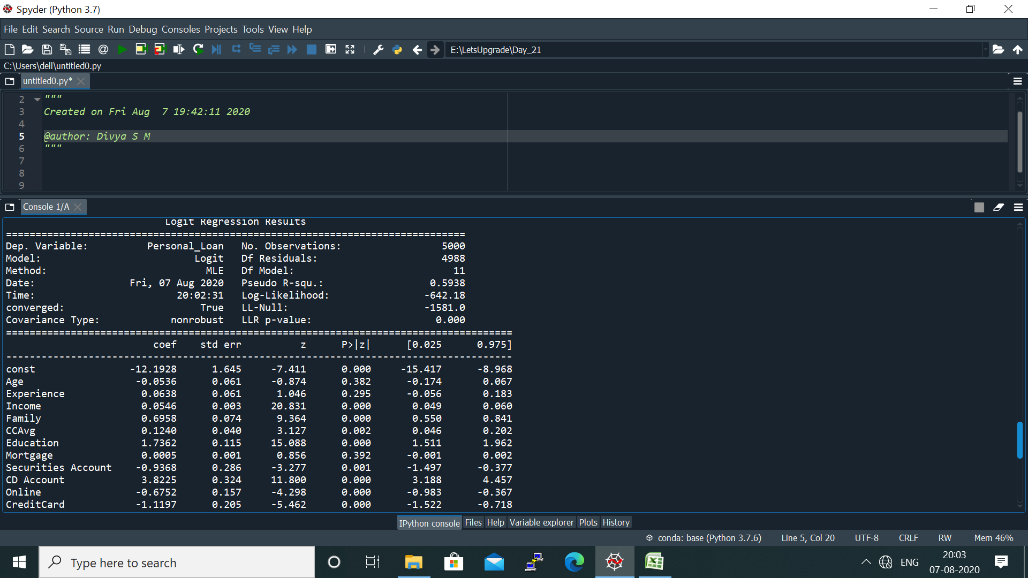

The variables that are most significant and affect the **dependent variable – Personal Loan** are:

* Income
* Family
* Education
* CD Account
* Online
* Credit Card

Thus, the income, family background and education of the loan applier is considered and the account, usage of online payment and credit cards also give an added advantage for the applier to get the loan.

## *Logistic Regression for Attrition Project*

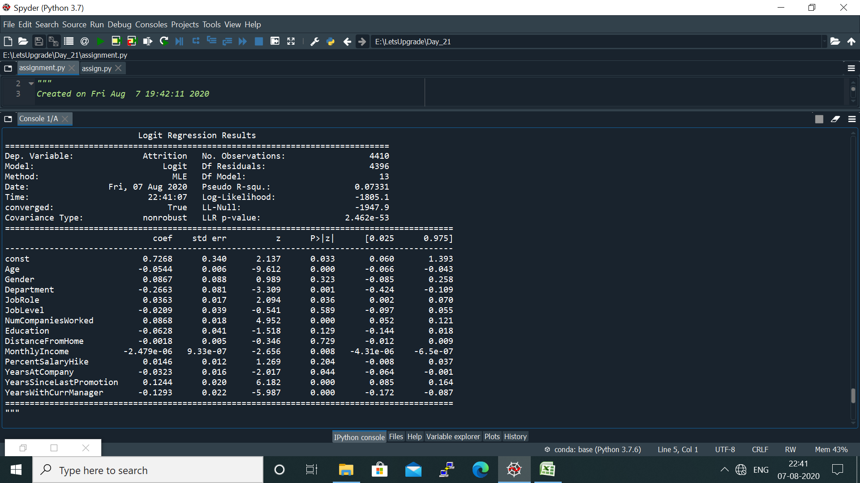

The variables that are most significant and affect the **dependent variable - Attrition** are:

* Age
* Number of Companies Worked
* Years since last promotion
* Years with current manager

Thus, Age of the employee and his department play a vital role in attrition, employees’ experience, years since last promotion and the relation with the current manager affects the attrition rate.

## *Linear Regression:*

**DV = Price**

**IDV = Bedrooms, Bathroom, Floor, sqrt_living**

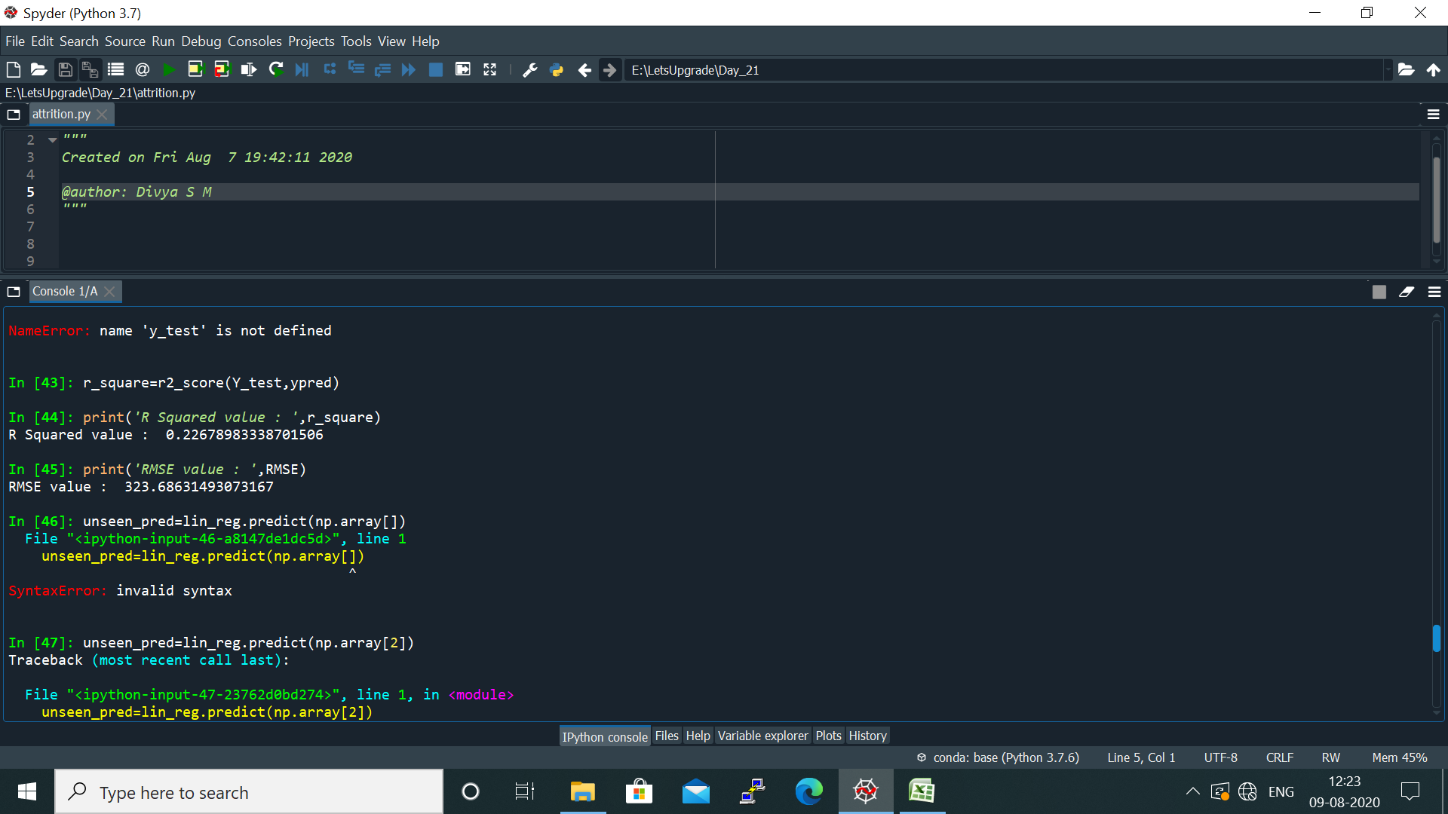

The calculated $R^{2}$ **value is 0.226** which is greater than 0.05, thus showing that the model is not a good fit.

The calculated **RMSE value is 323.68** which is very much high value, which shows that there are many insignificant variables that are present in the model created. Thus, to find a good fit model, significant variables only must be added to the model.