1. Create table depart

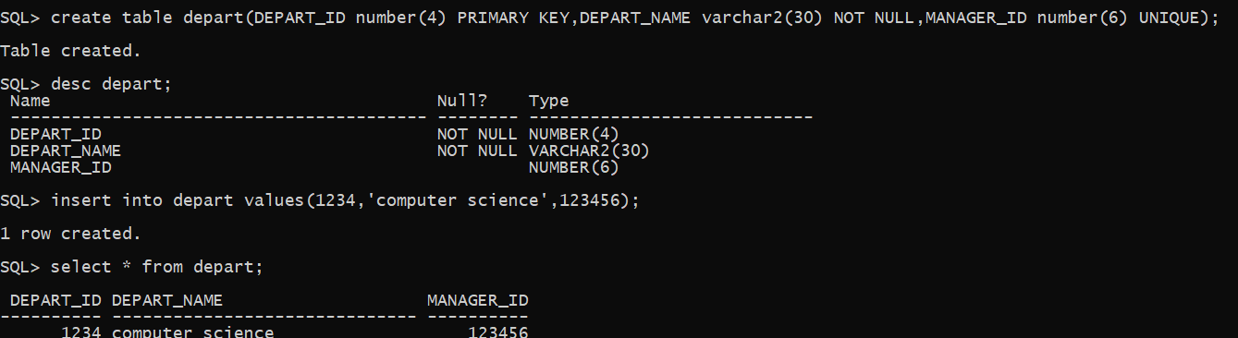

1. Create table employee
2. Add salary column to employee

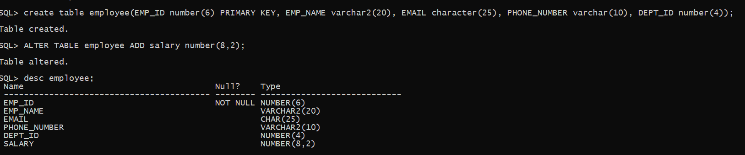

1. Add foreign key to employee table

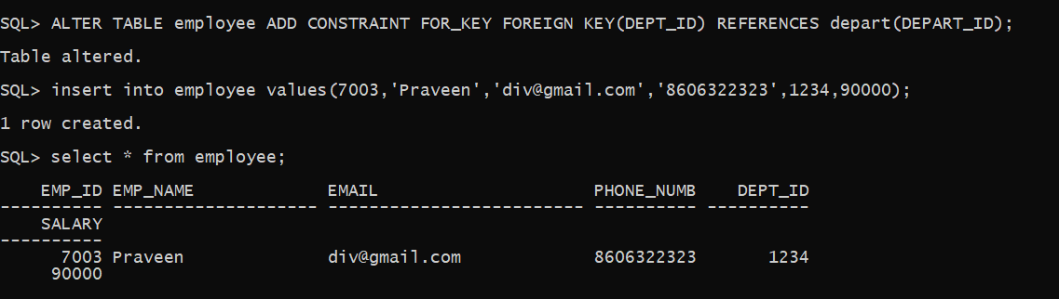

1. Drop column email from employee table.

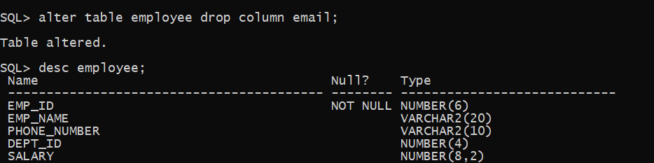

1. Add constraint to employee table to check salary value.

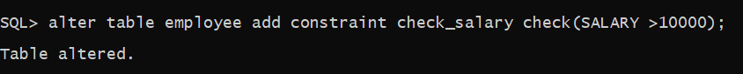

1. Rename the employee table as empl.

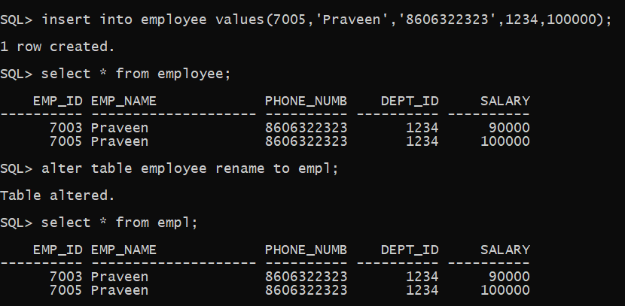

1. Create table depart1 and
2. Drop the depart1 table

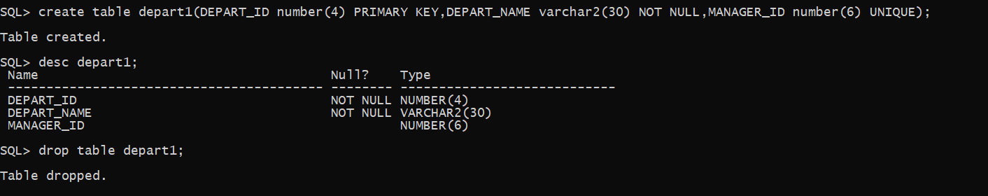

1. Drop constraint for_key from employee table

