Internship Project Report
Project Title: Weather Prediction using Machine Learning Internship Program: BharatCares – IBM SkillsBuild
Student Name: Divya Singh Tomar
Date: September 2026
  - 1. Introduction
The objective of this project is to analyze historical weather data and build predictive models for temperature forecasting.
Dataset Source: ExploreMyData – Weather Dataset
Rows: ~1460 (10 cities × 146 days)
  - 2. Data Cleaning
- Missing values handled using imputation.
- Outlier detection results:
  - Precipitation → 62 outliers (6.2%)
  - Wind speed → 6 outliers (0.6%)
  - Cloud cover → 12 outliers (1.2%)
  - Temperature & Humidity → no outliers detected.
Outlier detection results for weather parameters
Column | Outlier Count | % Outliers
Precipitation | 62 | 6.2%
Wind Speed | 6 | 0.6%
Cloud Cover | 12 | 1.2%
Temperature | 0 | 0.0%
Humidity | 0 | 0.0%

  - 3. Exploratory Data Analysis
- Descriptive Statistics:
  - Average Temperature: 16.08°C
  - Average Humidity: 62.6%
  - Average Wind Speed: 15.47 km/h
  - Average Precipitation: 8.4 mm
  - Maximum Temperature: 38.34°C, Minimum: -5.99°C
Descriptive statistics of weather parameters.
Metric | Temperature (°C) | Humidity (%) | Wind Speed (km/h) | Precipitation (mm) | Cloud Cover (%)
Mean | 16.08 | 62.6 | 15.47 | 8.4 | 27.0
Min | -5.99 | 38.16 | 0.09 | 0.0 | 0.0
Max | 38.34 | 87.2 | 42.48 | 73.16 | 79.9

- Monthly Trends:
  - June–July hottest (27–28°C)
  - December coldest (14.36°C)
  - September–November → heavy rainfall (32–73 mm)
  - Humidity peak in August (83%)
Monthly average temperature, precipitation, and humidity.
Month | Avg Temp (°C) | Avg Precipitation (mm) | Avg Humidity (%)
Jan | 16.56 | 8.08 | 75.1
Jun | 27.12 | 11.69 | 51.3

- Seasonal Statistics:
  - Summer → hottest (27.26°C, lowest precipitation 4.75 mm)
  - Winter → coldest (3.01°C, humidity 73%)
  - Autumn → moderate temp (9.75°C) but higher rainfall (9.28 mm)
  - Spring → warm (20.79°C) with balanced humidity (58.9%)
Seasonal averages of weather parameters.
Season | Avg Temp (°C) | Avg Humidity (%) | Avg Wind Speed (km/h) | Avg Precipitation (mm)
Winter | 3.01 | 73.25 | 16.26 | 7.55
Summer | 27.26 | 53.34 | 15.1 | 4.75

  - 4. Visualizations
- Seasonal Temperature Boxplot → clear seasonal variation.
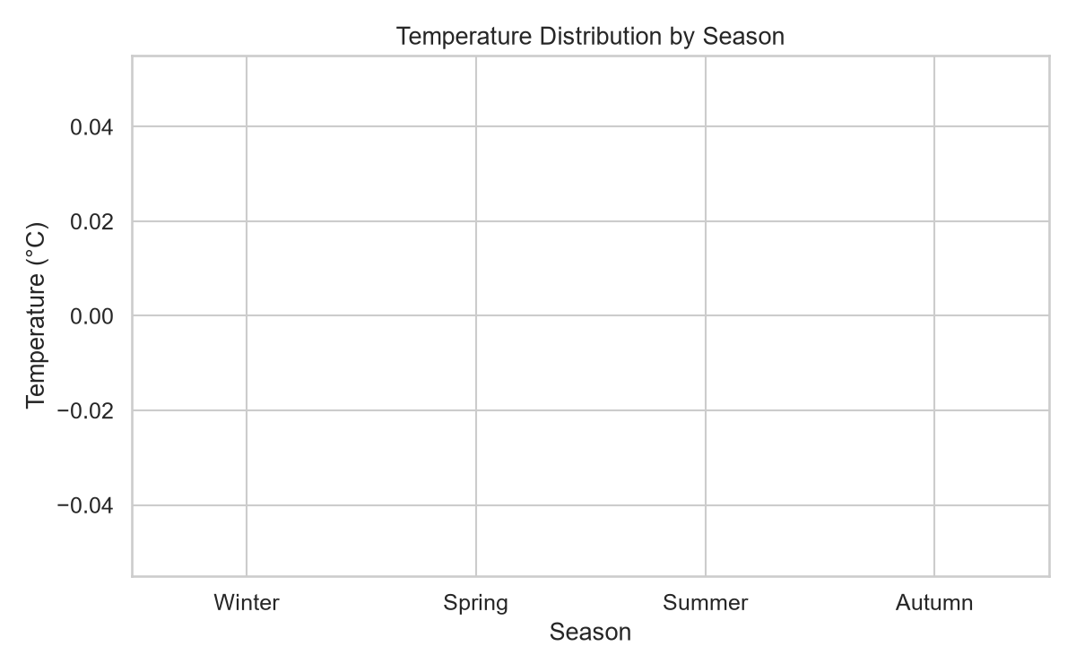
- Monthly Average Temperature Line Chart → peak in June–July, dip in December.
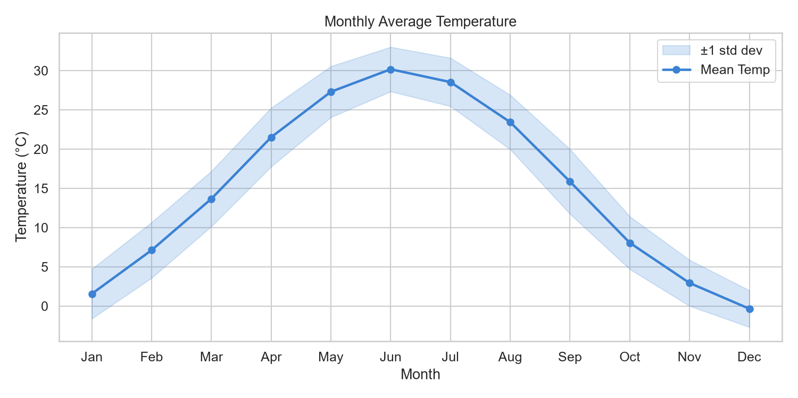
- Correlation Heatmap → strong negative correlation between temperature & humidity (-0.87), positive correlation between precipitation & cloud cover (0.65).
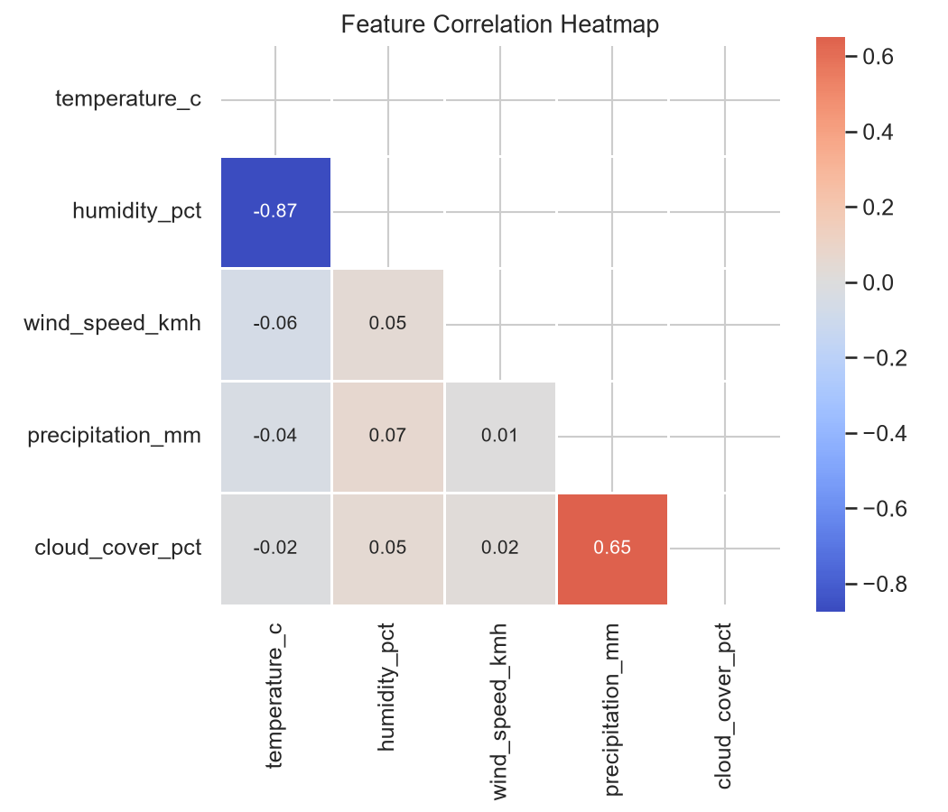
- Precipitation Distribution by Season → summer driest, spring wettest.
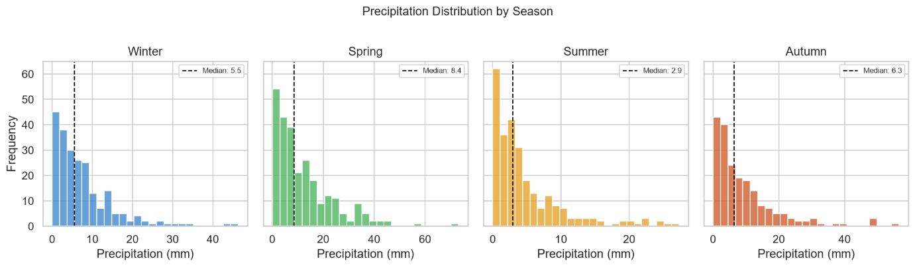
- Wind vs Temperature Scatter Plot → weak correlation.
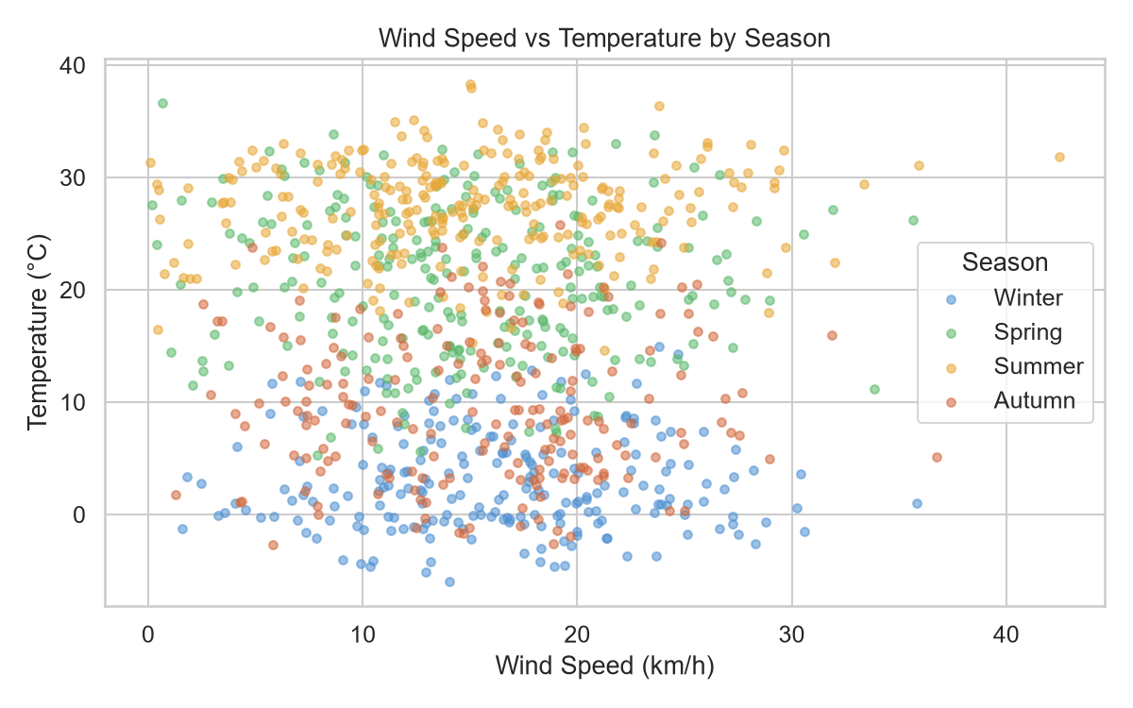
- Humidity vs Temperature Scatter Plot → negative correlation, precipitation influence visible.
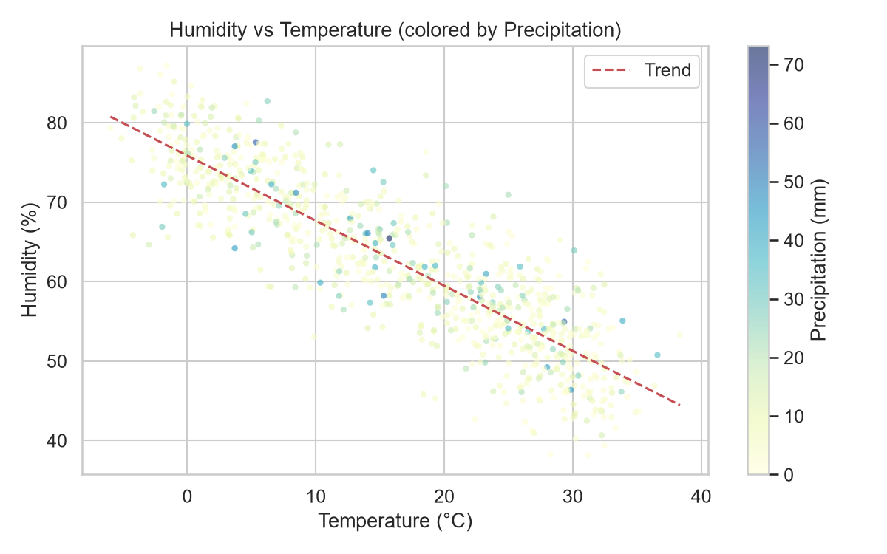
- Monthly Precipitation Bar Chart → rainfall peaks in April–May, drops in June–July.
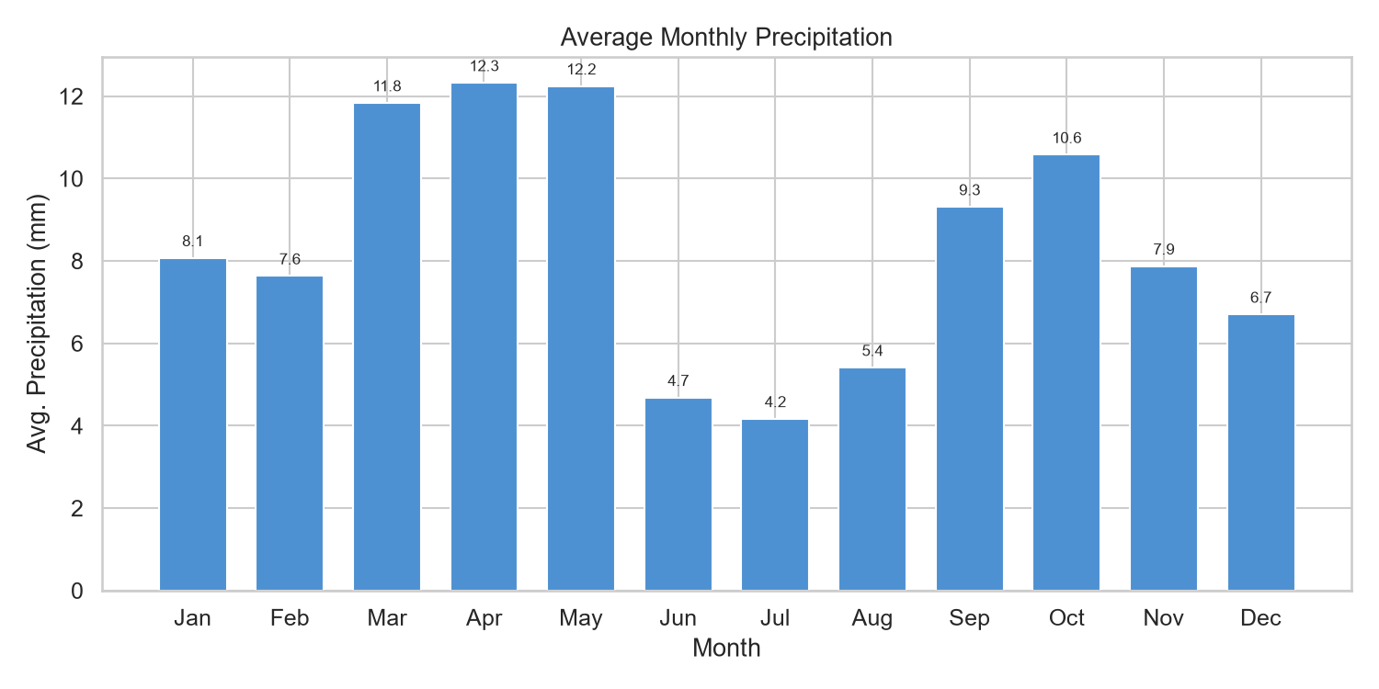
- Cloud Cover vs Precipitation Scatter Plot → higher cloud cover corresponds to higher rainfall.
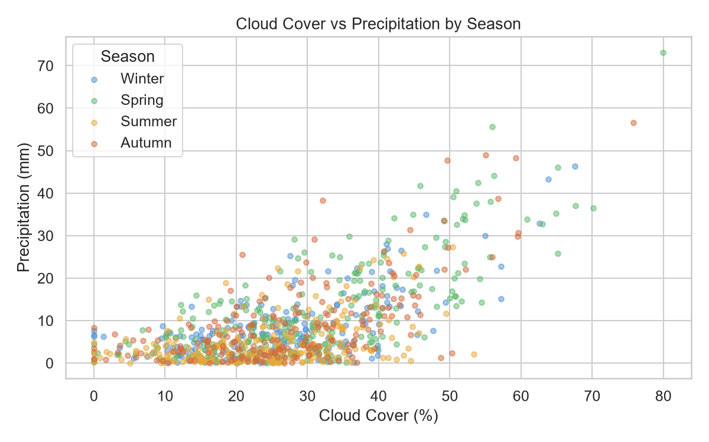
- Prediction vs Actual Plots → Ridge Regression shows best fit (R² = 0.947).
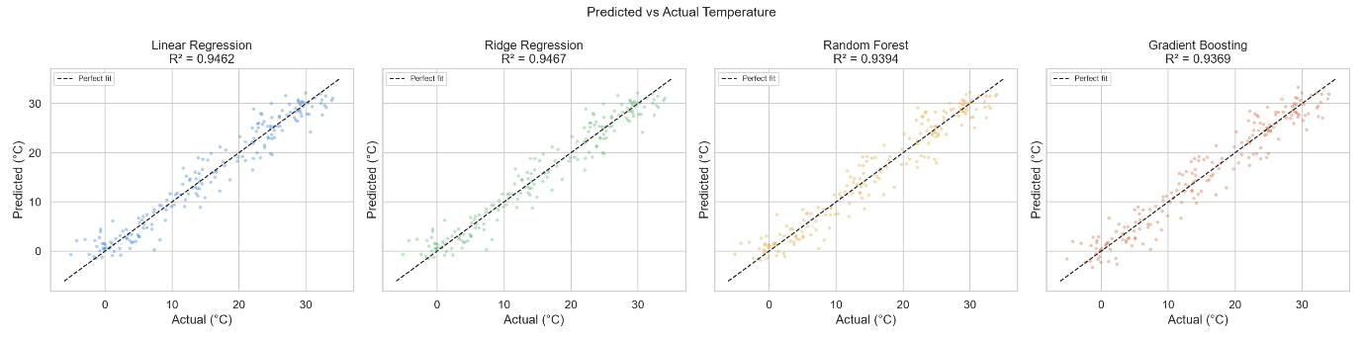
- Residuals Plot → errors centered around zero, confirming good model fit.
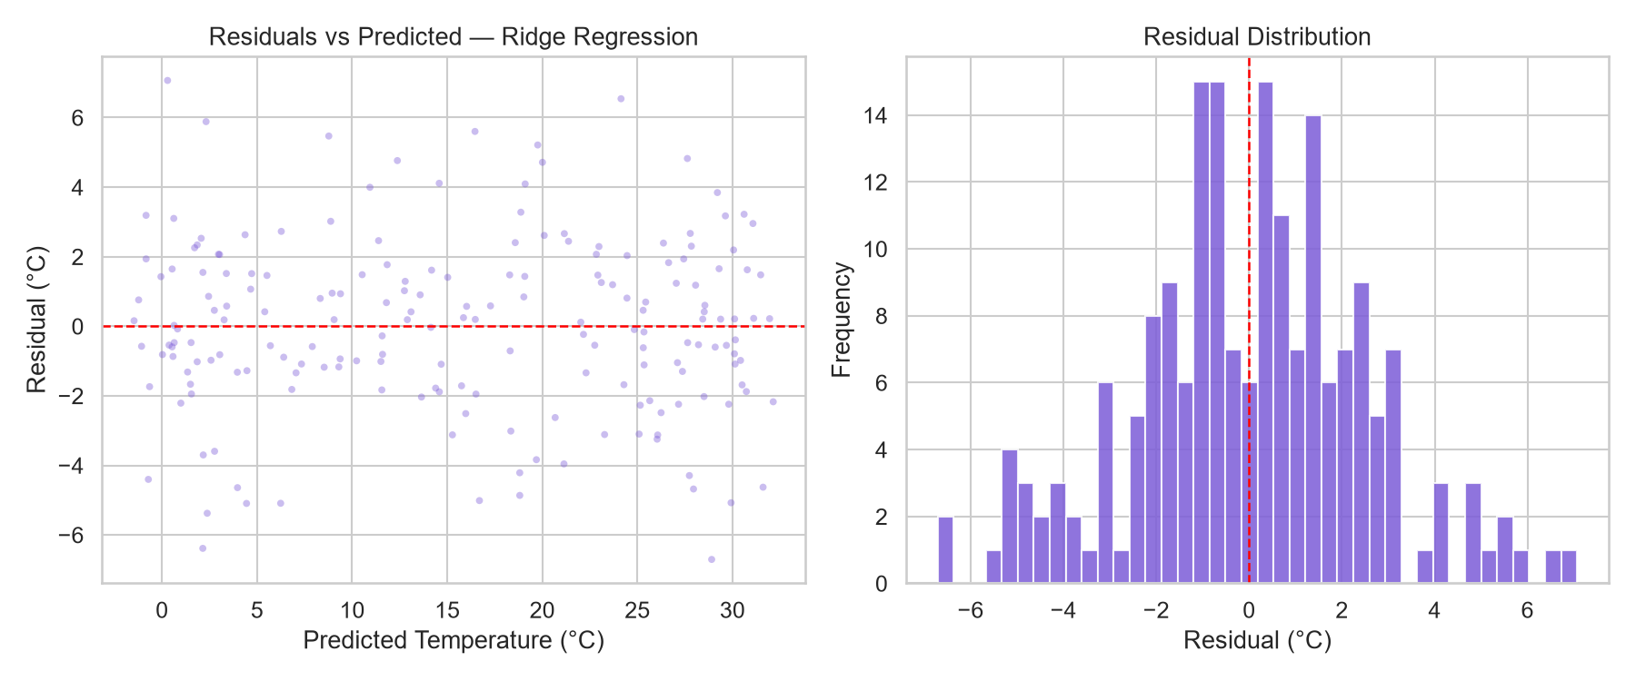

5. Model Training & Evaluation
- Models tested: Ridge Regression, Linear Regression, Random Forest, Gradient Boosting.
- Best Model: Ridge Regression
  - MAE: 1.96
  - RMSE: 2.51
  - R²: 0.947 (highest among all models).
- Random Forest & Gradient Boosting showed slightly lower performance (R² ~0.93–0.94).
Performance metrics of regression models.
Model | MAE | RMSE | R²
Ridge Regression | 1.96 | 2.51 | 0.947
Linear Regression | 1.97 | 2.52 | 0.946
Random Forest | 2.09 | 2.67 | 0.939
Gradient Boosting | 2.17 | 2.73 | 0.937

  - 6. Conclusion
- The weather dataset analysis revealed clear seasonal patterns and strong predictive accuracy.
- Key Insights:
  - June–July are the hottest months, December the coldest.
  - August shows peak humidity (83%).
  - Ridge Regression provided the most accurate predictions.
- Future Improvements:
  - Add more features (pressure, visibility, solar radiation).
  - Experiment with deep learning models for enhanced accuracy.

