Milestone–2
Field Extraction, Validation, and Database Storage

1. Introduction
Milestone–2 represents the core intelligence layer of the Receipt and Invoice Digitizer system. While Milestone–1 focuses on document ingestion and OCR-based text extraction, the raw text generated from OCR is still unstructured, noisy, and unsuitable for direct use in financial systems. OCR output may contain misaligned text, missing delimiters, or inconsistent formatting, which makes it unreliable for immediate storage or analysis.
Milestone–2 addresses this gap by transforming the raw OCR output into structured, validated, and persistent financial data. This milestone introduces intelligent field extraction using artificial intelligence, supported by rule-based techniques, followed by validation and database storage. The main goal is to ensure that extracted invoice data is accurate, consistent, duplicate-free, and ready for analytics or integration with accounting systems.
2. Scope of Milestone-2
The scope of Milestone–2 covers all activities required to convert OCR text into reliable financial records. It includes extracting meaningful invoice fields, validating numerical correctness, handling duplicate uploads, and storing verified data in a structured database.
Specifically, this milestone focuses on:
- Parsing raw OCR text into structured invoice fields
- Extracting line items, quantities, prices, tax amounts, and total values
- Applying accounting rules to validate extracted data
- Detecting and preventing duplicate invoice entries
- Persisting only valid invoices into a relational database
- Handling extraction failures using fallback mechanisms
Visualization, dashboards, and reporting are intentionally excluded from this milestone. Instead, the emphasis is placed on building a strong and trustworthy data foundation for future milestones.

3. System Design Overview
Milestone–2 follows a hybrid extraction architecture that combines AI-based extraction with rule-based fallback parsing. This design leverages the strengths of both approaches to achieve high accuracy and reliability.
The AI-based approach provides flexibility and contextual understanding, allowing the system to process invoices with different layouts and formats. The rule-based approach ensures robustness by guaranteeing that essential invoice information can still be extracted when AI services are unavailable. This layered design ensures uninterrupted invoice processing even under inconsistent OCR output or external service failures.
This layered design ensures that invoice processing continues even in cases of AI failure or inconsistent OCR output.
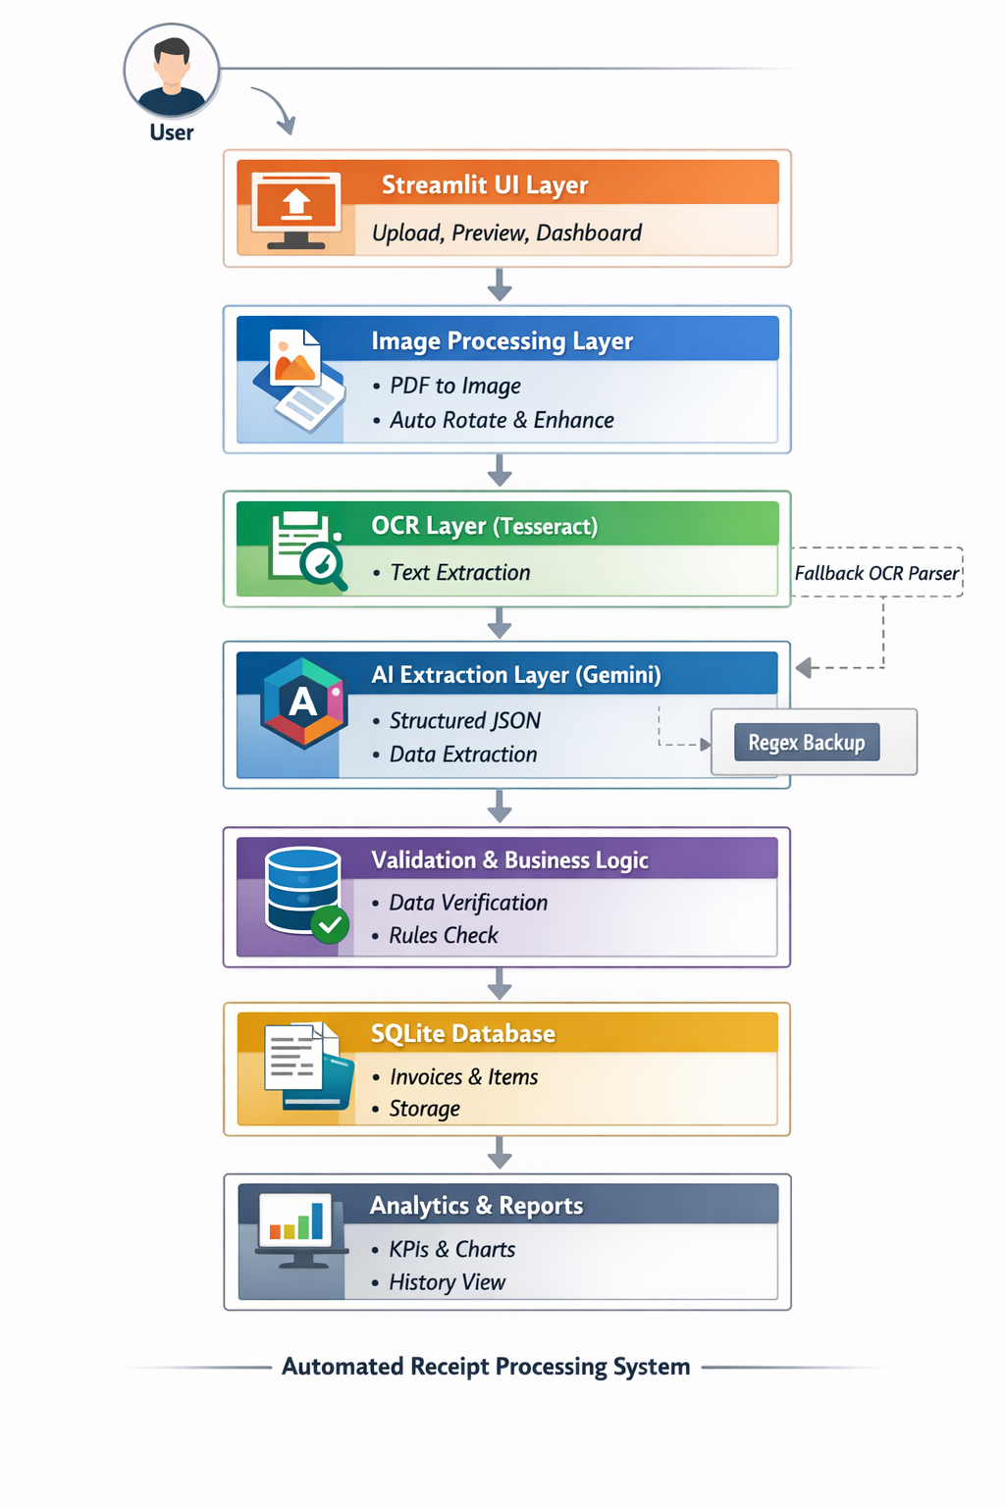

4. Field Extraction Module
4.1 Purpose of Field Extraction
The purpose of the Field Extraction module is to convert unstructured OCR text into a structured representation that can be stored, validated, and analyzed. Since invoices vary widely in format, layout, and terminology, traditional fixed-template parsing is insufficient. Therefore, an intelligent and adaptive approach is required.

4.2 Extracted Invoice Fields
The system extracts the following key invoice components:
- Invoice Identifier
  - A unique identifier assigned to each invoice
- Vendor Information
  - Name of the merchant or service provider
- Invoice Date
  - Date of transaction in standardized format
- Currency
  - Detected based on symbols or textual hints
- Line Items
  - Item name
  - Quantity
  - Unit price
- Tax Amount
  - GST, VAT, or equivalent
- Total Amount
  - Final payable amount
These fields collectively represent a complete financial transaction.

5. AI-Based Field Extraction Using Gemini
Invoices often contain inconsistent layouts, multi-line item descriptions, mixed numerical and textual formats, and regional variations in tax and currency representation. Handling such diversity using only rule-based logic is difficult and error-prone.
To address this challenge, the system integrates Google Gemini, a Large Language Model capable of understanding context within unstructured text. Raw OCR text is passed to Gemini along with a carefully designed prompt that enforces strict JSON-only output. Gemini analyzes the text and extracts relevant invoice fields in a structured format.
The Gemini-based extraction process follows these steps:
- Raw OCR text is sent to the Gemini model
- A strict prompt enforces structured JSON output
- Relevant invoice fields are identified and extracted
- The output is checked for completeness and correctness
This AI-based approach significantly improves extraction accuracy, especially for complex or non-standard invoices.
5.3 Schema Enforcement and Data Normalization
The Gemini prompt enforces:
- Mandatory fields
- Correct data types (numbers for prices and quantities)
- Structured line items
- No inclusion of subtotal or total rows as items
This prevents malformed or inconsistent data from entering the system.

6. Fallback Extraction Mechanism
6.1 Need for a Fallback Strategy
AI-based systems may fail due to:
- API rate limits
- Network interruptions
- Invalid or incomplete responses
To ensure uninterrupted operation, a fallback extraction mechanism is implemented.

6.2 Rule-Based Parsing Approach
Although AI-based extraction offers high accuracy, it may fail due to API rate limits, network interruptions, or invalid responses. To ensure system reliability, a fallback extraction mechanism is implemented.
The fallback mechanism uses regular expressions (Regex) and rule-based parsing techniques. It performs line-by-line analysis of OCR text and applies pattern matching to extract numerical and textual information. Regex is used to identify:
- Numeric values such as prices and quantities
- Tax-related values like GST or VAT
- Total amounts appearing near keywords such as “Total” or “Amount Due”
Keyword filtering is applied to remove non-item rows such as subtotals or payment summaries. Although this approach is less flexible than AI-based extraction, it guarantees minimum functional output and ensures uninterrupted invoice processing.

7. Data Cleaning and Normalization
Before validation, the extracted data undergoes cleaning and normalization to improve consistency and accuracy. OCR and extraction processes may introduce inconsistencies such as missing quantities, incorrect numeric formats, or irrelevant entries.
The cleaning process includes:
- Removing non-item rows such as subtotal, tax, and total from line items
- Assigning default quantities when values are missing
- Converting numeric fields to standard formats
- Removing empty or invalid item entries
This normalization step ensures that invoice data from different sources follows a consistent structure, enabling accurate validation and storage.

8. Validation Module
8.1 Importance of Validation
Financial data must be accurate to be trustworthy. OCR or AI extraction errors can lead to incorrect totals, which can compromise accounting integrity. Therefore, validation is a mandatory step before database storage.

8.2 Validation Rules Implemented
The system validates invoices using real-world accounting logic:
- If sum of line items equals total amount, the invoice is marked as VALID
- If sum of line items plus tax equals total amount, the invoice is marked as VALID
- Otherwise, the invoice is marked as NOT VALID
Invoices with no line items are automatically invalidated.

8.3 Validation Outcome Handling
- VALID invoices are persisted in the database
- NOT VALID invoices are displayed to the user but not stored
This ensures only reliable data is retained.

9. Duplicate Detection
Duplicate invoices may occur when users upload the same receipt multiple times. Storing duplicate data can lead to incorrect analytics and redundant records.
To prevent this, the system implements duplicate detection by:
- Comparing initial segments of OCR text
- Using partial text hashing techniques
- Checking for matching entries in the database
If a duplicate invoice is detected, the system retrieves the existing record instead of creating a new one. This approach maintains database cleanliness and improves data consistency.

10. Database Storage Module
10.1 Database Design
The system uses SQLite, a lightweight relational database suitable for local and small-scale applications.
The database contains two primary tables:
Invoices Table
- Invoice ID (Primary Key)
- Vendor name
- Date
- Currency
- Tax amount
- Total amount
- Validation status
- Creation timestamp
Items Table
- Item ID
- Invoice ID (Foreign Key)
- Item name
- Quantity
- Price

10.2 Storage Conditions
- Only VALID invoices are stored
- Line items are normalized into a separate table
- Existing invoices are updated using replace logic
This design maintains relational integrity and scalability.

11. Outcomes of Milestone-2
By the end of Milestone-2, the system achieves:
- Accurate extraction of invoice fields
- AI-assisted and rule-based reliability
- Strong validation for financial correctness
- Duplicate-free database storage
- A clean, structured data layer for analytics

12. Conclusion
Milestone-2 is the most critical phase of the Receipt & Invoice Digitizer system. It bridges the gap between raw OCR text and meaningful financial data. By integrating AI-driven extraction, strict validation, and robust storage mechanisms, this milestone ensures that the system produces trustworthy and actionable data. This forms a strong foundation for dashboard visualization and reporting in subsequent milestones.

References
- Smith, R. (2007). An Overview of the Tesseract OCR Engine. Proceedings of the Ninth International Conference on Document Analysis and Recognition (ICDAR), IEEE.
This reference provides foundational knowledge about the OCR engine used for extracting text from scanned documents.
- OpenCV Documentation. Image Processing Techniques.
Available at: https://docs.opencv.org
This resource was referred to for image preprocessing techniques such as resizing, noise removal, thresholding, and contrast enhancement to improve OCR accuracy.
- Google. Gemini API Documentation.
Available at: https://ai.google.dev
This documentation explains the usage of the Gemini Large Language Model for structured data extraction from unstructured text.
- Friedl, J. E. F. (2006). Mastering Regular Expressions (3rd Edition). O’Reilly Media.
This book serves as a reference for understanding and implementing regular expressions used in rule-based fallback extraction.
- SQLite Consortium. SQLite Documentation.
Available at: https://www.sqlite.org/docs.html
This reference describes the relational database system used for structured storage of invoice and item data.
- Streamlit Inc. Streamlit Documentation.
Available at: https://docs.streamlit.io
This documentation was used to design the web-based user interface for uploading invoices and displaying extracted data.
- Jurafsky, D., & Martin, J. H. (2023). Speech and Language Processing (3rd Edition). Pearson.
This book provides conceptual background on natural language processing techniques relevant to AI-based text understanding.

