Hypothesis Testing – One-Way ANOVA (Regional Sales Analysis)

Objective
To determine whether there is a statistically significant difference in sales among the four regions: West, East, Central, and South.

Hypotheses
Null Hypothesis (H₀):
There is no significant difference in average sales across regions.
Alternative Hypothesis (H₁):
There is a significant difference in average sales across regions.

Significance Level
α = 0.05
Test Used
One-Way ANOVA (Single Factor)

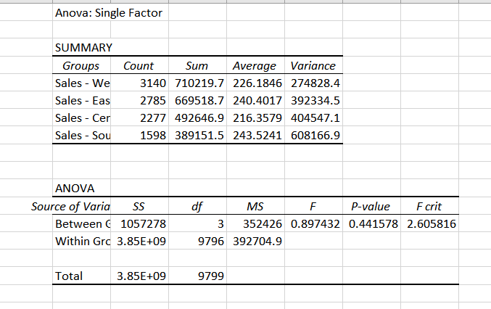

Reason:
ANOVA is used because we are comparing the means of more than two independent groups (four regions).

ANOVA Results
F-value = 0.8974
P-value = 0.4416
F-critical = 2.6058

Decision Rule
If P-value < 0.05
Reject H₀
Means regional sales difference significant
If P-value > 0.05
Fail to reject H₀
Means difference not statistically significant
Since 0.4416 > 0.05, we fail to reject the null hypothesis.
Compare F and F Critical
Rule:
- If F > F Critical, reject the null hypothesis (H₀)
- If F < F Critical, fail to reject (accept) the null hypothesis (H₀)

In this case:
- F = 0.8974
- F Critical = 2.6058
Since 0.8974 < 2.6058, we fail to reject the null hypothesis (H₀).

Conclusion
The analysis shows that there is no statistically significant difference in sales among the four regions. Regional location does not appear to significantly influence sales performance.

Business Interpretation
Although average sales vary slightly between regions, the variation is not statistically significant. Therefore, business strategies should focus more on product categories, promotions, and seasonal trends rather than geographical differences.

