SEVA SADAN’S R.K.TALREJA
COLLEGE OF ARTS SCIENCE AND
COMMERCE

PROJECT
LANGUAGE LEARNING
APPLICATION
A.Y 2025

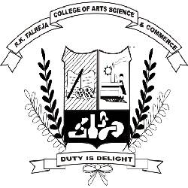

SUBMITTED TO: SUBMITTED BY:

PROF.KIARA SANGTANI DIVYANSHI UPADHYAY

