**CMDB and Satellite compared:**

Compared Both CMDB list of Servers and Satellite list of Servers:

* Both Data should be in Sync
* Exported CMDB – There are 1458 Servers found.
* Exported Satellite – There are 998 Servers found.
* Found that both Servers are not in sync. Some servers are missing.
* Compared both using Automated Script using Shell Script
* Found the missing servers. Able to get the data.

**Process Followed:**

Copied CMDB list and Satellite list using Winscp to the Folder (cmdb_automation)

1. Created new Folder cmdb_automation

# Login to the Server as sstadmin

# Become Root user – sudo su –

# Copied the list in the below path

* **Path : /home/sstadmin/cmdb_automation**

# [root@fwnleistwrvp001 c102074]# cp cmdb_ci_linux_server.csv Satellite.csv /home/sstadmin/cmdb_automtion/

#[root@fwnleistwrvp001 c102074]# cd ../

#[root@fwnleistwrvp001 home]# cd sstadmin/cmdb_automation/

#[root@fwnleistwrvp001 cmdb_automation]# ls

cmdb_ci_linux_server.csv Satellite.csv

1. Create and edit compare.sh script

# vi compare.sh and save it

**Below is the script executed:**

#!/bin/bash

# Define the file names

file1="cmdb_ci_linux_server.csv"

file2="Satellite.csv"

# Extract the first column from each CSV and sort them

cut -d',' -f1 "$file1" | sort > file1_names.txt

cut -d',' -f1 "$file2" | sort > file2_names.txt

# Find entries in file1 that are not in file2

comm -23 file1_names.txt file2_names.txt > only_in_file1.txt

# Print results

echo "Entries in $file1 but not in $file2:"

cat only_in_file1.txt

# Clean up temporary files

rm file1_names.txt file2_names.txt only_in_file1.txt

Save it

# [root@fwnleistwrvp001 cmdb_automation]# ls

cmdb_ci_linux_server.csv compare.sh Satellite.csv

1. Now run the script –

# sh compare.sh

You will see the list of missed files which are not in Satellite

Found 603

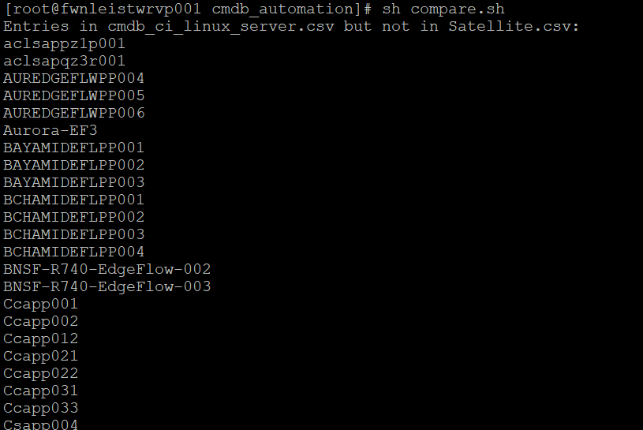

# sh compare.sh | wc -l

