ASG Airlines
End-to-End Data Engineering Case Study
Technical Documentation — Pipeline Architecture, Data Model & Transformation Logic
Implementation : Local Python (pandas) + MySQL implementation

1. Dataset Structure
The flight dataset contains 1,020 records and 7 columns: flight_id, airline, source, destination, departure_time, arrival_time, and duration. After removing 15 exact duplicate records, the final dataset contains 1,005 records.
The pipeline starts with the raw Excel file. Python and Pandas are used to load the different datasets and perform data profiling, cleaning, validation, and transformation. The cleaned data is then masked where sensitive information is present and exported as CSV files. These files are loaded into MySQL for SQL analysis and are then connected to Power BI for visualization and reporting.
The flight data flow is: Raw Excel Data → Data Profiling → Data Cleaning → Data Validation → Transformation → Cleaned Data → MySQL → Power BI.
The main data model contains Flights, Passengers, Bookings, and Payments. Passengers are connected to Bookings using passenger_id, and Bookings are connected to Payments using booking_id. Flight records use flight_key as the unique identifier because some flight_id values occur more than once.
The main assumptions are that the airline can be identified from the flight_id prefix when the airline value is missing, duplicate flight_id values are retained because they can represent different flight records, and flights crossing midnight are treated as overnight flights.
The data cleaning process includes checking missing values, removing exact duplicate records, validating flight IDs, checking source and destination values, and validating departure and arrival timestamps. Missing airline values are inferred from the flight ID prefix. The flight duration is converted into a usable time format and validated against the calculated duration.
Duration is calculated using arrival time minus departure time. For an overnight flight, where the arrival timestamp is earlier than the departure timestamp, one day is added to the arrival timestamp before calculating the duration. This prevents negative or incorrect flight durations and ensures that overnight flights are handled correctly.

2. Pipeline Architecture & Data Flow
The pipeline runs as four independent per-table cleaning scripts, followed by a masking stage for the two tables holding PII, followed by loading into a MySQL data warehouse (airlines_dw). The diagram below covers both the architecture (which components exist and how they're wired) and the data flow (how rows move and transform between them).
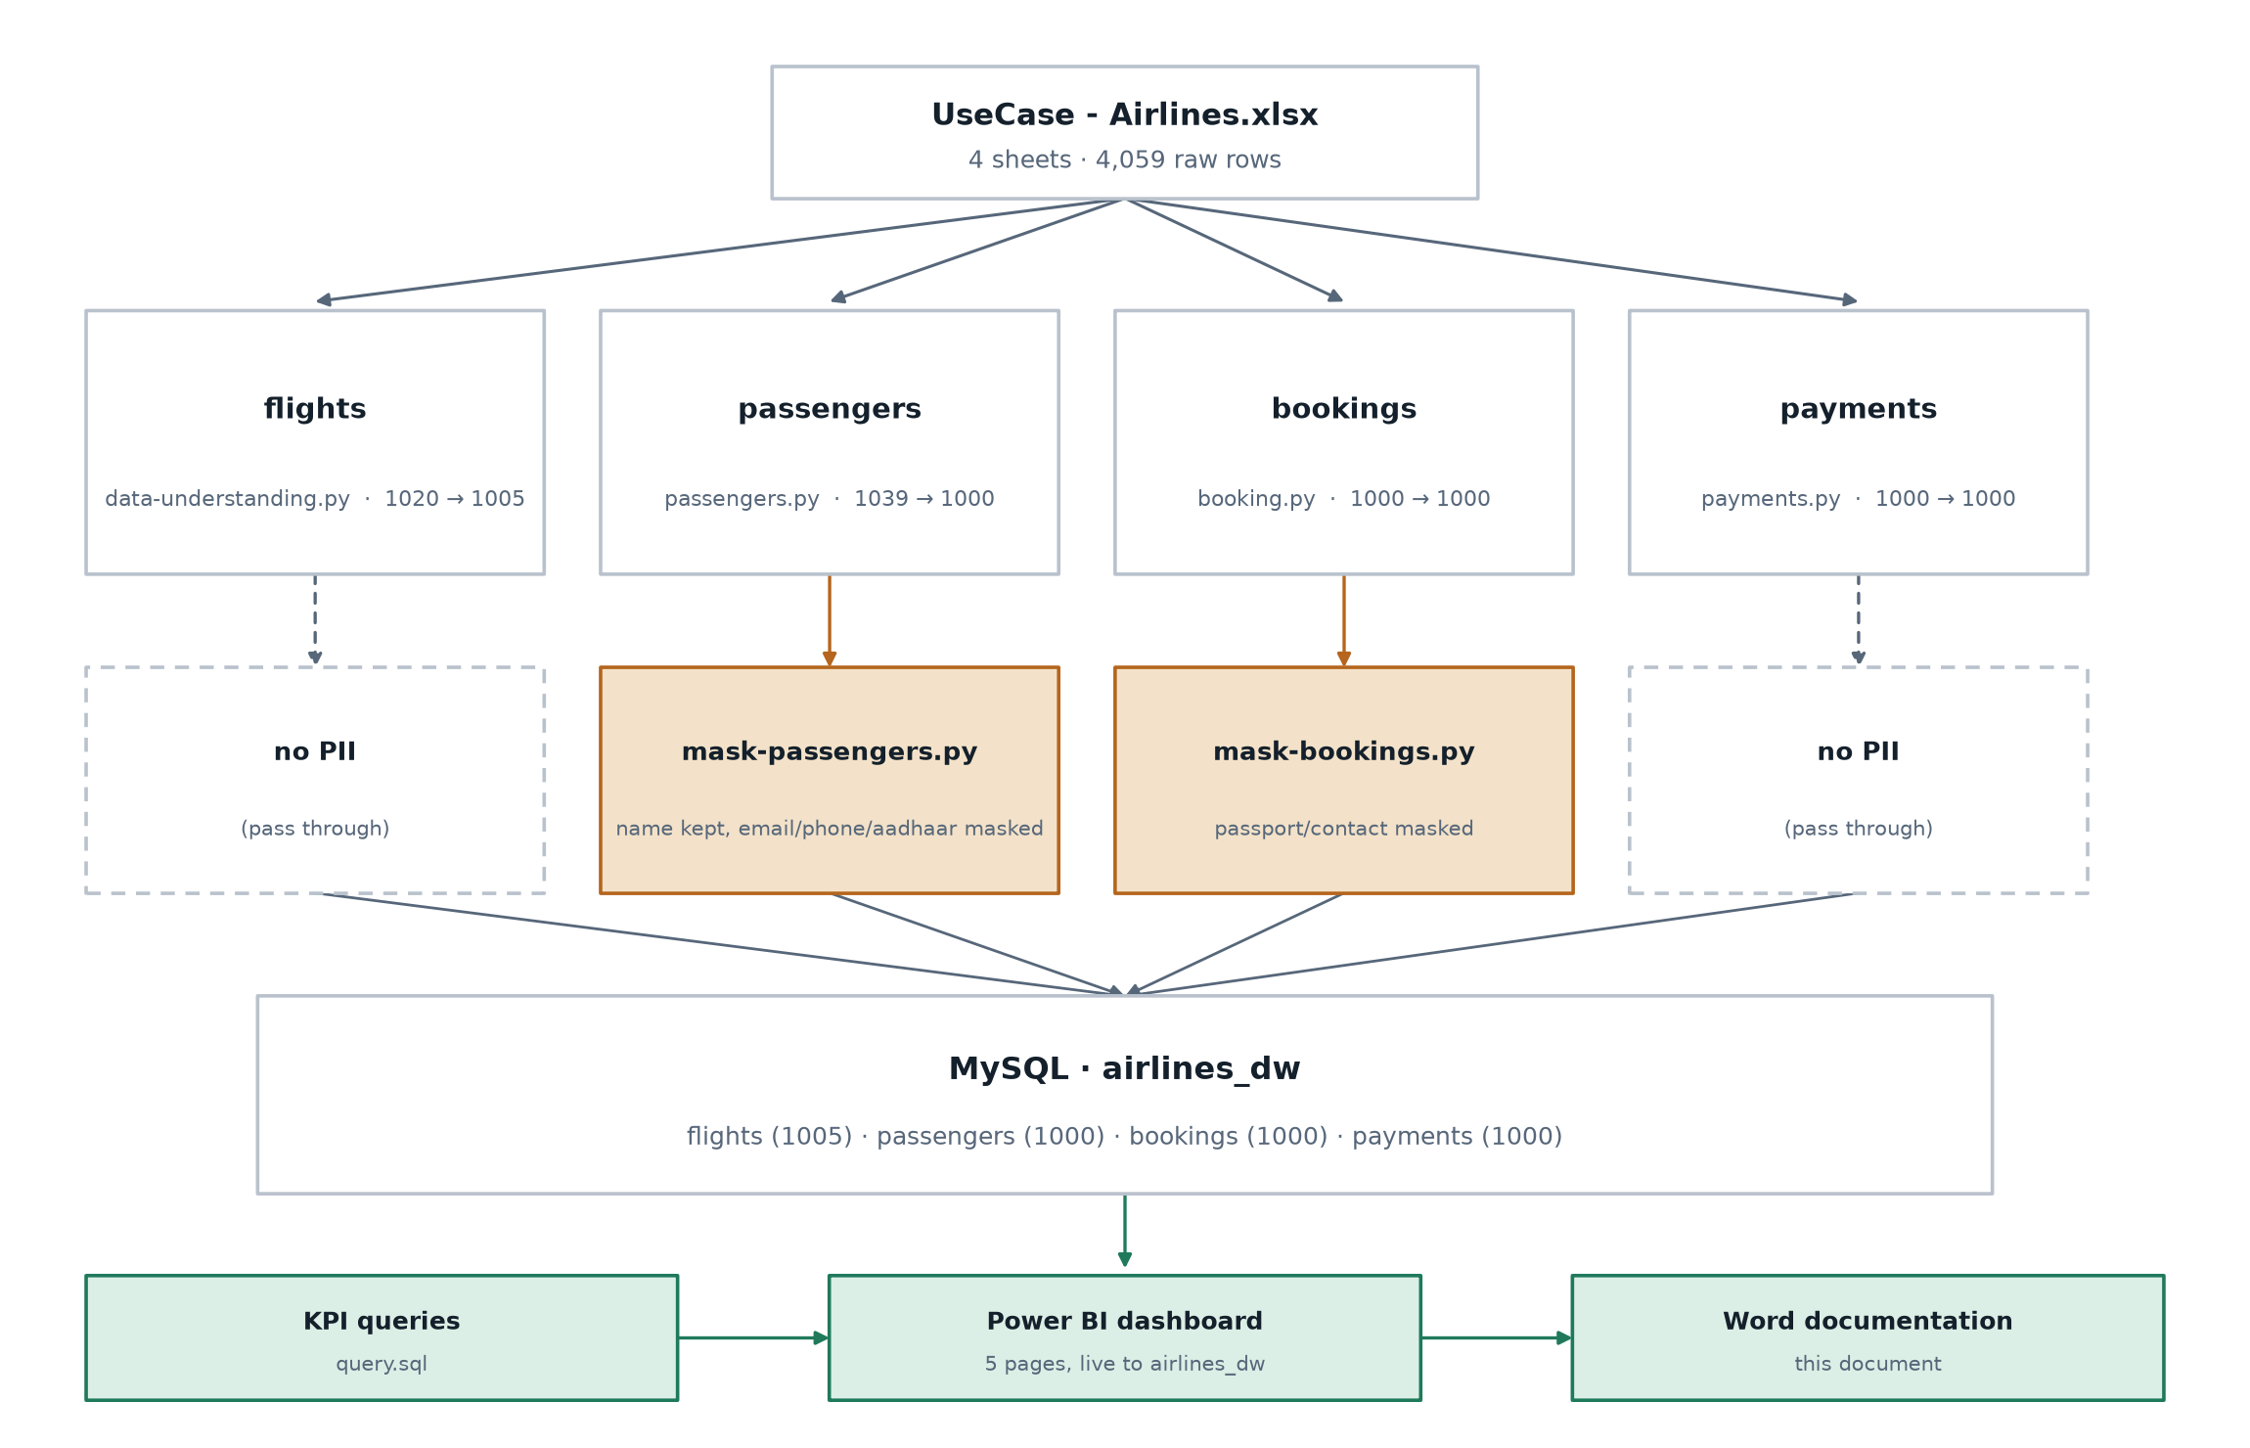
Figure 1. Pipeline architecture and data flow, from source workbook to MySQL. Only bookings and passengers — the two tables holding PII — pass through a masking stage before loading.
Each cleaning script (data-understanding.py, passengers.py, booking.py, payments.py) is independently runnable and saves its own cleaned .xlsx output under data/cleaned/. The two masking scripts (mask-passengers.py, mask-bookings.py) read those cleaned files and write *_analytics.xlsx outputs — the only versions of passenger/booking PII that are loaded into MySQL.
Architecture

The pipeline follows a simple ETL architecture. The raw airline data is stored in an Excel file. Python and Pandas are used for data ingestion, cleaning, validation, and transformation. PII masking is then applied to sensitive passenger and booking information. The cleaned data is exported as CSV files and loaded into a MySQL database. SQL is used for analysis and validation, and Power BI is connected to MySQL to create the final dashboard.

Flow:
Excel → Python/Pandas → Data Cleaning & Transformation → PII Masking → CSV → MySQL → SQL Analysis → Power BI
Data Flow

Raw Excel file is first read using Python. The four datasets — Flights, Passengers, Bookings, and Payments — are processed separately. Missing values, duplicates, invalid values, data types, IDs, and timestamps are checked and corrected where required. Sensitive information is masked before the analytical data is exported. The cleaned datasets are then loaded into MySQL, where relationships and data quality are validated using SQL. Finally, the MySQL data is connected to Power BI for visualization and business insights.

Flow:
Raw Data → Ingestion → Profiling → Cleaning → Transformation → PII Masking → Cleaned Data → MySQL → SQL Analysis → Power BI Dashboard

3. Data Model
MySQL database airlines_dw holds four base tables plus two views that resolve a specific data-quality issue in flight_id (detailed below).
The data model consists of four main tables: Flights, Passengers, Bookings, and Payments.

Passengers are connected to Bookings using passenger_id. Bookings are connected to Payments using booking_id. Bookings also contain flight_id to connect booking information with flight information.

Since some flight_id values are repeated in the source data, flight_key is used as the unique identifier for individual flight records. This prevents valid repeated flight records from being incorrectly removed.

Relationship flow:
Passengers → Bookings → Payments
Bookings → Flights

flight_id 6F250 is not a duplicate row — it identifies two genuinely different flights (Delhi→Bangalore and Kolkata→Bangalore, different departure times). This is the “corrupted flight identifier” scenario the brief calls out explicitly. Deleting either row would silently lose a real flight, so the flights table uses a surrogate primary key (flight_key, AUTO_INCREMENT) instead of relying on flight_id to be unique.
That choice has a real consequence: flight_id is no longer unique, so bookings cannot carry a foreign key to flights on that column, and any join from bookings to flights on flight_id would match both 6F250 rows for the 2 bookings that reference it (B1235, B1294) — silently double-counting them in any route/duration/airline KPI.
Two views resolve this cleanly:
- flight_mapping — maps each flight_id to a single flight_key (MIN(flight_key) per flight_id). This is a no-op for every ordinary flight_id and only matters for 6F250, where it would otherwise pick one of the two real flights arbitrarily.
- valid_booking_flights — joins bookings to flights through flight_mapping, then explicitly excludes WHERE flight_id <> '6F250'. This is the deliberate choice not to use flight_mapping's arbitrary pick for the one flight_id where it would be guessing: the 2 affected bookings are excluded from any flight-joined KPI rather than silently misattributed to one specific flight.
All flight-joined KPI queries in sql/airlines_analysis.sql use valid_booking_flights, not raw bookings, for this reason.

4. Assumptions Made
- Missing airline values can be identified using the prefix of the flight_id.
- Exact duplicate flight records can be removed without affecting the valid data.
- Repeated flight_id values are retained because they may represent different flight records.
- flight_key is used as the unique identifier for individual flight records.
- Missing passenger last names are replaced with UNKNOWN.
- When duplicate passenger IDs contain conflicting information and no authoritative source is available, the first record is retained.
- A flight with an arrival time earlier than its departure time is assumed to have crossed midnight and is treated as an overnight flight.
- Flight duration is calculated as arrival time minus departure time.
- Sensitive passenger and booking information is masked before the data is used for analytics.

5. Privacy & Access Control
PII masking (covered above) answers how sensitive data is concealed. Access control — who can see it — is addressed structurally:
- Two-tier separation: cleaned files with plaintext PII (cleaned_data_passengers.xlsx, cleaned_data_bookings.xlsx) exist only as local working files used to produce the masked versions; the MySQL database used for reporting and Power BI holds only masked values.
- This was actually caught and fixed mid-project: the passengers and bookings tables were initially loaded from the plaintext cleaned files rather than the masked *_analytics.xlsx outputs. Verified directly (a live query returned real names, emails, and Aadhaar numbers), then corrected by converting the masked files to CSV and reloading via a staging-table UPDATE ... JOIN — the same pattern already established for payments — so the primary keys never changed and no foreign-key constraints were disturbed.
- Principle of least privilege: only the pipeline's own cleaning/masking scripts should ever read the raw workbook or the plaintext cleaned files. Any reporting tool (Power BI, ad-hoc SQL clients) should only ever have read access to the masked columns already loaded into airlines_dw — in a production deployment this maps to separate database roles/schemas with GRANT SELECT scoped accordingly, or row/column-level security in a managed warehouse.
- Hashed or partially-masked identifiers stay usable for operational purposes (support lookups via the last 4 digits of a phone/Aadhaar number) without exposing the full value.
- The payments load wraps its MySQL operations in try/except/finally — a failure partway through triggers a rollback rather than leaving payments in a half-loaded, inconsistent state, and the connection/cursor are guaranteed to close in finally even on error, so credentials and an open session to airlines_dw are never left dangling longer than the load itself takes.

6. Power BI Dashboard
ASG_Airlines_Dashboard.pbix connects live to airlines_dw (MySQL, Import mode) across 5 pages. All measures are DAX, built on flights, valid_booking_flights, payments, and passengers, with a bi-directional relationship between bookings and valid_booking_flights specifically so route/airline selections correctly reach revenue figures in payments (a single-direction relationship would have left route-level revenue blank).

Overview
KPI cards for total flights/bookings/passengers/revenue, flight distribution by airline (donut), bookings by route, booking status distribution, and revenue by airline — with route and airline slicers.
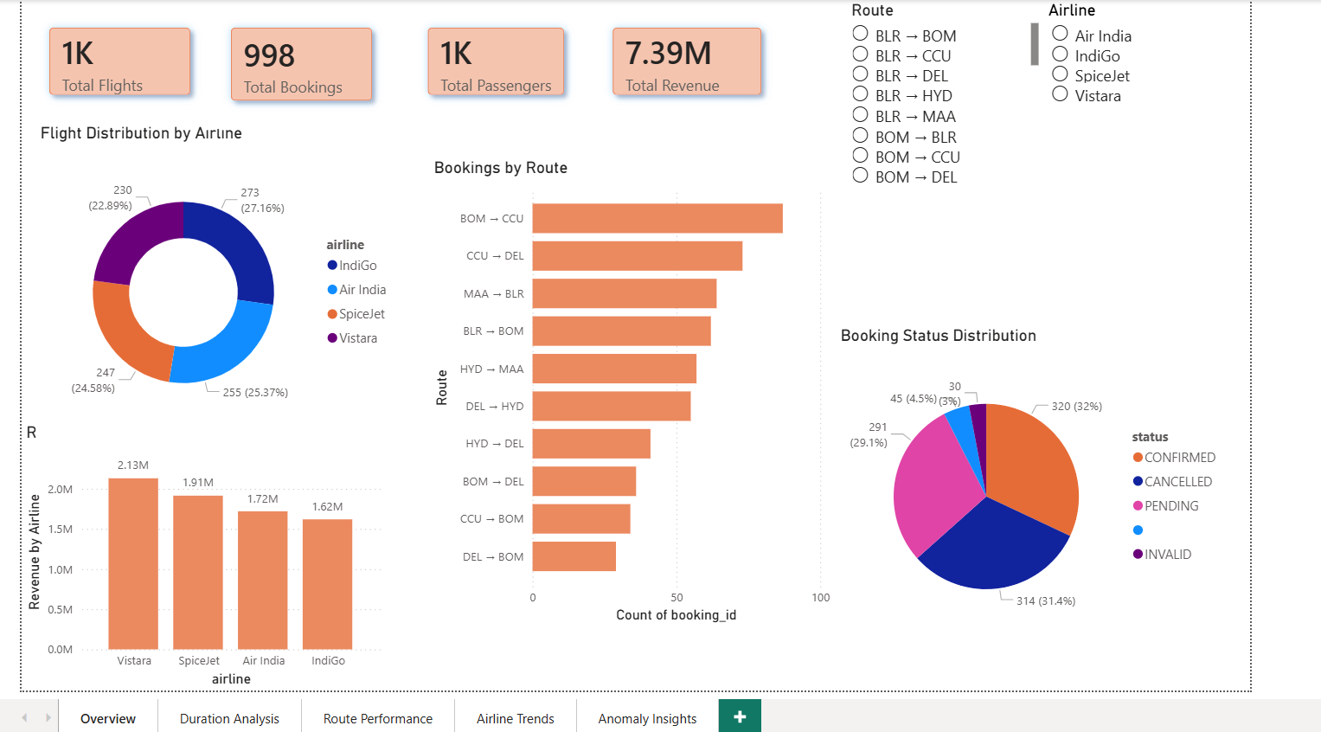
Figure 2. Overview page.

Duration Analysis
Min/average/max flight duration, overnight-flight count and percentage, average duration by airline and by route.
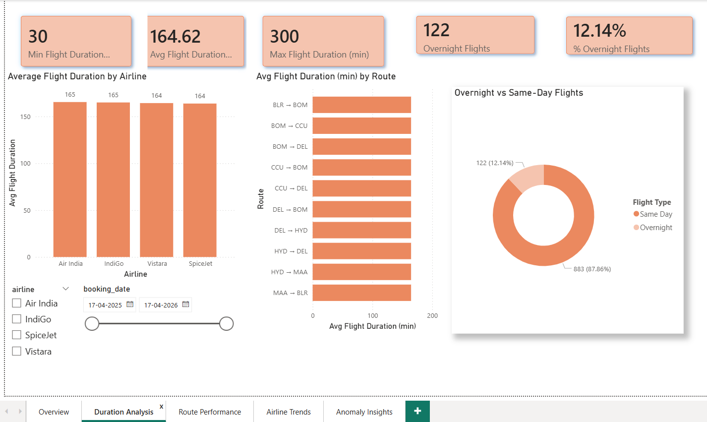
Figure 3. Duration Analysis page.

Route Performance
Bookings, revenue, and flight count by route side by side — the same top routes (BOM→CCU, CCU→DEL, MAA→BLR, ...) appear consistently across all three, which is itself a sanity check that the underlying relationships are correct.
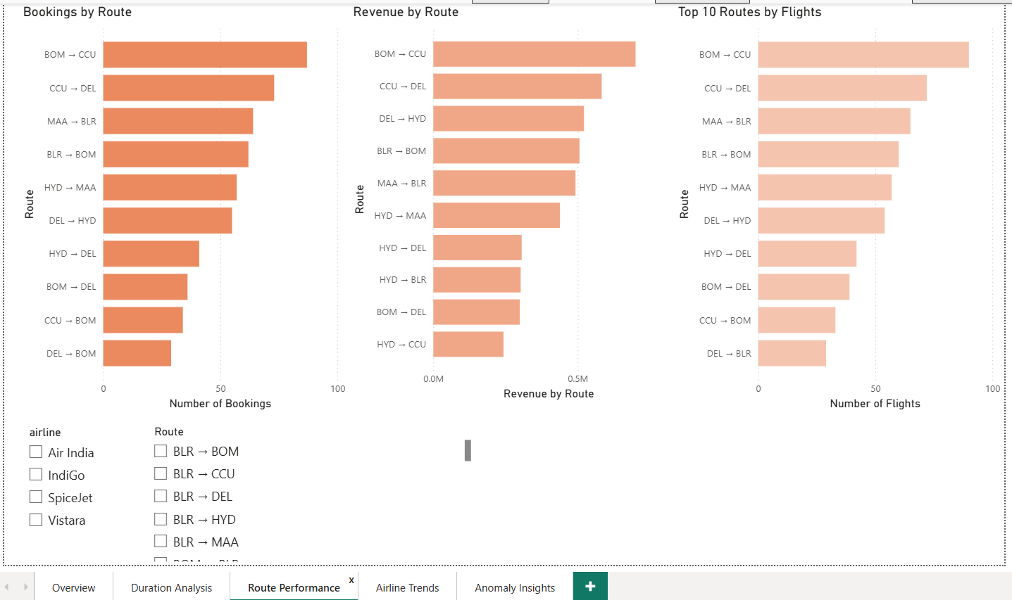
Figure 4. Route Performance page.

Airline Trends
Flights and revenue by airline, plus cancellation rate by airline. Revenue ranking (Vistara highest) doesn't follow flight-count ranking (IndiGo highest) — a real finding about ticket pricing/booking mix, not an inconsistency.
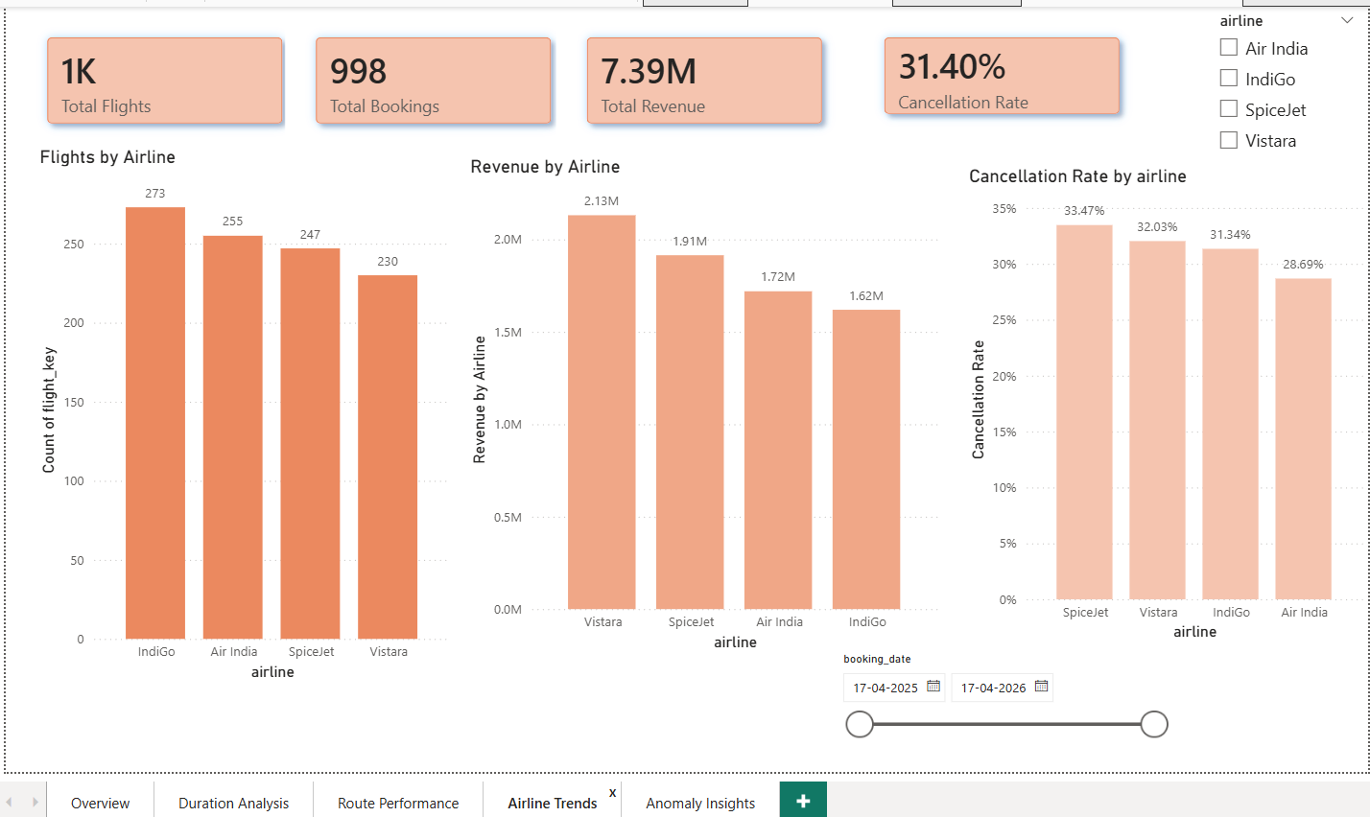
Figure 5. Airline Trends page.

Anomaly Insights
Mean and standard deviation of flight duration, the ±2×STDDEV threshold values, and the anomaly count — 0, matching the equivalent SQL query's result. The page states this plainly rather than hiding an empty result, and includes the underlying flight detail table for context.
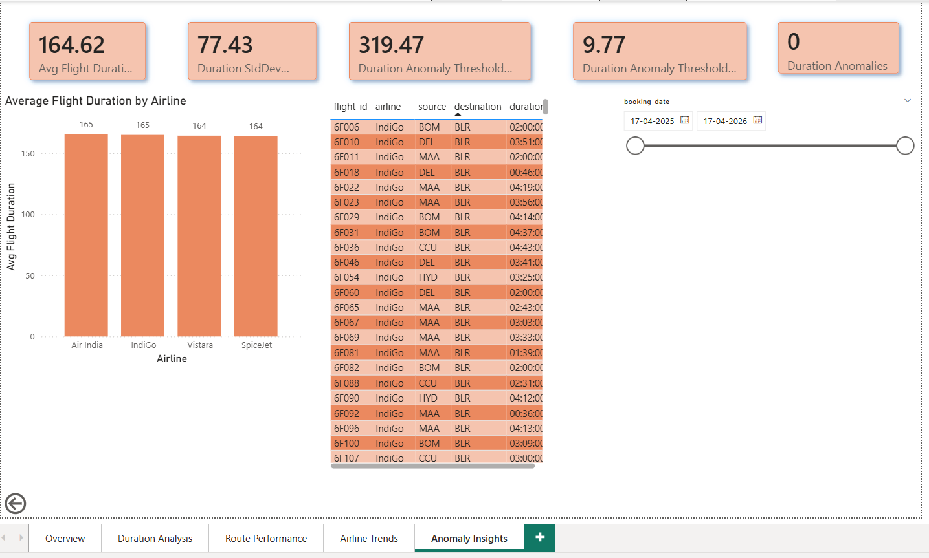
Figure 6. Anomaly Insights page.

7. Known Limitations
- bookings.status nulls (45) and literal 'INVALID' values (30) remain unresolved — a deliberate deferral, not an oversight, pending a decision on the correct default.
- The Power BI Overview page's booking-status pie has one unlabeled slice — the 45 null-status bookings above. The underlying data decision is intentional and documented; the chart itself doesn't yet label that slice for a viewer without this context.
- date_of_birth is not masked in the passenger analytics output, despite being PII on its own.
- Some flight_id values are repeated, making it difficult to uniquely map every booking to a specific flight record.
- Some passenger records contain duplicate passenger IDs with conflicting information.
- Missing payment amounts cannot be recovered from the available data.
- The pipeline is implemented locally and does not include production-level cloud infrastructure or automated scheduling.

