Q1.

Code:

|  |
| --- |
| package Q1;  public class Q1 {  public static void main(String[] args) {   //part a  int A=12;  int B=8;  int C=20;   double result1=Math.sqrt(Math.pow(B,2)+4*A*C);  //double result1=Math.sqrt(B*B+4*A*C);  System.out.println(result1);   //part b  int X=15;  int Y=18;   double result2=Math.sqrt(X+4*Math.pow(Y,3));  //double result2=Math.sqrt(X+4*Y*Y*Y);  System.out.println(result2);   //part c  double result3=Math.cbrt(X*Y);  System.out.println(result3);   //part d  float r=21;  double area=Math.PI*Math.pow(r,2);  System.out.println(area);   } } |

Output:

Q1

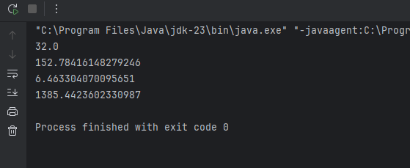

Q2.

Code:

|  |
| --- |
| package Q2;  import java.util.Scanner;  public class Q2 {  public static void main(String[] args) {  Scanner input=new Scanner(System.*in*);  System.*out*.println("Enter the length centimeters:");  float length=input.nextFloat();   double inches=length/2.54;   //1feet=12inches  int feet=(int)inches/12;  double remaining_inches= (inches%12);   System.*out*.println("The length you entered is "+length+"cm");  System.*out*.println("Entered cm in inches="+inches+" inches");  System.*out*.println("Entered cm in feet="+feet+" feet");  System.*out*.println("Remaining inches after converting to feet is"+" "+remaining_inches);   } } |

Output

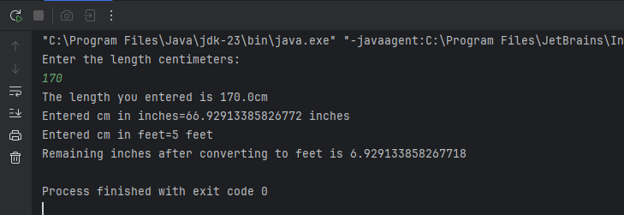

Q3.

Code:

|  |
| --- |
| package Q3;  import java.util.Scanner;  public class Q3 {  public static void main(String[] args) {  Scanner input=new Scanner(System.*in*);  System.*out*.println("Enter the temperature in celsius:");  double celsius=input.nextDouble();   double fahrenheit= (1.8*celsius)+32;  System.*out*.println("Temperature in fahrenheit:"+fahrenheit);   } } |

Output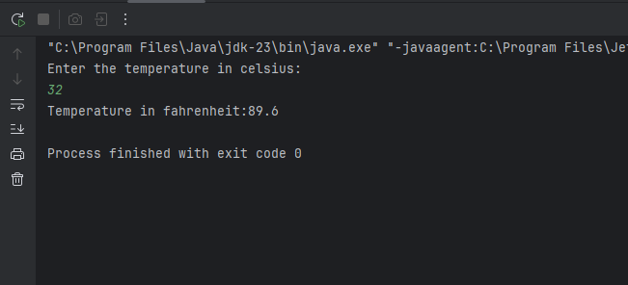

Q4 Code

|  |
| --- |
| package Q4;  import java.util.Scanner;  public class Q4 {  public static void main(String[] args) {  Scanner input=new Scanner(System.*in*);  System.*out*.println("Enter your body weight in kg:");  double weight=input.nextDouble();  // 1Kg = 2.20462 lb  double pounds=weight*2.20462;  double calories=pounds*19;  System.*out*.println("The numbers of calories needed per day:"+calories);  } } |

Output

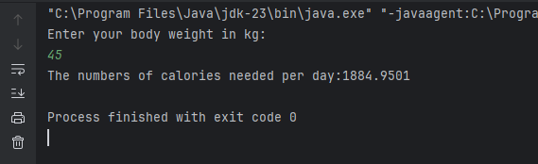

Q5 Code

|  |
| --- |
| package Q5;  import java.util.Scanner;  public class Q5 {  public static void main(String[] args) {  Scanner input=new Scanner(System.*in*);  System.*out*.println("Enter the temperature in fahrenheit:");  double fahrenheit=input.nextDouble();   double celsius=(5.0/9)*(fahrenheit-32) ;  System.*out*.println("Temperature in celsius:"+celsius);  } } |

Output

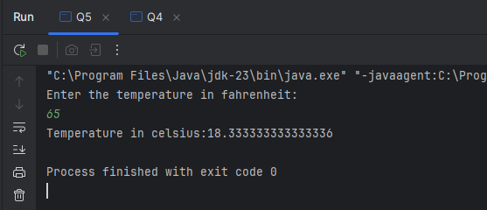

Q6 Code

|  |
| --- |
| package Q6;  import java.util.*;  public class Q6 {  public static void main(String[] args) {  Scanner input=new Scanner(System.*in*);  System.*out*.println("Enter your birth year:");  int birthYear=input.nextInt();   GregorianCalendar cal=new GregorianCalendar();  int currentYear=cal.get(GregorianCalendar.*YEAR*);  int age=currentYear-birthYear;   System.*out*.println("You were born on "+birthYear+" and will be "+age+" this year.");     } } |

Output

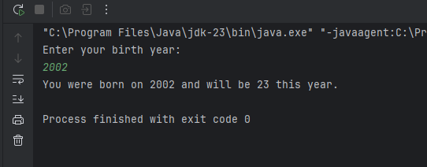

Q7 Code

|  |
| --- |
| package Q7;  import java.util.Scanner;  public class Q7 {  public static void main(String[] args) {  Scanner input = new Scanner(System.*in*);   System.*out*.println("Enter your weight in kg:");  double weight = input.nextDouble();   System.*out*.println("Enter your height in cm:");  double height = input.nextDouble();   double bmi = weight / Math.*pow*((height / 100.0), 2);   System.*out*.println("Your BMI is " + bmi);   if (bmi >= 20 && bmi <= 25) {  System.*out*.println("Your BMI value is normal");   } else {  System.*out*.println("Your BMI value is not in the healthy range");   }  } } |

Output

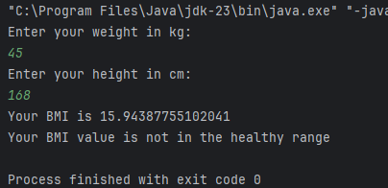

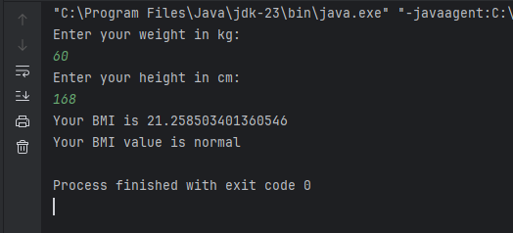

Q8 Code

|  |
| --- |
| package Q8;  import java.util.Scanner;  public class Q8 {  public static void main(String[] args) {  Scanner input = new Scanner(System.*in*);   System.*out*.println("Enter the radius of sphere:");  double r = input.nextDouble();   double volume=(4.0/3)*Math.*PI*\*Math.*pow*(r,3);   System.*out*.println("The volume of the sphere given radius "+r+"is "+volume);   } } |

Output

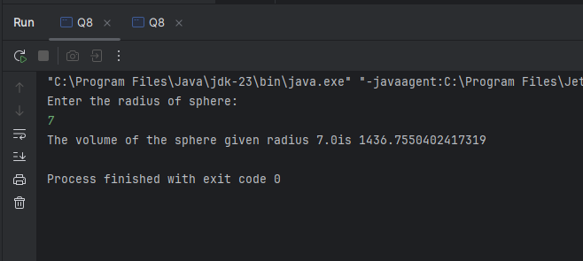

Q9 Code

|  |
| --- |
| package Q9;  import java.util.Scanner;  public class Q9 {  public static void main(String[] args) {  Scanner input = new Scanner(System.*in*);   System.*out*.println("Enter the amount you invest in dollars:");  double P = input.nextDouble();   System.*out*.println("Enter the annual interest rate:");  double R= input.nextDouble();   System.*out*.println("Enter the number of years for investment:");  int N = input.nextInt();   double totalAmount=P*Math.*pow*(1+(R/100),N);  System.*out*.println("Total amount of money earned after "+N+" years is "+totalAmount);  } } |

Output

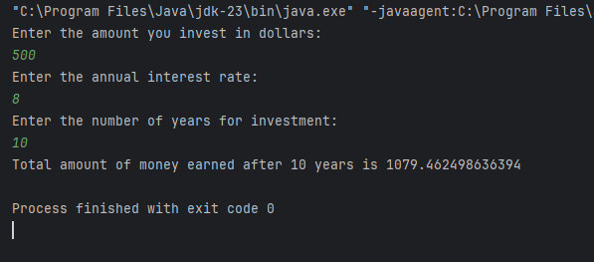

Q10 Code

|  |
| --- |
| package Q10;  import java.util.Scanner;  public class Q10 {  public static void main(String[] args) {  Scanner input = new Scanner(System.*in*);  System.*out*.println("Enter the loan amount:");  double loanAmount= input.nextDouble();   System.*out*.println("Enter the annual interest rate:");  double annualInterestRate= input.nextDouble();   System.*out*.println("Enter the loan period in years:");  int loanPeriod= input.nextInt();   final int MONTHS_IN_YEAR =12;   double monthlyInterestRate = annualInterestRate / 100.0 / MONTHS_IN_YEAR;  System.*out*.println("_____________________________");// to show the section  System.*out*.println("Monthly interest rate: "+monthlyInterestRate);   int numberOfPayments = loanPeriod * MONTHS_IN_YEAR;  System.*out*.println("Number of payments:"+numberOfPayments);  System.*out*.println("\n");   double monthlyPayment = (loanAmount * monthlyInterestRate) /  (1 - Math.*pow*(1 / (1 + monthlyInterestRate), numberOfPayments));  System.*out*.println("***********Required output**********"); //to show the required output  System.*out*.println("Monthly payment = "+monthlyPayment);   double totalPayment = monthlyPayment * numberOfPayments;  System.*out*.println("Total payment= "+totalPayment);    } } |

Output

