Q1:

package Q1;  
  
public class Q1 {  
 public static void main(String[] args) {  
 int number=10;  
 for(int row=1; row<=4;row++ ){  
 for(int col=1; col<=10; col++){  
 System.*out*.print(number+" ");  
 number++;  
 }  
 System.*out*.println();  
 }  
 }  
}

Output:

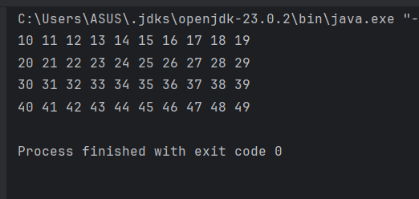

Q1 Method 2:

package Q1;  
  
public class Q1_2 {  
 public static void main(String[] args) {  
 int count = 0;  
 for (int i = 10; i < 50; i++) {  
 System.*out*.print(i + " ");  
 count++;  
 if (count == 10) {  
 System.*out*.println();  
 count = 0;  
 }  
 }  
 }  
 }

Output:

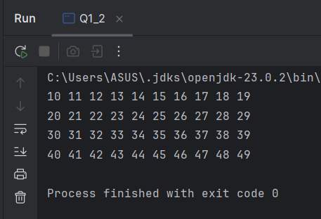

Q1 Method 3:

package Q1;  
  
public class Q1_3 {  
 public static void main(String[] args) {  
 for(int i=10; i<50; i++){  
 System.*out*.print(i+" ");  
 if((i+1)%10==0){  
 System.*out*.println();  
 }  
 }  
 }  
}

Output:

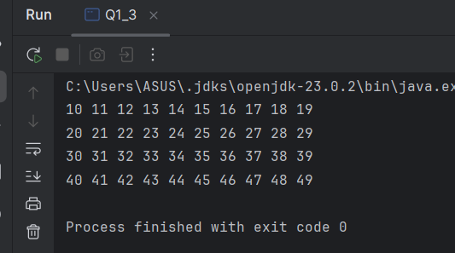

Q2:

package Q2;  
  
import java.util.Scanner;  
  
public class Q2 {  
 public static int countDigit(int number){  
 return String.*valueOf*(number).length();  
 //to convert integer to string and getting the length  
 }  
  
 public static void main(String[] args) {  
 Scanner scanner=new Scanner(System.*in*);  
  
 while(true){  
 System.*out*.println("Enter an integer(Negative to stop):");  
 int input= scanner.nextInt();  
  
 if(input<0){  
 System.*out*.println("Negative number is entered so, programme is terminated");  
 break;  
 }  
  
 System.*out*.println("Number of digits :"+*countDigit*(input));  
 }  
  
 }  
}

Output:

`

Q2 Method 2:

package Q2;  
import java.util.Scanner;  
  
public class Q2_2 {  
 public static int countDigit(int number){  
 if(number==0){  
 return 1;  
 }  
 int count=0;  
 while(number>0){  
 number/=10;  
 count++;  
 }  
 return count;  
 }  
 public static void main(String[] args) {  
 Scanner scanner=new Scanner(System.*in*);  
  
 while(true){  
 System.*out*.println("Enter an integer(Negative to stop):");  
 int input= scanner.nextInt();  
  
 if(input<0){  
 System.*out*.println("Negative number is entered so, programme is terminated");  
 break;  
 }  
  
 System.*out*.println("Number of digits :"+*countDigit*(input));  
 }  
 }  
}

Output:

Q3:

package Q3;  
  
import java.util.Scanner;  
  
public class Q3 {  
 public static void main(String[] args) {  
 Scanner scanner=new Scanner(System.*in*);  
 System.*out*.println("Enter an integer:");  
 int n= scanner.nextInt();  
  
 System.*out*.println("**********MULTIPLICATION TABLE OF "+n+"*************");  
 for(int i=1; i<11; i++){  
 System.*out*.println(n+"*"+i+"="+(i*n));  
 }  
 }  
}

Output:

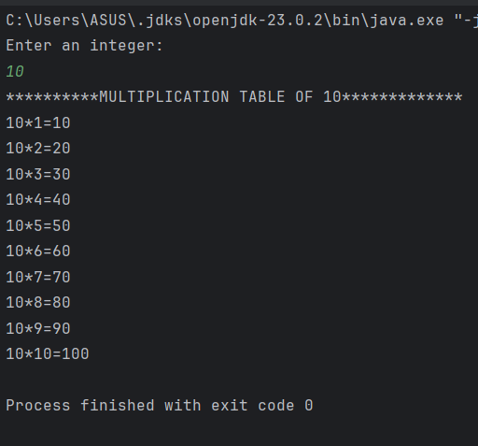

Q4:

package Q4;  
  
import java.util.Scanner;  
  
public class Q4 {  
 public static void main(String[] args) {  
 Scanner scanner = new Scanner(System.*in*);  
 System.*out*.print("Enter number of rows: ");  
 int rows = scanner.nextInt();  
  
 for (int i = 1; i <= rows; i++) {  
 // print spaces  
 for (int j = i; j < rows; j++) {  
 System.*out*.print(" ");  
 }  
 // print stars  
 for (int l = 1; l <= (2 * i - 1); l++) {  
 System.*out*.print("*");  
 }  
 System.*out*.println();  
 }  
 }  
}

Output:

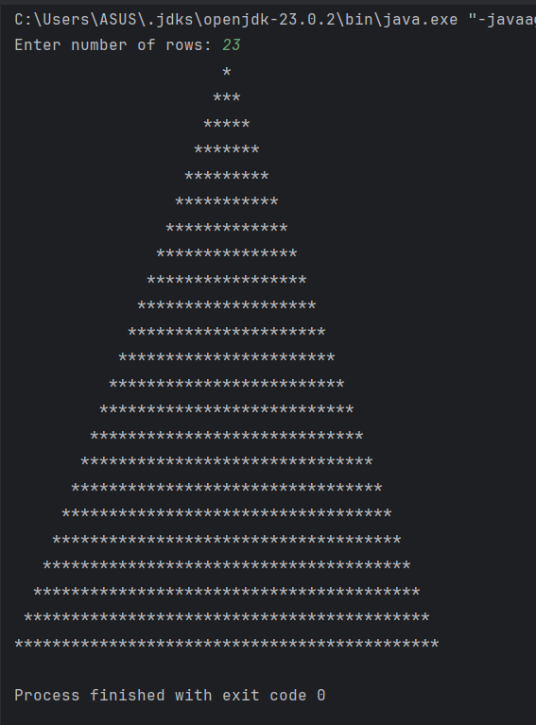

Q5:

package Q5;  
  
import java.util.Scanner;  
  
public class Q5 {  
 public static void main(String[] args) {  
 Scanner scanner =new Scanner(System.*in*);  
  
 System.*out*.println("Enter a word or phrase or number or other sequence characters:");  
 String input=scanner.nextLine().replaceAll("[^a-zA-Z0-9]","").toLowerCase();  
 //This removes everything that is not a letter or digit (i.e., spaces, punctuation, special characters).  
  
 String reversed="";  
 for(int i=input.length()-1; i>=0; i--){  
 reversed += input.charAt(i);  
 }  
 if (input.equals(reversed)) {  
 System.*out*.println("It is a palindrome.");  
 } else {  
 System.*out*.println("It is not a palindrome.");  
 }//Compares the **original cleaned input** with the **reversed string**-----`.equals()` checks if they are **exactly the same**.  
 }  
}

Output:

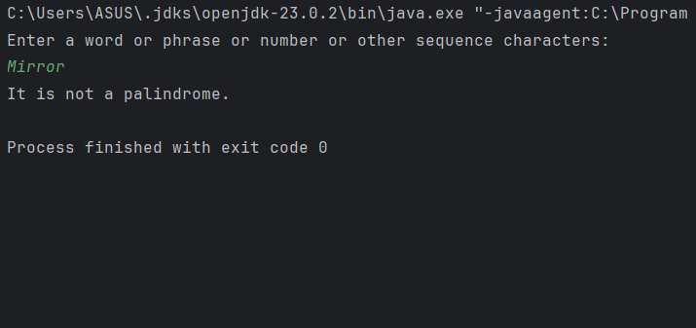

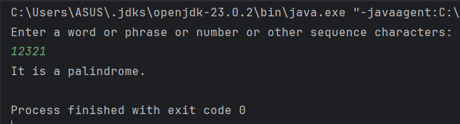

Q5 Method 2:

package Q5;  
  
import java.util.Scanner;  
  
public class Q5_2 {  
 public static void main(String[] args) {  
 Scanner scanner=new Scanner(System.*in*);  
  
 System.*out*.println("Enter a word or phrase or number or other sequence characters:");  
 String input=scanner.nextLine().replaceAll("[^a-zA-Z0-9]","").toLowerCase();  
  
 boolean isPalindrome = true;  
 int start = 0;  
 int end = input.length() - 1;  
  
 while (start < end) {  
 if (input.charAt(start) != input.charAt(end)) {  
 isPalindrome = false;  
 break;  
 }  
 start++;  
 end--;  
 }  
 System.*out*.println(isPalindrome ? "It is a palindrome." : "It is not a palindrome.");  
 }  
}

Q5 Method 2 output:

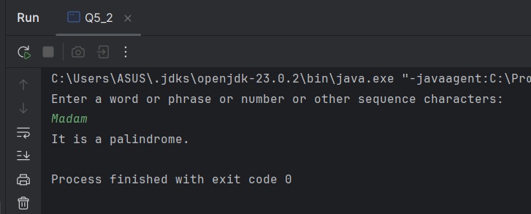

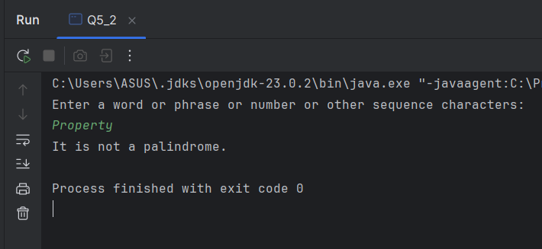

Q5 Method 3 (Palindrome checker for numbers):

package Q5;  
//PALINDROME CHECKER FOR NUMBERS  
  
import java.util.Scanner;  
  
public class Q5_3 {  
 public static void main(String[] args) {  
 Scanner scanner = new Scanner(System.*in*);  
 System.*out*.print("Enter a number: ");  
 int num = scanner.nextInt();  
 int original = num;  
 int reversed = 0;  
  
 while (num > 0) {  
 int digit = num % 10;  
 reversed = reversed * 10 + digit;  
 num /= 10;  
 }  
  
 if (original == reversed) {  
 System.*out*.println("It is a palindrome number.");  
 } else {  
 System.*out*.println("It is not a palindrome number.");  
 }  
 }  
}

Q5 Method 3 Output:

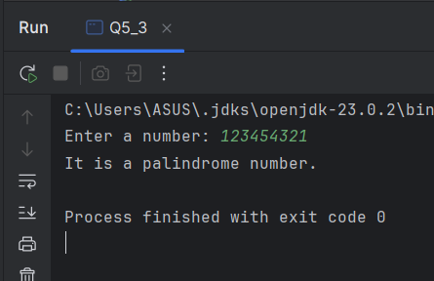

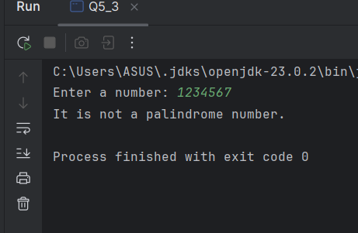

Q5 Method 4(palindrome with recursion):

package Q5;  
  
import java.util.Scanner;  
  
public class Q5_4 {  
 public static boolean isPalindrome(String s, int start, int end) {  
 if (start >= end) {  
 return true;  
 }  
 if (s.charAt(start) != s.charAt(end)) {  
 return false;  
 }  
 return *isPalindrome*(s, start + 1, end - 1);  
 }  
  
 public static void main(String[] args) {  
 Scanner sc = new Scanner(System.*in*);  
 System.*out*.print("Enter a word or phrase or sequence of characters: ");  
 String input = sc.nextLine().replaceAll("[^a-zA-Z0-9]", "").toLowerCase();  
  
 if (*isPalindrome*(input, 0, input.length() - 1)) {  
 System.*out*.println("It is a palindrome.");  
 } else {  
 System.*out*.println("It is not a palindrome.");  
 }  
 }  
}

Q5 Method 4 Output:

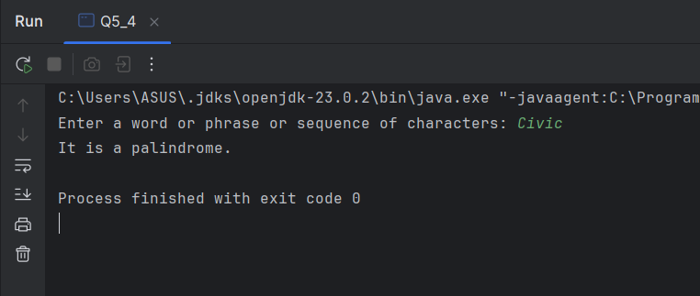

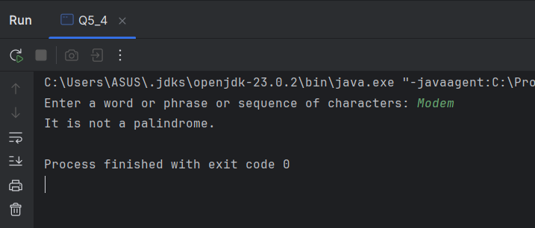

Q5 Method 5(String Builder method):

package Q5;  
  
import java.util.Scanner;  
  
public class Q5_5 {  
 public static void main(String[] args) {  
 Scanner sc = new Scanner(System.*in*);  
 System.*out*.print("Enter input: ");  
 String str = sc.nextLine().replaceAll("[^a-zA-Z0-9]", "").toLowerCase();  
  
 StringBuilder sb = new StringBuilder(str);  
 System.*out*.println(str.equals(sb.reverse().toString()) ? "It is a palindrome." : "It is not a palindrome.");  
 }  
 }

Output for method 5:

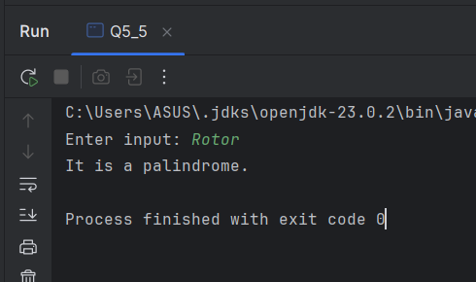

Q6:

package Q6;  
  
import java.util.Random;  
import java.util.Scanner;  
  
public class Q6 {  
 public static void main(String[] args) {  
 Random random = new Random();  
 int randomNum = random.nextInt(100) + 1;  
 Scanner input = new Scanner(System.*in*);  
 int guess = 0;  
  
 System.*out*.println("\uD83C\uDFAF A number between 1 and 100 has been chosen!");  
 System.*out*.println("\uD83E\uDD14 Can you guess it?");  
  
 while (guess != randomNum) {  
 System.*out*.print("Your guess: ");  
 guess = input.nextInt();  
 int diff = Math.*abs*(guess - randomNum);  
  
 if (guess == randomNum) {  
 break;  
 } else if (diff >= 20) {  
 System.*out*.println(guess < randomNum ? "\uD83D\uDCC9 Way too low!" : "\uD83D\uDCC8 Way too high!");  
 } else if (diff >= 10) {  
 System.*out*.println(guess < randomNum ? "\uFE0FA bit low!" : "\uFE0F A bit high!");  
 } else if (diff >= 5) {  
 System.*out*.println(guess < randomNum ? "\uD83D\uDE2C Close, try higher!" : " \uD83D\uDE2CClose, try lower!");  
 }

else {  
 System.*out*.println(guess < randomNum ? "\uD83D\uDD25 Very close! Just a little higher!" : " \uD83D\uDD25Very close! Just a little lower!");  
 }  
 }  
  
 System.*out*.println("\uD83C\uDF89 Correct! The number was " + randomNum);  
 }  
}

Output:

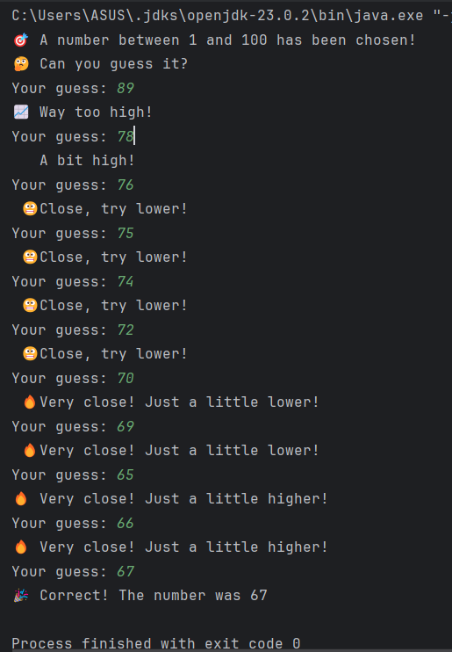

Q6 method 2:

package Q6;  
  
import java.util.Random;  
import java.util.Scanner;  
  
public class Q6_2 {  
 public static void main(String[] args) {  
  
 Random random = new Random();  
 int randomNum = random.nextInt(100) + 1;  
 Scanner input = new Scanner(System.*in*);  
 pa int guess = 0;  
 int attempts = 0;  
  
 System.*out*.println("Number between 1-100 selected. Try to guess it!");  
  
 while (guess != randomNum) {  
 System.*out*.print("Guess: ");  
 guess = input.nextInt();  
 attempts++;  
  
 int diff = Math.*abs*(guess - randomNum);  
  
 if (guess == randomNum) {  
 break;  
 } else if (diff > 20) {  
 System.*out*.println(guess < randomNum ? "Too low!" : "Too high!");  
 } else if (diff > 10) {  
 System.*out*.println(guess < randomNum ? "Low!" : "High!");  
} else if (diff > 5) {  
 System.*out*.println(guess < randomNum ? "Almost there! Low!" : "Almost there! High!");  
} else {  
 System.*out*.println(guess < randomNum ? "Very close, bit low!" : "Very close, bit high!");  
}

}  
  
 System.*out*.println("Correct! The number was " + randomNum);  
 System.*out*.println("You took " + attempts + " guesses.");  
  
 // Give a fun ranking  
 if (attempts <= 3) {  
 System.*out*.println("🥇 Genius Guesser!");  
 } else if (attempts <= 6) {  
 System.*out*.println("🥈 Smart Player!");  
 } else {  
 System.*out*.println("🥉 You got there! Keep practicing.");  
 }  
  
  
 }  
  
}

Output:

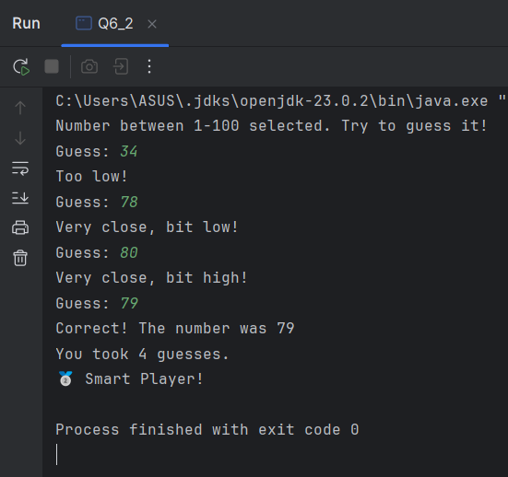

Output for method 2:

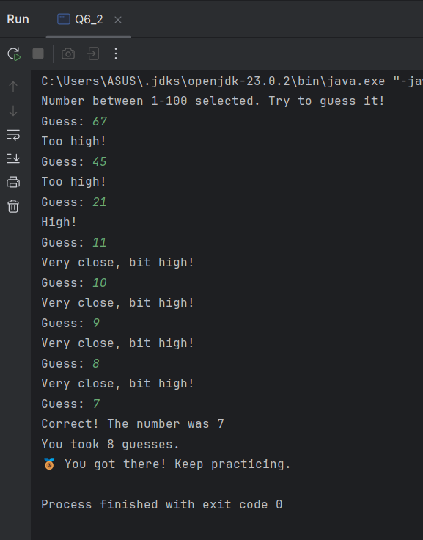

Q6 method 3:

package Q6;  
  
import java.util.Random;  
import java.util.Scanner;  
  
public class Q6_3 {  
 public static void main(String[] args) {  
 Random random = new Random();  
 int randomNum = random.nextInt(100) + 1;  
  
 Scanner input = new Scanner(System.*in*);  
 int guess = 0;  
  
 System.*out*.println("I've generated a number between 1 and 100.");  
 System.*out*.println("Try to guess it!");  
  
 while (guess != randomNum) {  
 System.*out*.print("Enter your guess: ");  
 guess = input.nextInt();  
  
 int diff = Math.*abs*(randomNum - guess);  
  
 if (guess == randomNum) {  
 break;  
 } else if (diff >= 20) {  
 System.*out*.println(guess < randomNum ? "Too low!" : "Too high!");  
 }

continue……

else if (diff >= 10) {  
 System.*out*.println(guess < randomNum ? "Low!" : "High!");  
 } else if (diff >= 5) {  
 System.*out*.println(guess < randomNum ? "Close, but low!" : "Close, but high!");  
 } else {  
 System.*out*.println(guess < randomNum ? "Very close, a bit low!" : "Very close, a bit high!");  
 }  
 }  
  
 System.*out*.println("Correct! The number was " + randomNum);  
 }  
}

Output for method 3:

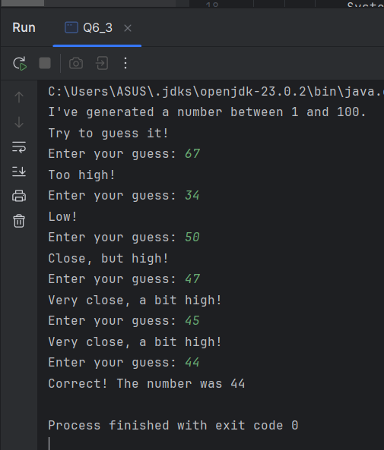

Q7:

package Q7;  
  
import java.util.Scanner;  
  
public class Q7 {  
 public static void main(String[] args) {  
 Scanner scanner = new Scanner(System.*in*);  
 System.*out*.print("Enter a sentence: ");  
 String sentence = scanner.nextLine();  
  
 System.*out*.print("Word to replace: ");  
 String word = scanner.nextLine();  
  
 System.*out*.print("Replacement word: ");  
 String replace = scanner.nextLine();  
  
 String[] parts = sentence.split("\\b");  
 StringBuilder result = new StringBuilder();  
  
 for (String part : parts) {  
 if (part.equalsIgnoreCase(word)) {  
 result.append(replace);  
 } else {  
 result.append(part);  
 }  
 }  
  
 System.*out*.println("Updated sentence: " + result.toString());  
 }  
}

Output:

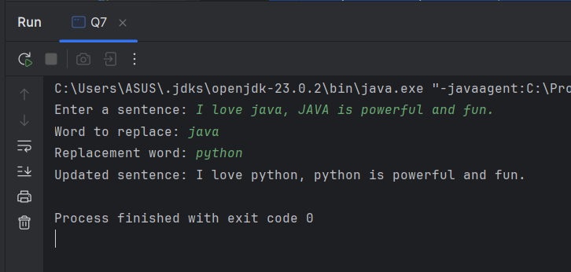

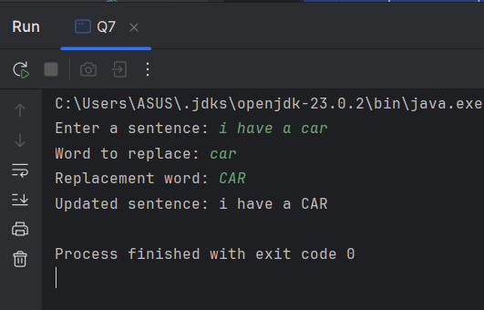

Q7 method 2:

package Q7;  
  
import java.util.Scanner;  
  
public class Q7_2 {  
 public static void main(String[] args) {  
 Scanner sc = new Scanner(System.*in*);  
 System.*out*.print("Enter a sentence: ");  
 String sentence = sc.nextLine();  
  
 System.*out*.print("Word to replace: ");  
 String oldWord = sc.nextLine();  
  
 System.*out*.print("Replacement word: ");  
 String newWord = sc.nextLine();  
  
 String result = sentence.replace(oldWord, newWord);  
 System.*out*.println("Updated sentence: " + result);  
 }  
}

Output:

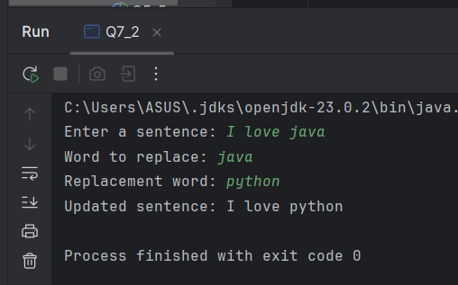

Q7 method 3:

package Q7;  
  
import java.util.Scanner;  
  
public class Q7_3 {  
 public static void main(String[] args) {  
 Scanner scanner = new Scanner(System.*in*);  
 System.*out*.print("Enter a sentence: ");  
 String sentence = scanner.nextLine();  
  
 System.*out*.print("Word to replace: ");  
 String oldWord = scanner.nextLine();  
  
 System.*out*.print("Replacement word: ");  
 String newWord = scanner.nextLine();  
  
 String result = sentence.replaceAll("(?i)\\b" + oldWord + "\\b", newWord);  
 System.*out*.println("Updated sentence: " + result);  
 }  
}

Output:

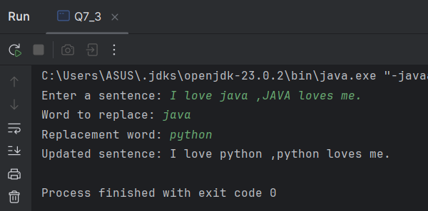

Q7 method 4:(case sensitive)

package Q7;  
import java.util.Scanner;  
  
public class Q7_4 {  
 public static void main(String[] args) {  
 Scanner scanner = new Scanner(System.*in*);  
  
 // Get inputs  
 System.*out*.print("Enter a sentence: ");  
 String sentence = scanner.nextLine();  
  
 System.*out*.print("Word to replace: ");  
 String target = scanner.nextLine();  
  
 System.*out*.print("Replacement word: ");  
 String replacement = scanner.nextLine();  
  
 // Split sentence into words  
 String[] words = sentence.split(" ");  
 StringBuilder newSentence = new StringBuilder();  
  
 boolean foundCaseInsensitive = false;  
 boolean foundExactMatch = false;  
  
 for (String word : words) {  
 if (word.equals(target)) {  
 // Case-sensitive match  
 newSentence.append(replacement).append(" ");  
 foundExactMatch = true;  
 } else {  
 // Check if the word matches ignoring case  
 if (word.equalsIgnoreCase(target)) {  
 foundCaseInsensitive = true;  
 }  
 newSentence.append(word).append(" ");  
 }  
 }

System.*out*.println("\nUpdated sentence: " + newSentence.toString().trim());  
  
 if (!foundExactMatch && foundCaseInsensitive) {  
 System.*out*.println("The word exists with a different case (e.g., '" + target + "' vs '"  
 + *capitalizeDifferent*(target, sentence) + "') but was not replaced due to case sensitivity.");  
 } else if (!foundExactMatch) {  
 System.*out*.println("No exact match of the word '" + target + "' found.");  
 }  
 }  
  
 // Helper method to find a mismatched case version  
 private static String capitalizeDifferent(String target, String sentence) {  
 for (String word : sentence.split(" ")) {  
 if (word.equalsIgnoreCase(target) && !word.equals(target)) {  
 return word;  
 }  
 }  
 return target;  
 }  
}

Output for method 4:

