Q1 Code:

package Q1;  
  
import javax.swing.*;  
  
public class SumThreeNumbers {  
 public static void main(String[] args) {  
 int num1 = Integer.*parseInt*(JOptionPane.*showInputDialog*(null, "Enter first number:"));  
 int num2 = Integer.*parseInt*(JOptionPane.*showInputDialog*(null, "Enter second number:"));  
 int num3 = Integer.*parseInt*(JOptionPane.*showInputDialog*(null, "Enter third number:"));  
 int sum = num1 + num2 + num3;  
  
 JOptionPane.*showMessageDialog*(null, "Sum is: " + sum);  
 }  
}

Output:

Q2 Code Method 1:

package Q2;  
  
import javax.swing.*;  
import java.awt.*;  
  
public class MyFrame extends JFrame{  
 public MyFrame() {  
 setTitle("MyFrame");  
 setSize(400, 450);  
 setDefaultCloseOperation(*EXIT_ON_CLOSE*);  
 getContentPane().setBackground(Color.*BLUE*);  
 }  
  
 public static void main(String[] args) {  
 MyFrame frame = new MyFrame();  
 frame.setVisible(true);  
 }  
}

Output

Q2 Code Method 2:

package Q2_2;  
  
import javax.swing.*;  
import java.awt.*;  
  
public class MyFrame1 extends JFrame {  
 public MyFrame1() {  
 setTitle("MyFrame");  
 setSize(400, 450);  
 setDefaultCloseOperation(JFrame.*EXIT_ON_CLOSE*);  
  
 // Set blue background  
 Container contentPane = getContentPane();  
 contentPane.setBackground(Color.*BLUE*);  
 }  
  
 public static void main(String[] args) {  
 MyFrame1 frame = new MyFrame1();  
 frame.setVisible(true);  
 }  
}

Q3Code:

package Q3;  
import javax.swing.*;  
import java.awt.event.ActionEvent;  
import java.awt.event.ActionListener;  
  
public class ButtonFrame extends JFrame implements ActionListener {  
 private final JButton button;  
  
 public ButtonFrame() {  
 setTitle("Click Event Demo");  
 setSize(300, 200);  
 setDefaultCloseOperation(JFrame.*EXIT_ON_CLOSE*);  
 setLayout(null);  
  
 button = new JButton("Click Me");  
 button.setBounds(100, 70, 100, 30);  
 button.addActionListener(this); // Register listener  
 add(button);  
 }  
  
 @Override  
 public void actionPerformed(ActionEvent e) {  
 JOptionPane.*showMessageDialog*(this, "You clicked!");  
 }  
  
 public static void main(String[] args) {  
 ButtonFrame frame = new ButtonFrame();  
 frame.setVisible(true);  
 }  
}

Output:

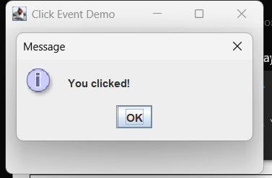

After pressing closing tab of frame program gets terminated.

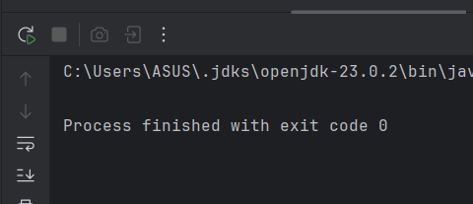

Q4 Code:

package Q4;  
import javax.swing.*;  
import java.awt.event.*;  
  
public class TitleChangeFrame extends JFrame implements ActionListener {  
 private JButton button;  
 private JTextField textField;  
  
 public TitleChangeFrame() {  
 setTitle("Change Title");  
 setSize(400, 200);  
 setDefaultCloseOperation(*EXIT_ON_CLOSE*);  
 setLayout(null);  
  
 textField = new JTextField();  
 textField.setBounds(100, 30, 200, 30);  
 add(textField);  
  
 button = new JButton("Set Title");  
 button.setBounds(150, 80, 100, 30);  
 button.addActionListener(this);  
 add(button);  
 }  
  
 public void actionPerformed(ActionEvent e) {  
 setTitle(textField.getText());  
 }  
  
 public static void main(String[] args) {  
 TitleChangeFrame frame = new TitleChangeFrame();  
 frame.setVisible(true);  
 }  
}

Output:

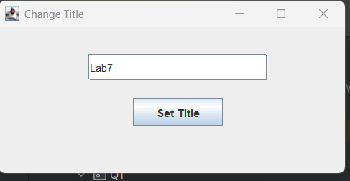

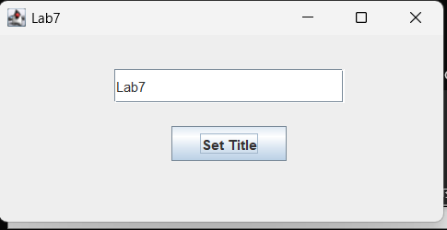

After pressing closing tab of frame program gets terminated

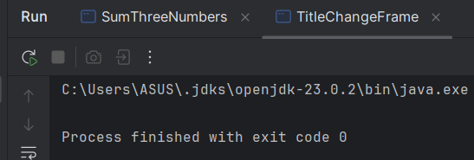

Q5 code:

package Q5;  
import javax.swing.*;  
import java.awt.*;  
import java.awt.event.*;  
  
public class ToggleButtonFrame extends JFrame implements ActionListener {  
 private JButton button;  
 private boolean isOn = false;  
  
 public ToggleButtonFrame() {  
 setTitle("Toggle Frame");  
 setSize(400, 300);  
 setDefaultCloseOperation(*EXIT_ON_CLOSE*);  
 setLayout(null);  
  
 button = new JButton("OFF");  
 button.setBounds(150, 100, 100, 40);  
 button.addActionListener(this);  
 add(button);  
 getContentPane().setBackground(Color.*GREEN*);  
 }  
  
 public void actionPerformed(ActionEvent e) {  
 if (isOn) {  
 button.setText("OFF");  
 getContentPane().setBackground(Color.*GREEN*);  
 } else {  
 button.setText("ON");  
 getContentPane().setBackground(Color.*RED*);  
 }  
 isOn = !isOn;  
 }  
 public static void main(String[] args) {  
 ToggleButtonFrame frame = new ToggleButtonFrame();  
 frame.setVisible(true);  
 }  
}

Output:

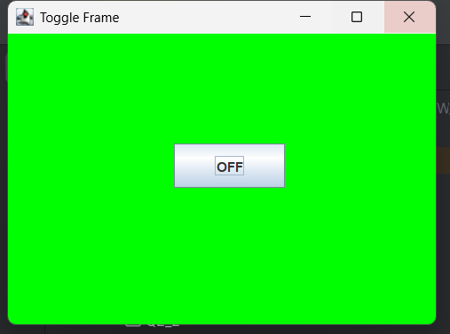

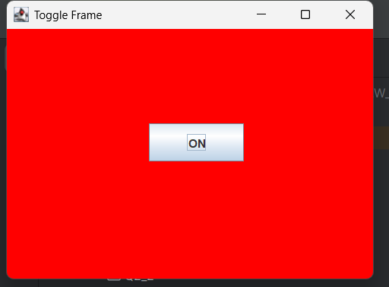

When we click the ON button,

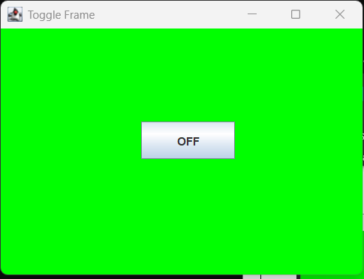

After clicking close tab of the Toggle Frame program gets terminated.

