Q1.

package Q1;  
  
import java.util.Scanner;  
  
public class Q1 {  
 public static void main(String[] args) {  
 Scanner scanner = new Scanner(System.*in*);  
  
 System.*out*.println("Enter the first integer:");  
 int num1 = scanner.nextInt();  
  
 System.*out*.println("Enter the second integer:");  
 int num2 = scanner.nextInt();  
  
 System.*out*.println("Enter the third integer:");  
 int num3 = scanner.nextInt();  
  
 if (num1 >= num2) {  
 if (num3 >= num2) {  
 System.*out*.println("Smallest number is " + num2);  
 } else {  
 System.*out*.println("Smallest number is " + num3);  
 }  
 } else if (num1 >= num3) {  
 System.*out*.println("Smallest number is " + num3);  
 } else {  
 System.*out*.println("Smallest number is " + num1);  
 }  
 }  
 }

Output

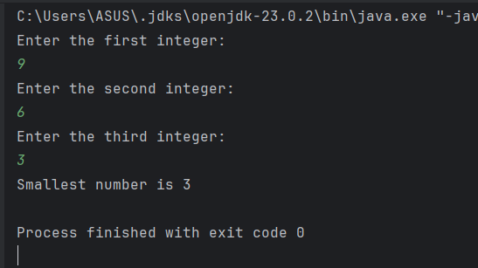

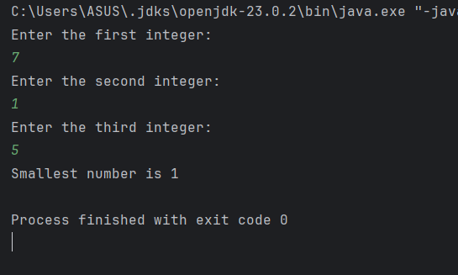

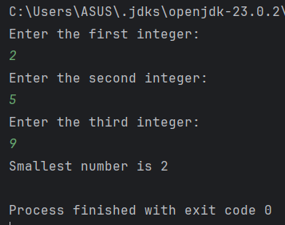

Q1 method 2:

package Q1;  
  
import java.util.Scanner;  
  
public class Q1method2 {  
 public static void main(String[] args) {  
 Scanner scanner = new Scanner(System.*in*);  
  
 System.*out*.println("Enter the first integer:");  
 int num1 = scanner.nextInt();  
  
 System.*out*.println("Enter the second integer:");  
 int num2 = scanner.nextInt();  
  
 System.*out*.println("Enter the third integer:");  
 int num3 = scanner.nextInt();  
  
 int smallest;  
  
 if(num1<=num2 && num1<=num3){  
 smallest=num1;  
 } else if (num2<=num1 && num2<=num3) {  
 smallest=num2;  
 }else{  
 smallest=num3;  
 }  
 System.*out*.println("Smallest number is "+smallest);  
 }  
}

Output for method 2:

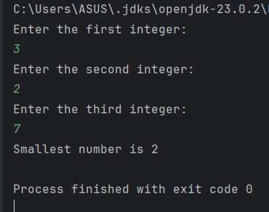

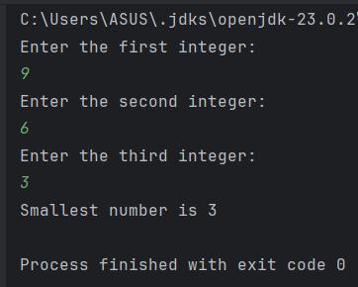

Q2:

package Q2;  
  
import java.util.Scanner;  
  
public class Q2 {  
 public static void main(String[] args) {  
 Scanner scanner= new Scanner(System.*in*);  
  
 System.*out*.println("0. Magenta");  
 System.*out*.println("1. Cyan");  
 System.*out*.println("2. Red");  
 System.*out*.println("3. Blue");  
 System.*out*.println("4. Green");  
  
 System.*out*.println("Select one color from the above list:");  
  
 int selection= scanner.nextInt();  
  
 switch(selection){  
 case 0:  
 System.*out*.println("You selected Magenta.");  
 break;  
  
 case 1:  
 System.*out*.println("You selected Cyan.");  
 break;  
  
 case 2:  
 System.*out*.println("You selected Red.");  
 break;  
  
 case 3:  
 System.*out*.println("You selected Blue.");  
 break;  
  
 case 4:  
 System.*out*.println("You selected Green.");  
 break;  
  
 default:  
 System.*out*.println("Invalid selection.");  
 }  
 }  
}

Output:

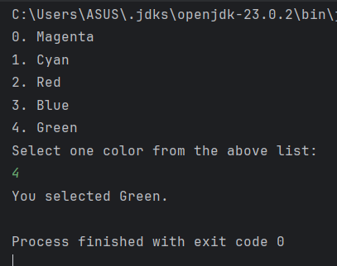

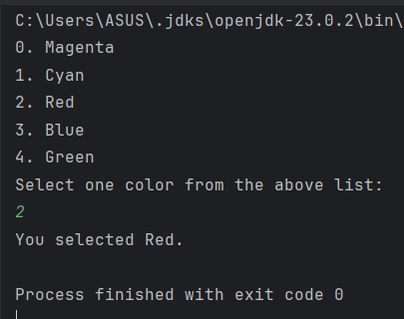

Q2 Method 2:

package Q2;  
  
import java.util.Scanner;  
  
public class Q2method2 {  
 public static void main(String[] args) {  
 Scanner scanner= new Scanner(System.*in*);  
  
 System.*out*.println("0. Magenta");  
 System.*out*.println("1. Cyan");  
 System.*out*.println("2. Red");  
 System.*out*.println("3. Blue");  
 System.*out*.println("4. Green");  
  
 System.*out*.println("Select one color from the above list:");  
  
 int selection= scanner.nextInt();  
  
 String color;  
  
 switch(selection){  
 case 0:  
 color="Magenta";  
 break;  
  
 case 1:  
 color="Cyan";  
 break;  
  
 case 2:  
 color="Red";  
 break;

case 3:  
 color="Blue";  
 break;  
   
 case 4:  
 color="Green";  
 break;  
  
 default:  
 color="Invalid color";  
 break;  
  
 }  
 System.*out*.println("You selected "+color);  
}

Output:

Q3 :

package Q3;  
  
import java.util.Scanner;  
  
public class Q3 {  
 public static void main(String[] args) {  
 Scanner scanner= new Scanner(System.*in*);  
  
 System.*out*.println("Enter the power of 10 in integer:");  
 int power= scanner.nextInt();  
  
 switch(power){  
 case 6:  
 System.*out*.println("Million");  
 break;  
  
 case 9:  
 System.*out*.println("Billion");  
 break;  
  
 case 12:  
 System.*out*.println("Trillion");  
 break;  
  
 case 15:  
 System.*out*.println("Quadrillion");  
 break;  
  
 case 18:  
 System.*out*.println("Quintillion");  
 break;

case 21:  
 System.*out*.println("Sextillion");  
 break;  
  
 case 30:  
 System.*out*.println("Nonillion");  
 break;  
  
 case 100:  
 System.*out*.println("Googol");  
 break;  
  
 default:  
 System.*out*.println("Invalid power.");  
 }  
 }  
}

Output:

Q3 method 2:

package Q3;  
  
import java.util.Scanner;  
  
public class Q3method2 {  
 public static void main(String[] args) {  
 Scanner scanner= new Scanner(System.*in*);  
  
 System.*out*.println("Enter the power of 10 in integer:");  
 int power= scanner.nextInt();  
  
 String name;  
  
 switch(power){  
 case 6:  
 name="Million";  
 break;  
  
 case 9:  
 name="Billion";  
 break;  
  
 case 12:  
 name="Trillion";  
 break;  
  
 case 15:  
 name="Quadrillion";  
 break;  
  
 case 18:  
 name="Quintillion";  
 break;

case 21:  
 name="Sextillion";  
 break;  
  
 case 30:  
 name="Nonillion";  
 break;  
  
 case 100:  
 name="Googol";  
 break;  
  
 default:  
 name="Invalid power";  
 }  
 System.*out*.println(name);  
  
 }  
}

Output for method 2:

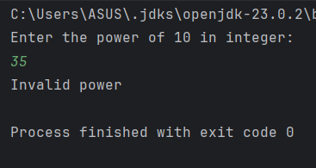

Q4:

package Q4;  
  
import java.util.Scanner;  
  
public class Q4 {  
 public static void main(String[] args) {  
 Scanner scanner= new Scanner(System.*in*);  
  
 System.*out*.println("Enter the year:");  
 int year= scanner.nextInt();  
  
 if(year %4==0){  
 if(year %100!=0) {  
 System.*out*.println("It is a Leap year.");  
 } else if (year %100==0 && year %400==0 ) {  
 System.*out*.println("It is a Leap year.");  
 }else{  
 System.*out*.println("It is not a Leap year.");  
 }  
 }else{  
 System.*out*.println("It is not a Leap year.");  
 }  
 }  
}

Output:

Q4 Method 2:

package Q4;  
  
import java.util.Scanner;  
  
public class Q4method2 {  
 public static void main(String[] args) {  
 Scanner scanner= new Scanner(System.*in*);  
  
 System.*out*.println("Enter the year:");  
 int year= scanner.nextInt();  
  
 if( (year %4==0 && year %100!=0) ||(year %4==0 && year%100==0 && year%400==0) ){  
 System.*out*.println("This is a Leap year.");  
 }else{  
 System.*out*.println("This is not a Leap year.");  
 }  
 }  
}

Output for method 2:

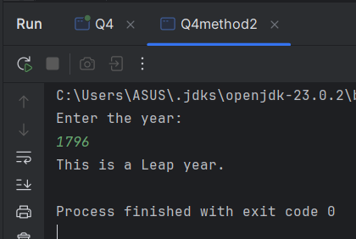

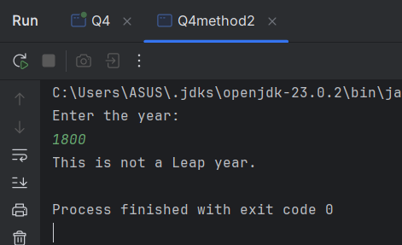

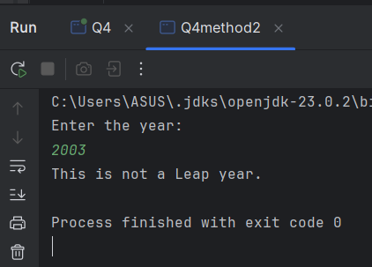

Q4 Method 3:

package Q4;  
  
import java.util.Scanner;  
  
public class Q4method3 {  
 public static void main(String[] args) {  
 Scanner scanner = new Scanner(System.*in*);  
  
 System.*out*.print("Enter the year: ");  
 int year = scanner.nextInt();  
  
 if ((year % 4 == 0 && year % 100 != 0) || (year % 400 == 0)) {  
 System.*out*.println("This is a Leap year.");  
 } else {  
 System.*out*.println("This is not a Leap year.");  
 }  
 }  
}

Output for method 3:

Q5:

package Q5;  
  
import java.util.Scanner;  
  
public class Q5 {  
 public static void main(String[] args) {  
 Scanner scanner = new Scanner(System.*in*);  
  
 System.*out*.println("\*\*\* Welcome to MyJava Lo-Fat Burgers \*\*\*");  
  
 // Entree Menu  
 System.*out*.println("\n\*\*\*\* Entree Menu \*\*\*\*");  
 System.*out*.println("1 -> Tofu Burger $3.49");  
 System.*out*.println("2 -> Cajun Chicken $4.59");  
 System.*out*.println("3 -> Buffalo Wings $3.99");  
 System.*out*.println("4 -> Rainbow Fillet $2.99");  
  
 // Side Dish Menu  
 System.*out*.println("\n\*\*\*\* Side Dish Menu \*\*\*\*");  
 System.*out*.println("1 -> Rice Cracker $0.79");  
 System.*out*.println("2 -> No-Salt Fries $0.69");  
 System.*out*.println("3 -> Zucchini $1.09");  
 System.*out*.println("4 -> Brown Rice $0.59");  
  
 // Drink Menu  
 System.*out*.println("\n\*\*\*\* Drink Menu \*\*\*\*");  
 System.*out*.println("1 -> Cafe Mocha $1.99");  
 System.*out*.println("2 -> Cafe Latte $1.90");  
 System.*out*.println("3 -> Espresso $2.49");  
 System.*out*.println("4 -> Oolong Tea $0.99");

int entree;  
int eqty = 0;  
//\*\*\*\*\*Entree selection\*\*\*\*\*  
System.*out*.println("Enter 0 to skip the Entree menu or Enter 1 to 4:");  
entree = scanner.nextInt();  
while (entree < 1 || entree > 4) {  
 System.*out*.println("Invalid entree! Please enter again.");  
 entree = scanner.nextInt();  
}  
  
double ecost = 0;  
switch (entree) {  
 case 1:  
 ecost = 3.49;  
 break;  
  
 case 2:  
 ecost = 4.59;  
 break;  
  
 case 3:  
 ecost = 3.99;  
 break;  
  
 case 4:  
 ecost = 2.99;  
 break;  
}  
  
if (entree != 0) {  
 System.*out*.println("Enter the quantity");  
 eqty = scanner.nextInt();  
}

int side;  
//\*\*\*\*\*Side dish selection\*\*\*\*\*  
System.*out*.println("Enter 0 to skip the Side Dish menu or Enter 1 to 4:");  
side = scanner.nextInt();  
while (side < 1 || side > 4) {  
 System.*out*.println("Invalid entree! Please enter again.");  
 side = scanner.nextInt();  
}  
  
double scost = 0;  
int sqty = 0;  
switch (side) {  
 case 1:  
 scost = 0.79;  
 break;  
  
 case 2:  
 scost = 0.69;  
 break;  
  
 case 3:  
 scost = 1.09;  
 break;  
  
 case 4:  
 scost = 0.59;  
 break;  
}  
  
if (side != 0) {  
 System.*out*.println("Enter the quantity");  
 sqty = scanner.nextInt();  
}

int drink;  
int dqty = 0;  
//\*\*\*\*\*Drink selection\*\*\*\*\*  
System.*out*.println("Enter 0 to skip the Drink menu or Enter 1 to 4:");  
drink = scanner.nextInt();  
while (drink < 1 || drink > 4) {  
 System.*out*.println("Invalid entree! Please enter again.");  
 drink = scanner.nextInt();  
}  
  
double dcost = 0;  
switch (drink) {  
 case 1:  
 dcost = 1.99;  
 break;  
  
 case 2:  
 dcost = 1.90;  
 break;  
  
 case 3:  
 dcost = 2.49;  
 break;  
  
 case 4:  
 dcost = 0.99;  
 break;  
}  
  
if (drink != 0) {  
 System.*out*.println("Enter the quantity");  
 dqty = scanner.nextInt();  
}

//Display Bill  
 if (entree == 0 && side == 0 && drink == 0) {  
 System.*out*.println("No Items Selected");  
 } else {  
 double total = (eqty \* ecost) + (sqty \* scost) + (dqty \* dcost);  
  
 System.*out*.println("\n\*\*\* Your Order \*\*\*");  
 System.*out*.println("Category Price Qty Amount");  
 System.*out*.println("-----------------------------------");  
 System.*out*.printf("Entree: $%.2f %d $%.2f\n", ecost, eqty, ecost \* eqty);  
 System.*out*.printf("Side Dish: $%.2f %d $%.2f\n", scost, sqty, scost \* sqty);  
 System.*out*.printf("Drink: $%.2f %d $%.2f\n", dcost, dqty, dcost \* dqty);  
 System.*out*.println("-----------------------------------");  
 System.*out*.printf("Total: $%.2f\n", total);  
 System.*out*.println("-----------------------------------");  
 }  
  
 }  
}

Q5 Output :

