Q1.

Code:

|  |
| --- |
| package Q1;  public class Temperature {  private double celsius; // Stores temperature in Celsius  // No-Arg Constructor (default 0.0°C)  public Temperature() {  this.celsius = 0.0;  }  // Parameterized Constructor  public Temperature(double celsius) {  this.celsius = celsius;  }  // Getter Method: Convert Celsius to Fahrenheit  public double toFahrenheit() {  return (celsius * 9 / 5) + 32;  }  // Getter Method: Return temperature in Celsius  public double toCelsius() {  return celsius;  }  // Setter Method: Set temperature in Celsius  public void setCelsius(double celsius) {  this.celsius = celsius;  }  // Setter Method: Set temperature using Fahrenheit (converts to Celsius)  public void setFahrenheit(double fahrenheit) {  this.celsius = (fahrenheit - 32) * 5 / 9;  }  } |

|  |
| --- |
| package Q1;  import java.util.Scanner;  class Main {  public static void main(String[] args) {  Scanner scanner = new Scanner(System.*in*);   System.*out*.println("Enter the temperature in Celsius: ");  double inputCelsius= scanner.nextDouble();   //create temperature object with user input  Temperature temp= new Temperature(inputCelsius);   System.*out*.println("Temperature in Fahrenheit: "+temp.toFahrenheit());  }  } |

Output:

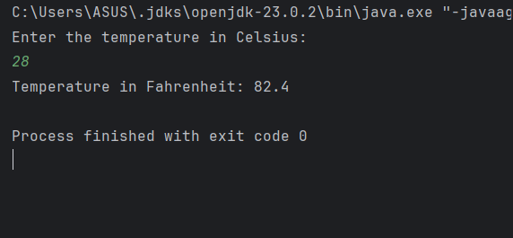

Q2.

Code:

|  |
| --- |
| package Q2;  import Q1.Temperature;  import java.util.Scanner;  public class FahrenheitToCelsius {  public static void main(String[] args) {  Scanner scanner=new Scanner(System.*in*);  System.*out*.println("Enter the Temperature in fahrenheit: ");   double fahrenheit=scanner.nextDouble();   Temperature temp= new Temperature();   temp.setFahrenheit(fahrenheit);   System.*out*.println("Temperature in celsius: "+temp.toCelsius());   } } |

Output:

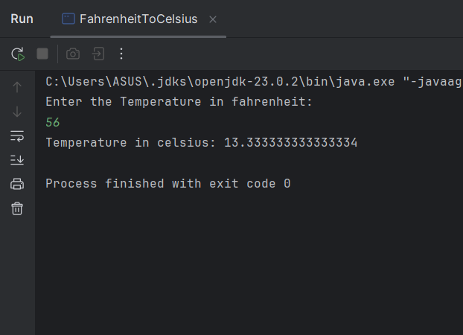

Q3.

Code:

|  |
| --- |
| package Q3;  class Circle {  private double radius;   public Circle(){  radius=0.0;  }  public Circle(double radius){  this.radius= radius;  }   public void setRadius(double radius) {  this.radius = radius;  }   public double computeArea(){  return(2*Math.*PI*\*Math.*pow*(radius,2));  }   public double computeCircumference(){  return(2*Math.*PI*\*radius);  }  } |

Code:

|  |
| --- |
| package Q3;  import java.util.Scanner;  class Main {  public static void main(String[] args) {  Scanner scanner=new Scanner(System.*in*);   System.*out*.println("Enter the radius of inner circle radius(ri):");  double ri=scanner.nextDouble();   System.*out*.println("Enter the radius of outer circle(ro): ");  double ro=scanner.nextDouble();   //Create Circle objects  Circle innerCircle=new Circle();  Circle outerCircle=new Circle();   //set method  innerCircle.setRadius(ri);  outerCircle.setRadius(ro);   //compute area  double innerArea=innerCircle.computeArea();  double outerArea=outerCircle.computeArea();   //compute circumference  double innerCircumference=innerCircle.computeCircumference();  double outerCircumference=outerCircle.computeCircumference();   //calculate the area of shaded region  double shadedArea=outerArea-innerArea;   System.*out*.println("\nInner Circle:");  System.*out*.printf("Area: %.2f%n", innerArea);  System.*out*.printf("Circumference: %.2f%n",innerCircumference );   System.*out*.println("\nOuter Circle:");  System.*out*.printf("Area: %.2f%n", outerArea);  System.*out*.printf("Circumference: %.2f%n",outerCircumference );   System.*out*.println("\nShaded Area between circles:");  System.*out*.printf("Area: %.2f%n", shadedArea);  } } |

Output:

Q4.

Code:

|  |
| --- |
| package Q4;  class Bicycle {  private Owner owner;   //constructor  public Bicycle(){  owner=new Owner();  }   public Bicycle(String name,String num){  owner=new Owner(name,num);  }   public Bicycle(Owner owner){  this.owner=owner;  }   //Returns the name of this bicycle's owner  public String getOwnerName() {  return owner.getOwnerName();  }   // Assigns the name of this bicycle's owner  public void setOwnerName(String name){  owner.setOwnerName(name);  }   public String getPhoneNo(){  return owner.getPhoneNo();  }   // Assigns the phone number of this bicycle's owner  public void setPhoneNo(String num){  this.owner.setPhoneNo(num);  }   // New methods to work with Owner object directly  public Owner getOwner(){  return owner;  }   public void setOwner(){  this.owner=owner;  } } |

Code:

|  |
| --- |
| package Q4;  class Owner {  private String ownerName;  private String phoneNo;  public Owner(){  ownerName="Unknown";  phoneNo="Not set";  }  public Owner(String name,String num){  ownerName=name;  phoneNo=num;  }  public String getOwnerName() {  return ownerName;  }  public void setOwnerName(String ownerName) {  this.ownerName = ownerName;  }  public String getPhoneNo() {  return phoneNo;  }  public void setPhoneNo(String phoneNo) {  this.phoneNo = phoneNo;  }  } |

Code:

|  |
| --- |
| package Q4;  class TestBicycle {  public static void main(String[] args) {   Bicycle bike1=new Bicycle();//unknown owner  Bicycle bike2=new Bicycle("John","123-456-789");   //Using Owner object directly  Owner owner1=new Owner("Anne","987-654-321");  Bicycle bike3=new Bicycle(owner1);   Owner owner2=new Owner();  Bicycle bike4=new Bicycle(owner2);   System.*out*.println("Details of bike1:\n");  System.*out*.println(bike1.getOwnerName());  System.*out*.println(bike1.getPhoneNo());   System.*out*.println("\nDetails of bike2:\n");  System.*out*.println(bike2.getOwnerName());  System.*out*.println(bike2.getPhoneNo());   System.*out*.println("\nDetails of bike3:\n");  System.*out*.println(bike3.getOwnerName());  System.*out*.println(bike3.getPhoneNo());   System.*out*.println("\nDetails of bike4:\n");  System.*out*.println(bike4.getOwnerName());  System.*out*.println(bike4.getPhoneNo());   // Modifying information  bike1.setOwnerName("New Owner");  bike1.setPhoneNo("555-555-5555");  System.*out*.println("New owner details of bike1:\n");  System.*out*.println(bike1.getOwnerName());  System.*out*.println(bike1.getPhoneNo());// "New Owner"  } } |

Output:

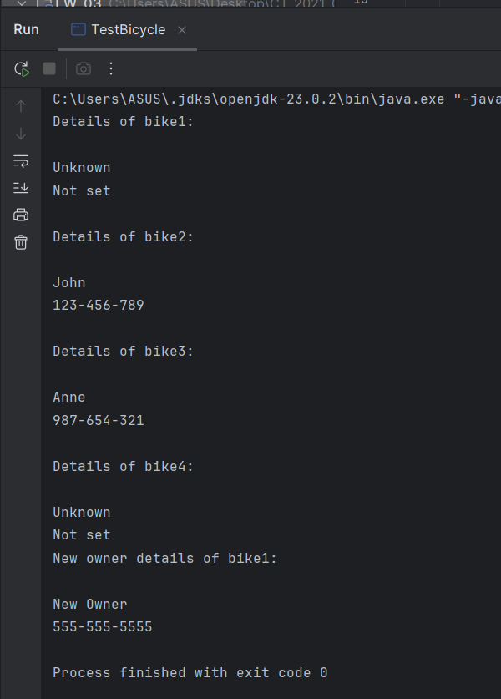

Q5.

Code:

|  |
| --- |
| package Q5;  class Course {  private String courseName;  private String courseCode;  private Lecturer lecturer;   // Constructor  public Course(String Name, String Code, Lecturer lecturer) {  this.courseName = Name;  this.courseCode = Code;  this.lecturer = lecturer;  }   // Getters and setters  public String getCourseName() {  return courseName;  }   public void setCourseName(String Name) {  this.courseName = Name;  }   public String getCourseCode() {  return courseCode;  }   public void setCourseCode(String Code) {  this.courseCode = Code;  }   public Lecturer getLecturer() {  return lecturer;  }   public void setLecturer(Lecturer lecturer) {  this.lecturer = lecturer;  } } |

Code:

|  |
| --- |
| package Q5; class Lecturer {  private String lecturerName;  private String courseTeaching;   // Constructor  public Lecturer(String Name, String course) {  this.lecturerName = Name;  this.courseTeaching = course;  }   // Getters and setters  public String getLecturerName() {  return lecturerName;  }   public void setLecturerName(String Name) {  this.lecturerName = Name;  }   public String getCourseTeaching() {  return courseTeaching;  }   public void setCourseTeaching(String course) {  this.courseTeaching = course;  } } |

Code:

|  |
| --- |
| package Q5; class Student {  private String studentName;  private String degreeName;  private String courseFollowing;   // Constructor  public Student(String Name, String degree, String course) {  this.studentName = Name;  this.degreeName = degree;  this.courseFollowing = course;  }   // Getters and setters  public String getStudentName() {  return studentName;  }   public void setStudentName(String name) {  this.studentName = name;  }   public String getDegreeName() {  return degreeName;  }   public void setDegreeName(String degree) {  this.degreeName = degree;  }   public String getCourseFollowing() {  return courseFollowing;  }   public void setCourseFollowing(String course) {  this.courseFollowing = course;  } } |

Code:

|  |
| --- |
| package Q5; class Main {  public static void main(String[] args) {  // Create lecturer objects  Lecturer lecturer1 = new Lecturer("Dr. Smith", "Introduction to Computer Science");  Lecturer lecturer2 = new Lecturer("Prof. Johnson", "Data Structures and Algorithms");   // Create course objects  Course course1 = new Course("Introduction to Computer Science", "CT101", lecturer1);  Course course2 = new Course("Data Structures and Algorithms", "CT201", lecturer2);   // Create student objects  Student student1 = new Student("Alice Brown", "Computer Science", "CT101");  Student student2 = new Student("Bob Wilson", "Computer Science", "CT201");  Student student3 = new Student("Charlie Davis", "Information Technology", "CT101");   // Display registration information  System.*out*.println("=== University Course Registration System ===");  System.*out*.println("\nAvailable Courses:");  *displayCourseInfo*(course1);  *displayCourseInfo*(course2);   System.*out*.println("\nStudent Registrations:");  *displayStudentInfo*(student1, course1);  *displayStudentInfo*(student2, course2);  *displayStudentInfo*(student3, course1);  }   private static void displayCourseInfo(Course course) {  System.*out*.println("\nCourse Code: " + course.getCourseCode());  System.*out*.println("Course Name: " + course.getCourseName());  System.*out*.println("Lecturer: " + course.getLecturer().getLecturerName());  }   private static void displayStudentInfo(Student student, Course course) {  System.*out*.println("\nStudent Name: " + student.getStudentName());  System.*out*.println("Degree Program: " + student.getDegreeName());  System.*out*.println("Registered Course: " + course.getCourseName() + " (" + course.getCourseCode() + ")");  System.*out*.println("Taught by: " + course.getLecturer().getLecturerName());  } } |

Output:

