Q 1 Java program to print welcome message.

**package** Day2;

**public** **class** Welcome {

**public** **static** **void** main(String[] args) {

// **TODO** Auto-generated method stub

System.***out***.println("Welcome in java class");

}

}

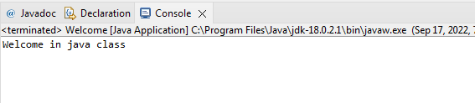

Q 2 Java program to print sum of  three float numbers

**package** Day2;

**import** java.util.*;

**public** **class** Sum {

**public** **static** **void** main(String[] args) {

// **TODO** Auto-generated method stub

**float** a,b,c;

**float** sum1;

System.***out***.println("enter the three float numbers");

Scanner s=**new** Scanner(System.***in***);

a=s.nextFloat();

b=s.nextFloat();

c=s.nextFloat();

sum1=a+b+c;

System.***out***.println("Sum of the three numbers is "+sum1);

}

}

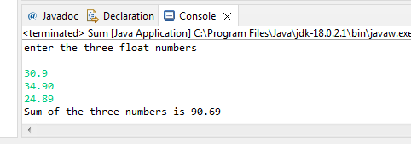

Q 3 Java Program to Swap Two Numbers

**package** Day2;

**import** java.util.*;

**public** **class** Swap {

**public** **static** **void** main(String[] args) {

// **TODO** Auto-generated method stub

System.***out***.println("enter two numbers");

**int** a,b;

Scanner s=**new** Scanner(System.***in***);

a=s.nextInt();

b=s.nextInt();

**int** temp;

temp=a;

a=b;

b=temp;

System.***out***.println("swapping of the numbers are "+a +b);

}

}

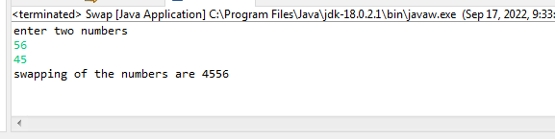

Q 4 Wap to check if number is even or odd

**package** Day2;

**import** java.util.*;

**public** **class** Even {

**public** **static** **void** main(String[] args) {

// **TODO** Auto-generated method stub

**int** a;

System.***out***.println("enter any number");

Scanner s=**new** Scanner(System.***in***);

a=s.nextInt();

**if** (a%2==0)

{

System.***out***.println("number is even");

}

**else**

{

System.***out***.println("number is odd");

}

}

}

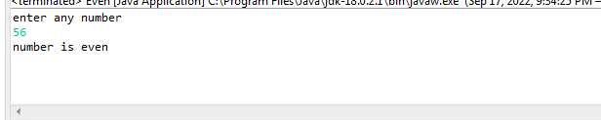

Q 5 wap to check from three given number  that whether a number is greater than or equal to 20 and less than other numbers .print appropriate message .

**package** Day2;

**import** java.util.Scanner;

**public** **class** Check {

**public** **static** **void** main(String[] args) {

// **TODO** Auto-generated method stub

**int** a,b,c;

System.***out***.println("enter the three numbers");

Scanner s=**new** Scanner(System.***in***);

a=s.nextInt();

b=s.nextInt();

c=s.nextInt();

**if** (a>20)

{

System.***out***.println("number is greater than 20");

}

**else**

{

**if** (a<20)

{

System.***out***.println("number is less than 20");

}

**else**

{

System.***out***.println("number is equal to 20");

}

}

}

}

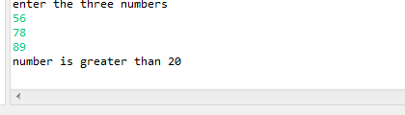  
  
Q 7 wap to check if sales of a person is greater than 10000 then eligible for bonus   
else not eligible calculate bonus as 20% of sales .

**package** Day2;

**import** java.util.*;

**public** **class** Sales {

**public** **static** **void** main(String[] args) {

// **TODO** Auto-generated method stub

**int** a;

System.***out***.println("enter the sale amount");

Scanner s=**new** Scanner(System.***in***);

a=s.nextInt();

**if**(a>10000)

{

System.***out***.println("you are eligible for bonus");

**int** b;

b=a*20/100;

System.***out***.println("your bonus amount is "+b);

}

**else**

{

System.***out***.println("you are not allowed for bonus");

}

}

}

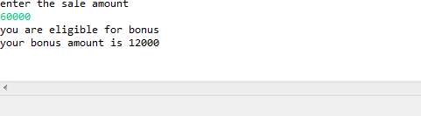  
  
Q 8 wap to check if two given integer value is in range of 18 and 100 print eligible for voting else not eligible .

**package** Day2;

**import** java.util.*;

**public** **class** Vote {

**public** **static** **void** main(String[] args) {

// **TODO** Auto-generated method stub

**int** age;

System.***out***.println("enter your age");

Scanner s=**new** Scanner(System.***in***);

age=s.nextInt();

**if**(age>18 && age<100)

{

System.***out***.println("you are eligible for voting");

}

**else**

{

System.***out***.println("you are not eligible for voting");

}

}

}

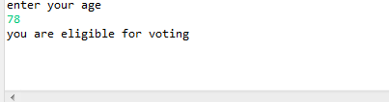

Q 9 wap to print average of  given five subjects marks of student and check if average >=40 print Pass else print fail

**package** Day2;

**import** java.util.*;

**public** **class** Average {

**public** **static** **void** main(String[] args) {

// **TODO** Auto-generated method stub

**float** s1,s2,s3,s4,s5;

**double** avg;

System.***out***.println("enter the marks of five subjects");

Scanner s=**new** Scanner(System.***in***);

s1=s.nextFloat();

s2=s.nextFloat();

s3=s.nextFloat();

s4=s.nextFloat();

s5=s.nextFloat();

avg =(s1+s2+s3+s4+s5)/5;

System.***out***.println("your five subjects average marks is "+avg);

**if** (avg>=40)

{

System.***out***.println("you are pass");

}

**else**

{

System.***out***.println("you are fail");

}

}

}

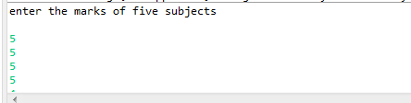  
  
  
  
Q10 WAP to ask name ,age and salary of an employee and print on console.

**package** Day2;

**import** java.util.*;

**public** **class** Employee {

**public** **static** **void** main(String[] args) {

// **TODO** Auto-generated method stub

**int** age;

String name;

**float** salary;

System.***out***.println("enter the name , age and salary of an employee");

Scanner s =**new** Scanner(System.***in***);

name=s.next();

age=s.nextInt();

salary=s.nextFloat();

System.***out***.println("Name =" +name);

System.***out***.println("age=" +age);

System.***out***.println("salary="+salary);

}

}

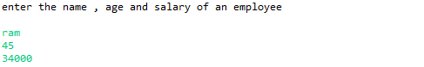  
   
   
Q 11 wap  that ask two numbers from user and print greater number among two

**package** Day2;

**import** java.util.*;

**public** **class** Greater {

**public** **static** **void** main(String[] args) {

// **TODO** Auto-generated method stub

**int** a,b;

System.***out***.println("enter the two number");

Scanner s=**new** Scanner(System.***in***);

a=s.nextInt();

b=s.nextInt();

**if**(a>b)

{

System.***out***.println("gretaer number is "+a);

}

**else**

{

System.***out***.println("gretaer number is "+b);

}

}

}

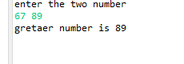

   
   
Q 12  wap to ask product name and price of product from user and calculate discount i.e   
if price > 2000 then discount is 10 percent of price   
else discount is 7 % of price

**package** Day2;

**import** java.util.*;

**public** **class** Percent {

**public** **static** **void** main(String[] args) {

// **TODO** Auto-generated method stub

**int** price;

String name;

**float** dis;

System.***out***.println("enter the product name and price of the product");

Scanner s=**new** Scanner(System.***in***);

name=s.next();

price=s.nextInt();

**if** (price>2000) {

System.***out***.println("price is greater than 2000");

dis=price*10/100;

System.***out***.println("your discount is "+dis);

}

**else**

{

System.***out***.println("price is less than 2000");

dis=price*7/100;

System.***out***.println("your discount is "+dis);

}

}

}

