Name Divya Gupta

Q 1 wap to print number 1 to 100.

**package** Assignment3;

**public** **class** Print {

**public** **static** **void** main(String[] args) {

// **TODO** Auto-generated method stub

**int** i;

**for**(i=1;i<=100;i++)

{

System.***out***.println(i);

}

}

}

Q 2 wap to print even numbers between 1 to 20

**package** Assignment3;

**public** **class** Print1 {

**public** **static** **void** main(String[] args) {

// **TODO** Auto-generated method stub

**int** i;

**for**(i=1;i<20;i++)

{

**if**(i%2==0)

{

System.***out***.println(i);

}

}

}

}

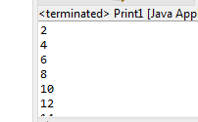

Q 3 wap to print cube of 1 to 5 number.

**package** Assignment3;

**public** **class** cube {

**public** **static** **void** main(String[] args) {

// **TODO** Auto-generated method stub

**int** i,j;

**for** (i=1;i<=5;i++)

{

j=i*i*i;

System.***out***.println(j);

}

}

}

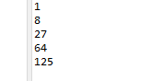  
Q 4 wap to check if a number is prime or not .

**package** Assignment3;

**import** java.util.Scanner;

**public** **class** prime {

**public** **static** **void** main(String[] args) {

// **TODO** Auto-generated method stub

**int** i, flag=0,n;

System.***out***.println("enter any number");

Scanner s=**new** Scanner(System.***in***);

n=s.nextInt();

**for**(i=2;i<=n/2;i++)

{

**if**(n%i==0)

{

flag=1;

}

}

**if** (flag==0)

{

System.***out***.println("number is prime");

}

**else**

{

System.***out***.println("number is not prime");

}

}

}

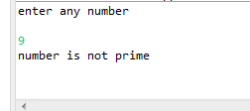

Q 5 wap to print fibonacci series using for loop i.e adding last two results  
ex  0 1 1 2 3 5 8 13 21 34

**package** Assignment3;

**import** java.util.Scanner;

**public** **class** Fib {

**public** **static** **void** main(String[] args) {

// **TODO** Auto-generated method stub

**int** a=0,b=1,c,i,j;

**int** n;

System.***out***.println("enter the size");

Scanner s=**new** Scanner(System.***in***);

n=s.nextInt();

System.***out***.print(+a +" " +b);

System.***out***.print(" ");

**for**(i=0;i<n-2;i++)

{

c=a+b;

System.***out***.print(c);

System.***out***.print(" ");

a=b;

b=c;

}

}

}

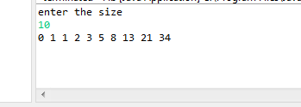  
  
Q 6 wap to print factorial of a number  
   5*4*3*2*1

**package** Assignment3;

**import** java.util.Scanner;

**public** **class** fac {

**public** **static** **void** main(String[] args) {

// **TODO** Auto-generated method stub

**int** n,i;

System.***out***.println("enter any number");

Scanner s=**new** Scanner(System.***in***);

n=s.nextInt();

**for**(i=n-1;i>0;i--)

{

n=n*i;

}

System.***out***.println(n);

}

}

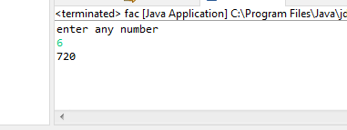  
Q 7wap to ask a number from user and print table of that number

**package** Assignment3;

**import** java.util.Scanner;

**public** **class** table {

**public** **static** **void** main(String[] args) {

// **TODO** Auto-generated method stub

**int** n,i,a;

System.***out***.println("enter the number");

Scanner s=**new** Scanner(System.***in***);

n=s.nextInt();

**for**(i=1;i<=10;i++)

{

a=n*i;

System.***out***.println(a);

}

}

}

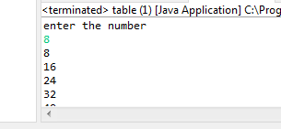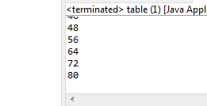  
Q 8 wap to print prime numbers between 2 to 20

**package** Assignment3;

**public** **class** prime1 {

**public** **static** **void** main(String[] args) {

// **TODO** Auto-generated method stub

**int** flag=0;

**int** n;

**for**(n=2;n<=20;n++)

{

flag=0;

**for**( **int** i=2;i<=n/2;i++)

{

**if**(n%i==0)

{

flag=1;

**break**;

}

}

**if**(flag==0) System.***out***.println( n);

}

}

}

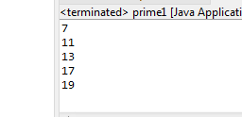  
  
  
Q 9  print patterns like   
*  
**   
***  
****  
*****

**package** Assignment3;

**public** **class** pattern1 {

**public** **static** **void** main(String[] args) {

// **TODO** Auto-generated method stub

**int** i,j;

**for**( i=1;i<=5;i++)

{

**for**(j=1;j<=i;j++)

{

System.***out***.print("*");

}

System.***out***.println();

}

}

}

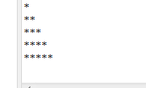  
  
b) 1  
     1 2   
     1 2 3   
    1  2 3 4  
    1 2 3 4 5

**package** Assignment3;

**public** **class** pattern2 {

**public** **static** **void** main(String[] args) {

// **TODO** Auto-generated method stub

**int** i,j;

**for**(i=1;i<=5;i++)

{

**for**(j=1;j<=i;j++)

{

System.***out***.print(j);

}

System.***out***.println();

}

}

}

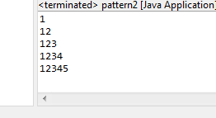  
  
c) A B  C D  
    A B  C  
    A  B   
    A  
**package** Assignment3;

**public** **class** pattern3 {

**public** **static** **void** main(String[] args) {

// **TODO** Auto-generated method stub

**for**(**int** i =1;i<=4;i++)

{

**char** r='A';

**for**(**int** j=4;j>=i;j--)

{

System.***out***.print(r);

r++;

}

System.***out***.println();

}

}

}

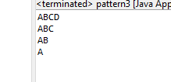  
  
D   A B C D  D C B A  
     A B C         C B A   
    A B                 B A  
   A                         A

**package** Assignment3;

**public** **class** pattern4 {

**public** **static** **void** main(String[] args) {

// **TODO** Auto-generated method stub

**int** i,j;

**char** r='A';

**int** space=0;

**for**( i=1;i<=4;i++)//row i 1 A

{

r='A';

**for**( j=4;j>=i;j--) { //A B C D D C BA

System.***out***.print(r);

r++;

}

**for**(**int** l=0;l<space;l++) System.***out***.print(" ");

**for**( j=4;j>=i;j--)

{ r--;

System.***out***.print(r);

}

space=space+2;

System.***out***.println();

}

}

}

