Title of the Project
Peer-to-Peer Rental Marketplace for Gadgets and Tools

Statement about the Problem
Some people have gear sitting around doing nothing most of the time. Meanwhile, someone else might need that exact thing for just a few days but can’t justiy buying it. Right now, renting stuff like this often means high prices, few choices, or worrying whether anyone will actually follow through.

Problem Description
Most times, things people could use just collect dust. Meanwhile, others find it tough to get hold of those same items without spending too much. When borrowing happens through word of mouth, problems pop up - someone might show up expecting an item already promised elsewhere. Payments often get overlooked due to the absence of a clear system. Disputes arise when issues occur, such as delays or returns. Implementing a robust digital solution is a logical approach in this context. It effectively integrates supply and demand in a seamless manner. Trust grows when every step leaves a trace. Safety improves when rules apply equally. Efficiency shows up quietly but sticks around

Objective and scope of the project
- Build an Airbnb‑style marketplace for renting gadgets/tools between individuals.
- Booking happens through a calendar so overlaps do not occur.
- Payments stay locked until conditions are met, then release happens automatically. Safety comes first when money moves between two sides. Rules built into the system decide when funds shift. Trust grows because neither person risks losing out. The process runs without anyone forcing a step too soon.
- Enable two‑sided reviews and a dispute resolution workflow.

Scope: The system will serve individuals, small communities, and student groups, with potential scalability to larger markets.
Methodology
- Frontend: React.js with date range picker and real-time availability calendar.
- Backend: Node.js/Express REST API with booking conflict detection.
- Database: PostgreSQL with date range overlap queries.
- Payments: Stripe payment intents with manual capture.
- Notifications: Email/SMS alerts for booking requests and confirmations.

Process Flow:
- Item listing → Availability calendar → Booking request → Secure payment hold → Rental completion → Payment release → Review/dispute handling.

Use case Diagram

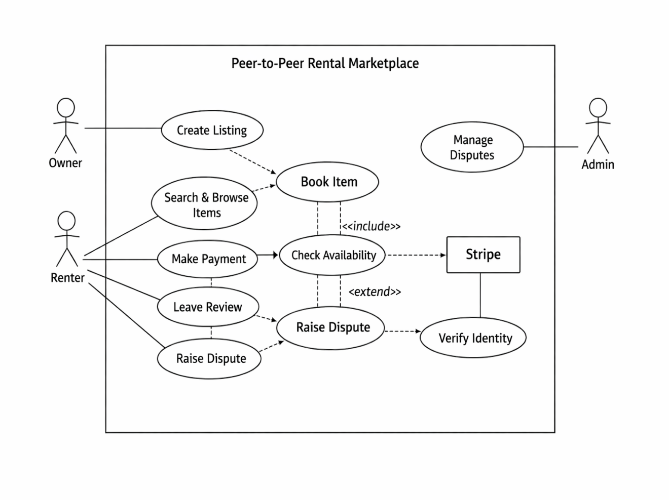

Hardware & Software Requirements
- Hardware: Standard PC/Laptop,16GB RAM, AMD Ryzen 7, 500GB HDD/SSD, Internet connectivity.
- Software:
  - OS: Windows/Linux
  - IDE: VS Code
  - Frameworks: React.js, Node.js/Express
  - Database: PostgreSQL
  - APIs: Stripe, Twilio (SMS), Email service

Future Work of this Project
- Integration of AI-based recommendation engine for personalized item suggestions.
- Now available on phones, sending alerts straight to your screen. Built-in updates arrive the moment they happen. Notifications pop up without needing to
open anything. Mobile access makes timing
faster than before.
- Addition of blockchain-based smart contracts for rental agreements.
- Working with insurers on costly home leases. Collaboration helps manage risks when renting expensive properties.

The Schedule of the project (Gantt chart/ PERT chart)

Phase | Duration | Tasks
Requirement Analysis | 3 days | Collect needs, finalize scope
Design | 1 week | UI/UX, database schema, flow diagrams
Development | 2 weeks | Frontend + Backend coding
Integration | 4 days | Payment, notifications, calendar
Testing | 5 days | Unit, integration, user testing
Deployment | 3 days | Hosting, documentation

Conclusion
This vision becomes real in a rental system that adapts without strain as needs change. Because items move easily between people, resources stretch further. When borrowing beats buying, spending shrinks while routines shift almost unnoticed. Confidence builds slowly, hand in hand with actual use, not words. Every transaction stay shielded, safety built into the core of each exchange. Back and forth it goes, feedback building how folks are seen, little by little. If things go sideways, there’s a path to sort it out - no shouting needed. Unlike loose, off-the-radar renting setups, this one holds itself together with structure and care.

References/Bibliography:
[1] https://www.scnsoft.com/ecommerce/marketplace-software/demo
[2] https://copilot.microsoft.com
[3] Stripe Documentation – Payment Intents API, Stripe

