PROJECT
Topic - Pandas

Initial Steps to follow:
Steps1: Importing python libraries for data manipulation and analysis.
Steps2: Importing table1 of sheet1 data from an excel file into a Pandas Data Frame(df_Table1).
Steps3: Fetching out data's in table1.
Steps4: Importing table2 of sheet2 data from an excel file into a Pandas Data Frame(df_Table2).
Steps5: Fetching out data's in table2.
Steps6: Checking for the number of rows and columns in table1.
Steps7: Checking for the duplicates in table1.
Steps8: Removing the duplicate rows in table1.
Steps9: Checking for the number of rows and columns in table1 after removing the duplicates.
Steps10: Checking for the number of rows and columns in table2.
Steps11: Checking for the duplicates in table2.
Steps12: In table2 there is no duplicate data's, so dropping the duplicates step is not required here.

Task
- Find out the top 5 months in terms of impressions?
Step1. Converting the date format.
Step2. Segregating day, month and year columns respectively.
Step3. Filtering 'Impressions' value from the 'Metric' column.
Step4. Using group by extracting data's of 'Impressions' value from the 'Metric' column for all the months and year.
Step5. Extracting top 5 months in terms of Impressions.
Output:
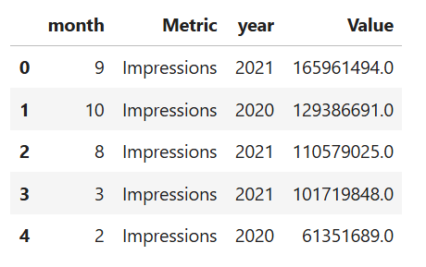
- Which model has maximum impressions?
Step1. Merging two tables using primary key.
Step2. Filtering 'Impressions' value from the 'Metric' column.
Step3.Using group by extracting data's of 'Impressions' value from the 'Metric' column for all the ‘model’.
Step4. Extracting ‘model’ for maximum 'Impressions'.
Output:
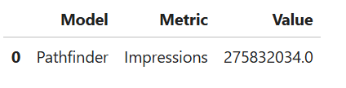

- Find out the top 3 campaigns in terms of impressions for every message type.
Step1. Merging two tables using primary key.
Step2. Filtering 'Impressions' value from the 'Metric' column.
Step3. Extracting ‘Campaigns’ value counts in terms of 'Impressions' for every message type using group by.
Step4.Sorting out the 'Value' column.
Step5. Extracting top 3 ‘Campaigns’ in terms of 'Impressions' for every message type.
Output:
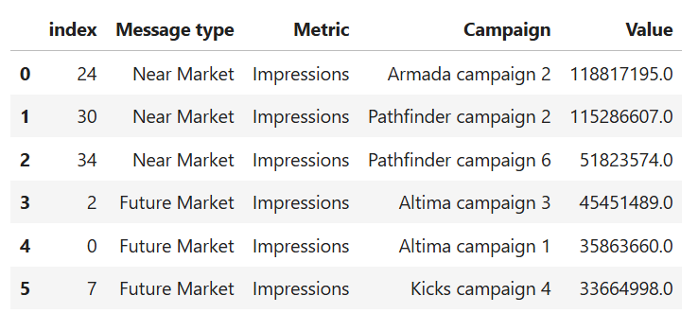
- Does the campaign with maximum impressions also have maximum clicks?
Step1. Filtering 'Impressions' and 'Clicks' value from the 'Metric' column.
Step2. Using group by to extract the 'Campaign' with maximum 'Impressions' and 'Clicks'.
Step3. Extracting 'Campaign' with maximum 'Impressions' and 'Campaign' with maximum 'Clicks'.
No, 'Campaign' with maximum 'Impressions' also have maximum 'Clicks'.
Output:
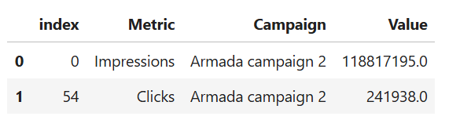

- Find out the top 3 campaigns in terms of CPM (CPM stands for cost per mile which means cost per 1000 impressions.
CPM = total media cost/total impressions * 1000)
Step1. Filtering 'Impressions' value from the 'Metric' column.
Step2. Creating a new column as ‘Total Impressions’ in terms of ‘Impressions’ and ‘Campaign’.
Step3. Sorting the ‘Total Impressions’ values.
Step4. Filtering 'Media Cost' value from the 'Metric' column.
Step5. Creating a new column as ‘Total Media Cost’ in terms of ‘Media Cost’ and ‘Campaign’.
Step6. Sorting the ‘Total Media’ Cost values.
Step7. Merging ‘Total Impressions’ and ‘Total Media Cost’ in terms of ‘Campaign’.
Step8. Creating a new column as ‘CPM’ in terms ‘Campaign’.
Step9. Filtering top 3 ‘Campaigns’ in terms of ‘CPM’.
Output:
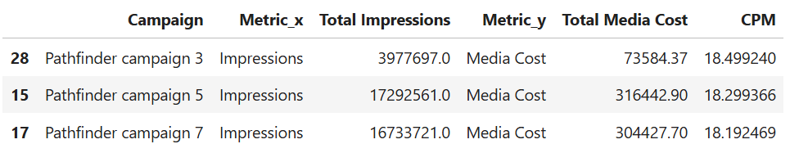

- What is the monthly average media cost for different media types?
Step1. Filtering 'Media Cost' value from the 'Metric' column.
Step2.Extracting 'Media Cost' in terms of 'Media Type'.
Step3. Extracting monthly average 'Media Cost' for different 'Media Type'.
Output:
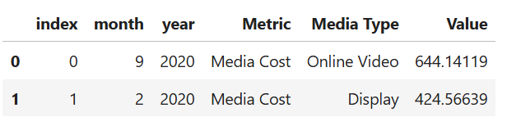

- Which media type is more expensive in terms of CPM?
Step1. Merging two tables using primary key.
Step2. Checking for the unique values in ‘Media Type’.
Step3. Filtering 'Media Cost' value from the 'Metric' column.
Step4. Creating a new column as ‘Total Media Cost’ in terms of ‘Media Type’.
Step5. Filtering 'Impressions' value from the 'Metric' column.
Step6. Creating a new column as ‘Total Impressions’ in terms of ‘Media Type’.
Step7. Merging ‘Total Impressions’ and ‘Total Media Cost’ in terms of ‘Media Type’.
Step8. Creating a new column as ‘CPM’ in terms ‘Media Type’.
Step9. Sorting the ‘CPM’ values to find out the expensive ‘Media Type’.
Output:

