2023_SKCET_Cloud_CC1

Time:30 minutes

Marks: 17Q

2. Create an IAM group called 'Network-L1-Team' with'AmazonVPCReadOnlyAccess'and ‘AWSNetworkManagerReadOnlyAccess' policies, then add an IAM user called 'Network-L1-User1' to the group.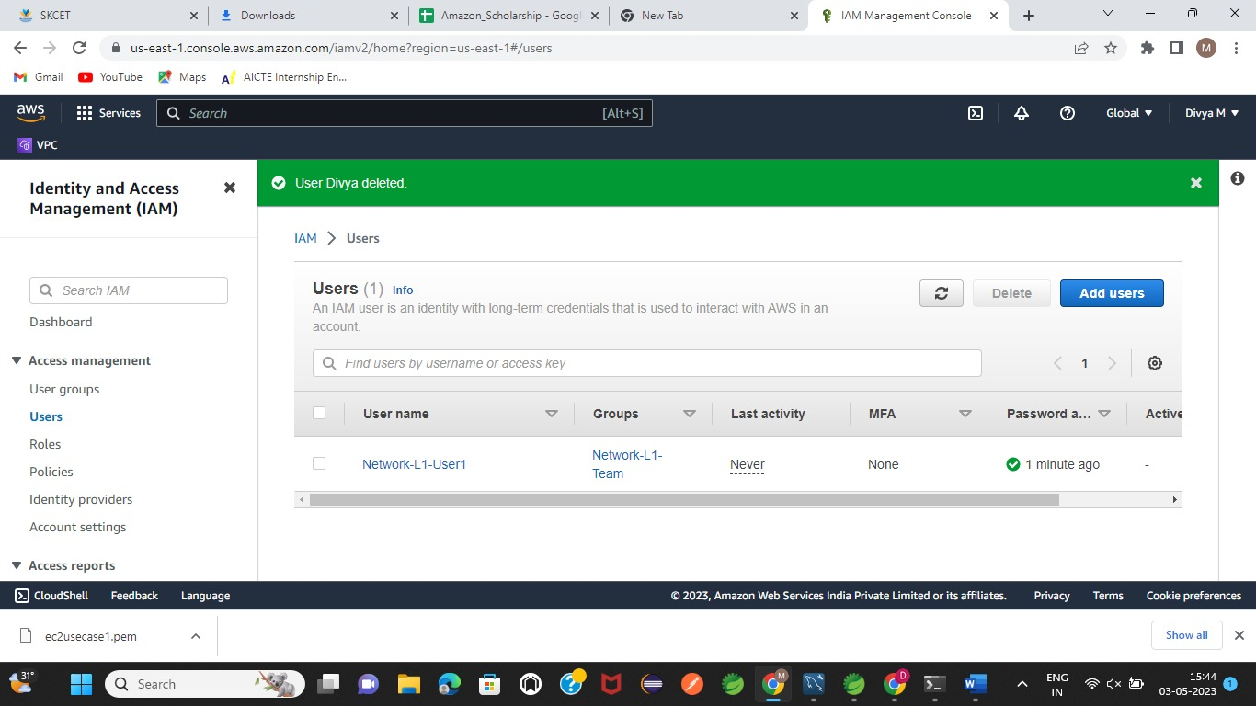

The name of the IAM group should be 'Network-L1-Team'.(4 Marks)

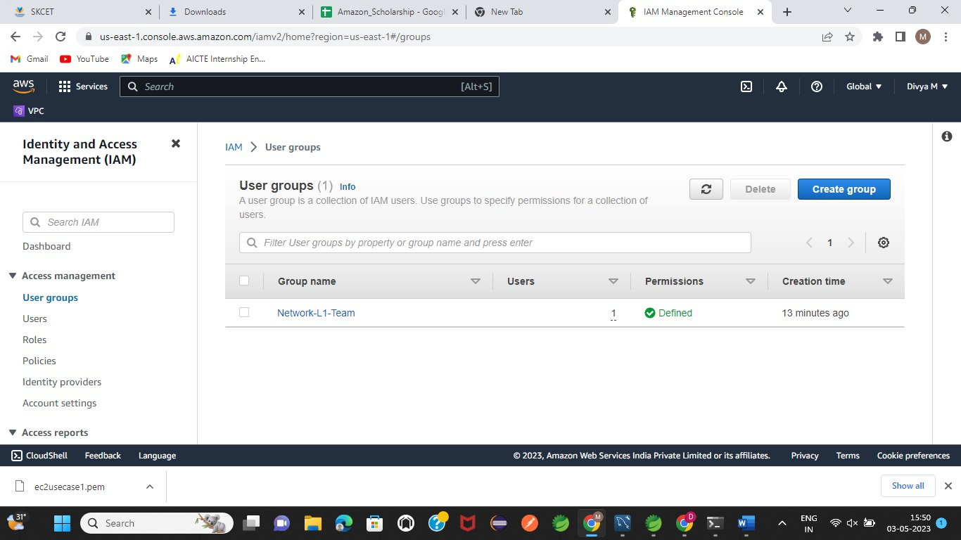

The name of the IAM user should be 'Network-L1-User1'.(4 Marks)The 'AmazonVPCReadOnlyAccess' policy should be attached.(4 Marks)The 'AWSNetworkManagerReadOnlyAccess' policy should be attached.(5Marks)

