023_SKCET_Cloud_CC1

Time:30 minutes

Marks: 17Q

3. Create a S3 bucket for the following requirementsCreate a new S3 bucket in the region of "Stockholm".(4 Marks)

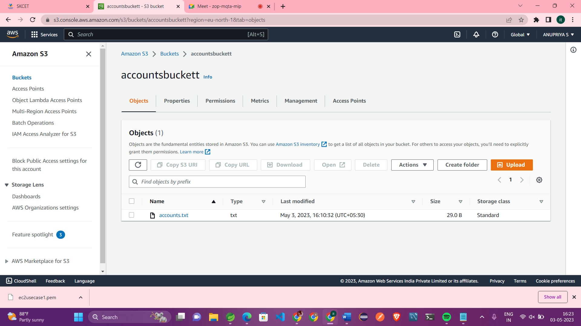

Make the bucket accessible to everyone(publicly) via Bucket ACL.(4 Marks)

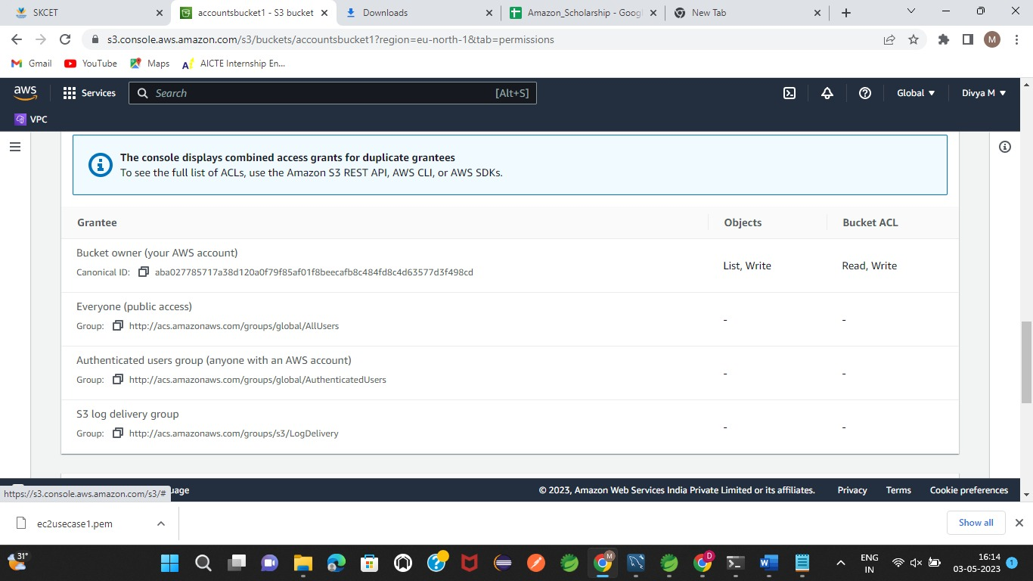

Upload a text file in the name of 'accounts.txt'. (5Marks)

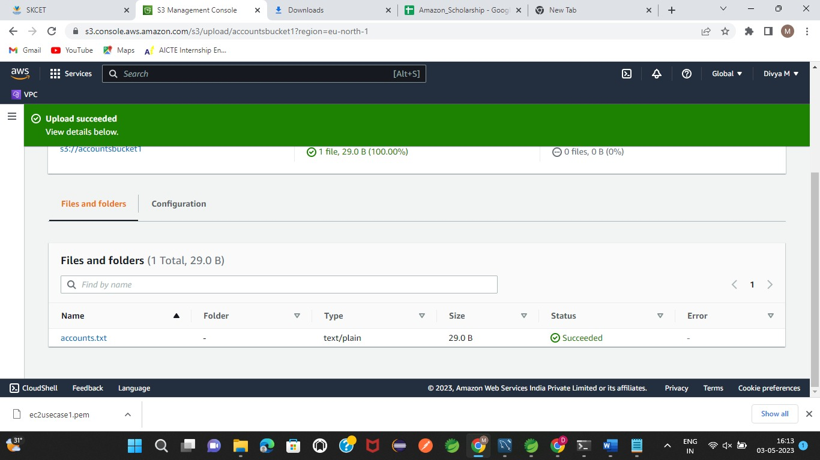

Make the object 'accounts.txt' file accessible to everyone(publicly).(4 Marks)

